Appendix 3: Indicators for niche conservatism
Table S3.1. Correlations (Pearson’s r) between factors tested as indicators of niche conservatism.
 | Range size | Niche breadth | Marginality | Time since introduction | Dispersal
Niche breadth | 0.453
Marginality | -0.409 | -0.109
Time since introduction | 0.261 | 0.148 | -0.018
Dispersal | 0.02 | 0.125 | -0.194 | 0.029
Duration | 0.125 | 0.038 | -0.018 | 0.316 | -0.34

Table S3.2. Indicators of niche conservatism – niche expansion limited to analogue climate space only, and without the weighting effect of US range size. qAIC weights and parameter estimates for all explanatory variables retained in the best model subset. Parameter estimates were averaged over all models in the best subset, and standard deviation is shown in parentheses.

Explanatory variable | Niche expansion |  | Niche expansion without effect of USA range size
 | qAIC weight | Model-averaged estimate | qAIC weight | Model-averaged estimate
log(Native range size) | 0.121 | -0.02 (0.049) | 0.414 | -0.061 (0.074)
Native niche-breadth | 1 | -1.372 (0.388) | 1 | -1.53 (0.1)
Log(Native marginality) | 0.276 | 0.093 (0.15) | 0.897 | -0.02 (0.331)
Time since introduction | 0.309 | -0.002 (0.003) | 0.646 | -0.006 (0.004)
log(Native range size ^2)
Native niche-breadth ^2 | 0.132 | -0.053 (0.131)
log(Native marginality^2) |  |  | 0.659 | 0.266 (0.256)
Time since introduction ^2

Table S3.3. Indicators of niche conservatism – excluding seven species for which data on the native distribution was incomplete. qAIC weights and parameter estimates for all explanatory variables retained in the best model subset. Parameter estimates were averaged over all models in the best subset, and standard deviation is shown in parentheses. Niche conservatism metrics were calculated using eight climatic variables.
Explanatory variable | Niche expansion |  | Niche-shift distance |  | Native-Naturalized Disequilibrium
 | qAIC weight | Model-averaged estimate | qAIC weight | Model-averaged estimate | qAIC weight | Model-averaged estimate
log(Native range size) | 0.153 | -0.035 (0.086) | 0.438 | -0.097 (0.616) | 0.297 | -0.152 (0.307)
Native niche-breadth | 1 | -1.359 (0.208) | 0.303 | -0.12 (0.191) | 0.426 | -1.002 (0.951)
log(Native marginality) | 0.275 | 0.093 (0.147) | 0.224 | 0.037 (0.082) | 0.233 | 0.049 (0.098)
Time since introduction | 0.294 | -0.002 (0.002) | 0.297 | -0.001 (0.001) | 0.298 | -0.001 (0.002)
log(Native range size ^2) |  |  | 0.065 | -0.014 (0.043)
Native niche-breadth ^2 | 0.112 | -0.026 (0.062) |  |  | 0.063 | 0.004 (0.012)

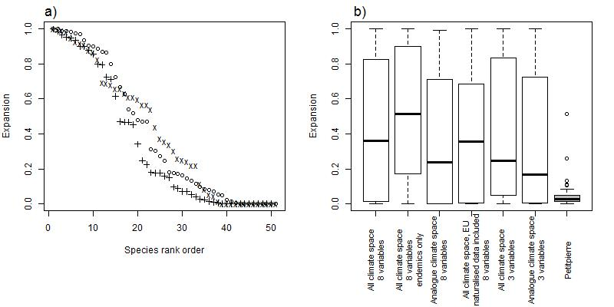
Figure S3.1. a) Niche expansion for each species, ‘o’ = expansion measured in all USA climate space using 3 climate variables, ‘+’ = expansion measured in analogue climate space only using 3 climate variables, ‘x’ = all climate space, native data includes European naturalised data; b) Boxplots show median, 25 and 75% percentiles, whiskers extend to 1.5 * interquartile range, and points are values lying outside this range. Endemics are species endemic to the study region (i.e. excluding the seven species with incomplete data on the native distribution). European naturalised data are locations where species have naturalised within Europe but outside their historical range.

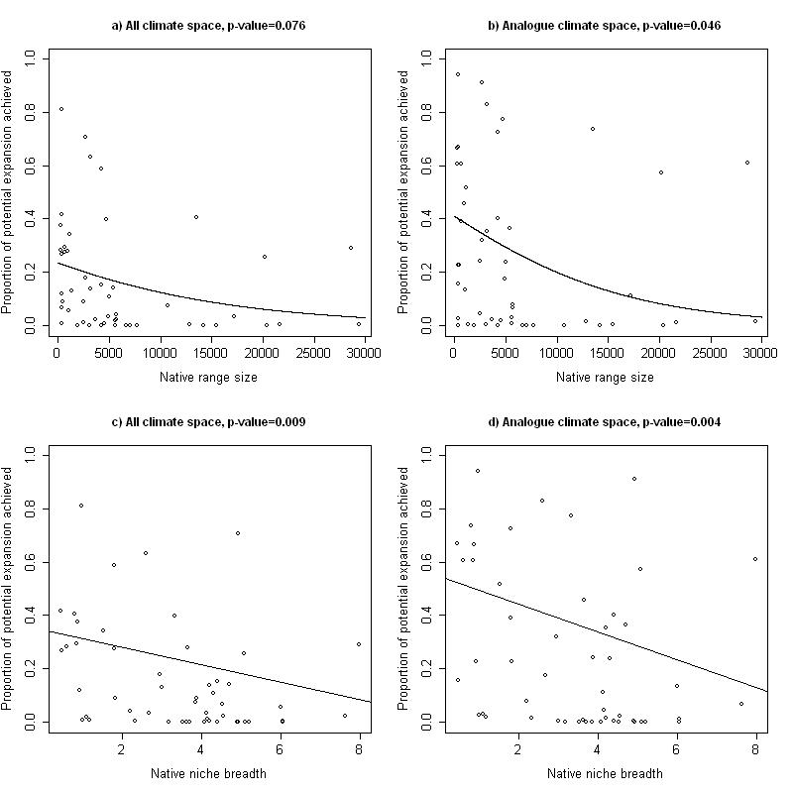
Figure S3.2. Testing the relationship between native niche breadth and the proportion of potential expansion achieved. Further explanation of terms used can be found in the main text. Relationships were tested using GLM with quasibinomial error structure with a log link function. Relationships are linear; quadratic terms were tested but were excluded from models (F-test).
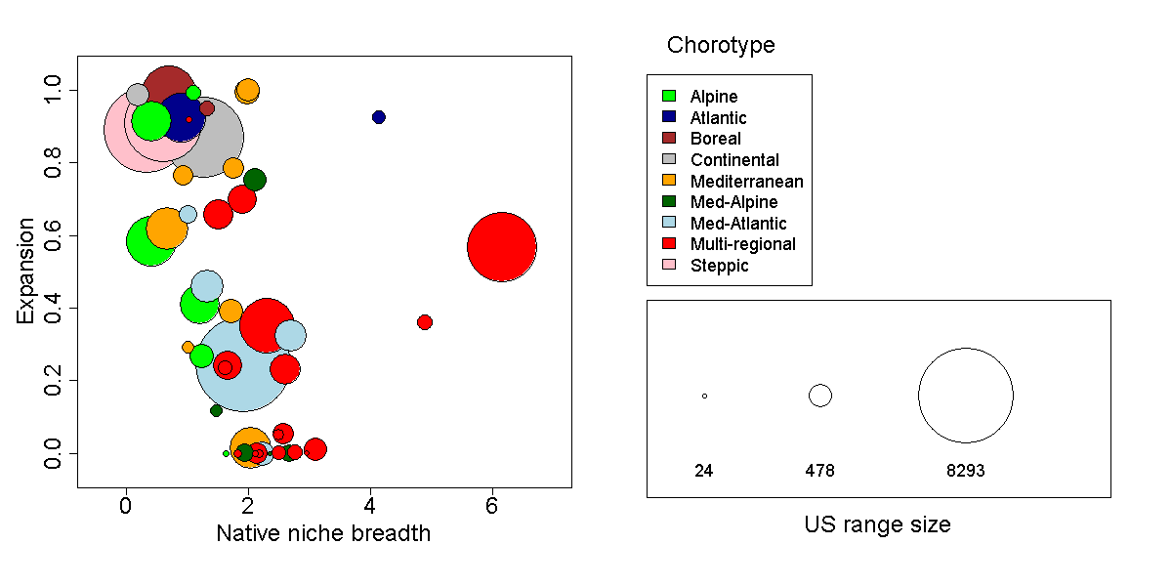
Figure S3.3. Demonstration of niche expansion for species with different native biogeographic affinities. Symbol colour is scaled by chorotype. Symbol size is scaled by the number of USA grid-cells.

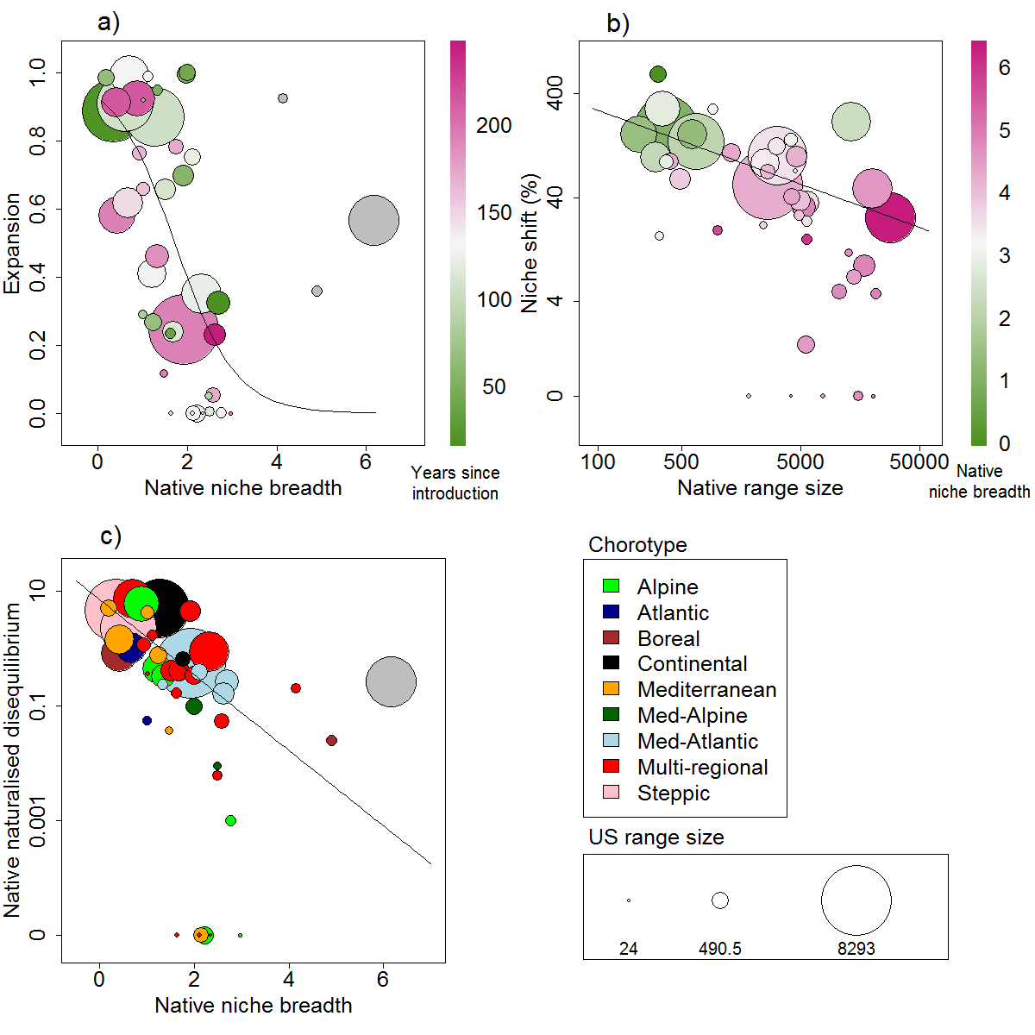
Figure S3.4. Examples of several indicators of niche conservatism, as assessed using different metrics of niche shift and excluding seven species for which data on the native distribution was incomplete; a) relationship of native niche breadth with niche expansion, i.e. the proportion of the USA distribution that falls outside the climatic conditions occupied in the native region, symbol colour is scaled by number of years since introduction; b) relationship of native range size with niche-shift distance, i.e. the magnitude of the shift between climate-space occupied in the native and naturalised region, relative to the native niche diameter, symbol colour is scaled by native niche breadth; c) relationship of native niche breadth with native-naturalised disequilibrium, symbol colour according to chorotype. Symbol size is scaled by the number of USA grid-cells. Regression lines were produced using the same methodology as for table 1, though only the x-axis variable was examined, and are significant (p<0.05).
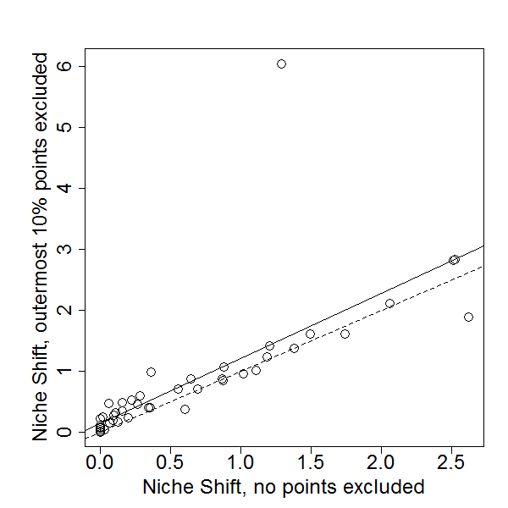
Figure S3.5. Relationship between niche shift distances calculated using all species data points in both the native and naturalised distribution, and after excluding the outermost 10% of points in each distribution. The dashed line is the line of equality, and the solid line is a linear regression (intercept = 0.139, slope = 1.071, R²=0.562).

