Pigeons can learn to make visual category discriminations using either low or high spatial frequency information

Stephen E. G. Leaª, Victoire Poser-Richet^{a,b} and Christina Meierª
ª University of Exeter
Psychology (CLES)
Washington Singer Laboratories
Exeter EX4 4QG
United Kingdom

^{b} Institut Polytechnique LaSalle Beauvais, France
Rue Pierre Waguet
BP30313
F-60026 Beauvais
France

Correspondence address:
S. E. G. Lea
University of Exeter
Psychology (CLES)
Washington Singer Laboratories
Exeter EX4 4QG
United Kingdom
Telephone +44 1392 724612, Fax +44 1392 724623, email s.e.g.lea@exeter.ac.uk

© Copyright 2014 S. E. G. Lea, V. Poser-Richet, and C. Meier. Moral right asserted.

This version saved 23 October 2014

Revised and resubmitted for a special issue of Behavioural Processes in honour of Tom Zentall

Keywords: Pattern recognition; Spatial frequency analysis; Pigeon vision

Abstract
Pigeons were trained to discriminate photographs of cat faces from dog faces, using either high- or low-pass spatial frequency filtered stimuli. Each pigeon was trained with multiple exemplars of the categories, but only with either high-pass or low-pass filtered stimuli. Not all pigeons reached the discrimination criterion. Successful pigeons were exposed in probe trials to test stimuli: cat and dog faces that had been subjected to the opposite kind of filtering from their training stimuli; the unfiltered original stimuli from which their training stimuli had been derived; and new exemplars of the cat- and dog-face categories, with the same filtering as was used in training. There was no transfer of discrimination to the stimuli with the opposite filtering from those used in training. Discrimination transferred, with some decrement, to the original unfiltered stimuli and to new exemplars with the same type of filtering as used in training. These results provide further evidence that both high and low spatial frequency information can be sufficient for pigeons to make category discriminations, and that there is no clear advantage for high spatial frequency information. They also confirm that high-pass and low-pass spatial frequency filtering produce images that have effectively no information in common.

Keywords
Pattern recognition; Spatial Frequency; Category discrimination; Pigeon vision

Pigeons can learn to make visual category discriminations using either low or high spatial frequency information
The eyes and visual brains of birds differ in many respects from those of mammals, and in particular of humans (Ziegler and Bischoff, 1993). Presumably as a result, the processing of complex stimuli seems to follow different rules in birds and humans. For example, a number of lines of evidence converge on the conclusion that pigeons respond more to local details of stimuli in situations where human behaviour is more determined by the Gestalt (Cook 1993). This is not an absolute rule: both pigeons and humans can be trained to use either local or global features (e.g., Goto et al., 2004), and in studies of object recognition, both detailed “geons” and more global properties such as spatial location can contribute to recognition of an object (Van Hamme et al, 1992). However, there are some striking examples of differences between pigeon and human pattern processing. Faced with hierarchical stimuli like those of Navon (1977), which humans classify in terms of global properties, pigeons classify them in terms of the elements of which they are composed (Cavoto and Cook, 2001). Faced with stimuli in which a small diamond sometimes does, and sometimes does not, fit exactly into a notch in the perimeter of a large square, pigeons detect the notch with equal ease regardless of whether the diamond is fitted into it, whereas humans find the task harder when the diamond fits into the notch, since we then see the image as a diamond superimposed on an intact square (Fujita and Ushitani, 2005). Faced with two long, parallel diagonal lines, one intersected with numerous short vertical lines and the other with short horizontal lines, humans see the lines as converging in one direction (the Zöllner illusion), whereas pigeons and chickens seem them as converging in the opposite direction (Watanabe et al., 2011, 2013). If pigeons are trained to discriminate between images of cats and dogs, and are then faced with chimeras made up of cat heads on dog bodies or vice versa, they classify them in terms of the body (Ghosh et al., 2004, Experiment 1) whereas human infants classify them in terms of the head (Quinn and Eimas, 1996).
Ghosh et al. (2004) and Goto et al. (2011) attempted to draw these and other results together by suggesting that, compared with humans, pigeons may be more sensitive to the higher spatial frequencies in a stimulus. In a direct test of this proposal, Lea et al. (2013) trained pigeons to discriminate cat faces from dog faces, and then tested them with high-pass and low-pass filtered versions of the training stimuli, and with hybrid stimuli in which the high spatial frequency components of a stimulus from one category were combined with the low spatial frequency components of a stimulus from the opposite category. They found better generalization to the low-pass than to the high-pass filtered stimuli, and furthermore found that the hybrid stimuli tend to be responded to in terms of their low spatial frequency component rather than their high spatial frequency component. These results were opposite to those obtained from humans, and this is surprising given the evidence that pigeons tend to respond in terms of the finer details of stimuli more than humans. Furthermore, in an experiment in which they removed narrow bands of spatial frequencies from images that pigeons had been trained to discriminate, Murphy and Cook (2008) reported that removing high spatial frequencies led to more generalization decrement than removing low spatial frequencies.
Because of the unexpected nature of Lea et al.’s (2013) results, the present experiment was designed to explore further the impact of high-pass and low-pass spatial frequency filtering on pigeons’ category discrimination. In particular, it investigated whether high- and low-pass filtered versions of the kind of stimuli used by Lea et al. (2013) contain truly independent information. Figure 1 shows examples of the kinds of stimuli we used; to ensure that the results obtained by Lea et al. (2013) were not due to any peculiarity of their stimuli, all the stimuli used in the present experiment were new. Because of our past experience of cats and dogs and pictures of them, humans recognize both kinds of filtered stimuli immediately as cat or dog faces, and would therefore generalize responses from one kind to the other. However, the pigeons we used had had no known exposure to either cats or dogs, and it is in any case doubtful that they would recognize the pictures as representations of the corresponding real objects (see, for example, Dittrich et al., 2010), so we would not expect any transfer to the opposite kind of stimulus, unless there is some experimental artefact. To test this prediction, pigeons were trained to discriminate images using high- or low-pass filtered stimuli. The pigeons that had been trained with high-pass filtered stimuli were then tested with low-pass filtered stimuli, and vice versa. Following this test of the independence of the information in the two kinds of filtered stimuli, the pigeons were tested on transfer to the original, unfiltered versions of the stimuli, and on transfer to new exemplars of the cat and dog face categories.
Method
Subjects
Nine pigeons, obtained as discards from local fanciers, were kept in an indoor aviary and maintained at or above 80% of free feeding weight. They had previously served other experiments on visual pattern discrimination, using similar training and testing procedures but with stimuli of completely different appearance. Eight birds were used in the initial design of the experiment; because some of these did not reach the training criterion, an additional pigeon was added later.
Apparatus
Each pigeon was tested in one of four 71 x 50.5 x 43.5 cm operant chambers. One long wall of each chamber was fitted with a 31 x 23.5 cm (15-in.) touch monitor (Model 1547L 1024 x 768 pixel TFT monitor with CarrollTouch infra-red detector; ELO Touchsystems Inc.), mounted 12 cm above the grid floor of the chamber. Effective pecks to target areas were followed by an immediate bleep from a 50-ohm loudspeaker, which also played white noise into the box. Two 2.8-W white houselights were mounted above and to either side of the screen. Two 6 x 5-cm apertures gave access to grain hoppers when solenoids were activated; they were located directly below the houselights and 4 cm above the floor of the chamber. The hoppers were illuminated by a 2.8-W white light when activated, and contained a 2:1 mixture of hemp seed and conditioner. The interior of some of the boxes was monitored by a video camera. The experiment was controlled by a computer (Quadvision Ltd) located in an adjacent laboratory area, using the Whisker control server system (Cardinal and Aitken, 2010) with client programs written in Microsoft ® Visual Basic 6.0.
Stimulus materials
The training stimuli were spatial-frequency filtered versions of full-colour cat and dog face images on medium grey backgrounds. The original images were similar to those used by Lea et al. (2013), but they were newly sourced and prepared for this experiment. Pictures of cats and dogs were downloaded from a variety of Internet sources; the heads were removed and placed on a circular medium grey background, and the resulting head images were converted into 240 x 240-pixel bitmap files, with a colour depth of 24 bits/pixel. In all, twenty cat faces and twenty dog faces were used; ten of each were used for training and ten for transfer tests. The overall brightness (mean of the sum of red, green and blue intensities across all pixels), redness (mean of red intensity minus green pixel intensity across all pixels) and blueness (mean blue intensity minus half the mean of red and intensity and half the mean of green intensity across all pixels) of each stimulus were calculated, and the mean values of these parameters in all four groups of stimuli (training cats, training dogs, transfer cats and transfer dogs) were equated as closely as possible. Their means and standard deviations are reported in Table 1, and it can be seen that in all cases, the variation of the parameters within categories was much greater than the difference of their means between categories: Among the training stimuli, each cat face was paired with the dog face of the same rank brightness for the purposes of assigning stimuli to sessions. Following filtering, all the images were reduced to 120 x 120 pixel bitmaps. They were then further reduced within the Whisker system to 90 x 90 pixels for display on the touchscreens, where the diameter of the background was approximately 3.0 cm. They subtended approximately 53° of arc at the pigeon’s eye at the moment of impact, given a typical pecking distance that positioned the bird’s eye about 3cm from the touchscreen. The final reduction for display introduced some visual noise, in the form of occasional single-pixel dots, into all images, but this factor was constant across all stimulus types. Figure 1 includes examples of the original images, rendered in greyscale.
Insert Table 1 about here
As in Lea et al. (2013), spatial frequency filtered stimuli were produced using methods recommended by Walisch et al. (2009, pp. 87ff). Low-pass filtered versions of each stimulus were produced by convolving the 2-dimensional matrix of its pixel values for each colour channel (red, green or blue) with a square filter kernel. In simple terms, this blends the pixel values across the area of the kernel, and thus removes high spatial frequency information. The convolution was carried out using the convn routine within Matlab® R2013a with a 32-pixel filter kernel, thereby removing spatial frequencies above .031 cycles/pixel; following the final reduction in size of the images, the cut-off frequency becomes .083 cycles/pixel. High-pass filtered stimuli were then produced by subtracting the low-pass filtered stimuli from the originals, leaving only the high spatial-frequency information, and adding half the maximal value to all pixel values to restore overall brightness. Figure 1 includes examples of high- and low-pass filtered stimuli. .
The filter kernel size of 32 pixels was chosen because to the experimenters’ eyes it appeared to make the high- and low-pass filtered stimuli equally different from the original images. It can be rationalized as follows. The lowest frequency that can be represented in a 90 x 90 pixel bitmap is 1/90 (0.011) cycles per pixel, and the highest is the Nyquist frequency, 0.5 cycles/pixel. Given the standard assumption that each octave of spatial frequencies will contain approximately the same energy in pictures of natural scenes and objects (Field, 1987), the frequency that would be expected to divide the spectral energy, and hence information, in these picture in half can be calculated as .075, slightly below the cut-off frequency we used.
Procedure
We used the same multiple simultaneous discrimination procedure (Huber et al., 2005; Wills et al., 2009, Experiment 2b) as in Lea et al. (2013). Sessions started with the presentation of a circular observing key, 80 pixels (2.5 cm) in diameter, centred on the vertical midline of the touchscreen and 238 pixels (7 cm) above its base. A peck to this key removed it, and an array of ten stimuli was then presented at random non-overlapping locations within a rectangle of 735 x 450 pixels (23 x 14 cm) centred on the vertical midline of the touchscreen and starting 56 pixels (1.8 cm) above its base. When the pigeon pecked a positive stimulus twice in succession, it disappeared, and a circular reward key of diameter 80 pixels (2.5 cm) appeared, centred 100 pixels (3.1 cm) from the right or left of the touchscreen and 168 pixels (5.3 cm) above its base. The left reward key appeared if the stimulus that had been pecked was centred in the left half of the touchscreen, and the right reward key otherwise. A peck on the reward key led to the presentation and illumination of the corresponding grain hopper for 2.5 s. If the pigeon pecked a negative stimulus twice in succession, this also disappeared, but no reward key appeared, and all keys became ineffective for 2.5 s. Once a stimulus had disappeared, it did not reappear. When all positive stimuli had disappeared, any remaining negative stimuli also disappeared, and after the feeder operation an inter-trial interval of 3 s ensued. The observing key was then presented again.
One session was run per day, two to five days per week. Because of the pigeons’ previous experience, minimal pretraining was required; pecking at images scattered across the touchscreen was established across 3 sessions by presenting arrays of ten white hexagons that fitted within 100 x 100 pixel squares, using the same procedure as in training but with pecks to all hexagons being reinforced.
Initial training sessions consisted of the presentation of ten arrays, each including five filtered cat faces and five filtered dog faces. The cat and dog faces that were paired for scheduling purposes were never presented in the same array, but within each pair of arrays, all ten faces of each type were presented. Initially, eight pigeons were trained: four had cat faces as positive stimuli, and the other four had dog faces as positive, and within each of these groups, two were trained with high-pass and two with low-pass filtered stimuli. Performance on each array was assessed by the rho statistic of Herrnstein et al. (1976), based on the rank order of removal of the 10 stimuli, with any negative stimuli left after all positives had been removed being assigned the mean of the remaining ranks. Training was continued for each pigeon for at least 5 sessions, and then until it had recorded two consecutive sessions with a mean rho across the ten arrays of 0.80 or above, or until 20 sessions had been completed.
For those pigeons that did not reach the criterion within 20 sessions, single-stimulus training was given. The procedure was the same as above but only a single cat face and its paired dog face was used within each session, so in each array five exemplars of these two faces were presented. Training with each pair of faces was continued for 20 sessions or until the same criterion as above was reached, and then the procedure was repeated with a second pair of faces, and so on. There were thus a minimum of 20 sessions of training in this phase. Pigeons that failed to reach criterion on four pairs of stimuli were dropped from the experiment. Those that reached criterion on at least 7 of the pairs of stimuli were then exposed to the initial training conditions again, for a further 30 sessions or until they reached criterion. Pigeons that did not reach criterion within the 30 sessions of further training on the stimulus categories were dropped from the experiment. Additional birds were added to the experimental design to replace birds that were dropped.
For those birds that reached criterion, test sessions followed. All pigeons were given a single test session that included probe stimuli of the opposite kind of filtering to that used in training, They were then tested with the original, unfiltered stimuli and with new exemplars of the filtered stimuli; half the birds were tested with the original stimuli before the new exemplars, and the other half had the tests in the reverse order.
Test sessions consisted of eleven arrays. Odd-numbered arrays contained only training stimuli. In even-numbered arrays, two positive and two negative stimuli were replaced by test stimuli. In all arrays, training contingencies of reinforcement were in effect for the training stimuli. The test stimuli were associated with the contingencies appropriate to them (i.e. if cat faces were positive in training, pecks to modified or novel cat stimuli were reinforced during tests). Three test sessions were given with each kind of test stimulus. If discrimination of the training stimuli within the test arrays of a test session was not maintained, data from that session were discarded and the test was repeated. After each test session, a training session was run, to confirm that performance remained at or above a mean rho of 0.8; if it did not, further training sessions were given until the mean rho returned to 0.8 or above.
Data Analysis
The numbers of sessions required to reach criterion by pigeons being trained on low-pass and high-pass filtered stimuli were compared using a Mann-Whitney U-test; a rank test was required because three pigeons in one group did not reach criterion at all, and with a rank test they could be included in the comparison without loss of information. Test-trial results are summarized as the mean ranks at which each kind of stimulus (including training stimuli) were removed from test arrays, ranking the first stimulus removed as 10, the second as 9, and so on. Any negative stimuli remaining after the last positive stimulus had been removed were assigned the mean of the remaining ranks. Session means of these ranks were submitted to a series of factorial Generalized Estimating Equations (GEE) analyses (see Hardin and Hilbe, 2013); this procedure was preferred to conventional ANOVA because it allows the low number of subjects to be mitigated by the fact that data were available from three test sessions under each condition for each bird. In all analyses in which performance on test stimuli was compared with performance on training stimuli, training stimulus data were taken from within the arrays in which the corresponding test stimuli appeared. A normal data distribution was assumed, an identity link function was used, and fitting was by maximum likelihood methods.
Ethics
All procedures complied with the Guidelines for the use of animals in research of the Association for the Study of Animal Behaviour, and were approved by the Ethical Review Board of the University of Exeter.
Results
Of the total of nine birds trained, four on low-pass and five on high-pass filtered stimuli, six reached criterion. In the low-pass group, all birds reached criterion, requiring between 15 and 102 sessions of training to do so. The two birds in the high-pass group that reached criterion required 17 and 83 sessions to do so. The difference between the two groups in sessions to criterion was not significant (Mann-Whitney U_{4,5} = 5, P = .19). Two of the birds frequently required further training after test sessions to restore discrimination performance, and several test sessions had to be discarded because discrimination of the training stimuli within the test arrays was inadequate.
Figure 2 shows the mean ranks at which the pigeons pecked positive and negative training and test stimuli in each test series, and Figure 3 shows corresponding data for each individual pigeon. It is clear that, overall, positive stimuli were ranked higher than negative stimuli, i.e. that discrimination was maintained; that this effect was stronger among the training stimuli than among the test stimuli taken together, i.e. that there was some generalization decrement; and that the extent of generalization decrement varied between the three test series, with clear generalization in the unfiltered and new exemplar tests, but none in the opposite filter test. Individual data followed the mean results closely. Only two of the six pigeons responded sooner to the positive than to the negative stimuli in the opposite-filter test. In contrast, five of the six pigeons tended to respond sooner to the positive than the negative unfiltered stimuli, and five of them tended to respond to the new positive filtered exemplars earlier than the new negative filtered exemplars; the exception was a different pigeon in each case.
The significance of these trends was confirmed by a global generalized estimating equations analysis using as factors positive vs negative stimuli, training vs test stimuli, and test series. The main effect of positive vs negative stimuli was significant (Wald χ²₁ = 154.25, P<.001), confirming that discrimination was observed overall. The interaction between positive vs negative stimuli and training vs test stimuli was significant (Wald χ²₁ = 109.15, P<.001), confirming that across the three test series there was a tendency to generalization decrement. Finally, the interaction between positive vs negative stimuli, training vs test stimuli, and test series was significant (Wald χ²₂ = 14.39, P<.001), confirming that the extent of generalization decrement varied between test series.
Insert Figure 2 about here
Supplementary GEE analyses were carried out to investigate specific hypotheses. An analysis using data from test stimuli only, with factors of positive vs negative stimuli and test series, showed a significant main effect of positive vs. negative (Wald χ²₁ = 7.70, P<.01), confirming that the test stimuli were correctly discriminated in at least some test series, as well as a significant interaction between positive vs. negative and test series (Wald χ²₂ = 39.54, P<.001), again demonstrating that generalization decrement varied between test series. Separate GEE analyses for each test series, taking as factors positive vs negative and training vs test stimuli showed that generalization decrement was significant for all three series (shown by the interaction between the two factors: Wald χ²₁ ≥ 27.42, P<.001 in all cases). GEE analyses confined to the test stimuli within each test series, using as a factor positive vs negative stimuli, showed that there was significant transfer to the unfiltered stimuli and the new filtered exemplars (Wald χ²₁ = 13.10, P<.001, and 6.05, P<.05, respectively), but not to the oppositely filtered stimuli (Wald χ²₁ = 1.30, P=.25).
The low number of birds completing training precludes any analysis of differences between those trained with low- and high-pass filtered stimuli.
Discussion
Although the filtered stimuli can be recognized as dog and cat faces by the human eye, the category discrimination between them was learned only with considerable difficulty by the pigeons, regardless of whether they were high- or low-pass filtered, and three of the nine pigeons that entered the experiment could not be trained within a reasonable time. All our results therefore need to be interpreted with some caution, as representing only pigeons that could be trained successfully. Huber et al. (2005) showed that the multiple simultaneous discrimination training procedure is exceptionally powerful, so it would appear that the band-pass filtering of the stimuli reduced the information in them to somewhere near the minimum a pigeon needs in order to learn a category discrimination.
Lea et al. (2013), using images very similar to those used in the present experiment, and a similar category discrimination procedure, found poorer transfer to high-pass than low-pass filtered stimuli after category discrimination training. Given this result, it would be expected that training would be more difficult with the high-pass than with the low-pass filtered stimuli. We did indeed find that all four birds trained with low-pass stimuli eventually reached criterion, but only two out of five birds trained with high-pass stimuli did so, but the difference in speed of acquisition fell short of significance. The successful transfer observed to the unfiltered versions of the training stimuli was also to be expected, given that Lea et al. (2013) had observed transfer in the opposite direction, though it is not inevitable that generalization will be symmetrical. The fact that there was some transfer to new exemplars of the filtered stimuli shows that the pigeons had learned more than a series of exemplars; since we used ten exemplars of each category during training, this was to be expected: Bhatt (1988, as reported by Wasserman and Astley, 1994) found that pigeons showed little transfer to new exemplars following category discrimination training when there were four exemplars in each category, but much better transfer when there were twelve.
The results of the transfer test to stimuli that had been filtered in the opposite way from those used in training were clear: no transfer was shown. This result confirms that the high and low spatial frequencies in these are carrying independent kinds of information. Physically, it is hard to see how this could not be true, but psychologically, it need not be. To a human, both frequency bands convey the information that the image represents a cat face, or a dog face as the case may be; but that can only happen because we already possess internal representations, or concepts, of a cat face and a dog face, and both the high and low frequency components of each type of face are associated with the relevant concept. The absence of transfer between the two spatial frequency bands shows that the pigeons did not have any such common concept with which both bands of frequency were associated. That could be because they had no concept of either cats or dogs, and given that they had never lived in the wild, that might well be true. It could also, however, be because the small two-dimensional images we showed them were not recognized as representations of the real object; although birds can show transfer of learned discrimination between pictures to the corresponding objects (e.g. Aust and Huber, 2006, 2010), they do not always do so (e.g. D’Eath and Dawkins, 1996; Dittrich et al., 2010). In fact, the present results suggest that testing for transfer between oppositely filtered images might be a promising way of investigating whether animals have recognized the objects depicted in two-dimensional images. Against that argument, however, it should be noted that there is some evidence that pigeons may process local and global information in different brain hemispheres (Yamazaki et al., 2007), and have difficulty accessing unihemispheric engrams from the opposite hemisphere (Xiao and Güntürkün, 2009). Yamazaki et al.’s results may not be consistent across all birds, since Chiandetti et al. (2014) produce some contradictory evidence from domestic chicks. However they are relevant to our present results, because it could be that for pigeons, the high and low spatial frequency components even of images that they know well are represented separately in the brain.
The results provide further evidence against any generalization that, in comparison with humans, pigeons extract more high spatial frequency than low spatial frequency information from visual images. Acquisition of the discrimination was slower with high-pass filtered stimuli than with the corresponding low-pass filtered stimuli, and although this difference was not significant, there was no question of a difference in the opposite direction, which is what would be expected if high spatial frequency information was more useful to pigeons. Objectively, the low-pass stimuli did contain slightly more information than the high-pass stimuli, because the cut-off frequency used (.083 cycles/pixel) was slightly above the value that should ensure equal information in each kind of stimulus (.075 cycles/pixel). To the experimenters’ eyes, however, the two kinds of image seemed equally informative.
The complete absence of transfer between the oppositely filtered stimuli provides some reassurance that the unexpected results of Lea et al. (2013) were not due to some artefact of the stimulus preparation or presentation methods used. Further experiments will be needed to clarify why results obtained with the present technique differ from those obtained by Murphy and Cook (2008), and anticipated on the basis of the many examples of pigeons tending, more than humans, to respond to local rather than global information. At present, the best conclusion seems to be that the priority for global cues observed in a number of experiments (but not, in fact always or immutably observed, as Goto et al., 2004, demonstrated) is not to be accounted for by a general tendency of pigeons to process high rather than low spatial frequency information.
Acknowledgements
We thank Catherine Bryant for developing the initial version of the client program used, Sophie Edwards, Chloe Angwin, Tom Seaman, Gemma Flynn and Linus Juen for helping to test the pigeons, Dan Brooks and Sophie Edwards for discussion, and Catriona Ryan for animal care.
References
Aust, U., Huber, L., 2006. Picture-object recognition in pigeons: Evidence of representational insight in a visual categorization task using a complementary information procedure. J. Exper. Psychol: Anim. Behav. Proc. 32, 190-195.
Aust, U., Huber, L., 2010. Representational insight in pigeons: comparing subjects with and without real-life experience. Anim. Cogn. 13, 207-218.
Cardinal, R.N., Aitken, M.R.F., 2010. Whisker: A client-server high-performance multimedia research control system. Behav. Res. Meth. 42, 1059-1071. doi:10.3758/BRM.42.4.1059
Cavoto, K.K., Cook, R.G., 2001. Cognitive precedence for local information in hierarchical stimulus processing by pigeons. J. Exper. Psychol.: Anim. Behav. Proc. 27, 3-16.
Chiandetti, C., Pecchia, T., Patt, F., Vallortigara, G., 2014. Visual hierarchical processing and lateralization of cognitive functions through domestic chicks' eyes. PLoS One, 9, e0084435.
Cook, R.G., 1993. Gestalt contributions to visual texture discriminations by pigeons. In Zentall, T. R. (Ed.), Animal Cognition, pp. 251-269. Erlbaum, Hillsdale NJ.
D'Eath, R., Dawkins, M.S., 1996. Laying hens do not discriminate between video images of conspecifics. Anim. Behav. 52, 903-912.
Dittrich, L., Adam, R., Ünver, E., Güntürkün, O., 2010. Pigeons identify individual humans but show no sign of recognizing them in photographs. Behav. Proc. 83, 82-89. doi:10.1016/j.beproc.2009.10.006
Field, D. J (1987). Relations between the statistics of natural images and the response properties of cortical cells. J. Opt. Soc. Amer. A: Optics, Image Science and Vision, 4, 2379-2394.
Fujita, K., Ushitani, T., 2005. Better living by not completing: a wonderful peculiarity of pigeon vision? Behav. Proc. 69, 59-66. doi:10.1016/j.beproc.2005.01.003
Ghosh, N., Lea, S.E.G., Noury, M., 2004. Transfer to intermediate forms following concept discrimination by pigeons: Chimeras and morphs. J. Exper. Anal. Behav. 82, 125-141.
Goto, K., Lea, S.E.G., Wills, A.J., Milton, F., 2011. Interpreting the effects of image manipulation on picture perception in pigeons (Columba livia) and humans (Homo sapiens). Journal of Comparative Psychology 125, 48-60. doi:10.1037/a0020791
Goto, K., Wills, A.J., Lea, S.E.G., 2004. Global-feature classification can be acquired more rapidly than local-feature classification in both humans and pigeons. Animal Cognition 7, 109-113.
Hardin, J. W., Hilbe, J. M., 2013. Generalized estimating equations (2nd edn). : CRC Press, Boca Raton FL.
Herrnstein, R.J., Loveland, D.H., Cable, C., 1976. Natural concepts in pigeons. J. Exper. Psychol.: Anim. Behav. Proc. 2, 285-302.
Huber, L., Apfalter, W., Steurer, M., Prossinger, H., 2005. A new learning paradigm elicits fast visual discrimination in pigeons. J. Exper. Psychol.: Anim. Behav. Proc., 31, 237-246.
Lea, S. E. G., De Filippo, G., Dakin, R., Meier, C., 2013. Pigeons use low rather than high spatial frequency information to make visual category discriminations. J. Exper. Psychol.: Anim. Behav. Proc. 39, 377-382. doi:10.1037/a0033104
Murphy, M.S., Cook, R.G., 2008. Spatial frequency use in picture processing in pigeons. Paper read at the Conference on Comparative Cognition, Melbourne, FL, March.
Navon, D., 1977. Forest before trees: The precedence of global features in visual perception. Cogn. Psychol. 9, 353-383.
Quinn, P.C., Eimas, P.D., 1996. Perceptual cues that permit categorical differentiation of animal species by infants. J. Exper. Child Psychol. 63, 189-211.
Van Hamme, L. J., Wasserman, E. A., Biederman, I., 1992. Discrimination of contour-deleted images by pigeons. J. Exper. Psychol.: Anim. Behav. Proc. 18, 387-399.
Walisch, P., Lusignan, M., Benayoun, M., Baker, T.I., Dickey, A.S., Hatsopoulos, N., 2009. MATLAB for Neuroscientists. Academic Press, Burlington MA.
Watanabe, S., Nakamura, N., Fujita, K., 2011. Pigeons perceive a reversed Zöllner illusion. Cognition 119, 137-141. doi:10.1016/j.cognition.2010.10.020
Watanabe, S., Nakamura, N., Fujita, K., 2013. Bantams (Gallus gallus domesticus) also perceive a reversed Zöllner illusion. Anim. Cogn. 16, 109-115. doi:10.1007/s10071-012-0556-0
Wills, A.J., Lea, S.E.G., Leaver, L.A., Osthaus, B., Ryan, C.M.E., Suret, M., Bryant, C.M.L., Chapman, S.J. Millar, L. 2009. A comparative analysis of the categorization of multidimensional stimuli: I. Unidimensional classification does not necessarily imply analytic processing; evidence from pigeons (Columba livia), squirrels (Sciurus carolinensis) and humans (Homo sapiens). J. Comp. Psychol. 123, 391-405. doi:10.1037/a0016216.
Xiao, Q., Güntürkün, O., 2009. Natural split-brain? Lateralized memory for task contingencies in pigeons. Neurosci. Lett. 458, 75-78.
Yamazaki, Y., Aust, U., Huber, L., Hausmann, M., Güntürkün, O., 2007. Lateralized cognition: Asymmetrical and complementary strategies of pigeons during discrimination of the "human concept". Cognition, 104, 315-344.
Zeigler, H. P., and Bischof, H.-J. (Eds), 1993. Bird vision and cognition. MIT Press, Cambridge, MA.
Table 1
Brightness and colour of the images from which the stimuli were derived. Entries are mean values, ± standard deviations, across all pixels in each of the ten images in each category. The maximum brightness would therefore be 255; blueness and redness could range from -255 to +255.
 | Training stimuli |  | New exemplars
Property | Cat face images | Dog face images | Cat face images | Dog face images
Brightness (mean of red, green and blue pixel intensities) | 132.3 ± 18.2 | 133.8 ± 9.0 | 112.9 ± 18.1 | 108.8 ± 7.9
Blueness (mean of blue intensity minus half the sum of red and green piexel intensities) | -3.2 ± 4.8 | -7.0 ± 6.1 | -7.7 ± 9.7 | -8.6± 10.4
Redness (mean of red pixel intensity minus green pixel intensity) | 3.0 ± 4.3 | 5.6 ± 4.4 | 6.3 ± 5.6 | 9.1 ± 10.8

Figure captions
Figure 1. Greyscaled examples of the stimuli used. “Parent” cat and dog face stimuli were used to generate the high-pass and low-pass filtered stimuli used in training; they were subsequently used in transfer tests. The stimuli were presented in full colour.
Figure 2. Response to modified positive and negative stimuli in test sessions. Data are mean ranks of pecking a stimulus within test arrays (first stimulus pecked has rank 10). High ranks imply that the stimulus was treated as positive. Data for training stimuli are for those presented within test arrays. Error bars show ranges across the 6 pigeons for which test data are available. “Opposite filter” stimuli were high-pass filtered for pigeons trained with low-pass filtered stimuli, and vice-versa. New exemplars were filtered in the same way as the images used in training.

Figure 3. Response to modified positive and negative stimuli in test sessions for individual pigeons. Data are mean ranks of pecking a stimulus within test arrays (first stimulus pecked has rank 10). High ranks imply that the stimulus was treated as positive. Data for training stimuli are for those presented within test arrays. “Opposite filter” stimuli were high-pass filtered for pigeons trained with low-pass filtered stimuli, and vice-versa. New exemplars were filtered in the same way as the images used in training.

Figure 1
Parent dogs
High-pass filtered dogs
Low-pass filtered dogs
Low-pass filtered cats
High-pass filtered cats
Parent cats
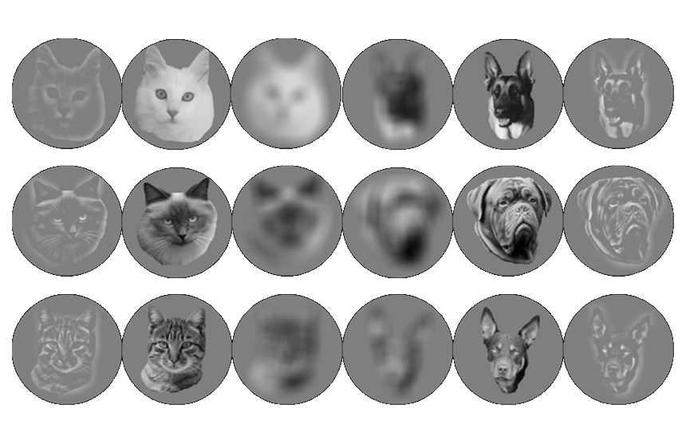
Greyscale examples of the stimuli used. “Parent” cat and dog face stimuli were used to generate the high-pass and low-pass filtered stimuli used in training; they were subsequently used in transfer tests. The stimuli were presented in full colour.

Figure 2
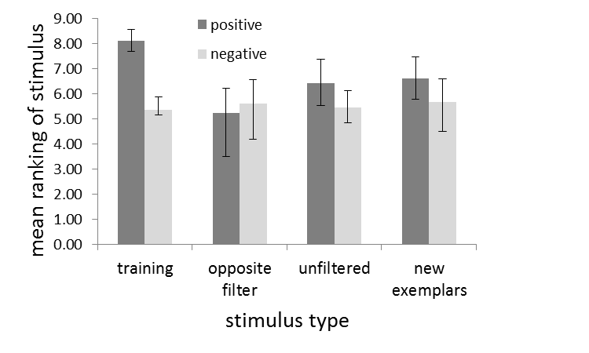
Response to modified positive and negative stimuli in test sessions. Data are mean ranks of pecking a stimulus within test arrays (first stimulus pecked has rank 10). High ranks imply that the stimulus was treated as positive. Data for training stimuli are for those presented within test arrays. Error bars show ranges across the 6 pigeons for which test data are available. “Opposite filter” stimuli were high-pass filtered for pigeons trained with low-pass filtered stimuli, and vice-versa. New exemplars were filtered in the same way as the images used in training.

Figure 3

Pigeon Ch  Dog Positive, Low-Pass training stimuli | Pigeon Zz  Cat Positive, Low-Pass training stimuli
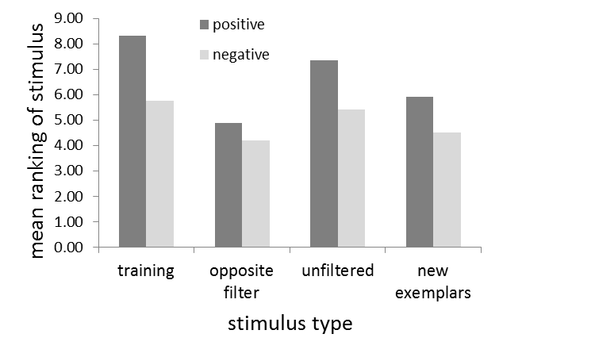 | 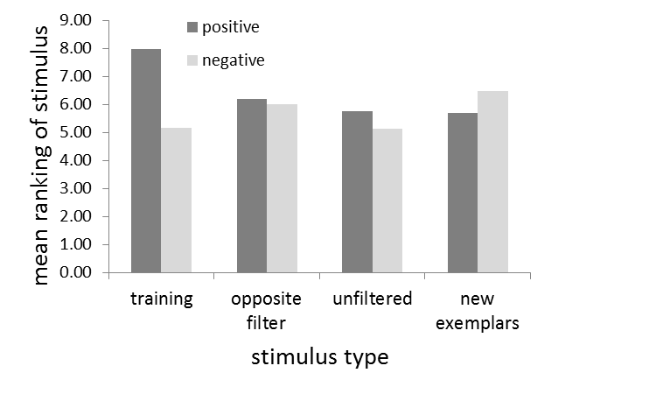
Pigeon La  Dog Positive, Low-Pass training stimuli | Pigeon Zm  Cat Positive, Low-Pass training stimuli
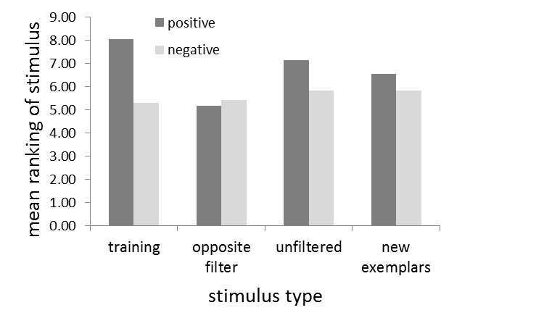 | 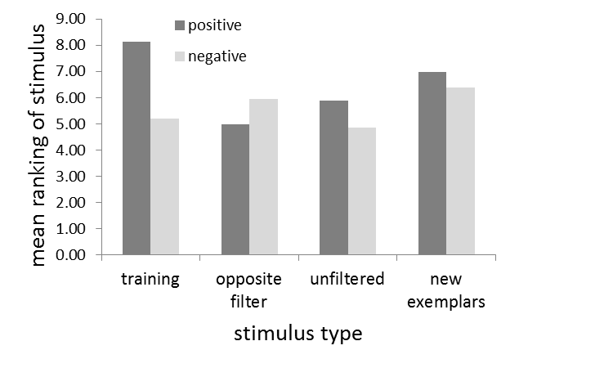
Pigeon Ki  Dog Positive, High-Pass training stimuli | Pigeon Pg  Cat Positive, High-Pass training stimuli
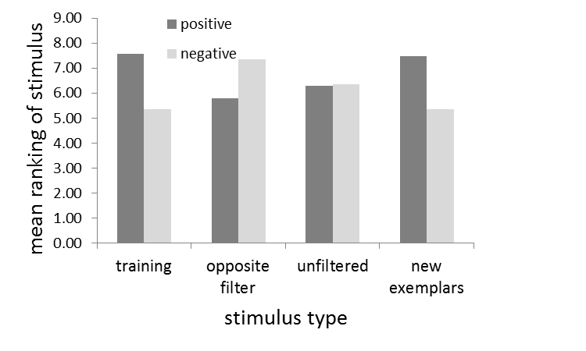 | 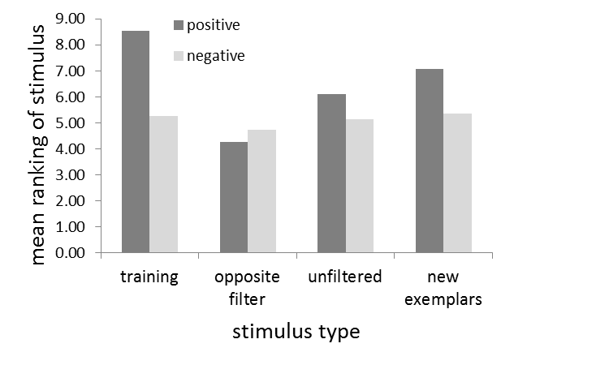
Response to modified positive and negative stimuli in test sessions for individual pigeons. Data are mean ranks of pecking a stimulus within test arrays (first stimulus pecked has rank 10). High ranks imply that the stimulus was treated as positive. Data for training stimuli are for those presented within test arrays. “Opposite filter” stimuli were high-pass filtered for pigeons trained with low-pass filtered stimuli, and vice-versa. New exemplars were filtered in the same way as the images used in training.

