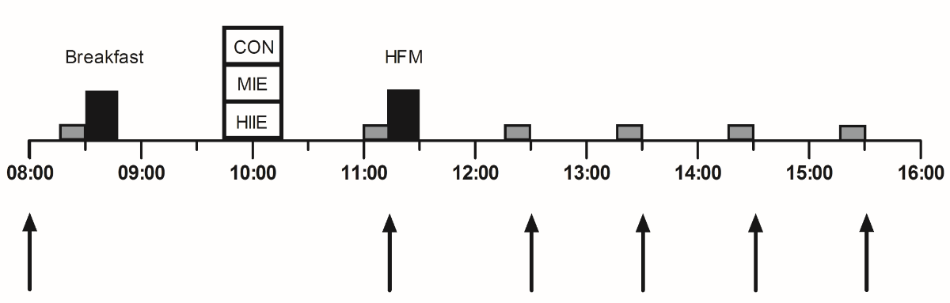
Figure 1 Protocol schematic. 1 = rest; 2 = moderate-intensity exercise; 3 = high-intensity interval exercise. Arrows represent capillary blood samples for plasma [TAG] and glucose; grey boxes represent the assessment of resting metabolic rate and blood pressure; HFM = high fat meal.

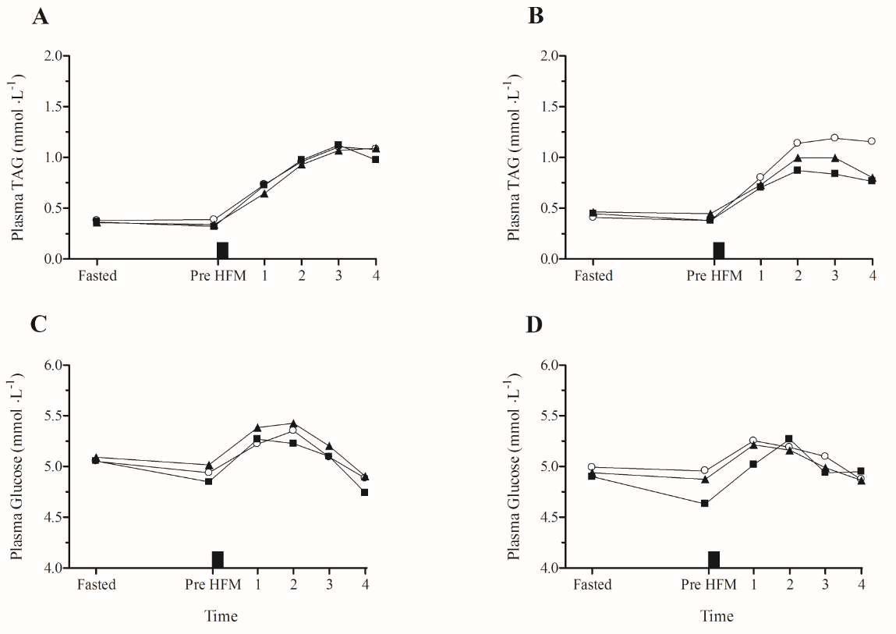
Figure 2 Mean postprandial plasma triacylglycerol ([TAG]) and [glucose] for the control (○), moderate-(▲) and high-(■) intensity exercise conditions for boys (A, C) and girls (B, D). Error bars are omitted for clarity. The high fat meal (HFM) is represented by the black rectangle.

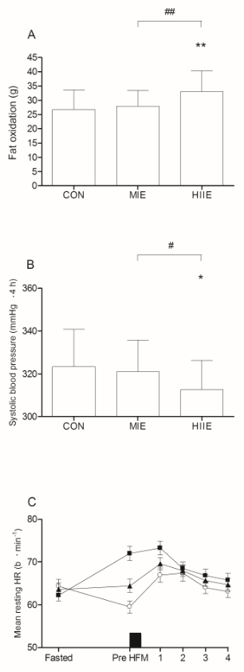
Figure 3 Mean total area under the curves for postprandial fat oxidation (A) and systolic blood pressure vs time (4 hours; B), and heart rate (C) collapsed for the boys and girls (n=20). CON, control trial (○); MIE, moderate-intensity exercise trial (▲); HIIE, high-intensity interval exercise trial (■). ** = P<0.001 for HIIE vs CON; * = P<0.05 for HIIE vs CON; ## = P<0.001 for HIIE vs MIE; # = P<0.05 for HIIE vs MIE. The high fat meal (HFM) is represented by the black rectangle. Error bars describe the standard deviation.

