Marine Rhodobacteraceae L-haloacid dehalogenase contains a novel His/Glu dyad which could activate the catalytic water.
Halina R. Novak¹, Christopher Sayer¹, Michail N. Isupov¹, Konrad Paszkiewicz¹, Dorothee Gotz², Andrew Mearns Spragg² and Jennifer A. Littlechild¹
¹ The Henry Wellcome Building for Biocatalysis, Biosciences, College of Life and Environmental Sciences, University of Exeter
Stocker Road
Exeter
EX4 4QD
UK

² Aquapharm Biodiscovery Ltd
European Centre for Marine Biotechnology
Dunstaffnage
Oban
Argyll
PA37 1QA
UK
Corresponding author
J.A.Littlechild@exeter.ac.uk
Tel: 44-1392-2634698
e-mail: J.A.Littlechild@exeter.ac.uk

Running title
A novel marine Rhodobacteraceae L-haloacid dehalogenase.

Enzyme
L-haloacid dehalogenases (EC. 3.8.1.2)

Abbreviations
HAD, haloacid dehalogenase; DehRhb, Rhodobacteraceae family L-haloacid dehalogenase; DehIVa, Burkholderia cepacia L-haloacid dehalogenase; L-DEX YL, Pseudomonas sp. YL L-haloacid dehalogenase; DhlB- Xanthobacter autotrophicus L-haloacid dehalogenase; DehSft, Sulfolobus tokodaii L-haloacid dehalogenase; MCPA, L-2-monochloropropionic acid; MCAA, monochloroacetic acid; MCBA, L-2-monochlorobutyric acid.
Keywords
Marine bacterium, L-2-haloacid dehalogenase, Novel Enzyme, Crystal structure, Enzyme mechanism.

Database
The coordinates and structure factors of the crystal structures have been deposited in the Protein Data Bank with the codes 2yml, 2ymm, 2ymp, 2ymq and 2yn4. Nucleotide sequence data has been deposited in the GenBank database under the accession number JX868516X.

Abstract
The putative L-haloacid dehalogenase gene (DehRhb) from a marine Rhodobacteraceae family has been cloned and over-expressed in Escherichia coli. The DehRhb protein was shown to be an L-haloacid dehalogenase with highest activity towards brominated substrates with short carbon chains (≤C3). The optimal temperature for enzyme activity is 55ºC and the V_{max} and K_{m} are 1.75 µM min⁻¹ mg⁻¹ and 6.72 mM respectively when using monobromoacetic acid as a substrate. DehRhb shows moderate thermal stability, with a melting temperature of 67ºC. The enzyme demonstrates high tolerance to solvents as shown by thermal shift experiments and solvent incubation assays. The DehRhb protein has been crystallised and structures of the native, reaction intermediate and substrate bound forms have been determined. The active site of DehRhb has significant differences from previously studied L-haloacid dehalogenases. The asparagine and arginine residues shown to be essential for catalytic activity in other L-haloacid dehalogenases are not present in DehRhb. The histidine residue, which replaces the asparagine in DehRhb is coordinated by a conformationally strained glutamate residue which replaces a conserved glycine. The His/Glu dyad is positioned for deprotonation of the catalytic water which attacks the ester bond in the reaction intermediate. The catalytic water in DehRhb is shifted by approximately 1.5 Å from its position in other L-haloacid dehalogenases. A similar His/Glu or Asp dyad is known to activate the catalytic water in haloalkane dehalogenases. The DehRhb enzyme represents a novel member within the L-haloacid dehalogenase family and it has potential to be used as a commercial biocatalyst.

Introduction
The dehalogenase enzymes catalyse the removal of a halogen atom from an organic substrate and have attracted interest for their applications in bioremediation and in fine chemical production [1,2]. The production of halogenated by-products from organic synthetic reactions and the use of halogenated pesticides and insecticides in farming are the two main sources of halogenated xenobiotic pollutants. The accumulation of these compounds, which are recalcitrant and carcinogenic pollutants, has driven the search for new microbial dehalogenases suitable for use in bioremediation [2,3].
Haloacid dehalogenases remove a halogen atom from a carbon adjacent to a carboxyl group. These hydrolytic enzymes can be sub-divided into two groups. Group I contains both the non stereospecific D/L-haloacid dehalogenases and the enantioselective D-haloacid dehalogenases [4,5]. The enantiospecific L-2-haloacid dehalogenases (L-HADs) that catalyse the dehalogenation of short chain haloalkanoic acids to produce their corresponding hydroxyalkanoic acids, belong to group II. This reaction of group II L-HADs occurs with an inversion of chirality [6]. These enzymes are of particular commercial interest since their products can be used as building blocks for the production of pharmaceuticals and fine chemicals [7,8].
L-haloacid dehalogenases (EC. 3.8.1.2) belong to the HAD enzyme superfamily which use an aspartate group as the nucleophile in their catalytic mechanism. The HAD superfamily of enzymes also includes phosphate monoesterases, ATPases, phosphonoacetaldehyde hydrolases and phosphomutases [9]. Structurally, these enzymes are dimers with each subunit consisting of two domains. The core domain resembles a ‘Rossmann-fold’ six stranded parallel β-sheet, flanked by five α-helices and the cap domain consists of a four helix bundle. The active site is located between the two domains. Proteins in the HAD superfamily share the same core domain but have variable cap domains which give rise to their enzymatic diversity. [10].
Many L-HADs have been identified, several of which have been biochemically and structurally characterised. These include the L-HAD from Pseudomonas sp. strain YL (L-DEX YL) [11], Xanthobacter autotrophicus GJ10 (DhlB) [12], Burkholderia cepacia MBA4 (DehIVa) [13] and Sulfolobus tokodaii (DehSft) [14]. The structures of the ester intermediates bound to the catalytic aspartate have been determined for L-DEX YL [15], DhlB [12] and DehIVa [13]. The structure of a D-lactic acid product bound in the active site of L-DEX YL has also been reported [15]. The structure of L-lactic acid bound in the active site of DehSft [14] is proposed to mimic the pre-reaction Michaelis complex. The general S_{N}2 nucleophilic substitution mechanism has been proposed based on the structures of the characterised L-HAD enzymes [15]. The first step of the reaction is the S_{N}2 nucleophilic attack by the catalytic aspartate carboxylate group on the C2 carbon of the substrate forming an ester intermediate and the release of free halide. The following nucleophilic attack on the ester intermediate by an activated water molecule results in the formation of a D-hydroxyalkanoic acid.
Amino acid sequence comparison of the L-HADs has highlighted residues which are conserved in all of the biochemically characterised members of the family. Knowledge of the L-HAD crystal structures has allowed assignment of some of these residues to the enzyme active site. Extensive site directed mutagenesis studies have identified the key amino acids that are essential for catalytic activity. Besides the catalytic aspartate (Asp10) in DehIVa, other completely conserved residues such as Arg42 and Asn178 are proposed to be involved in substrate binding [13]. The conserved Asp180 in L-DEX YL has been proposed to stabilise the orientation of the catalytic Asp10 and to activate the catalytic water [16].
To date, the majority of dehalogenase enzymes have been isolated from terrestrial organisms [17]. The marine environment is considered an untapped resource, which is now recognised as an important source of novel enzymes and metabolites [18]. The oceans are known to contain a variety of halogenated compounds, with marine algae being the largest source of organohalogen production [19,20]. They produce a diverse range of biologically active compounds including halogenated terpenes, which are of interest to the pharmaceutical industry, as they often show antimicrobial and anticancer properties [21,22]. Some species of polychaete tube worms are also known to produce a range of structurally diverse halogenated compounds [23]. The toxic characteristics of some halogenated metabolites are thought to be responsible for driving the evolution of algal defence mechanisms [24,25]. Microorganisms living in symbiosis with tube worms and on the surface of algae may use dehalogenase enzymes to degrade some of these toxic compounds. The abundance of organohalogens in the marine environment makes algae and marine microbes a potential source of novel halogenase and dehalogenase enzymes. A recent study describes a number of species from the Rhodobacteraceae family that tested positive for haloacid dehalogenase activity [26]. However, none of these L-HADs had been structurally characterised.
This paper describes the biochemical characterisation and structural determination of the Rhodobacteraceae DehRhb enzyme in its native, reaction intermediate and pre-reaction Michaelis complex bound forms. Several amino acid residues shown to be conserved and essential for activity in related dehalogenases, are not present in DehRhb. The amino acids found to be unique to DehRhb are proposed to be involved in the activation of the catalytic water in the second part of the dehalogenase reaction.

Results and Discussion

Cloning, over-expression and purification
A species from the Rhodobacteraceae (Rhb) family that was isolated from a polychaeta worm collected from Tralee beach, Argyll, UK, tested positive for L-HAD activity towards L-monochloropropionic acid (MCPA). Only one gene coding for a putative L-HAD (DehRhb) was identified that had limited sequence identity with known L-HAD enzymes within the 4.5 Mbp genome sequenced as part of this study. The key catalytic aspartic acid residue was conserved, but some other proposed active site residues in other L-HAD enzymes were not conserved. Since DehRhb appeared to be the only candidate gene for the L-HAD, this was cloned and over-expressed for further characterisation. The DehRhb gene was cloned into pET-28a incorporating an N-terminal His-tag. The recombinant protein was over-expressed in Escherichia coli BL21 (DE3)-RIPL, where it accounted for 30% of the total soluble cell protein, as estimated by SDS-PAGE. The recombinant DehRhb enzyme was successfully purified by nickel affinity chromatography (GE Healthcare) and gel filtration chromatography using Superdex 75 (GE Healthcare). From the size exclusion chromatography, the protein was estimated to elute in the form of a dimer. The purified DehRhb enzyme migrated on an SDS-PAGE gel at 25 kDa which agreed with the calculated monomeric protein molecular weight of 25.6 kDa.

Biochemical characterisation

Substrate specificity
Biochemical characterisation of the recombinant DehRhb enzyme has shown it to have L-HAD activity. The protein shows varying substrate specificity towards L-2-haloalkanoic acids with different chain lengths and halogen substitutions (Fig. 1). Similarly to previously characterised L-HADs, DehRhb shows activity towards only the L-enantiomer of substrates which are brominated or chlorinated at the α-carbon position.
The DehRhb enzyme shows highest activity towards monobromoacetic acid (100%) followed by monochloroacetic acid (MCAA) (71%), S-bromopropionic acid (71%), S-chloropropionic acid (MCPA) (10%) and dichloroacetic acid (9%). Although activity towards 2-chlorobutryic acid was not observed in the time frame of the substrate specificity experiment, some activity was observed over 48 hours. This shows that DehRhb has some reduced activity with substrates that have carbon chains >3.
Both DehRhb and DehIVa (22% amino acid sequence identity) have a preference for L-brominated substrates with short carbon chains, with highest activity towards monobromoacetic acid and 2-bromopropionic acid [27]. The DhlB enzyme [28] which has 20% amino acid sequence identity to DehRhb also prefers substrates with shorter carbon chain lengths, however this enzyme shows highest activity towards dihalogenated substrates which have 2 halogens attached to the α-carbon such as, dibromoacetic acid and dichloroacetic acid. Other L-HAD enzymes L-DEX YL [5] and DehSft [14] (18% and 19% amino acid sequence identity to DehRhb, respectively) show highest activity towards long chain substrates such as 2-chlorobutryic acid.
The V_{max} and K_{m} for the DehRhb enzyme were calculated to be 1.75 µM min⁻¹ mg⁻¹ and 6.72 mM, respectively when using monobromoacetic acid as a substrate. In comparison, L-DEX YL and DehIVa have slightly lower K_{m} values of 1.1 mM and 1.13 mM, respectively [5, 27]. DehSft has a comparable K_{m} value of 6.23 mM [14].

Solvent stability
The solvent stability of DehRhb was initially assessed by incubating the enzyme in the presence of the solvent at various concentrations for one hour as previously carried out with DehSft [14]. In both cases an aliquot of the treated enzyme was then checked for activity in the standard assay. DehRhb showed 150% and 123% activity after incubation in 40% DMSO and 30% methanol respectively (Fig. 2). This could be explained by small amounts of these solvents present in the final assay conditions that could increase the availability of the substrate (without denaturing the enzyme) as MCAA is more soluble in DMSO and methanol in comparison to water. The DehRhb enzyme retained 100% of its activity after incubation in 20% ethanol and 10% acetonitrile.
Solvent stability experiments with DehRhb were also carried out by performing thermal shift experiments with the enzyme in the presence of different solvents over a range of concentrations. Results from these experiments (Table 1) showed that in the presence of 10-40% ethanol, methanol and acetonitrile the enzyme melting temperature decreased by values between 6 and 34°C. No melting temperature was recorded for 50% ethanol, methanol and acetonitrile suggesting the enzyme had unfolded at these concentrations of solvent. The enzyme was most stable in 10-50% DMSO, showing a decrease in melting temperature between 6-22°C.
In contrast to these results for DehRhb, the previous experiments with the thermostable DehSft enzyme [14] showed that activity was greatly reduced after exposure to different organic solvents for 1 hour. DehSft lost more than 60% of its activity towards the substrate MCPA when incubated in 30% DMSO or 10% ethanol, methanol and acetonitrile. Other described studies with the Pseudomonas putida L-HAD have showed higher activity towards substrates with longer carbon chain lengths such as 2-bromohexadecanoic acid in the presence of anhydrous DMSO [29]. The L-DEX YL enzyme also showed increased activity towards this substrate in n-heptane, although the activity towards substrates with short carbon chain lengths such as MCPA dropped by 94% in comparison to untreated protein [5].
Since industrial processes are often carried out in the presence of organic solvents it is advantageous to have a solvent stable enzyme. The organic solvent can improve or change the substrate specificity and solubility [30]. Both the thermal shift experiments in the presence of solvents and the solvent incubation assays have demonstrated that DehRhb has a relatively high tolerance to solvents. Other studies with enzymes from halotolerant microorganisms have shown the proteins to have good stability in organic solvents [18,31].

Thermostability
As determined from the thermal shift experiment (Fig. 3a), DehRhb has a melting temperature of 67ºC. The residual activity after incubation of DehRhb at temperatures between 30-70ºC showed that the enzyme retained 85% of its activity after being incubated at 50ºC for 90 min (Fig. 3b). Enzyme activity was reduced after incubation of the enzyme at 60ºC, with the enzyme retaining just 14% activity after 90 min of incubation. The optimal temperature for the activity of the DehRhb is 55ºC.
Other L-HADs from both mesophilic and thermophilic sources have been biochemically characterised. DehSft from the thermophilic S. tokodaii shows high thermal stability, retaining 92% of activity after incubation at 50ºC for 90 min and has a temperature optimum for activity of 60ºC [14]. This is to be expected as S. tokodaii is a thermophilic archaeon isolated from the volcanic hot springs of Oita Prefecture in Kyushu, Japan [32]. However, L-DEX YL from the mesophilic Pseudomonas sp. YL is also relatively thermostable, retaining 100% of activity when incubated at 60ºC for 30 min [5]. The optimum temperature for activity of L-DEX YL is 65ºC despite the Pseudomonas species having an optimally growth temperature of 30ºC.
Thermophilic enzymes have been exploited in industrial applications since increased thermostability results in a more robust catalyst with increased solvent stability and less susceptibility to proteolysis [33]. High thermostability allows enzymes to operate at elevated temperatures where non-natural substrates are more soluble. The reported experiments show that DehRhb is a relatively thermostable enzyme from a mesophilic marine bacterium from the Rhodobacteraceae family.
Structural studies
Crystallisation
The DehRhb crystals grew from microbatch crystallisation screens at 18ºC with equal volumes of protein and precipitant solution containing 0.2 M LiCl, 0.1 M Tris-HCl, pH 8.0, 20% PEG 6000. Substrate soaks were conducted at pH 4.5 for 1 hour which proved to be sufficient for ensuring high occupancy in the active site.

Quality of the models
The native structure, sulfate complex, reaction intermediate structures with MCAA and MCPA and the substrate bound structure with MCBA were refined to a resolution equivalent or higher than 2.0 Å. For each model, the final round of refinement resulted in a R_{free} value equivalent of 20.4% or better. Some residues were excluded from the model when poor electron density was observed at the C and N termini of the protein (Table 2). The G-factors calculated for each model confirmed the structures have good stereochemical properties [34]. The Ramachandran plot for the native structure revealed 94.0% of the residues are in the most favoured regions, with a further 5.4% in the additionally allowed regions and a single residue of each subunit lying in the disallowed region, with the other DehRhb complex structures having similar statistics. Glu21 is an outlier in the Ramachandran plot in all DehRhb structures; this residue is in the active site pocket of DehRhb and is well defined in the electron density map. Density for the DehRhb active site complexes with MCAA, MCPA and MCBA were confirmed by calculating F_{o}-F_{c} omit maps (Fig. 4a,b,c). The occupancies of the intermediates were estimated by ensuring the similarity of B-factors of the ligands to neighbouring residues. The final refinement statistics and validation results for all structures are shown in Table 2. Residues Pro132 and Pro158 of each subunit in all structures are in the cis-conformation. Many residue side chains were modelled with alternative conformations and in some cases secondary positions of the main chain oxygen were also modelled.

Overall structure of DehRhb
The approximate dimensions of the DehRhb monomer are 40 Å x 27 Å x 33 Å. The DehRhb monomer contains two domains (Fig. 5a). The core domain is formed by residues 14-17 and 119-232 and has a typical ‘Rossmann fold’ which consists of six parallel open twisted β-strands with a Richardson [35] topology of +1x,+1x,-3x,-1x,-1x surrounded by four helices and three 3₁₀ helices. The cap domain is made up of a four-helix bundle formed by residues 26-115. Approximately 37% of the residues in each subunit are in α-helices, 11% in β-sheets and 5.5% in 3₁₀ helices. The core and cap domains of DehRhb are structurally similar to DehIVa, DhlB, DehSft, and L-DEX YL, with RMSDs between matching Cα positions of 1.41 Å over 195 residues, 1.41 Å over 194 residues, 1.40 Å over 178 residues and 1.41 Å over 200 residues, respectively. The cut-off distance of 3.5 Å was used to calculate these values. The active site is located between the cap and the core domain following the β1 strand. The side chains of amino acid residues from both domains contribute to the active site cavity.
The asymmetric unit of the native DehRhb crystal contains a biological homodimer, which is in agreement with the estimated size of the protein in solution, as determined by size exclusion chromatography. The oligomeric state of DehRhb is consistent with those of the DehIVa, DhlB, and DehSft which are also dimeric proteins. The two subunits of DehRhb are related by a molecular 2-fold axis to which the α2 helix from each subunit are parallel (Fig. 5b). The dimer has approximate dimensions of 70 Å x 40 Å x 43 Å. Upon the formation of the DehRhb dimer 18.7% of the surface of each monomer is buried, in comparison to 13.4%, 13.5% and 19% in DehSft, L-DEX YL and DhlB respectively.
The DehRhb dimer is similar to the dimers of other HADs, with the subunit interface formed by the α2 and α3 helices. The main differences between the different enzymes regarding this interface are the conformations and lengths of the loops. In the DehRhb these loops are made up from residues 61-64 and 79-84 from the cap domain which are located at the N- and C-termini of helix α3 and the loop formed from residues 201-213 belonging to the core domain. There are other areas of contact between the two subunits. The α2 helix interacts with α2 and α8 helices from the other subunit. The loop between β5 and β6 is in close proximity to the α3 helix from the adjacent subunit. These interactions which are involved in dimer formation in DehRhb are different to the dimerization interactions previously described for L-DEX YL [11] and DehSft [14]. However, Tyr53 in DehRhb and the equivalent residues in DehIVa (Tyr57), DehSft (Tyr31), L-DEX YL (Tyr57) and DhlB (Tyr45) are conserved and involved in dimer stabilisation.
The native, substrate and intermediate complex structures are quite similar with an RMSD value of ≤0.55 Å between Cα atom positions of the individual monomers. There appears to be no conformational changes of the DehRhb after substrate binding or the formation of reaction intermediates.
Native, sulfate, intermediate complex and substrate bound forms of DehRhb
The structure of the DehRhb has been solved in 5 different forms by altering the composition of the ‘mother liquors’ in which crystals were soaked prior to freezing for data collection. Native crystals were grown at pH 8.0 and soaked in a cryoprotectant at pH 8.0. To obtain the reaction intermediate complex structures, the pH of the ‘mother liquor’ was lowered to pH 4.5, as the reaction intermediate can not be hydrolysed below pH 5.0 [12,13]. Initial soaks with substrates at pH 4.5 did not result in ester intermediate complexes, as the sulfate ion present in the buffer competes for binding in the enzyme active site at low pH. The sulfate DehRhb complex showed clear electron density for a tetrahedral shaped sulfate ion in the active site next to the catalytic Asp18 residue in all four chains. The sulfate ion is coordinated by residues Asp18, Thr124, His183 and Lys157.
Further crystal soaking experiments were conducted in a sulfate free, Tris-HCl ‘mother liquor’ at pH 4.5 in an attempt to obtain the reaction intermediate complex structures. Clear continuous electron densities were observed for the ester intermediates of MCAA and MCPA bound to the catalytic Asp18 (Fig. 4a,b) The MCAA ester intermediate was modelled in the active site in two different conformations. The major and minor conformers have an occupancy of 0.7 and 0.3 respectively, with the minor conformer in a similar position as the ester intermediate of MCPA. Crystal soaking experiments were also conducted with the weak substrate MCBA at a concentration of 25 mM at pH 4.5. The resulting complex did not contain a covalent intermediate, but instead the MCBA substrate was bound as a pre-reaction Michaelis complex at an occupancy of 0.6 in the active site cavity (Fig. 4c). Two water molecules (observed in the same position in the native structure) were also modelled in the substrate carboxyl binding site at an occupancy of 0.4.

Active site of DehRhb
The MCAA and MCPA intermediate complexes of DehRhb confirm Asp18 to be the main catalytic residue, which attacks the C2 of the substrate to form the ester intermediate in the first half of the reaction. The structure of the MCPA intermediate complex has the C2 atom in a D configuration, confirming that inversion of the chiral carbon occurs upon the halogen removal step in the first part of the reaction [12]. The intermediates of MCAA and MCPA and the substrate MCBA are located in a pocket with Asp18 on one side and a predominately hydrophobic aromatic environment on the other side, consisting of residues Phe47, Leu50, Ile51, Phe66, His183 and Trp185 (Fig. 4a,b). No movement of the main chain or side chains of residues are observed either upon substrate binding or during the first step of the enzymatic reaction.
Unlike the hydrolysis of the ester intermediate, the S_{N}2 nucleophilic attack by Asp18 on the C2 of the substrate in the first step of the reaction can proceed at low pH. The lower activity of DehRhb towards long chain substrates is confirmed by observing the MCBA bound in the active site as a Michaelis complex rather than the intermediate ester complex after a one hour soak. This is in contrast to the MCAA and MCPA substrates which form the high occupancy ester complexes after a one hour soak at pH 4.5.
For successful dehalogenation of the substrate, the halogen should be located in the hydrophobic cradle, with the C2-halogen bond aligned in a straight line with OD1 of Asp18 (12). The additional carbon atom (C4) of the MCBA sterically clashes with active site residues, reducing the probability of MCBA being in a favourable orientation for nucleophilic attack by Asp18, thus rendering MCBA a weak substrate. The carboxyl group of MCBA occupies the same site as the carboxyl group of the MCPA reaction intermediate and the minor conformer of MCAA reaction intermediate.
The ester bond in the reaction intermediate occupies an identical position in both the MCAA and MCPA complex structures with the OD1 oxygen forming an H-bond with His183, as observed for the Asp18 in the native structure. The carboxyl group of the major conformation of the MCAA intermediate makes contacts with the side chain nitrogen atoms of Asn125 and Lys157 and the main chain nitrogen of Asn125. It should be noted that the major conformation of the MCAA complex of DehRhb has not been observed in other known complexes of L-HADs.
The carboxyl group of MCPA makes H-bonds with the main chain nitrogens of Val19, Asn20, Asn125 and the OG1 of Thr124. This group is also shifted nearly 2 Å deeper into the active site, and is rotated 90º in comparison to the MCAA major conformation. This conformation is similar to that previously observed for the intermediate ester complexes in other L-HADs. Manual positioning of the MCPA ester intermediate in a conformation similar to that observed for the major conformer of MCAA would result in the substrate C3 atom occupying the position of the catalytic water, which would prevent hydrolysis of the ester intermediate complex. The MCAA intermediate does not have a C3 atom and can accept an additional conformation, which forms fewer H-bonds than the MCPA intermediate. The hydrolysis of the MCAA intermediate seems to be able to proceed in both conformations, with the major one not bound as tightly resulting in a faster release of the product. If the hydrolysis of the MCAA was possible only in minor conformation, the reaction rate for this substrate would drop below that of the MCPA, which was not observed. The higher energy of the MCPA binding may slow down the product release step of the enzymatic reaction, explaining the lower activity observed for this substrate compared to the MCAA. It is also possible that the extra carbon in the MCPA substrate could sterically hinder the initial binding of this substrate to the active site of DehRhb. This could slow the first step of the reaction down, also contributing to the different rates of activity observed with the two substrates.
Halide binding site
Some dehalogenase structures have a clearly defined free halogen ion binding site. For example, the crystal structure of Sphingomonas japonicum UT26 haloalkane dehalogenase has a chloride ion bound at a high occupancy in the active site [3]. However, no halide binding sites have been observed in the crystal structures of most HAD structures. The exception reported so far is the structure of the DhlB enzyme, which in the presence of 20 mM MCPA or MCAA was found to contain a chloride ion bound in close proximity to the catalytic intermediate. The chloride ion is coordinated by Arg139 and Asn115 and sits in a hydrophobic pocket formed by side chains of Leu43, Phe58 and Phe175. This halide position maps a halide-stabilising cradle which is necessary for positioning of the substrate C2-halogen bond in line with the attacking OD1 of the active site aspartate before cleavage of this bond [12]. No halide site was observed in the DhlB structure soaked with the same substrates at pH 8.0. This suggests that the halogen ion does not have high affinity for the site and is probably trapped upon intermediate complex formation at low pH.
Although the crystallisation media contained 100 mM sodium chloride, no bound halogen ions could be located in any of the DehRhb structures. A DehRhb crystal was soaked in 1 M sodium bromide at pH 8.0 and data were collected close to the bromine absorption peak wavelength. Anomalous difference maps calculated with refined model phases (data not shown) did not shown any features in the catalytic cavity, confirming the low affinity of a free halogen ion in the active site of DehRhb.
The MCBA halogen group is thought to map the halogen cradle in DehRhb, which is formed by the side chains of Phe47, Ile51, Phe66, Asn125 and Trp185. Due to steric clashes of this substrate in the active site, the halogen group of MCBA could be slightly misplaced from the reaction position. Interestingly, the side chain of Trp185 has an alternative conformation in subunit A of the MCBA complex structure indicating the possibility of some induced change in shape of the halogen cradle.

Structural features affecting substrate specificity
In order to interpret the enzyme’s stereospecificity, both MCPA and D-2-chloropropionic acid were modelled in the active site of DehRhb as substrates prior to formation of the ester intermediate. The substrates were modelled with the carboxyl group in the same orientation as in the MCPA intermediate structure, with the C2-Cl bond pointing away from OD1 of Asp18. In positions where the chloride of the substrate did not overlap with neighbouring residues, the C3 atom of the modelled D-2-chloropropionic acid clashed with the main chain oxygen of Asn20. This steric restriction prevents activity of the enzyme towards D-haloacids. The MCPA model fits the active site in a position similar to that observed for L-lactate in the active site of DehSft (PDB 2w11) [14,36]. The orientation of the C2-Cl bond in the modelled MCPA pre-reaction complex is 40 degrees different from that observed in the MCBA Michaelis complex structure.
Similar to many other L-HADS, DehRhb has higher activity towards brominated substrates in comparison to chlorinated substrates (Fig. 1). This is expected as bromide is a better leaving group. Some exceptions exist such as DehSft which has slightly higher activity towards MCPA than towards L-2-bromopropionic acid [36]. This appears to be due to steric restrictions imposed by the narrow active site in this enzyme where the halide binding residue Arg23 is shifted towards the active site aspartate favouring binding of the smaller MCPA substrate.
The DhlB enzyme shows highest activity with dibromoacetic acid and dichloroacetic acid, in comparison with MCPA and MCAA [29]. The wider active site of DhlB accommodates the second non-hydrolysable halogen of dihaloacetic acid, but is too big for the C3 carbon of MCPA. Therefore, when dihaloacetic acid is bound in the active site of DhlB, its C2-halogen bond is fixed in a position favourable for the nucleophilic attack by the catalytic aspartate. In comparison, when MCPA and MCAA bind to the active site of DhlB, this bond is not fixed in one position, which slows down the reaction. Similarly, the C3 atom of MCPA is fixed in the narrow active site of DehSft, which favours high activity towards MCPA. Mobility of the MCAA substrate slows down the reaction in DehSft, which also seems to have lower affinity for bulkier dihalogenated haloacids [36]. The L-DEX YL enzyme, which prefers substrates with longer chains, has a significantly more open active site than other haloacid dehalogenases. DehRhb has the highest activity towards monobromoacetic acid as it has a more constrained active site which does not have a favourable site for the C3 of MCPA or the non-reactive halogen of dihalogenated haloacids.
Structural comparisons and the DehRhb mechanism
The DehIVa enzyme shares 22% sequence identity with DehRhb. Point mutations of the DehIVa active site residues Asp11, Arg42, Ser119, Lys152, Ser176, Asn178 Asp181 and equivalent residues in L-DEX YL resulted in a loss of activity between 70-100% [37,38]. These residues are conserved in previously characterised L-HADs. However, some of these residues are not present in the DehRhb enzyme (Fig. 5c). The most interesting changes are in the active site of DehRhb where conserved residues Arg42, Asn178 and Gly14 found in DehIVa are replaced by Phe47, His183 and Glu21 in DehRhb (Fig. 6a).
The residues Arg42 and Asn178 in DehIVa have been proposed to be involved in a “lock down” mechanism of the substrate [13]. This was based on the observation of different conformations of Arg42 between the empty and intermediate bound active sites. In the case of the DehRhb enzyme where the equivalent arginine and asparagine residues are missing, this “lock down” mechanism cannot be responsible for substrate binding. This may explain the lack of movement of residue side chains observed in the DehRhb active site upon the complex formation compared to the ‘open’ and ‘closed’ positions seen in DehIVa. The conserved Arg42 is the positively charged residue in the halogen cradle in DehIVa. Its absence in DehRhb may slow down the halogen removal step in this enzyme, which does not have charged residues involved in halogen binding.
When the catalytic water molecule was observed in a constrained environment in the active site of DehIVa [13], Asp181 was proposed to participate in the activation of the catalytic water molecule required for hydrolysis of the ester intermediate [13]. Molecular dynamics calculations with the L-DEX YL model [16] concluded that the equivalent Asp180 and Lys151 (Asp186 and Lys157 in DehRhb) are responsible for deprotonation of the catalytic water molecule in the second part of the enzyme reaction (Fig. 6b).
In DehRhb, the catalytic water molecule is coordinated by His183 and the conserved Asp186. This residue makes an ion pair with the conserved Lys157 which is H-bonded to OD1 of the MCPA intermediate. The His183 makes a H-bond with the catalytic Asp18 on one side and an ion pair with Glu21 (an outlier on the Ramachandran plot) on the other side (Fig. 6c). This forms a catalytic triad similar to that observed in the haloalkane dehalogenases [39].
In all of the DehRhb structures, the catalytic water molecule is positioned for potential deprotonation by His183. The water is close to the plane of the imidazole group of this histidine and to the potential hydrogen atom position of the ND1 atom (Fig. 6c). In the DehRhb enzyme the catalytic water is far from the plane of the carboxylate group of Asp186, which makes water deprotonation by this residue unlikely.

In the DehlVa structure, the catalytic water is lying in a position convenient for deprotonation by the corresponding Asp181, in the plane of its carboxylate group (Fig. 6b). When the structures of the propionate intermediate complexes of DehIVa and DehRhb are superimposed, the corresponding Asp181 and Asp186 have similar orientations. However, the catalytic water in DehRhb is shifted by approximately 1.5 Å away from the plane of the aspartate carboxylate group (Fig. 6a). We therefore propose that for the DehRhb enzyme, the catalytic water is activated by the His183-Glu21 dyad (Fig. 7) and not by the conserved Asp186-Lys157 pair as in previously characterised L-HADs.

Conclusions
DehRhb from a marine bacterium in the Rhodobacteraceae family shows highest activity towards brominated substrates with short carbon chains (≤C3). The enzyme shows a high tolerance to solvents and is stable up to temperatures of 50ºC for 90 min, with an optimal activity at 55ºC.
The solvent and thermally stable DehRhb means that it has the potential to be used for industrial applications in the pharmaceutical sector for the production of optically pure drug intermediates including hydroxyalkanoic and haloalkanoic acids. The DehRhb enzyme has kinetic reaction values comparable with those of other characterised L-HADs.
The crystal structures of the complexes of DehRhb with covalently bound substrates MCAA and MCPA, have confirmed Asp18 as the main catalytic residue in this enzyme. Residues His183 and Glu21 in the active site of DehRhb are proposed to form a dyad which activates the catalytic water for attack of the ester intermediate in the second part of the dehalogenase reaction. The structure of the Michaelis complex for DehRhb with the longer chain substrate MCBA, shows that there is a steric clash of this substrates C4 atom within the active site. This prevents it from occupying a favourable position for dehalogenation which explains why it is a poor substrate.
The different structures of DehRhb reported in this paper have provided an insight into the mechanism of this marine L-HAD enzyme which appears to be novel with respect to the active site residues involved in water activation. In DehRhb the catalytic water molecule appears to be activated by a His/Glu dyad which is not present in other L-HADs. The DehRhb enzyme therefore represents a new member within the L-HAD enzyme family and shows features that have not been previously observed in related L-HAD enzymes.

Material and methods
Gene identification, cloning and overexpression
A bacterium from the Rhodobacteraceae (Rhb) family was isolated from a polychaeta worm collected from Tralee beach, Argyll, UK, which tested positive for L-HAD activity towards the substrate MCPA. The Rhb genome was sequenced using an Illumina GA2 sequencer. Using the NCBI BLAST tool [40] on a Galaxy bioinformatics pipeline [41], a single L-HAD gene (DehRhb) was identified within the 4.5 Mbp genome. The DehRhb gene sequence has been deposited in the GenBank databank with the accession number JX868516.
The DehRhb gene was cloned from genomic DNA into the pET-28a multicopy plasmid with the incorporation of an N-terminal His-tag. The DehRhb protein was over-expressed in BL21-CodonPlus (DE3)-RIPL E. coli and the recombinant protein purified by nickel affinity chromatography and gel filtration chromatography using a Superdex 75 chromatography column. The purified protein was stored in 0.1 M Tris-H₂SO₄, 0.1 M NaCl, pH 8.2 buffer. The purity of the recombinant DehRhb was analysed using SDS-PAGE [42].
Enzyme activity
L-HAD activity was measured using a previously described colorimetric assay [43] with some modifications. The assay solution had a final concentration of 1 mM HEPES, 1 mM EDTA, 20 mM sodium sulfate, 10 mM substrate, 20 μg/ml phenol red, pH 8.2. To initiate the assay, 180 μl of dehalogenase assay solution was mixed with 20 μl of purified protein (0.2 mg/ml in buffer C). All reactions unless otherwise stated were carried out at 25ºC with MCAA as the substrate. The reaction was followed by measuring a decrease in absorbance at 540 nm. To produce a standard curve, the standard dehalogenase assay solution was mixed with 1 M HCl to final concentrations between 0-2 mM in a total volume of 200 μl. Since the temperature was found to have a slight effect on the activity assay, standard curves were performed at 10ºC intervals between 25-65ºC.

Biochemical characterisation
Activity assay experiments
The optimal temperature of the enzyme was determined by performing the assay at temperatures ranging between 25-65ºC. The assay solution was pre-incubated at the set temperatures for 5 min before the addition of the enzyme.
The thermostability of the enzyme was determined by incubating the enzyme at temperatures between 30-60ºC for 30, 60 and 90 min followed by incubation on ice for 10 min. The solvent stability of the enzyme was investigated by incubating the enzyme with ethanol, methanol, acetonitrile and DMSO at concentrations between 10-70% for 1 hour at room temperature. The substrate specificity was determined by performing the standard assay with a range of substrates with varying chain lengths, halides and halide positions. Enzyme kinetics parameters were determined by carrying out the standard dehalogenase assay with bromoacetic acid at 55ºC. The substrate concentration was varied from 0.1-5 mM. The program GraFit version 6 [44] was used to calculate the values of K_{m} and V_{max}.
Thermal shift experiments
Thermal shift experiments were performed with a StepOneTM Real-time PCR system and analysed using the Protein Thermal Shift TM Software version 1.0 (Applied Biosystems). The final mixture composition consisted of 20 μl of 0.075 mg/ml protein (in buffer C), 5 mM K₂HPO₄/KH₂PO₄ buffer and 4x SYPRO Orange dye (Invitrogen). Solvent stability experiments were performed in the same conditions with the addition of 0-50% methanol, ethanol, DMSO and acetonitrile.
Crystallisation
The purified DehRhb was concentrated using a 10 kDa membrane (Vivaspin 20; Vivascience) at 3,000 x g, at 4ºC until a final concentration of 10 mg/ml was reached. The concentrated protein was subjected to microbatch crystallisation screens at 18ºC. All crystals were grown in equal volumes of protein and precipitant solution containing 0.2 M LiCl, 0.1 M Tris-HCl, 20% PEG 6000 pH 8.0. Prior to data collection, all crystals were soaked in a suitable ‘mother liquor’.
The native crystal was soaked in a ‘mother liquor’ containing 0.2 M LiCl, 0.1 M Tris-H₂SO₄, 18% PEG 6000, 25% PEG 400, pH 8.0 for 5 min. The sulfate complex crystal was soaked in mother liquor containing 0.2 M LiCl, 0.1 M Tris-H₂SO₄, 18% PEG 6000, 25% PEG 400, 25 mM MCPA, pH 4.5 for 1 hour. The crystals used for the intermediate complexes were soaked in a mother liquor containing 0.2 M LiCl, 0.1 M Tris-HCl, 18% PEG 6000, 25% PEG 400, 25 mM substrate (MCAA or MCPA) at pH 4.5 for 1 hour. The MCBA substrate bound structure crystal was soaked in a ‘mother liquor’ containing 0.2 M LiCl, 0.1 M Tris-HCl, 18% PEG 6000, 25% PEG 400, 25 mM MCBA at pH 4.5 for 1 hour.
Data collection and structure determination
All diffraction data were collected at Diamond Light Source synchrotron (beamlines are listed in Table 1). Data were processed with XDS [45] using the Xia2 [46] pipeline. All further data and model manipulation was carried out using the CCP4 suite of programs [47].
A modified dimeric polyalanine DehIVa (22 % sequence identity; PDB code 2NO4) [13] model without the N and C termini (residues 1-8 and 202-225) was used for molecular replacement with the program MOLREP [48]. The rotation function was calculated using a radius of 21 Å at a resolution of 2.5 Å and the translation search was performed at a resolution of 5 Å. Refinement of the resulting solution with REFMAC5 [49] was initially unsuccessful. The model correction feature of MOLREP was used in which the model was modified according to the target sequence. This modified model was aligned to the previously found molecular replacement solution and successfully refined. The solution was then submitted to automated refinement using ARP/wARP version 7.0.1 [50]. The model was manually rebuilt in COOT [51] and refined using REFMAC5.
Further structure complexes were solved using the final structure of the native DehRhb as a model for molecular replacement and model building and refinements were conducted in the same manner as the native structure.
The R_{free} statistical value using 5% of randomly selected data was used throughout refinement for all data sets. Dictionary definitions for the reaction intermediate and substrate bound complexes were built using JLigand [52]. The quality of the structures was checked using the program PROCHECK [35]. The final refinement statistics and validation results for the native DehRhb and complex structures are shown in Table 1. Structure factors and coordinates of the final models have been deposited in the PDB, accession IDs: 2yml, 2ymm, 2ymp, 2ymq, 2yn4 for the native, sulfate bound, MCAA and MCPA intermediate complexes and the MCBA substrate bound structure respectively. The program PyMOL [53] was used to produce figures 4, 5a, 5b and 7.
Acknowledgements
The Biotechnology and Biological Science Research Council, UK and Aquapharm Biodiscovery, Oban are acknowledged for PhD studentship funding (HRN). The authors thank the Diamond Light Source, UK for access to beamline I03 (proposal number MX6851) and the beamline staff scientists. CS acknowledges a PhD GTA bursary from the University of Exeter. Funding in JALs laboratory has been supported by the Wellcome Trust, BBSRC and EPSRC.

References

1. Li Y F (1999) Global technical hexachlorocyclohexane usage and its contamination consequences in the environment: from 1948 to 1997. Sci. Total Environ. 232, 121-158.

2. Janssen D B (2007) Biocatalysis by dehalogenating enzymes. Adv. Appl. Microbiol. 61, 233-252.

3. Oakley A J, Prokop Z, Bohac M, Kmunicek J, Jedlicka T, Monincova M, Kuta-Smatanova I, Nagata Y, Damborsky J & Wilce M C J (2002) Exploring the structure and activity of haloalkane dehalogenase from Sphingomonas paucimobilis UT26: evidence for product-and water-mediated inhibition. Biochemistry 41, 4847-4855.

4. Smith J M, Harrison K & Colby J (1990) Purification and characterization of D-2-haloacid dehalogenase from Pseudomonas putida strain AJ1/23. J. Gen. Microbiol. 136, 881-886.

5. Liu J Q, Kurihara T, Hasan A K, Nardi-Dei V, Koshikawa H, Esaki N & Soda K (1994) Purification and characterization of thermostable and non-thermostable 2-haloacid dehalogenases with different stereospecificities from Pseudomonas sp. Strain YL. Appl. Environ. Microbiol. 60, 2389-2393.

6. Nardi-Dei V, Kurihara T, Park C, Esaki N & Soda K (1997) Bacterial DL-2-haloacid dehalogenase from Pseudomonas sp. strain 113: gene cloning and structural comparison with D- and L-2-haloacid dehalogenases. J. Bacteriol. 179, 4232-4238.

7. Haki G D & Rakshit S K (2003) Developments in industrially important thermostable enzymes. Bioresour. Technol. 89, 17-34.

8. Schoemaker H E, Mink D & Wubbolts M G (2003) Dispelling the myths-biocatalysis in industrial synthesis. Science 299, 1694-1697.

9. Lahiri S D, Zhang G, Dai J, Dunaway-Mariano D & Allen K N (2004) Analysis of the substrate specificity loop of the HAD superfamily cap domain. Biochemistry 43, 2812-2820.

10. Burroughs A M, Allen K N, Dunaway-Mariano D & Aravind L (2006) Evolutionary genomics of the HAD superfamily: understanding the structural adaptations and catalytic diversity in a superfamily of phosphoesterases and allied enzymes. J. Mol. Biol. 361, 1003-1034.

11. Hisano T, Hata Y, Fujii T, Lui J Q, Kurihara T, N Esaki & Soda K (1996) Crystal structure of L-2-haloacid dehalogenase from Pseudomonas sp. YL. An alpha/beta hydrolase structure that is different from the alpha/beta hydrolase fold. J. Biol. Chem. 271, 20322-20330.

12. Ridder I S, Rozeboom H J, Kalk K H & Dijkstra B W (1999) Crystal structures of intermediates in the dehalogenation of haloalkanoates by L-2-haloacid dehalogenase. J. Biol. Chem. 274, 30672-30678.

13. Schmidberger J W, Wilce J A, Tsang J S & Wilce M C (2007) Crystal structures of the substrate free-enzyme, and reaction intermediate of the HAD superfamily member, haloacid dehalogenase DehIVa from Burkholderia cepacia MBA4. J. Mol. Biol. 368, 706-717.

14. Rye C A, Isupov M N, Lebedev A A & Littlechild J A (2009) Biochemical and structural studies of a L-haloacid dehalogenase from the thermophilic archaeon Sulfolobus tokodaii. Extremophiles 13, 179-190.

15. Li Y F, Hata Y, Fujji T, Hisano T, Nishihara M, Kurihara T & Esaki N (1998) Crystal Structures of reaction intermediates of L-2-haloacid dehalogenase and implications for the reaction mechanism. J. Biol. Chem. 273, 15035-15044.

16. Nakamura T A, Yamaguchi A, Kondo H, Watanable H, Kurihara T, Esaki N, Hirono S & Tanaka S (2009) Roles of K151 and D180 in L-2-haloacid dehalogenase from Pseudomonas sp. YL: Analysis by molecular dynamics and ab initio fragment molecular orbital calculations. J. Comput. Chem. 30, 2625-2634.

17. Querellou J, Børresen T, Boyen C, Dobson A, Höfle M, Ianora A, Jaspars M, Kijjoe A, Olafsen J, Querellor J, Rigos G & Wijffels R (2010) Marine biotechnology: a new vision and strategy for Europe. 15.

18. Trincone A (2011) Marine biocatalysts: enzymatic features and applications. Mar. Drugs 9, 478-499.

19. Field J A, Verhagen F J M & de Jong E (1995) Natural organohalogen production by Basidiomycetes. Trends Biotech. 13, 451-456.

20. Valverde C, Orozco A, Becerra A, Jeziorski M C, Villalobos B & Solis J C (2004) Halometabolites and cellular dehalogenase systems: an evolutionary perspective. Int. Rev. Cytol. 234, 143-199.

21. Kurata K, Taniguchi K, Agatsuma Y & Suzuki M (1998) Diterpenoid feeding-deterrents from Laurencia saitoi. Phytochemistry 47, 363-369.

22. Cabrita M T, Vale C & Rauter A P (2010) Halogenated compounds from marine algae. Mar. Drugs 8, 2301-2317.

23. Fielman K T, Woodin S A & Lincoln D E (2001) Polychaete indicator species as a source of natural halogenated organic compounds in marine sediments. Environ. Toxicol. Chem. 20, 738-747.

24. Nightingale P D, Malin G & Liss P S (1995) Production of chloroform and other low-molecular-weight halocarbons by some species of macroalgae. Limnol. Oceanogr. 40, 680-689.

25. Paul N A, de Nys R & Steinberg P D (2006) Chemical defence against bacteria in the red alga Asparagopsis armata: linking structure with function. Mar. Ecol. Prog. Ser. 306, 87-101.

26. Huang J, Xin Y, Cao X P & Zhang W (2011) Phylogenetic diversity and characterization of 2-haloacid degrading bacteria from the marine sponge Hymeniacidon perlevis. World J. Microbiol. Biotechnol. 27, 1787-1994.

27. Tsang J S & Sam L (1999) Cloning and characterization of a cryptic haloacid dehalogenase from Burkholderia cepacia MBA4. J. Bacteriol. 181, 6003-6009.

28. Van der Ploeg J, Van Hall G & Janssen D B (1991) Characterization of the haloacid dehalogenase from Xanthobacter autotrophicus GJ10 and sequencing of the dhlB gene. J. Bacteriol. 173, 7925-7933.

29. Hasan A K, Takada H, Esaki N & Soda K (1991) Catalytic action of L-2-haloacid dehalogenase on long chain L-2-haloalkanoic acids in organic solvents. Biotechnol. Bioeng. 38, 1114-1117.

30. Schmid A, Dordick J S, Hauer B, Kiener A, Wubbolts M & Witholt B (2001) Industrial biocatalysis today and tomorrow. Nature 409, 258-268.

31. Marhuenda-Egea F C & Bonete M J (2002) Extreme halophilic enzymes in organic solvents. Curr. Opinin. Biotechnol. 13, 385-389.

32. Inatomi K, Ohba M & Oshima T (1983) Chemical properties of proteinaceus cell wall from an acido-thermophile, Sulfolobus acidocaldarius. Chem. Lett. 8, 1191-1194.

33. Littlechild J A (2011) Thermophilic archaeal enzymes and application in biocatalysis. Biochem. Soc. Trans. 39, 155-158.

34. Laskowski R A, MacArthur M W, Moss D S & Thornton J M (1993) PROCHECK: a program to check the stereochemical quality of protein structures. J. Appl. Crystallogr. 26, 283-291.
35. Richardson J S (1981) The anatomy and taxonomy of protein structure. Adv. Prot. Chem. 34, 167-339.

36. Rye C A, Isupov M N, Lebedev A A & Littlechild J A (2007) An order-disorder twin crystal of L-2-haloacid dehalogenase from Sulfolobus tokodaii. Acta Crystallogr. D 63, 926-930.

37. Kurihara T, Liu J Q, Nardi-Dei V, Koshikawa H, Esaki N & Soda K (1995) Comprehensive site-directed mutagenesis of L-2-halo acid dehalogenase to probe catalytic amino acid residues. J. Biochem. 117, 1317-1322.

38. Pang B C M & Tsang J S (2001) Mutagenic analysis of the conserved residues in dehalogenase Iva of Burkholderia cepacia MBA4. FEMS Microbiol. Lett. 204, 135-140.

39. Janssen, D. B. (2004). Evolving haloalkane dehalogenases. Curr. Opin. Chem. Biol. 8, 150-159.

40. Altschul S F, Gish W, Miller W, Myers E W & Lipman D J (1990) Basic local alignment search tool. J. Mol. Biol. 215, 403-410.

41. Goecks J, Nekrutenko A, Taylor J & Galaxy Team (2010) Galaxy: A comprehensive approach for supporting accessible, reproducible, and transparent computational research in the life science. Genome Biol. 11, R86.

42. Laemmli U K (1970) Cleavage of structural proteins during the assembly of the head of bacteriophage T4. Nature 227, 680-685.

43. Holloway P, Trevors J T & Lee H (1998) A colorimetric assay for detecting haloalkane dehalogenase activity. J. Microbiol. Methods 32, 31-36.

44. Leatherbarrow R J & Horley U K (2007) GraFit Version 6, Erithacus Software Ltd.

45. Kabsch W (2010) XDS. Acta Crystallogr. D 66, 125-132.

46. Winter G (2010) Xia2: an expert system for macromolecular crystallography data reduction. J. Appl. Crystallogr. 43, 186-190.
47. Winn M D, Ballard C C, Cowtan K D, Dodson E J, Emsley P, Evans P R, Keegan R M, Krissinel E B, Leslie A G W, McCoy A, McNicholas S J, Murshudov G N, Pannu N S, Potterton E A, Powell H R, Read R J, Vagin A and Wilson K S (2011) Overview of the CCP4 suite and current developments. Acta Crystallogr. D 67, 235-242.

48. Vagin A & Teplyakov A (2010) Molecular replacement with MOLREP. Acta Crystallogr. D 66, 22-25.

49. Murshudov G N., Skubák, P, Lebedev A A, Pannu N S, Steiner R A, Nicholls R A, Winn M D, Long F & Vagin A A (2011) REFMAC5 for the refinement of macromolecular crystal structures. Acta Crystallogr. D 67, 355-367.

50. Cohen S X, Ben Jelloul M, Long F, Vagin A, Knipscheer P, Lebbink J, Sixma T K, Lamzin V S, Murshudov G N & Perrakis A (2008) ARP/wARP and molecular replacement: the next generation. Acta Crystallogr. D 64, 49-60.

51. Emsley P, Lohkamp B, Scott W G, & Cowtan K (2010) Features and development of Coot. Acta Crystallogr. D 66, 486-501.

52. Lebedev A A, Young P, Isupov M N, Moroz O V, Vagin A A & Murshudov G N (2012) JLigand: a graphical tool for the CCP4 template-restraint library. Acta. Crystallogr. D 86, 431-440.

53. DeLano W L (2002) The PyMOL Molecular Graphics System, DeLano Scientific, Palo Alto, CA.
54. Larkin M A, Blackshields G, Brown N P, Chenna R, McGettigan P A, McWilliam H, Valentin F, Wallace I M, Wilm A, Lopez R, Thompson J D, Gibson T J, Higgins D G (2007) Clustal W and Clustal X version 2.0. Bioinformatics 23, 2947-2948.
55. Gouet P, Courcelle E, Stuart D I & Metoz F (1999) ESPript: analysis of multiple sequence alignments in PostScript. Bioinformatics 15, 305-308.
56. Vaguine A A, Richelle J & Wodak S J (1999) SFCHECK: a unified set of procedures for evaluating the quality of macromolecular structure-factor data and their agreement with the atomic model. Acta Crystallogr. D 55, 191-205.
Tables
Table 1
Concentration of solvent (%) | Melting temperature in ethanol (ºC) | Melting temperature in methanol (ºC) | Melting temperature in acetonitrile (ºC) | Melting temperature in DMSO (ºC)
0 | 66.8 | 66.8 | 66.8 | 66.8
10 | 53.6 | 59.8 | 60.9 | 60.2
20 | 44.3 | 47.1 | 51.2 | 55.7
30 | 36.3 | 40.9 | 43.8 | 51.5
40 | 33.4 | 32.7 | 34.4 | 50.1
50 | / | / | / | 44.7

Table 2
Crystal | Native L-HAD | L-HAD complex with sulfate | L-HAD reaction intermediate with MCAA | L-HADs reaction intermediate with MCPA | L-HADs substrate complex with MCBA
Beamline (Diamond) | I02 | I03 | I24 | I03 | I24
Resolution (Å) | 39.93-1.79 (1.83-1.79) | 55.34-1.64 (1.68-1.64) | 42.3-1.96  (2.01-1.96) | 41.97-1.66 (1.71-1.66) | 79-1.74  (1.79-1.74)
Wavelength (Å) | 0.92 | 0.98 | 0.98 | 0.98 | 0.98
Cell dimensions (Å), P2₁2₁2₁ | a, b, c= 43.8 , 68.3 , 159.7 | a, b, c= 42.8 , 68.6, 283.3 | a,b,c=42.4, 68.4, 158.0 | a, b, c= 42.8 , 68.9 , 157.2 | a,b,c=42.7, 68.6, 158.0
No. of protomers | 2 | 4 | 2 | 2 | 2
Solvent content (%)  V_{M} (Å³ Da⁻¹) | 45.4 (2.2) | 37.1 (1.9) | 43.0 (2.2) | 45 (2.2) | 43.5 (2.1)
Unique reflections | 44022 | 97923 | 32131 | 48073 | 45568
Redundancy | 7.1 | 12.8 | 7.2 | 10.5 | 4.1
Completeness | 99.8 (99.8) | 99.9 (99.8) | 99.9 (100) | 99.9 (100) | 99.9 (99.9)
(I)/ δ (I) | 15.1 (2.8) | 18.2 (3.4) | 13.6 (2.9) | 19.5 (3.7) | 14.8 (2.1)
R_{merge} † (%) | 0.085 (0.728) | 0.075 (0.83) | 0.099 (0.6) | 0.073 (0.67) | 0.055 (0.398)
Refinement
Overall R-factor (%) | 15.7 | 16.3 | 15.9 | 16.3 | 16.2
R_{free} (5.1 % total data) | 20.4 | 20.5 | 20.6 | 19.7 | 20.3
No. of residues modelled | A (8-234)  B (11-234) | A (12-236)  B (8-236)  C (12-236)  D (12-236) | A (12-233)  B (13-233) | A (12-236)  B (12-236) | A (12-233)  B (13-233)
No. of waters modelled | 746 | 884 | 180 | 506 | 242
No of ligands modelled | 0 | 4 | 2 | 2 | 2
RMSD bond length (Å) | 0.012 (0.022) | 0.010 (0.022) | 0.015 (0.022) | 0.011 (0.022) | 0.012 (0.022)
RMSD bond angle (º) | 1.32 (1.98) | 1.3 (1.98) | 1.49 (1.98) | 1.3 (1.98) | 1.3 (1.97)
Wilson B factor (Å²) | 29.8 | 24 | 24.1 | 22.1 | 20.9
Average B factor
Protein (Å²) | 20.2 | 22.7 | 23.9 | 21 | 20.5
Water (Å²) | 35.5 | 36.1 | 28.1 | 34.3 | 28.4
Ligand (Å²) | N/A | 21.8 | 18.9 | 19.3 | 34
REFMAC RMS error (Å²) | 0.1 | 0.1 | 0.15 | 0.1 | 0.1
Ramachandran analysis (% of residues)
Most favoured | 94.0 | 94.7 | 95.8 | 96.6 | 95.6
Additionally allowed | 5.4 | 4.4 | 3.4 | 2.9 | 3.9
Generously allowed | 0 | 0.4 | 0.3 | 0 | 0
Disallowed | 0.5 | 0.7 | 0.5 | 0.1 | 0.5
G-factor | 1.3 | 0.7 | 1.5 | 1.2 | 1.1

Figure legends

Fig. 1- The activity of DehRhb towards substrates with varying chain lengths, halogen groups, halogen positions and chirality. Activity with bromoacetic acid is taken as 100% in relation to all other substrates.

Fig. 2- The solvent stability of DehRhb determined by the activity of DehRhb after exposure to varying concentrations of ethanol, methanol, DMSO and acetonitrile for 1 hour.
Fig. 3- The thermal stability of DehRhb determined by (a) the melting curve of DehRhb determined by the thermal shift analysis and (b) the incubation of the enzyme at varying temperatures for 1 hour followed by the standard activity assay.
Fig. 4- The F_{o}-F_{c} omit electron density maps of the active site cavity of DehRhb showing (a) the MCAA-Asp18 ester intermediate complex built in the major conformation, with occupancy of all atoms of the intermediate set to zero and contoured at a level of 5 σ, (b) the MCPA-Asp18 ester intermediate complex with occupancy of all atoms of the intermediate set to zero and contoured at a level of 6 σ, (c) the MCBA substrate bound complex, contoured at 4 σ. The neighbouring side chains and ligands are shown as stick models.
Fig. 5- (a) The folding of the DehRhb monomer presented as a ribbon diagram. The catalytic Asp 18 residue is displayed as a CPK model in magenta with α helices, β strands and loops coloured in red, yellow and green respectively. The secondary structure elements are labelled in context to the cap and core domain. (b) A ribbon diagram of the DehRhb dimer viewed along the molecular dyad. The catalytic Asp18 residues are displayed as CPK models in green and the C and N termini are labelled. (c) An amino acid sequence alignment of DehRhb and DehIVa prepared using ClustalW [54]. The secondary structure assignment of DehRhb was carried out using ESPript [55] and is shown above the sequence with a spiral and an arrow representing α-helices and β-strands respectively. Conserved residues are shown in red boxes and residues with similar properties are in blue boxes. The catalytically important residues in DehIVa and equivalent residues in DehRhb are highlighted with blue stars beneath the sequence alignment.
Fig. 6- A stereo diagram showing the active site residues in the structures of the DehRhb and DehIVa complexes with the bound ester intermediate MCPA. The catalytic residues and ester intermediates are shown as stick models and catalytic waters shown as spheres. Important hydrogen bonds are shown as black dashed lines. (a) The superimposition of DehRhb (magenta) and DehIVa (cyan) structures. (b) The catalytically important residues which are involved in water activation and the substrate ‘lock down’ mechanism in DehIVa. (c) The catalytically important residues which are involved in water activation in DehRhb.
Fig. 7- The proposed reaction mechanism of DehRhb. (a) The first step of the reaction; the S_{N}2 nucleophilic attack by the catalytic Asp 18 carboxylate group on the C2 carbon of the substrate forming an ester intermediate. (b) The second step of the reaction; the nucleophilic attack on the ester intermediate by a water molecule which is activated by His183 which makes an ion pair with Glu21. This results in the formation of D-2-hydroxyalkanoic acid and the release of the free halide. (c) The formation and release of the product D-2-hydroxyalkanoic acid and restoration of the active site residue Asp18.

Table Legends
Table 1. The melting temperature of DehRhb with varying concentrations of ethanol, methanol, DMSO and acetonitrile as determined by the thermal shift analysis. No recorded melting temperature suggests that the enzyme had unfolded in the presence of the solvent prior to the assay being performed.
Table 2. The data processing and refinement statistics for the DehRhb structures. Values for the outer resolution shell are given in brackets. R_{merge}=Σ_{h}Σ_{J}|<I_{h}>-I _{J}(h) |/Σ_{h}Σ_{J}I(h), where I(h) is the intensity of the reflections h, Σ_{h} is the sum over all the reflections and Σ_{J} is the sum over J measurements of the reflections. The final refinement statistics for the different DehRhb structures. Rcryst =Σ||Fo|-|Fc||/Σ|Fo|. Target values are given in brackets. Wilson B-factor was estimated by SFCHECK [56]. The Ramachandran plot analysis was performed by PROCHECK [34].
Figures

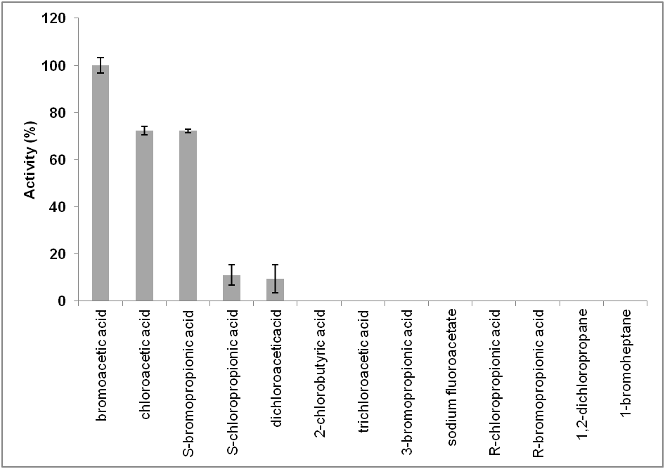

Fig. 1.
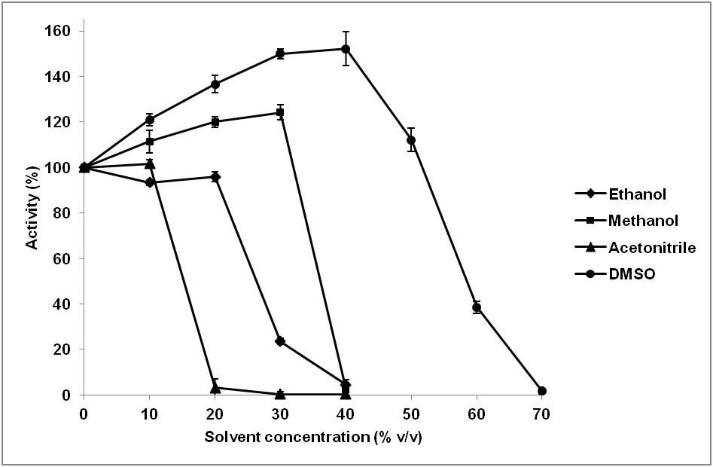

Fig. 2.
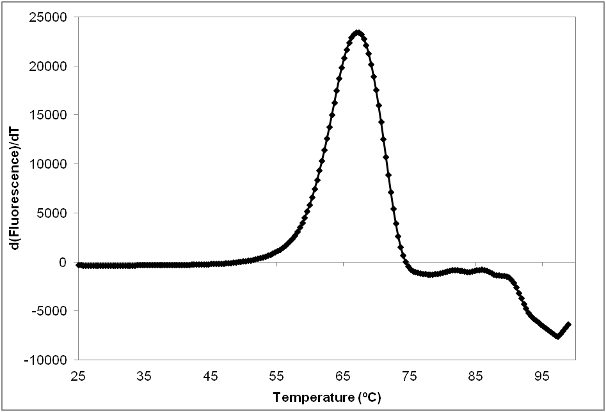
Fig. 3a.
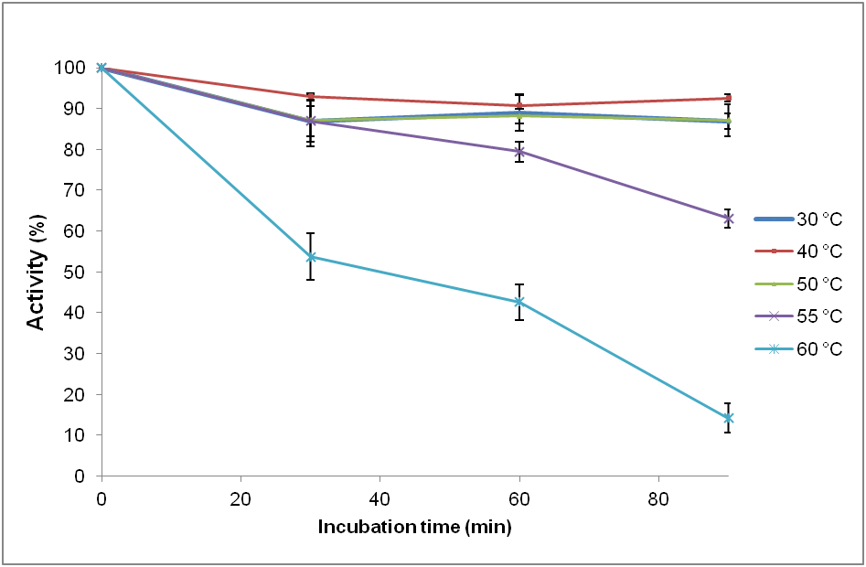
Fig. 3b.
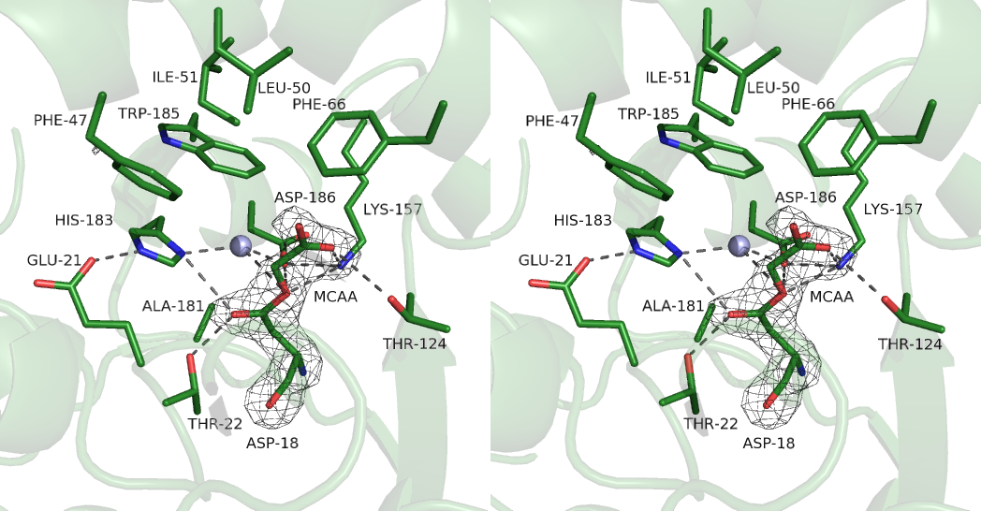

Fig. 4a.
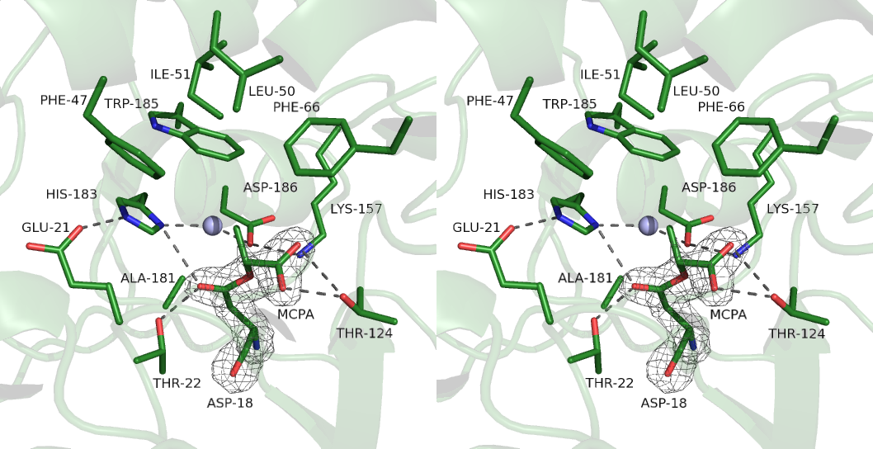
Fig. 4b.
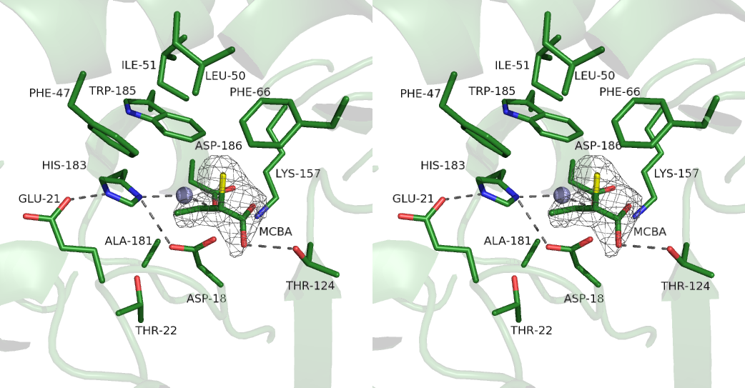
Fig. 4c.
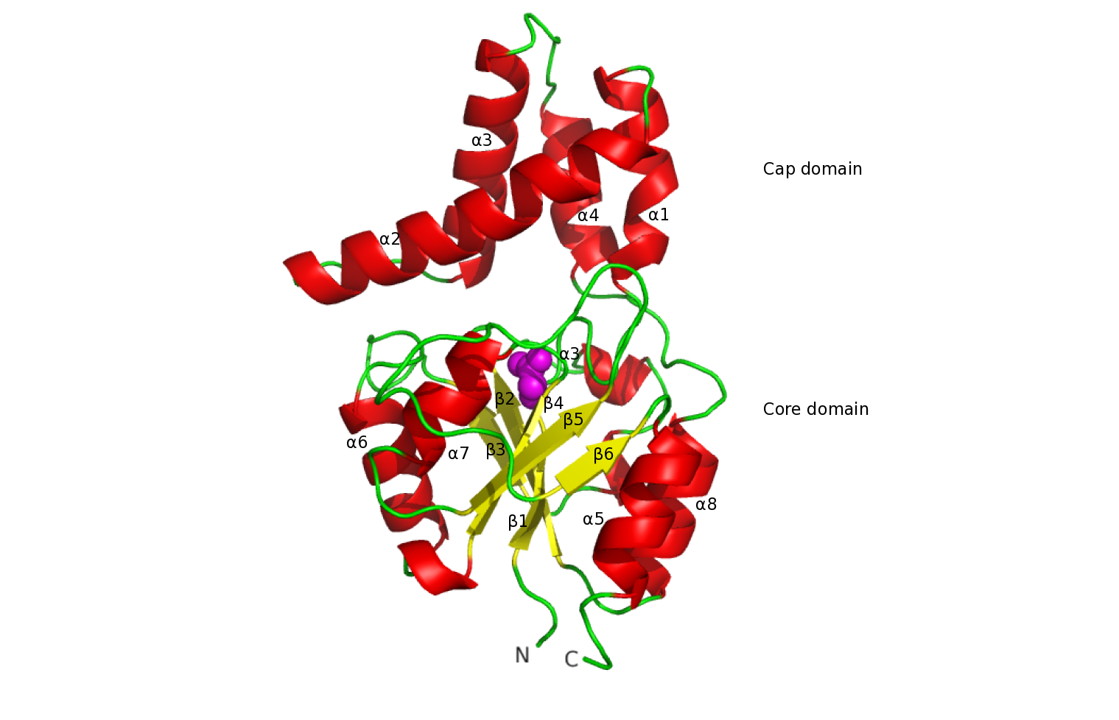
Fig. 5a.
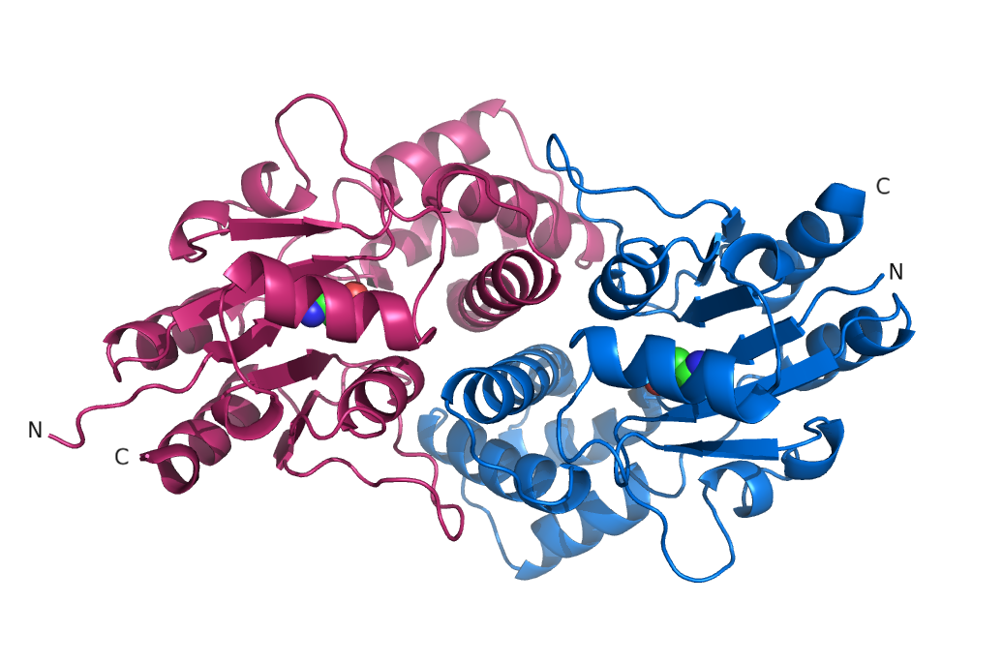
Fig. 5b.
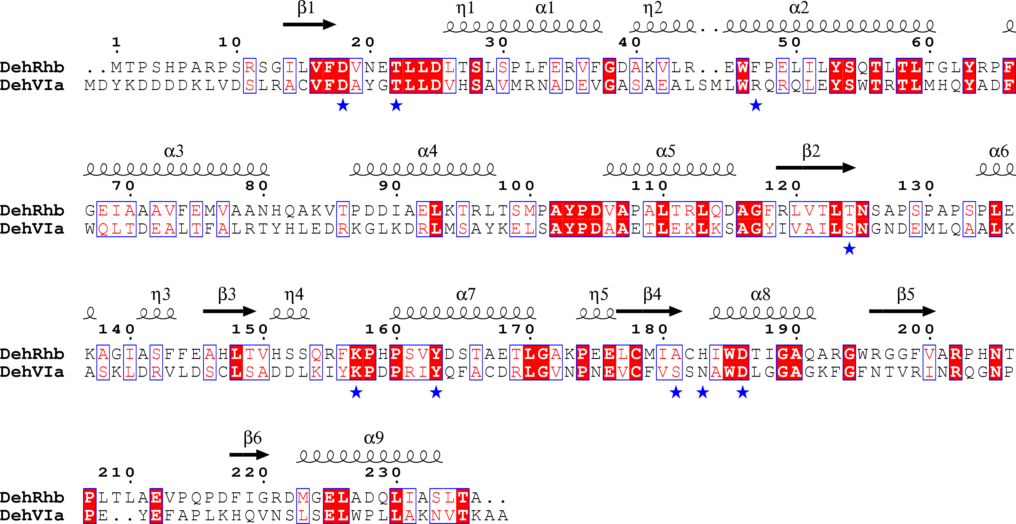
Fig. 5c.
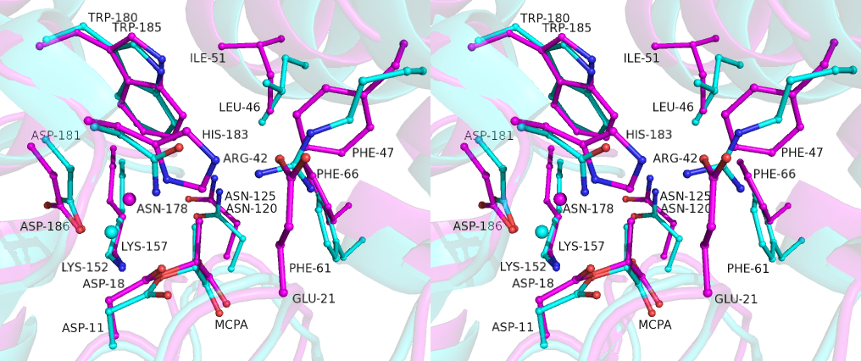
Fig. 6a.
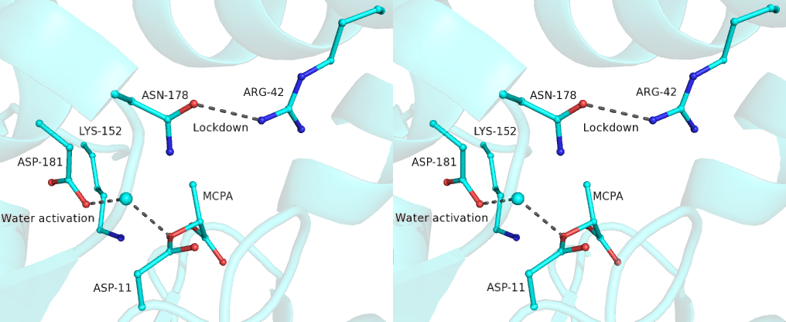
Fig. 6b.
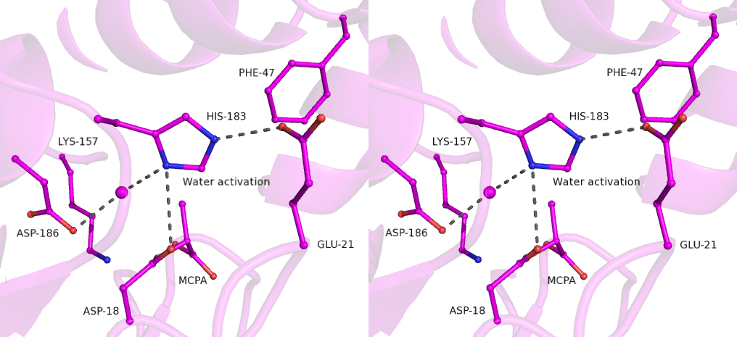
Fig. 6c.
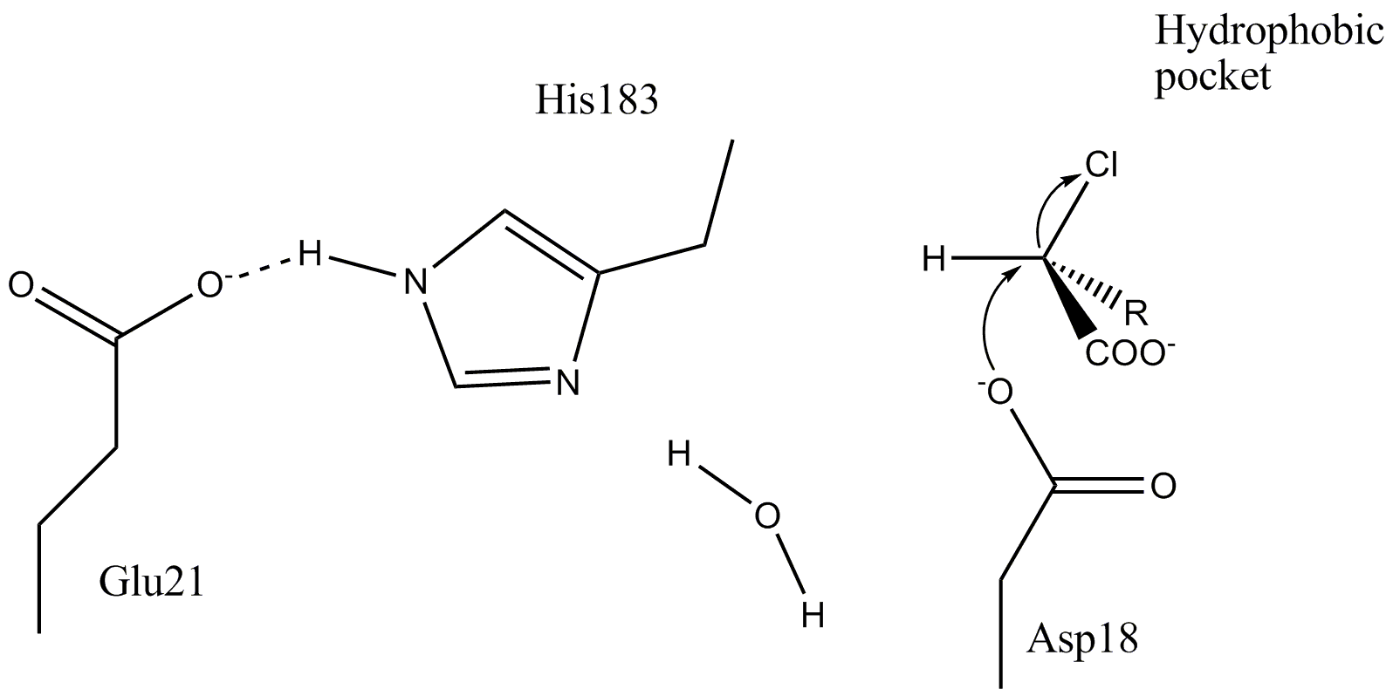
Fig. 7a.
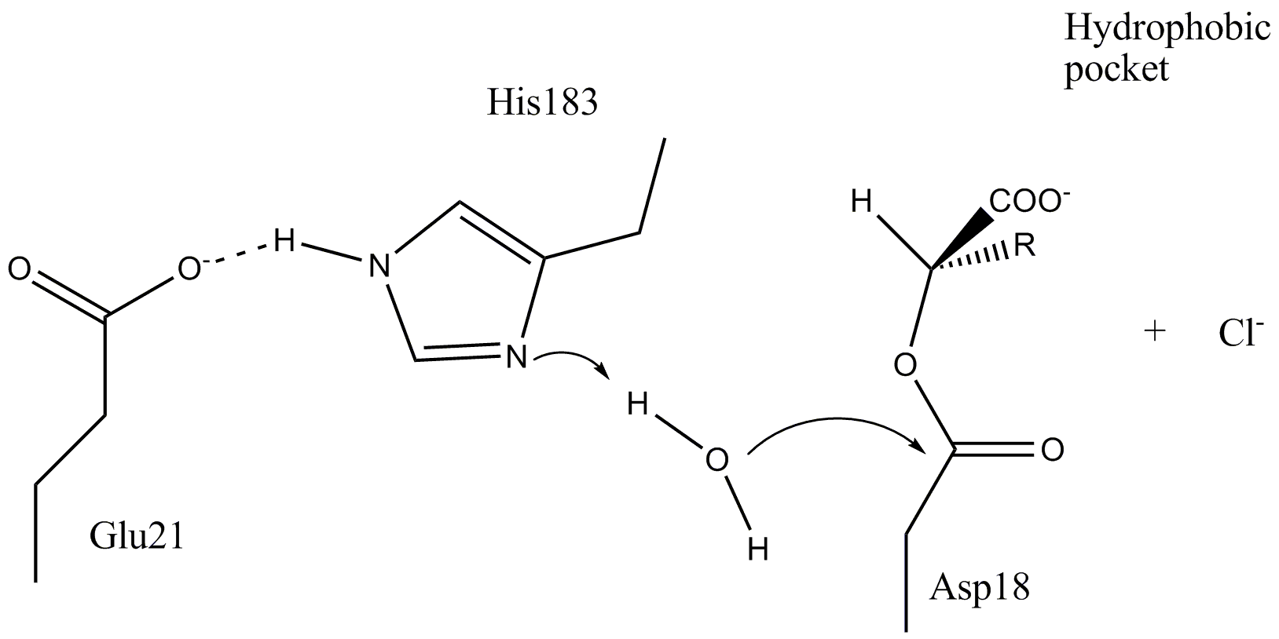
Fig. 7b.
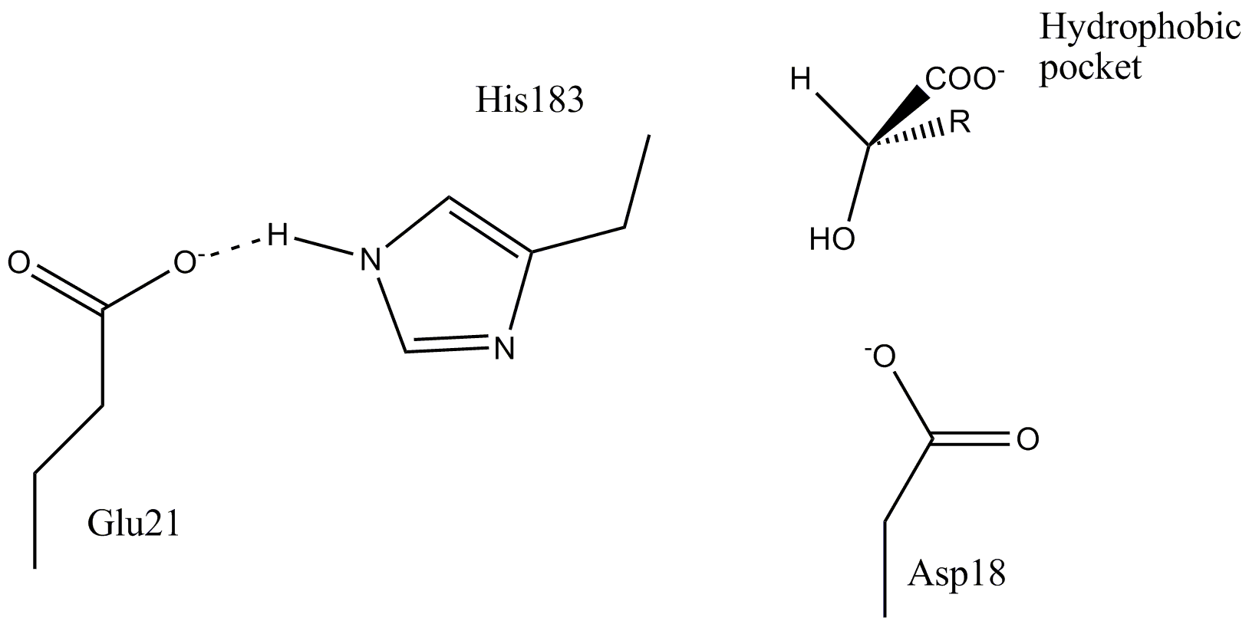
Fig.7c.

