Running head: Adaptive foraging and link-flexibility
Title: Link flexibility: evidence for environment-dependent adaptive foraging in a food web time-series
Authors: D.C. Henri^{1,2} & F.J.F. van Veen¹
1. Centre for Ecology and Conservation, University of Exeter, UK.
2. School of Biological, Biomedical & Environmental Sciences, University of Hull, UK.
Article type: Report
Word Count:
Abstract: 139
Main text: 3450
Number of References: 46
Number of Figures: 1
Authorship: DCH is the corresponding author and was responsible for the direction and composition of the manuscript. FJFvV was responsible for the initial data collection and contributed significantly to writing the report. Statistics were performed by DCH.
Dr Dominic C Henri can be contacted on d.henri@hull.ac.uk or +44 01482466694

Abstract
Temporal variability in the distribution of feeding links in a food web can be an important stabilising factor for these complex systems. Adaptive foraging and prey choice have been hypothesised to cause this link flexibility as organisms adjust their behaviour to variation in the prey community. Here, we analyse a 10-year time series of monthly aphid-parasitoid-secondary parasitoid networks and show that interaction strengths for polyphagous secondary parasitoids are generally biased towards the larger host species within their fundamental niche; however, in months of higher competition for hosts, size-based biases are reduced. The results corroborate a previous hypothesis stating that host-selectivity of parasitoids should be correlated to the relative likelihood of egg-limitation vs time-limitation. Our results evince adaptation of foraging behaviour to varying conditions affects the distribution of host-parasitoid link-strengths, where link-rewiring may be integral to stability in complex communities.
Key words: ecological networks, adaptive behaviour, interaction strength, egg- limitation, network structure, condition-dependent foraging.
Introduction
Important architectural components of ecological networks, such as connectivity and linkage density, are not consistent between network types (e.g. mutualistic vs. trophic networks) and even the same networks are not structured consistently across time and space (Eveleigh et al. 2007; Bukovinszky et al. 2008; Thébault & Fontaine 2010). The dynamic nature of ecological network structure is thought to be integral to long-term stability as it represents adaptations of the component species to a changing environment (Kaiser-Bunbury et al. 2010). Particularly, modelling studies have shown that adaptive foraging behaviour can increase community persistence and dampen extreme population fluctuations via the adjustment of relative link-strengths according to the availability and profitability of different resource species (Kondoh 2003; Abrams 2010; Kaiser-Bunbury et al. 2010; Heckmann et al. 2012). A major assumption made by these studies is that individual foraging behaviour can respond to environmental conditions, such as relative resource densities, rapidly and with sufficient strength to induce changes in network structure (Heckmann et al. 2012). Individual level behaviour has previously been shown to impact upon network structure in situ (Henri et al. 2012) and, under controlled conditions, species exhibit rapid individual adjustment of foraging behaviour to various environmental conditions, such as climate (de Sassi et al. 2012) and host availability (Charnov, 1976). However, empirical studies of flexible adaptive foraging behaviour and link strength rewiring in a natural community are lacking.
The advent of quantitative networks, which consider the relative strengths of interactions within a network, has improved our understanding of how individual behaviour is linked with ecological network structure (Brose et al. 2006; Ings et al. 2009), especially for systems including herbivorous arthropods and parasitoids (Morris et al. 2005; van Veen et al. 2006). Foraging behaviours determine important network characteristics such as interaction strength and complementarity, which in turn determine community structure and long-term system stability (Petchey et al. 2008; Ings et al. 2009). This is especially true in host-parasitoid networks where insect parasitoids lay offspring in/on a ‘host’ (mostly other arthropods), which is the sole source of the offspring’s biomass and inevitably results in the host’s death. Therefore, foraging behaviour directly determines both the parasitoid population’s growth-rate and host mortality rates (Morris et al. 2005).
Host preference regards the relative allocation of limited resources across all available hosts, and host-size dependent preference behaviour can determine the strength of a host-parasitoid interaction (Henri et al. 2012). Parasitoids may either optimise the ‘number’ of offspring they produce or offspring ‘quality’ (Charnov 1976). Offspring quality is related to host size, as all things being equal larger hosts produce larger offspring that have greater reproductive success, and so optimal foraging theory predicts that the realised niche of a parasitoid species should be biased towards larger hosts (Cohen et al. 2005; Henri & van Veen 2011; Stoepler et al. 2011); a prediction that has been corroborated in previous studies (Bukovinszky et al. 2008; de Sassi et al. 2012; Henri et al. 2012). If the realised niche of a parasitoid species is biased towards particular host species at any given time, it can alter the structure and composition of the host community and create asymmetrical mortality rates among multiple host species (Holt 1977; Rand & Tscharntke 2007; Prado & Frank 2014).
Species physiology and phylogeny are associated with optimal foraging behaviour, suggesting that the feeding behaviour of different species may contribute to variation in network structure in different ecosystems (Rohr et al. 2010; Kaiser-Bunbury et al. 2010; Elias et al. 2013). For parasitoids, there are multiple theories relating physiology to life-history characteristics such as life-span (Price 1973), egg-load (Rosenheim et al. 2008) and development time (Askew & Shaw 1986). Further, environmental conditions can alter parasitoid life-history characteristics as well as the relative quality and availability of host species, all of which link back to foraging behaviour (Bukovinszky et al. 2008; Boivin 2010; de Sassi et al. 2012). The optimal host preference behaviour at any given time can be related to whether reproductive success is limited by not having enough time to lay all one’s eggs (time limitation), which weakens host-size dependent foraging behaviour, or by there being too many hosts to allocate eggs to all of them (egg limitation), which strengthens size-dependent host-choice behaviour (Henri & van Veen 2011). The inherent likelihood that an individual will be egg- or time- limited at any given time is related to its physiology; primarily initial egg-load, ovigenesis rate and life-span (Jervis et al. 2008). However, environmental conditions that reduce the number of hosts a parasitoid can oviposit in (e.g. low host density, high competition for hosts or unfavourable weather) increase the likelihood of a parasitoid being time-limited and, therefore, the cost to investing in offspring quality (Visser et al. 1990; Rosenheim 1999; Zhang et al. 2014).
Adherence to either an egg- or time- limited foraging strategy may alter the structure of host-parasitoid networks, where increasing egg-limitation is predicted to result in increasingly uneven link-strength distribution among available host species (Henri & van Veen 2011). While foraging behaviour exhibits significant inter- and intra- specific variation, there has been little research into how environmental variation may drive changes in host preference foraging behaviour (but see de Sassi et al. 2012; Stoepler & Lill 2013), especially in a natural, whole-community setting. Here, we study the host preference behaviour of four species of Hymenopteran secondary parasitoid using a 10-year study of an aphid-parasitoid-secondary parasitoid community in an English meadow. We test three particular hypotheses: (i) that, within the fundamental niche of each parasitoid species, larger hosts will be over-represented in the ‘diet’ relative to their density at any point in time; (ii) that the slope of the preference / host-size relationship will not be the same for species of secondary parasitoid; and (iii) that the slope of the preference / host-size relationship is inversely related to competition for hosts (reduced egg-limitation).
Methods
Study species
In order to be included in this analysis, the secondary parasitoid species must meet certain criteria: they must have exhibited consistently high densities across all ten years data were collected such that sufficient data were available and they must also have sufficiently broad host ranges to provide meaningful host-preference behaviour analyses.
Alloxysta victrix (Westwood) [Figitidae, Charipinae, Alloxystini]: A koinobiont, or ‘true’, endo-secondary parasitoid. A. victrix attacks a parasitoid larva while its aphid host is still alive and suspends development until the aphid has been consumed by the primary parasitoid before consuming the parasitoid larvae in turn. The host can therefore still grow during A. victrix development and a foraging/ovipositing female has imperfect information on the ultimate size of the host. A. victrix is known to have a particularly broad host range for an Alloxystine secondary parasitoid, thus is an ideal candidate for comparison with the generalist idiobionts (van Veen et al. 2003).
Asaphes vulgaris (Walker) [Pteromalidae, Asaphinae] & Coruna clavata (Walker) [Pteromalidae, Pteromalinae]: Are idiobiont, or ‘mummy’, ectosecondary parasitoids, meaning they attack primary parasitoid (pre-)pupa within the mummified remains of the host’s skin (‘mummy’). Host-size is therefore fixed at the time of oviposition. A. vulgaris foraging behaviour is well studied, previous work has shown it exhibits size-dependent preference behaviour (Henri et al. 2012). Conversely, the foraging behaviour and life-history characteristics of C. clavata are not evident in the currently available literature.
Dendrocerus carpenteri (Curtis) [Megaspilidae, Megaspilinae]: Is also an idiobiont ecto-secondary parasitoid but belongs to a different taxonomic family to the other ‘mummy’ secondary parasitoids. The preferential foraging behaviour of this species has been well studied, and previous studies have shown that when confronted by hosts of different quality (different age, but same host species) D. carpenteri exhibits quality-dependent preference attack rates (Sullivan & Volkl 1999).
Host samples
The data used to measure the foraging behaviour of secondary parasitoid wasps came from a long-term study of an aphid-parasitoid-secondary parasitoid network (Müller et al. 1999; van Veen et al. 2008; Elias et al. 2013); for details see Appendicies. Surveys were conducted between April and October, from 1994 through to 2003, within a single meadow (approx. 18 000m² in size) in Silwood Park, Berkshire, UK. Each month, samples of 200 mummies of each aphid species (if present) were taken to the laboratory to rear out primary and secondary parasitoids, in order to obtain data on host–parasitoid associations. Parasitoid densities were estimated by multiplying the proportion of each parasitoid species eclosing from the sample mummies by the density of mummies of that aphid species on site for each sample date.
Host size & competition
A ‘Leica M165C’ microscope and its associated image analysis software ‘Leica Application Suite v. 3’ was used to measure the length and width of ~3800 aphid mummies, comprising all undamaged samples from which one of the four focal secondary parasitoids eclosed. Mummy volume (length x width x width) provides a strong linear relationship with fresh mummy weight (correlation coefficient = 0.9), which we consider to be a good measure of host biomass and quality (Henri et al. 2012). The relative sizes of available hosts, and not their absolute values, are important for preferential foraging behaviour in a laboratory setting (Chow & Heinz 2005); therefore, size difference was calculated as the difference between the average mummy size of an aphid species and the average size of all mummies sampled that month. It is important to note that the relative size, and therefore its value, of each aphid species varied from month to month.
For each parasitoid species, values for competition for hosts were calculated as total viable mummy density of all host species divided by conspecific density in each month. Total mummy density only included viable host species; i.e. aphid species that at some point in our record have actually been parasitized by that particular secondary parasitoid. By only considering viable species, we avoided over-estimation of available hosts via the inclusion of species the secondary parasitoid is physiologically or behavioural incapable of parasitising. For use in statistical analysis, competition values were logged as the untransformed data were not normally distributed.
Measuring foraging behaviour
Host preference metrics
The various possible metrics for preferential foraging behaviour have been reviewed in Lechowicz (1982). For this study we utilised the Modified Foraging Ratio (Q) because its non-linear nature allows for meaningful comparisons between time points when host densities vary (see Appendix 1 for analysis using Vanderploeg and Scavia E* index). Q values were calculated for each aphid species in each month they were present for each of the four secondary parasitoid species with the following equation:
$$Q_{ij}=\frac{r_{ij}(1-p_{ij})}{p_{ij}(1-r_{ij})}$$
Where r_{ij} was the proportion of all individuals of secondary parasitoid species i that eclosed from the aphid species j; and p_{ij} was the proportion of all mummies available that were aphid species j. Lechowicz (1982) recommends utilising log(Q) values, which give a range from ∞ to -∞, where negative values indicate avoidance of a host species and positive values indicate preference (Lechowicz 1982). A log(Q) value of zero indicates that the host species was utilised as would be expected by its relative density.
Statistics
A Generalised Linear Mixed-Effect Model (GLMM) using a random intercept structure tested the relationship between the dependent variable preference behaviour [logQ]and the fixed effects ‘secondary parasitoid species’, ‘competition for hosts’ and ‘relative host size’; ‘month’, ‘year’ and ‘aphid species’ were included as random effects.
The GLMM was performed using R statistical package (R Core Team 2014) using the glmer function in the lme4 package (Bates et al., 2014). Initial exploration to check GLMM assumptions were performed following guidelines in Zuur et al. (2010). Prior to analyses we assessed the data for colinearity using pairwise scatterplots checking for fixed effect correlations >0.7 (Dormann et al., 2013). The Minimum Adequate Model was established via log-likelihood ratio comparisons using Maximum Likelihood approximation, for which X² results indicating significance are reported; fixed effect parameters were estimated using Restricted Maximum Likelihoods. A random intercepts structure was used as random slopes structure resulted in model non-convergence. Our GLMM model accounted for temporal pseudoreplication through the inclusion of ‘year’ and ‘month’ as random effects (Bates, 2014).
Results
Our linear mixed effect analysis indicated a significant positive relationship between the relative size of a primary host species and the observed preference [logQ] value for that month; furthermore, this relationship differed significantly between the four secondary parasitoid species (relative host size:secondary parasitoid species interaction term X²₃ = 43.67, P < 0.001; Figure 1). Importantly, across all four secondary parasitoid species, the slope of the preference [logQ] / relative host-size relationship was steeper in months where there were more hosts per secondary parasitoid (relative host size:competition interaction term X²₁ = 22.16, P < 0.001; Figure 1). We found no evidence of a higher-order interaction between all three fixed-effects (relative host size, secondary parasitoid species and competition for hosts) with our measure of foraging preference (X²₃ = 3.07, P = 0.381).
Discussion
We predicted that the host preference behaviour of secondary parasitoids would exhibit realised niches biased towards larger host species at the population level. Correspondingly, all study species exhibited preference for larger aphid host species, as shown by a positive relationship between relative host size and preference [logQ values] (Figure 1). We further predicted that secondary parasitoid species would not all exhibit the same degree of size-dependent bias; corroboratively, the relationship between primary host species size and foraging preference was significantly different across the four focal parasitoid species (Figure 1). Finally, we predicted that species behaviour would adapt to the prevailing environment (i.e. competition for hosts), resulting in variability in the distribution of interaction strengths relative to the distribution of host densities. Our results show that a species’ realised niche was more strongly biased to larger primary host species when competition for hosts was low, and link strength was more density dependent when competition for hosts was high (Figure 1), which is consistent with the predictions of the egg-/time- limitation hypothesis outlined in Henri & van Veen (2011).
Our results build on previous studies of adaptive foraging behaviour to show that size-dependent host-preference responds to prevailing conditions and that these changes in behaviour manifest as temporal fluctuations in the structure of an in situ host-parasitoid community (de Sassi et al. 2012). Particularly, our results suggest that conditions that increase competition for hosts weaken bias towards large host species and cause parasitoids to behave in a more ‘random’ fashion. These results support the validity of the egg-/time-limitation framework for a mechanistic understanding of the dynamic nature of host-parasitoid networks and the causes of temporal and spatial differences in network structure. This is particularly important given recent advances in ecological network theory that have concluded that temporal changes in the distribution of interactions are integral to community stability (Kondoh 2003; Kaiser-Bunbury et al. 2010; Poisot et al. 2014).
The distribution of link strengths in interaction networks is often summarised as link evenness, which has been shown to respond to environmental factors such as habitat modification (Tylianakis et al. 2007). Link evenness depends on the density distributions of species at each of the trophic levels, the diet range of each of the consumer species and preferences of the consumer species. Because it depends on so many factors, evenness does not provide much information on the mechanisms underlying variation in link strength distribution. We consider the species-level preference index to be a more informative metric of link-strength distribution because it accounts for variations in host diversity and relative abundance, and because it measures deviation from random foraging and thereby the importance of selective foraging as a mechanism for determining link distribution (Petchey et al 2008). If preference index values do not deviate from zero, this means that the distribution of link strengths is within the network is determined by the relative densities of hosts within each parasitoid’s fundamental niche. The more the preference index deviates from zero, the more the link strength distribution is driven by host quality (Henri et al. 2012).
It is possible that behaviour could be inflexible and we could still observe the patterns in preference metric values exhibited within. If the behaviour is to attack the preferred host, and only utilise smaller hosts when competition for the preferred host reaches a certain level, then apparent preference would increase with increasing density of non-preferred host. However, this would be evident in our data as a single host that consistently makes up most of the diet with the other hosts being minor components. This idea is contradicted by the graphs in Appendix S2, which show that while some aphid species are obviously favoured by different parasitoids, none are used exclusively; which is evinced by the proportion in the diet values being highly variable (even for preferred species). This is consistent with our initial screening attempts to only include aphid host species that were consistently present in the ‘diet’ of each parasitoid individually. Combined, these data suggest that the changes in link strength are the result of ‘true’ switching behaviours and not artefacts of the preference index used.
The idiobiont parasitoids Dendrocerus carpenteri and Asaphes vulgaris both exhibited weaker condition-dependent host preference behaviour than Alloxysta victrix, as host size had a smaller effect on host preference in these two species (Figure 1). This pattern is converse to that expected by the ‘dichotomous hypothesis’, where koinobiont parasitoids are more likely to exhibit r-selected characteristics, particularly a reduced investment in each individual offspring, compared to idiobionts (Godfray 1994; Jervis & Ferns 2011). This hypothesis is based on the idea that koinobionts allow their hosts to continue development following oviposition and thus suffer increased juvenile mortality relative to adult mortality, in a manner analogous to the processes that promote semelparity, when compared to idiobionts (Stearns 1993; Jervis & Ferns 2011). The observed differences in preferential foraging behaviour may possibly be explained by differences in relative egg-/time- limitation, but there is insufficient data of secondary parasitoid egg loads, longevity and realised foraging success due to the significant effect of primary host species on these characteristics (Sullivan & Vӧlkl 1999). Our conclusions on this topic are further limited by the strict criteria that our study species must meet for meaningful analyses to be made; namely that they be sufficiently common for enough data to be available and that they have a broad enough host range for preference behaviour to be comparable. However, we see no reason why the same processes would not be acting in the data-deficient species that could not be analysed and indeed, more generally, in any system where consumers feed on multiple resources and where there is a degree of preference.
A major strength of our study is that it uses a comprehensive data set of a large natural community that was sampled quantitatively every month that insects were present for ten years. While there are many community level studies of host-parasitoid networks, very few have the resolution required to study foraging behaviour in a similar manner to this study. However, we have inferred parasitoid preference from the frequency of emerging offspring. An alternative explanation for our observations is that parasitoid offspring exhibit a positive relationship between host size and larval survival. This could lead to the same pattern even if host size played no role in the oviposition and foraging decisions of parasitoid females. We think it is unlikely that this is the case and behavioural studies of host acceptance and sex ratio allocation of some of the study species in isolation have shown significant host-size dependent responses (Sullivan 1987). Further, this would not explain the variation in logQ values associated with variation in host competition found in this study. We have not been able to account for the effect of primary parasitoid identity and its impact on preference behaviour as it is generally not possible to identify which primary parasitoid acted as the host for the secondary parasitoid larvae. However, we believe that the effects of primary parasitoid identity are likely to be minimal as they exhibit very narrow host ranges, and are rarely found on multiple host aphid species (van Veen et al. 2008).
Conclusions
While there are multiple potential mechanisms driving inter- and intra- specific differences in foraging patterns there are limited long-term field studies exploring foraging behaviour. This report uses a uniquely detailed 10 year-long quantitative data set to show that short-term fluctuations in the strength of preferential foraging behaviour, resulting from adaptation to host availability, can induce short-term changes in host-parasitoid link-strength, which is an important aspect of ecological network dynamics. Our results provide empirical evidence that behavioural adaptations may be responsible for temporal fluctuations in ecological network structure. Further, the observed changes in foraging behaviour adhere to the predictions made in the egg-/time- limitation framework (Henri & van Veen 2011). Future studies of network structure and stability may wish to consider the effects of environmentally induced fluctuations in foraging behaviour and their effect on the strength of interspecies interactions.
Acknowledgements
Joseph Faulks provided technical assistance. This project was funded by a Linnean Society of London SynTax grant to FJFvV and DCH’s studentship, funded by the UK Natural Environment Research Council (NE/I528326/1). The authors declare that they have no conflict of interest related to the publication of this work.
References
1. Abrams, P.A. (2010) Implications of flexible foraging for interspecific interactions: lessons from simple models. Functional Ecology, 24, 7-17.
2. Askew, R.R. & Shaw, M.R. (1986) Parasitoid communities: their size, structure and development. Insect Parasitoids (ed. D. Greathead), pp. 225-264. 13th Symposium of Royal Entomological Society of London.
3. Bates, D. (2014). Computational methods for mixed models. ftp://ftp.uni-bayreuth.de/pub/math/statlib/R/CRAN/doc/vignettes/lme4/Theory.pdf [Accessed 28/04/15]
4. Brose, U., Jonsson, T., Berlow, E.L., Warren, P., Banasek-Richter, C., Bersier, L.F. et al. (2006) Consumer-resource body-size relationships in natural food webs. Ecology, 87, 2411-2417.
5. Bukovinszky, T., van Veen, F.J., Jongema, Y. & Dicke, M. (2008a) Direct and indirect effects of resource quality on food web structure. Science, 319, 804-807.
6. Charnov, E.L. (1976) Optimal foraging, marginal value theorum. Theoretical Population Biology, 9, 129-136.
7. Chow, A., & Heinz, K. M. (2005). Using hosts of mixed sizes to reduce male‐biased sex ratio in the parasitoid wasp, Diglyphus isaea. Entomologia experimentalis et applicata, 117(3), 193-199.
8. Cohen, J.E., Jonsson, T., Muller, C.B., Godfray, H.C.J. & Savage, V.M. (2005) Body sizes of hosts and parasitoids in individual feeding relationships. Proceedings of the National Academy of Sciences of the USA, 102, 684-689.
9. de Sassi, C., Staniczenko, P.P.A. & Tylianakis, J.M. (2012) Warming and nitrogen affect size structuring and density dependence in a host–parasitoid food web. Philosophical Transactions of the Royal Society B: Biological Sciences, 367, 3033-3041.
10. Dormann, C. F., Elith, J., Bacher, S., Buchmann, C., Carl, G., Carré, G., ... & Lautenbach, S. (2013). Collinearity: a review of methods to deal with it and a simulation study evaluating their performance. Ecography, 36(1), 27-46.
11. Elias, M., Fontaine, C., van Veen, F.J.F. (2013) Evolutionary history and ecological processes shape a local multilevel antagonistic network. Current Biology, 23, 1355-1359.
12. Eveleigh, E. S., McCann, K. S., McCarthy, P. C., Pollock, S. J., Lucarotti, C. J., Morin, B., et al. (2007). Fluctuations in density of an outbreak species drive diversity cascades in food webs. Proceedings of the National Academy of Sciences of the USA, 104(43), 16976-16981.
13. Godfray, H.C.J. (1994) Parasitoids: Behavioural and Evolutionary Ecology. Princeton University Press, Princeton, New Jersey.
14. Heckmann, L., Drossel, B., Brose, U., & Guill, C. (2012). Interactive effects of body‐size structure and adaptive foraging on food‐web stability. Ecology letters, 15(3), 243-250.
15. Henri, D.C., Seager, D., Weller, T. & van Veen, F.J. (2012) Potential for climate effects on the size-structure of host-parasitoid indirect interaction networks. Philosophical Transactions of the Royal Society B: Biological Sciences, 367, 3018-3024.
16. Henri, D.C. & van Veen, F.J.F. (2011) Body size, life history and the structure of host–parasitoid networks. Advances in Ecological Research, 45, 136-174.
17. Holt, R.D. (1977) Predation, apparent competition, and the structure of prey communities. Theoretical Population Biology, 12, 197-229.
18. Ings, T.C., Montoya, J.M., Bascompte, J., Bluthgen, N., Brown, L., Dormann, C.F., et al. (2009) Ecological networks - beyond food webs. Journal of Animal Ecology, 78, 253-269.
19. Jervis, M. & Ferns, P. (2011) Towards a general perspective on life-history evolution and diversification in parasitoid wasps. Biological Journal of the Linnean Society, 104, 443-461.
20. Jervis, M.A., Ellers, J. & Harvey, J.A. (2008) Resource acquisition, allocation, and utilization in parasitoid reproductive strategies. Annual Review of Entomology, 53, 361-385.
21. Kaiser-Bunbury, C.N., Muff, S., Memmott, J., Müller, C.B. & Caflisch, A. (2010) The robustness of pollination networks to the loss of species and interactions: a quantitative approach incorporating pollinator behaviour. Ecology Letters, 13, 442-452.
22. Kondoh, M. (2003) Foraging adaptation and the relationship between food-web complexity and stability. Science, 299, 1388-1391.
23. Lechowicz, M.J. (1982) The sampling characteristics of electivity indices. Oecologia, 52, 22-30.
24. Morris, R.J., Lewis, O.T. & Godfray, H.C.J. (2005) Apparent competition and insect community structure: towards a spatial perspective. Annales Botanici Fennici, 42, 449-462.
25. Müller, C.B., Adriaanse, I.C.T., Belshaw, R. & Godfray, H.C.J. (1999) The structure of an aphid-parasitoid community. Journal of Animal Ecology, 68, 346-370.
26. Petchey, O.L., Beckerman, A.P., Riede, J.O. & Warren, P.H. (2008) Size, foraging, and food web structure. Proceedings of the National Academy of Sciences of the USA, 105, 4191-4196.
27. Poisot, T., Stouffer, D.B. & Gravel, D. (2014) Beyond species: why ecological interactions vary through space and time. bioRvix. doi: http://dx.doi.org/10.1101/001677
28 Prado, S.G. & Frank, S. (2014) Optimal foraging by an aphid parasitoid affects the outcome of apparent competition. Ecological Entomology, 39, 236-244.
29. Price, P.W. (1973) Reproductive strategies in parasitoid wasps. American Naturalist, 107, 684-693.
30. Rand, T.A. & Tscharntke, T. (2007) Contrasting effects of natural habitat loss on generalist and specialist aphid natural enemies. Oikos, 116, 1353-1362.
31. Rohr, R.P., Scherer, H., Kehrli, P., Mazza, C. & Bersier, L.F. (2010) Modeling food webs: Exploring unexplained structure using latent traits. American Naturalist, 176, 170-177.
32. Rosenheim, J.A. (1999) Characterizing the cost of oviposition in insects: a dynamic model. Evolutionary Ecology, 13, 141-165.
33.Rosenheim, J.A., Jepsen, S.J., Matthews, C.E., Smith, D.S. & Rosenheim, M.R. (2008) Time limitation, egg limitation, the cost of oviposition, and lifetime reproduction by an insect in nature. American Naturalist, 172, 486-496.
34. Stearns, S.C. (1993) The Evolution of Life Histories. Oxford University Press, London.
35. Stoepler, T. M., Lill, J. T., & Murphy, S. M. (2011). Cascading effects of host size and host plant species on parasitoid resource allocation. Ecological Entomology 36: 724-735
36. Stoepler, T. M., & Lill, J. T. (2013). Direct and indirect effects of light environment generate ecological trade-offs in herbivore performance and parasitism. Ecology 94: 2299-2310.
37. Sullivan, D.J. (1987) Insect hyperparasitism. Annual Reviews in Entomology, 32, 49-70
38. Sullivan, D.J. & Vӧlkl, W. (1999) Hyperparasitism: Multitrophic ecology and behavior. Annual Review of Entomology, 44, 291-315.
39. Thébault, E. & Fontaine, C. (2010). Stability of ecological communities and the architecture of mutualistic and trophic networks. Science, 329(5993), 853-856.
40. Tylianakis J.M., Tscharntke T., & Lewis O.T. (2007) Habitat modification alters the structure of tropical host-parasitoid food webs, NATURE, 445, 202-205
41. van Veen, F.J.F., Belshaw, R. & Godfray, H.C.J. (2003) The value of the ITS2 region for the idenification of species boundaries between Alloxysta hyperparasitoids (Hymenoptera: Charipidae) of aphids. European Journal of Entomology, 100, 449-453.
42. van Veen, F.J.F., Morris, R.J. & Godfray, H.C.J. (2006) Apparent competition, quantitative food webs, and the structure of phytophagous insect communities. Annual Review of Entomology, 51, 187-208.
43. van Veen, F.J.F., Mueller, C.B., Pell, J.K. & Godfray, H.C.J. (2008) Food web structure of three guilds of natural enemies: predators, parasitoids and pathogens of aphids. Journal of Animal Ecology, 77, 191-200.
44. Visser, M.E., van Alphen, J.J.M. & Nell, H.W. (1990) Adaptive superparasitism and patch time allocation in solitary parasitoids - The influence of the number of parasitoids depleting a patch. Behaviour, 114, 21-36.
45. Zhang, Y., Zhang, H., Yang, N., Wang, J., & Wan, F. (2014). Income resources and reproductive opportunities change life history traits and the egg/time limitation trade‐off in a synovigenic parasitoid. Ecological Entomology, 39(6), 723-731.
46. Zuur, A. F., Ieno, E. N., & Elphick, C. S. (2010). A protocol for data exploration to avoid common statistical problems. Methods in Ecology and Evolution, 1(1), 3-14.

Figure Legends
Figure 1. Illustration of the relationship between the preference metric [logQ]for each host species against the average size of the host (relative to rest of host community) in each month. Plots are separated vertically according to the species of secondary parasitoid. Plots are separated horizontally according to quartiles of competition for hosts; with the 1st quartile (fewest hosts per parasitoid) representing the highest competition for hosts. Lines represent estimates and +/- 95% confidence intervals from a GLMM fit. Each point represents the preference metric value for a single, primary aphid host during a single month in a year and point sizes are weighted according to the log(host density) of that specific aphid species during that month.
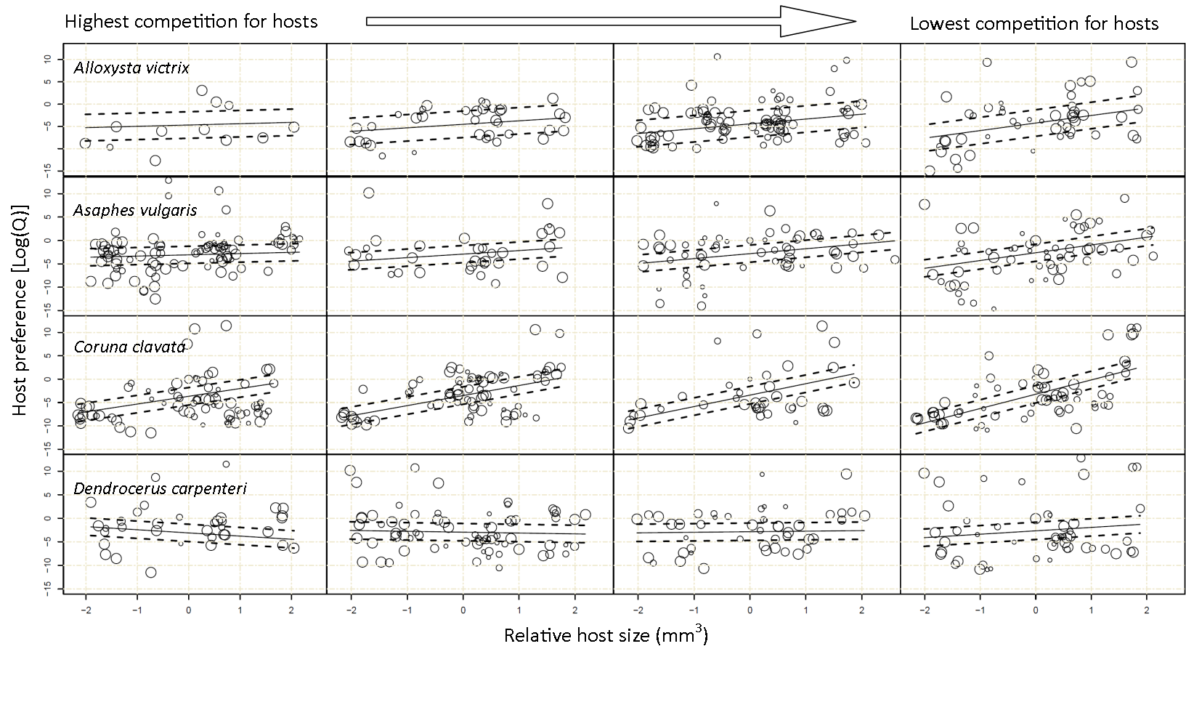Figure 1

Appendix S1: Reanalysis of data using Vanderploeg and Scavia E* index
This index is recommended as being the single most useful in Lechowicz (1982) but because of the inherent inclusion of host count within the calculations, we decided it was less suitable for testing the effect of host densitybased metrics on preference behaviour. However, the paper recommends that analyses are performed using multiple indices to assess the veracity of any conclusions made using any particular index.
Equation S1a. $W_{ij}=\frac{{(r}_{ij}/p_{ij})}{\sum{{(r}_{ij}/p_{ij})}}$
Equation S1b. ${E*}_{ij} =\left[W_{ij}-\left(\frac{1}{n}\right)\right]/\left[W_{ij}+\left(\frac{1}{n}\right)\right]$
E* for secondary parasitoid i and aphid primary host j is calculated for each month by first calculating Vanderploeg and Scavia’s selectivity coefficient Wij. Where r_{ij} was the proportion of all individuals of secondary parasitoid species i that eclosed from the aphid species j; and p_{ij} was the proportion of all mummies available that were aphid species j. The E* index is then calculated where n is the number of host species available during that particular month.
We performed the same statistical analyses as those in the main article but utilising E* values instead of logQ values. The results suggested the same pattern. With a significant positive relationship between the relative size of a primary host species and the observed preference [E*] value for that month; furthermore, this relationship differed significantly between the four secondary parasitoid species (relative host size:secondary parasitoid species interaction term X²₃ = 25.02, P < 0.001; Figure 1). Importantly, across all four secondary parasitoid species, the slope of the preference [E*] / relative host-size relationship was steeper in months were there where more hosts per secondary parasitoid (relative host size:competition interaction term X²₁ = 4.09, P = 0.043; Figure 1). We found no evidence of a higher-order interaction between all three fixed-effects (relative host size, secondary parasitoid species and competition for hosts) with our measure of foraging preference (X²₃ = 1.25, P = 0.741).
That we found the same results using two different measures of preference further strengthens the conclusions of this paper.

Appendix S2: Each aphid species’ average proportion in diet for the four parasitoids considered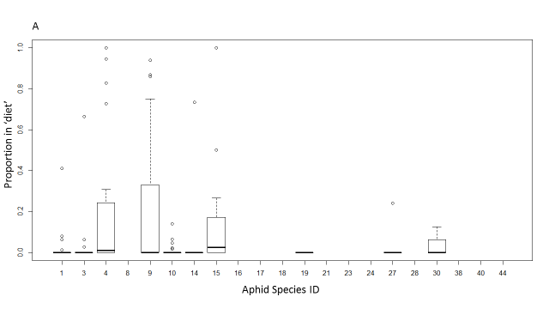 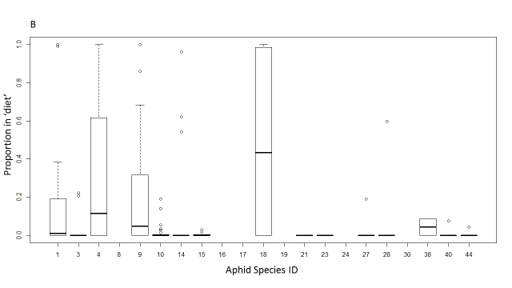 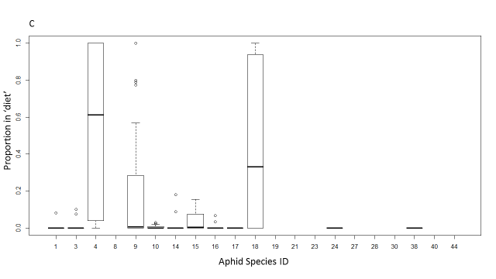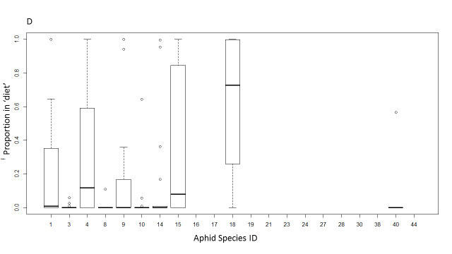Appendix Figure S2.1: Average and interquartile ranges of PoD for each of the 21 aphid species and 4 hyperparasitoid species: A – Alloxysta victrix; B - Asaphes vulgaris; C – Coruna clavata; D – Dendrocerus carpenteri.

Appendix S3. Detailed methods
From April to October all plants in the field were scanned for aphids. When noted on a particular plant species, the density of each aphid species and mummies of that species on that plant species were estimated by counting twice a month the number of individuals per ‘plant unit’. The plant unit was chosen to be a relatively constant unit of vegetation, often the individual plant in the case of herbaceous forbs, a flowering stem in the case of grasses fed on by aphids that congregate on flower spikes, or a 30 cm terminal shoot in the case of shrubs where aphids feed on young growth. On every fortnightly sampling occasion a minimum of 300 units of every plant species were chosen at random, stratified over forty 20 × 20 m grid cells covering the whole site. Plant abundance was estimated by recording the number of plant units per m² at 3-m intervals along 15 parallel transects. Transects were placed at 20-m intervals over the whole site and care was taken that they ran through each of the forty 20 × 20 m grids. Estimates of plant density per m² allowed us to translate all the relative estimates of aphid and natural enemy densities to absolute figures with units per m².
For each plant species on which parasitoid mummies were observed we collected a maximum of 200 mummies every fortnight or fewer when they were rare. The parasitoid mummies were reared individually in gelatine capsules and the adult insects identified using the keys in Mackauer (1959), Starý (1966), Gärdenfors (1986) and Pungerl (1983).
References
Gärdenfors, U. (1986) Taxonomic and biological revision of Palaearctic Ephedrus Haliday (Hymenoptera: Braconidae, Aphidiinae). Entomologica Scandinavica (Suppl. 27), 1–95.
Mackauer, M. (1959) Die europäischen Arten der Gattungen Praon und Areopraon (Hymenoptera: Braconidae, Aphidiinae). Beiträge Zur Entomologie, 9, 810–865.
Pungerl, N.B. (1983) Morphometric and electrophoretic study of Aphidius species (Hymenoptera: Aphidiidae) reared from a variety of aphid hosts. Systematic Entomology, 11, 327–354.
Starý, P. (1966) Aphid Parasites of Czechoslovakia. A Review of the Czechoslovak Aphidiidae (Hymenoptera). Dr W. Junk, The Hague.

