The influence of the food–predation trade-off on the foraging behaviour of central-place foragers

Andrew D. Higginson, Alasdair I. Houston

School of Biological Sciences, Life Sciences Building, University of Bristol, 24 Tyndall Avenue, Bristol, BS8 1TQ, UK

Tel: +44 (0) 117 394 1296

Fax: +44 (0)117 331 7985

E-mail: a.d.higginson@bristol.ac.uk , a.i.houston@bristol.ac.uk
ABSTRACT

Social animals that bring resources to a central place have commonly been used to test the predictions of optimal foraging models. Such animals are amenable to test because they do not themselves reproduce, and so we might expect them to be selected to maximise some measure of input of food to the colony. Several currencies have been proposed to predict behaviour, such as net rate, efficiency, and the ratio of the mortality rate to energy gain rate. Observations on social animals, especially bees, show mixed support for each currency. Here, we examine how these currencies can be united by considering the expected lifetime input of energy to the colony in a representative study of patch residence time. This currency explains partial loads because it leads to the prediction that the energy that a forager delivers to the colony over its lifetime is maximised by returning to the colony after a critical amount has been collected, even if energy is gained at a constant rate. We show that the extent to which foraging carries a greater mortality risk than travelling controls whether this currency makes similar predictions to net rate or to efficiency. We assess the evidence that bee behaviour actually maximises this currency and argue that mortality risk at resource sites is likely to be a critical determinant of foraging strategies in central-place foragers.

Keywords: partial loads, pollination, optimal foraging theory, worker behaviour, marginal value theorem, predation risk, flower-dwelling predators
INTRODUCTION
.
Models of foraging behaviour are generally based solely on energetic gains and losses (Pyke 1980; Hodges 1981; Pyke 1982; Schmid-Hempel et al. 1985). Optimal foraging theory has tended to assume that animals maximise net rate of gain (Stephens & Krebs 1986), but observations of animals often show deviations from the predictions of these models (Charlton & Houston 2010). A useful approach for assessing the validity of foraging currencies involves predicting when a foraging animal should leave a resource patch and travel elsewhere. The marginal value theorem (MVT; Charnov 1976) is concerned with when a forager should leave depleting patches of food if it is to maximise its long-term rate of gain. The theorem states that it is optimal to leave a patch when the marginal rate of gain on a patch falls to the overall rate of gain for the environment. Several models that have been applied to bees are variants of the MVT (e.g. Pyke 1980; Hodges 1981). However, Schmid-Hempel et al. (1985) and Kacelnik et al. (1986) assess when a bee should return to the nest and show that efficiency (the net rate of energetic gain per energy spent) but not net rate of gain, predicts observations on bees in an experimental arena. Social animals, such as bees, may appear to maximise efficiency because workers from colonies of social insects solely gather resources, and so might act to maximise their lifetime input to the colony from a limited individual budget (Neukirch 1982).

Given that foraging insects are subject to various sources of mortality while foraging (Dukas 2001; Dukas and Morse 2003; Heiling et al. 2004; Reader et al. 2006), such models may not be adequate for predicting foraging decisions (Houston et al. 1988). For growing animals, a common currency is the ratio of the mortality rate to energy gain rate of Gilliam (Gilliam 1982; Werner & Gilliam 1984). Clark & Dukas (1994) adapted this currency to compare foraging options that differ in mortality and gain. Their model can be summarised as follows. If option i is used then M_{i} denotes the probability of death per trip and E_{i} denotes the energy gain per trip. It is assumed that a bee keeps foraging until it dies. If F_{i} is the lifetime profit if option i used then F_{i} equals the expected number of trips multiplied by energy per trip, i.e.
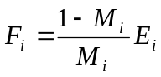 (1)
Equation (1) allows us to predict the option that a bee should choose. Clark & Dukas point out that for very low mortalities, the bee should maximize 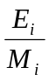 – or equivalently minimize 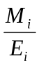: the ratio of the mortality rate to energy gain rate. This currency has also been used to predict the distribution of colonial foragers across resources (Dukas & Edelstein-Keshet 1998).

In order to further assess the importance of including the risk of mortality in models of foraging behaviour, it is critical that we generate predictions that can be compared to observation. Several studies have focussed on the duration of foraging trips. In this paper we include mortality and find the behaviour that maximises a bee’s expected lifetime delivery of energy to the colony (hereafter referred to as ‘lifetime profit’). We use the maximisation of lifetime profit to predict the duration of foraging trips, the optimal load size, and the relationship between body size and foraging decisions, when mortality is taken in to account. If lifetime profit is a more appropriate currency, it will also be necessary to understand cases where foraging behaviour appears to be consistent with maximising net rate and/or efficiency (Charlton & Houston 2010), and we provide a testable explanation. Although the currency may apply to many animals, for convenience we refer to the foraging social insect as a bee.

THE MODEL

We assume that the bee can choose between several foraging areas, where each area contains only flowers with a constant reward and mortality risk. If bees are assumed to be flower-constant, these areas do not have to be spatially separated. A trip involves three stages: travelling from the nest to foraging area, foraging for time t, and travelling back to the nest.

General case
Let τ be the travel time between the nest and the foraging area, L(t) be the energy content of the bee’s load as a function of foraging time t, and μ be the rate of mortality while travelling between nest and resource. We denote the ratio of the rate of mortality while foraging to the rate of mortality when travelling by α, where α>1 indicates that foraging is more dangerous than travelling. The bee’s rule is to keep foraging until time t has been spent in the foraging area and then return to the nest.

If a bee aims to spend a time t in the foraging area, then her probability of surviving a trip is
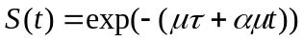. (2)
It follows that her expected lifetime profit is
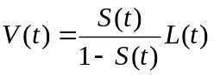, (3a)
which is similar to the assumption of Clark & Dukas (1994), but focussing on survival rather than mortality rate. Given equation (2), we can rewrite equation (3a) as
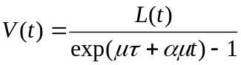. (3b)
If the mortality rates μ and α are small then
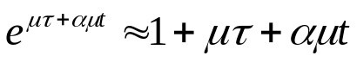, (4)

so for convenience we can work with
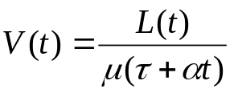. (5)
Note that this the MVT modified by mortality (cf. Houston & McNamara 1986; Gilliam 1990).

In a large patch, especially one exploited by many foragers, the rate of gain may be effectively constant, and so we can define
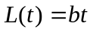. (6)

We can find the optimal value of t from the condition 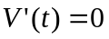and equation (3b), which gives
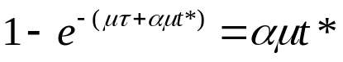. (7)
This equation gives us the value t* of t that maximises expected lifetime profit. It can be seen that αμt* is an invariant (cf. Charnov 1993) that depends on μτ but not on the rate b. This means the gross rate of gain does not influence the optimal foraging time. The equation also tells us that the mortality per trip if the bee adopts the optimal time t* is μαt*. We cannot isolate μαt* , but can get a solution for μτ
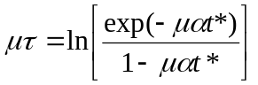. (8)
If the animal adopts the optimal foraging duration t* then the resulting lifetime profit is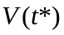. It follows from equations (5) and (6) that
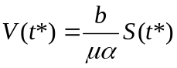 (9a)
or equivalently
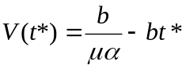. (9b)
A forager that starts in the foraging area and forages there until it dies has an expected lifespan of 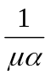 and hence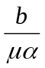 is the expected energy that it collects. Thus equation (9b) means that a forager that returns to the nest after time t* delivers a lifetime profit which is less than this by the optimal load size. In general,
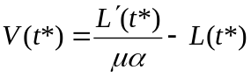. (10)
Note that although τ does not appear in these equations, it has an effect through t*. In Appendix A we include energy costs of foraging and travelling to give the expected lifetime net energy gain.

In the previous model the bee does not keep track of individual visits to flowers. In Appendix B we explore a model where the bee visits a certain number of flowers and find that this does not affect our predictions: bees should return to the nest with a partial load. Next, we explore the validity of this foraging currency and make quantitative predictions by exploring a particular functional form, parameterised from observations of flowers and bumblebees (Table 1).

Bee-based parameterisation

Observations have shown that the relationships between mass and energy use during flying and walking follow power laws, with exponents that are around 0.6 (Ellis & Delaphane 2009). In the following, we assume that relationships between mass and energy use are linear (i.e. exponent of unity) because this allows us to solve the model analytically and gives approximately correct results. Below we show, by way of numerical analyses, that our results are not qualitatively altered by this simplifying assumption. We parameterise the mass-energy equations so that for a 100mg bee the costs are as predicted by the power law, meaning that we underestimate costs of less massive bees and overestimate the costs of more massive bees. In line with the size variation among workers of bumblebees (Goulson et al 2002) we make predictions for body sizes from 50 to 200mg, in order to maximise the potential for testing of our predictions within species, thereby avoiding confounding differences between species.

If the rate of energy expenditure per milligram of mass carried is m Joules per milligram per second then for a bee weighing S milligrams the cost flying out unladen is τmS. We assume that the bee collects nectar at a rate of J milligrams per second when on flowers and spends a proportion of the time p on flowers whilst in the flower patch. Observations suggest that bees pay an energetic cost of carrying the load (Feuerbacher et al 2003, Wolf et al 1989), but not as great per unit mass as for the body. If the proportional cost of carrying the load compared to body mass is k (k<1) then since the total amount of mass collected is Jtp the cost of flying back is τm(S+kJtp). The mean metabolic cost during foraging is therefore 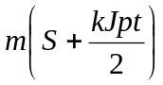. Now, the net energy delivered is given by
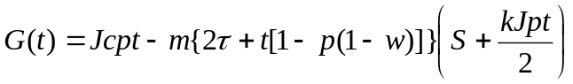 (11)
where c is the concentration of energy in nectar, w is the relative metabolic energy use when alighted on flowers compared to flying. The expected number of trips is
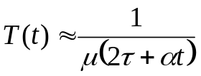. (12)
where μ is the mortality rate when travelling and α is the ratio of the risk whilst foraging compared to flying. The lifetime profit is 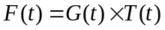.

Comparison to other currencies
We show in Appendix C that the magnitude of α controls whether maximising expected lifetime profit makes predictions that are similar to maximising net rate or efficiency. Specifically, when α is unity (foraging is equally as dangerous as travelling) lifetime profit is equivalent to net rate; if α is large then maximising lifetime profit makes similar predictions to maximising efficiency. See Figure 1 for the optimal patch times (t*) and relative returning metabolic rate 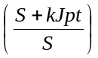for each currency for several α values.

Schmid-Hempel et al. (1985) predicted the number of flowers that should be visited as a function of the distance between flowers in their experimental set-up if honeybees maximise net rate or efficiency. Here, we predict this relationship by exploring the response of t* to the value of p, because p will decrease when flowers are more distant from each other (provided the duration of individual flower visits does not change). Our predictions agree with theirs in that net rate predicts very high (> 2 hours) patch durations (Figure 2). When maximising net rate, t* increases with the energy concentration of nectar. Maximisation of efficiency leads to much shorter t*, and interestingly our predictions are not sensitive to energy concentration (c does not appear in equation C6). However, maximising efficiency leads to predictions of shorter patch durations than was observed (Schmid-Hempel et al. 1985). Maximisation of lifetime profit predicts longer patch durations than maximisation of efficiency (and there is a further increase when energy concentration is high). These predictions therefore more closely match the observations.

Effect of body size
Studies of energy use and foraging in bees have provided data on the effects of body size S and thus a way to test this model. In Appendix D we show that when maximising net rate, larger individuals should bring back smaller loads than small individuals. By contrast, when maximising efficiency larger individuals should bring larger loads than small individuals. In both cases increasing the proportion of time on flowers p (e.g. flower density) and increasing gain rate J will both increase the load size of large bees relative to small bees (Figure 3). When maximising lifetime profit larger individuals should bring back larger loads than small individuals, but here we predict an interaction between J and p in predicting the relative size of the loads of larger bees.

As can be anticipated from the above results, the magnitude of α controls whether optimal load increases with body size: optimal load decreases with body size when α is small, and increases with body size when α is large (Figure 4b), because t* is insensitive to S when α is small and increases with S when α is large (Figure 4a). The expected number of trips declines with α because overall mortality is increased. The relative returning metabolic rate is greater for smaller α, especially for small bees (Figure 4d).

Additional considerations
There are several known effects of body size on foraging in bees that may affect our predictions. In Appendix E we consider how including these in the equations affect our results in Figures 2-4. Note that including these complexities makes the equations intractable so we solve numerically using the parameter values in Table 1.

First, we consider the possibility that large size reduces the mortality rate (Rodriguez-Girones and Bosch 2012) with slope β such that equations (12) becomes
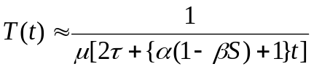 (13)
Even when 200mg bees are 50% less vulnerable than 50mg bees (β=0.003) our predictions are not qualitatively changed (Appendix C1, Figure E1a, C2a, C3a). Indeed, this assumption actually exaggerates the effect of α on the relationship between size and optimal load (cf. Figure 4a, E3a).

We also consider the possibility that uptake rate of nectar is greater for large bees (Morse 1978) and so equation (11) becomes
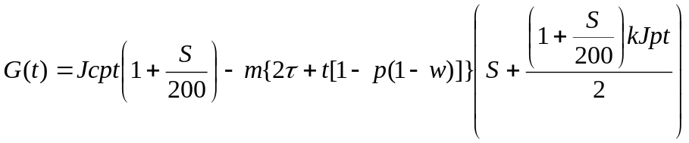 (14)
This assumption leads to a positive relationship between S and L* for all α for three currencies (i.e. including net rate, Figure E3b), and larger bees are predicted to carry larger loads at all times (Figure E2b), but net rate still predicts unrealistically long foraging trips (cf. Figure E1b and data in Goulson et al 2002).

Bees of different size may go to different patches. We assume that the colony suppresses resources nearby such that the gain rate is greater for distant patches, and thus there is a trade-off between gain rate and travel costs. That is, τ may be optimised to conditions because foraging distance is under behavioural control so equation (11) becomes
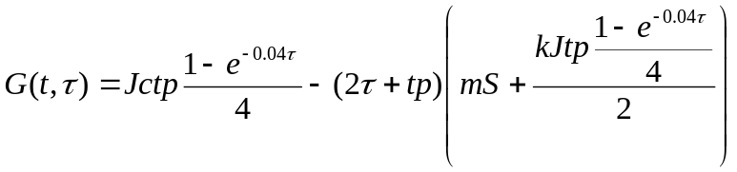 (15)
and we solve simultaneously for τ and t. Note that the parameter values used in equation (15) were chosen so as to rescale the other parameters to match the main model (equation 11, Table 1). Allowing optimised travel time leads to even longer trips predicted by maximisation of net rate (Figure E1c), and efficiency predicts an increase of patch time as p decreases. We again predict even stronger effects of α on the relationship between S and L* (Figure E3c).

Finally, we check that our assumption that the relationships between mass and costs are straight lines does not lead to erroneous predictions. Taking values from Ellis and Delaphane (200), equation (11) becomes
(16)
Including this realism does not affect our predictions about relative loads of small and large bees (Figure E2d, E3d); therefore our simplifying assumption of linear scaling does not qualitatively affect most of our predictions. However, this realism does lead to a non-linear effect of p on time on flowers (Figure E1d); thus even more clearly matching the observations of Schmid-Hempel et al (1985).

DISCUSSION

Explanations of the foraging behaviour of social insects can be based on the advantage to the colony that results from the behaviour of a single individual or the interaction between individuals. Here, we have used the first of these approaches to predict when a central place forager should return to the nest, and found support for a currency of lifetime profit. This currency might be most appropriate as non-reproductives will be selected to maximise their individual profitability to their colony, which means trading off energy profit against mortality risk (Houston et al 1988). This is an example of a general approach that captures animal behaviour as behavioural strategies that trade-off the gain of energy against the risk of mortality (Houston and McNamara 1999). The risk of mortality affects the behavioural strategies that all animals use to maximise their fitness (Lima 1998). Social insects maximise their fitness by providing resources to reproductive individuals, often at the end of a colony cycle, and so their foraging strategies have been selected to maximise colony growth rate up to the point of reproduction (Macevicz & Oster 1976), which leads to significantly different predictions than are made when maximising simple foraging currencies (Houston et al 1988).

We have shown that lifetime profit can explain the mixed support for different simpler currencies (net rate of gain and energetic efficiency) observed in experiments. Specifically, the relative risk at the resource compared to travelling determines whether we predict that animals should behave as though they are maximising net rate or energetic efficiency. In addition, if energetic costs are negligible compared to the rate of energy gain, then our currency reduces to the rate of gain to rate of mortality ratio, and so is consistent with Gilliam’s rule as applied to bees by Dukas and Edelstein-Keshet (1998) in predicting spatial distribution of colonial foragers. Houston (2009) used data from foraging eastern chipmunks (Barrette and Giraldeau 2008) to approximate a value for α of 20, which would mean the chipmunks might appear to maximise efficiency.

The bees in Schmid-Hempel et al (1985) tended to have longer patch durations than prediction by the maximisation of efficiency, suggesting that they were behaving as though they are adapted to ‘expect’ predation risk on flowers to be larger – but not greatly so – than the predation rate in flight. There is plenty of evidence that predation risk at flowers affects bee foraging decisions. For instance, predation affects choice of foraging mode (Clark & Dukas 1994): if mortality has a greater impact than the loss of the worker, as is the case for solitary species, then foragers should be more wary. Bumblebees split attention to detect predation, and avoid flowers where they had previously been subject to a simulation attack (Ings and Chittka 2009). Honeybees consider danger at flowers in the waggle dance (Abbott & Dukas 2009) and avoid locations associated with predation risk (Higginson et al 2007; Jones and Dornhaus 2011). All this illustrates that the currency of efficiency or net rate cannot hope to capture the complexities of colony-level decisions. A complication is that plasticity in behaviour may result in colony-size effects on worker lifespan (Rueppell et al 2009), since worker survival may be more important for small colonies leading to behaviour that reduces mortality at the expense of resource gain.

There are various reasons why a bee should return to the nest. The simplest explanation is that it has a full load. This is not a general explanation because bees sometimes return before their crop is full, i.e. they return with a partial load (Nuñez 1982; Schmid-Hempel et al 1985; Kacelnik et al 1986). Previous explanations of why a bee might return before its crop is full are based on energetic costs and information. The former sort of explanation is exemplified by Schmid-Hempel et al. (1985) and Kacelnik et al. (1986), who incorporate mass-dependent flight costs in a model of optimal foraging by honeybees and show that a bee’s load maximises the energetic efficiency of a trip. Varju & Nuñez (1991) adopt the latter approach, arguing that it is important for honeybees to return to the nest in order to participate in the transfer of information about foraging opportunities; for further discussion see Schmid-Hempel (1993) and Varju & Nuñez (1993). Each of these explanations can predict partial loads even when nectar is gained at a constant rate (e.g. Schmid-Hempel et al. 1985; Kacelnik et al. 1986; Dornhaus et al. 2006). Of course both energetic costs and information could have an influence in some cases, but information is unlikely to be important except in honeybees because other social foragers generally show much less sophisticated recruitment. Here, we have presented a new argument for partial loads based on mortality. Our explanation is based on the advantage that accrues to a single forager, and does not require mass-dependent flight costs or the transfer of information.

We have assumed, in line with many models of optimal foraging, that the forager has perfect information about its environment. In fact, foragers can learn about predation risk during foraging, and in the absence of cues the fact that an animal has not yet been attacked provides information about predation risk (Welton et al 2003). This suggests that if predation risk on a patch is uncertain, the perceived risk will decrease as the time spent in a patch increases. Given our results, this means that they should increasingly behave as though maximising net rate, and so stay longer on patches too. Nonacs (2001) incorporated such a decrease in predation risk into of the MVT. It is, however, difficult to compare his work with ours because he considers a state-dependent model in which the forager can die as a result of starvation. A complication is that patch-based predators often take time to attack and there are cues of their presence (e.g. flower-dwelling spiders: Reader et al 2006, Higginson et al 2007), so heightened risk may actually cause visits to become shorter so as to avoid giving predators time to attack.

Testing of our assumptions requires data on the predation rates of animals when foraging compared to travelling. Many predators hunt bees on flowers, and it is intuitive that bees are easier to catch when alighted on flowers. Generally, animals that are gathering food must trade-off efficient food gathering against being vigilant for predators (Ings and Chittka 2008; Llandres et al 2012). This is especially true of bees that insert their head, and so their eyes, into flowers. However, there are many predators that take bees in flight, both invertebrates (e.g. bee wolves, Dukas 2005) and birds (e.g. flycatchers, Davies 1977; Avery et al 1988; Krebs and Avery 1985). Non-flying central-place foragers may face higher mortality during travelling than within patches, such as ants (Nonacs & Dill 1991). Thus, in some cases α might be smaller than unity. Testing of the currency of lifetime profit could focus on the effect of body size on load size. For instance, the lifetime profit currency predicts that patch distance will affect the relationship between nectar availability and the relative load size of larger bees. For dense flower patches, increasing nectar uptake rate should result in a smaller effect of body size on load size, but if flowers are more sparse larger bees should spend increasingly longer in patches as the nectar uptake rate increases. This interaction is not predicted by other currencies. One additional way to distinguish efficiency from lifetime profit is by assessing the effect of nectar concentration on trip duration, since we predict that a strategy maximising lifetime profit will be much more sensitive to concentration than a strategy maximising efficiency.

Clearly lifetime profit is still an approximation of the selective pressures that operate on social foragers even in the absence of other concerns, such as information and selfish reproduction. For instance, it has been proposed that the flight machinery of insects is somehow limited (Neukirch 1982) and previously we have both suggested that the currency of flying insects should account for this (Higginson & Gilbert 2004; Houston & McNamara 2014). In such a case, foragers may maximise the lifetime profit given two sources of mortality: predation and the wearing out of the flight system (Higginson& Gilbert 2004). Efficiency will sometimes be close to this measure but includes energy cost when not in flight, so efficiency may again be consistent with behaviour if energy use when alighted on flowers is negligible compared to energy use in flight. We suggest that an ever more realistic currency will incorporate both these factors, such as by the concept of damage (Houston & McNamara 1999; 2014). Such an approach would be based on the concept of the value of the animal’s life (McNamara & Houston 1986), which (all else being equal) declines as the expected remaining lifespan decreases and so is likely to predict changes behaviour as foragers age (e.g. Higginson & Barnard 2004). In social species, the value of the forager’s life will depend on the state of the colony, in terms of food stocks and number of workers, and so extensions of our model may enable us to predict the aforementioned colony size effects on worker behaviour and lifespan (Rueppell et al 2009).

Consideration of lifetime profit as a foraging currency suggests several possible important impacts of predators on pollination systems. Predators may increase outbreeding in pollinated plants by causing shorter foraging bouts, between which bees remove pollen. Thus, if bees have evolved to respond to the risk of predation in their foraging decisions, predator distribution could have cascading impacts on pollination systems and thereby plant populations (Dukas 2005). We propose that future developments of food web models must include this possibility, along with plasticity in pollinator behaviour.

ACKNOWLEDGMENTS
The authors are grateful to Olav Rueppell and two anonymous reviewers for comments on an earlier version of this manuscript. This work was supported by the European Research Council (Advanced Grant 250209 to A.I.H.) and a College for Life Sciences Fellowship at the Wissenschaftskolleg zu Berlin awarded to A.D.H.

REFERENCES
Abbott KR, Dukas R (2009) Honeybees consider flower danger in their waggle dance. Anim Behav. 78:633-635.
Avery MI, Krebs JR, Houston AI (1988) Economics of courtship-feeding in the European bee-eater (Merops apiaster). Behav Ecol Sociobiol. 23:61-67.
Barette S, Giraldeau L-A (2008) Evidence against maximisation of gross rate of seed delivery to the burrow in food-hoarding eastern chipmunks Tamias striatus. Anim Behav 75:655-661.
Becerra-Guzman F, Guzman-Novoa E, Correa-Benitez A, Zozaya-Rubio A (2005) Length of life, age at first foraging and foraging life of Africanized and European honey bee (Apis mellifera) workers, during conditions of resource abundance. J Apicult Res. 44:151-156.
Cartar RV (1991) A test of risk-sensitive foraging in wild bumble bees. Ecology. 72:888-895.
Carvell C, Jordan WC, Bourke AFG, Pickles R, Redhead JW, Heard MS (2012) Molecular and spatial analyses reveal links between colony-specific foraging distance and landscape-level resource availability in two bumblebee species. Oikos 121:734-742.
Charlton NL, Houston AI (2010) What currency do bumble bees maximise? PLoS One 5:e12186
Charnov EL (1976) Optimal foraging: the marginal value theorem. Theoret Pop Biol. 9:129-136.
Charnov EL (1993) Life history invariants. Oxford University Press, Oxford.
Clark, CW, Dukas R (1994) Balancing foraging and antipredator demands: an advantage of sociality. Amer Nat. 144:542-548.
Cresswell JE, Osborne JL, Goulson D (2000) An economic model of the limits to foraging range in central place foragers with numerical solutions for bumblebees. Ecol Entomol. 25:249-255.
Davies NB (1997) Prey selection and the search strategy of the spotted flycatcher (Muscicapa striata): a field study on optimal foraging. Anim Behav. 25:1016-1032.
Dornhaus A, Collins EJ, Dechaume-Moncharmont FX, Houston AI, Franks NR, McNamara JM (2006) Paying for information: partial loads in central place foragers. Behav Ecol Sociobiol. 61:151-161.
Dramstad WE (1996) Do bumblebees (Hymenoptera: Apidae) really forage close to their nests? J Insect Behav. 9:163-182.
Dukas R (2001) Effects of predation risk on pollinators and plants. In: Chittka L, Thompson JD (eds) Cognitive ecology of pollination. Cambridge University Press, Cambridge, pp. 214-236.
Dukas R, Edelstein-Keshet L (1998) The spatial distribution of colonial food provisioners. J Theoret Biol. 190:121-134.
Dukas R (2008) Mortality rates of honey bees in the wild. Insect Soc. 55:252-255.
Dukas R, Morse DH (2003) Crab spiders affect flower visitation by bees. Oikos. 101:157-163.
Dukas R (2005) Bumble bee predators reduce pollinator density and plant fitness. Ecology. 86:1401-1406.
Dukas R, Dukas L (2011) Coping with nonrepairable body damage: effects of wing damage on foraging performance in bees. Anim Behav. 81:635-638.
Ellington CP, Machin KE, Casey TM (1990) Oxygen consumption of bumblebees in forward flight. Nature. 347:472-473.
Ellis A, Delaphane KS (2009) Individual forager profits in Apis mellifera unaffected by a range of colony Varroa destructor densities. Insect Soc. 56:419-424.
Feuerbacher E, Fewell JH, Roberts SP, Smith EF, Harrison JF (2003) Effects of load type (pollen or nectar) and load mass on hovering metabolic rate and mechanical power output in the honey bee Apis mellifera J Exp Biol. 206: 1855-1865.
Gilliam JF (1982) Habitat use and competitive bottlenecks in size-structured fish populations. PhD Thesis. Michigan State University.
Gilliam JF (1990) Hunting by the hunted: optimal prey selection by foragers under predation hazard, In: Hughes RN (ed) Behavioural mechanisms of food selection. Springer, Berlin, pp. 797-818.
Goulson D, Peat J, Stout JC, Tucker J, Darvill B, Derwent LC, Hughes WHO (2002) Can alloethism in workers of the bumblebee, Bombus terrestris, be explained in terms of foraging efficiency? Anim Behav. 64:123-130.
Harrison JF, Fewell JH (2002) Environmental and genetic influences on flight metabolic rate in the honey bee, Apis mellifera. Comparat Biochem Physiol A. 133:323-333.
Heiling, AM, Cheng K, Herberstein ME (2004) Exploitation of floral signals by crab spiders (Thomisus spectabilis, Thomisidae). Behav Ecol. 15:321-326.
Heinrich B (1976) Resource partioning among some eusocial insects: bumblebees. Ecology. 57:874-889.
Hodges CM (1981) Optimal foraging in bumblebees: hunting by expectation. Anim Behav 29:1166-1171.
Higginson AD, Barnard CJ (2004) Accumulating wing damage affects foraging decisions in honeybees (Apis mellifera L.). Ecol Entomol 29:52-59
Higginson AD, Gilbert FS (2004) Paying for nectar with wingbeats: A new model of honeybee foraging. Proc Roy Soc Lond B 271: 2595-2603
Higginson AD, Gilbert FS, Reader T (2007) Reduction of visitation rates by honeybees (Apis mellifera) to individual inflorescences of lavender (Lavandula stoechas) upon removal of coloured accessory bracts (Hymenoptera : Apidae). Entomol General 29:165-178.
Houston AI, Schmid-Hempel P, Kacelnik A (1988) Foraging strategy, worker mortality, and the growth of the colony in social insects. Amer Nat 131:107-114.
Houston AI, McNamara JM (1986) The influence of mortality on the behavior that maximizes reproductive success in a patchy environment. Oikos 47:267-274
Houston (2009) Flying in the face of nature. Behav Proc 80:295-305.
Houston AI, McNamara JM (1999) Models of Adaptive Behaviour Cambridge, Cambridge University Press, Cambridge.
Houston AI, McNamara JM, and J M C Hutchinson (1993) General results concerning the trade-off between gaining energy and avoiding predation, Phill Trans Roy Soc Lond B. 341:375-397.
Houston AI, McNamara JM (2014) Foraging currencies, metabolism and behavioural routines. J Anim Ecol. 83:30-40.
Ings TC, Chittka L (2008) Speed-accuracy tradeoffs and false alarms in bee responses to cryptic predators. Curr Biol 18:1520-1524
Ings TC, Chittka L (2009) Predator crypsis enhances behaviourally mediated indirect effects on plants by altering bumblebee foraging preferences. Proc Roy Soc Lond B 276:2031-2036
Jones EI, Dornhaus A (2011) Predation risk makes bees reject rewarding flowers and reduce foraging activity 65:1505-1511
Kacelnik A, Houston AI, Schmid-Hempel P (1986) Central-place foraging in honey bees: the effect of travel time and nectar flow on crop filling. Behav Ecol Sociobiol 19:19-24
Krebs JR, Avery MI (1985) Central place foraging in the European bee-eater, Merops-apiaster. J Anim Ecol. 54:459-472
Lima SL (1998) Stress and decision making under the risk of predation: recent developments from behavioral, reproductive, and ecological perspectives. Adv Study of Behav. 27:215–290
Llandres AL, de Mas E, Rodriguez-Girones MA (2012) Response of pollinators to the tradeoff between resource acquisition and predator avoidance. Oikos. 121:687-696
Macevicz S, Oster G (1976) Social insects modeling. Behav Ecol Sociobiol. 1:265-282.
McNamara JM, Houston AI (1986) The common currency for behavioral decisions. Am Nat 127:358-378.
Moody AL, Houston AI, McNamara JM (1996) Ideal free distributions under predation risk. Behav Ecol Sociobiol. 38:131-143
Morse DH (1978) Size-related foraging differences of bumblebee workers. Ecol Entomol. 3:189–192
Neukirch A (1982) Dependence of the life span of the honeybee upon flight performance and energy consumption. J Comp Physiol A 146: 35–40.
Nuñez J (1982) Honeybee foraging strategies at a food source in relation to its distance from the hive and the rate of sugar flow. J Apic Res. 21:139-150
Nonacs P, Dill LM (1991) Mortality risk versus food quality trade-offs in ants: patch use over time. Ecol Entomol 16:73-80.
Nonacs (2001) State-dependent behaviour and the Marginal Value Theorem. Behavioral Ecology 12: 71-83.
Pleasants JM (1981) Bumblebee response to variation in nectar availability. Ecology. 62:1648-1661
Pyke GH (1980) Optimal foraging in Bumblebees: calculation of net rate of energy intake and optimal patch choice. Theoret Pop Biol. 17:232-246
Pyke GH (1982) Foraging in bumblebees: rule of departure from an inflorescence Canad J Zool. 60:417-428
Reader T, Higginson AD, Barnard CJ, Gilbert FS (2006) The effects of predation risk from crab spiders on bee foraging behavior. Behav Ecol. 17:933-939
Rodriguez-Girones MA, Bosch J (2012) Effects of body size and sociality on the anti-predator behaviour of foraging bees. Oikos 121:1473-1482
Rueppell O, Bachelier C, Fondrk MK, Page RE (2007) Regulation of life history determines lifespan of worker honey bees (Apis mellifera L). Exp Gerontol. 42:1020-1032
Rueppell O, Kaftanouglu CO, Page RE (2009) Honey bee (Apis mellifera) workers live longer in small than in large colonies. Exp Gerontol. 44:447-452.
Schippers MP, Dukas R, McClelland GB (2010) Lifetime- and caste-specific changes in flight metabolic rate and muscle biochemistry of honeybees, Apis mellifera. J Comp Physiol B. 180:45-55.
Schmid-Hempel P (1993) On optimality, physiology and honeybees - a reply to Varju and Nuñez. J Comp Physiol A. 172:251-256
Schmid-Hempel P, Kacelnik A, Houston AI (1985) Honeybees maximize efficiency by not filling their crop. Behav Ecol Sociobiol. 17:61-66
Seeley T (1994) Honey bee foragers as sensory units of their colony. Behav Ecol Sociobiol 34:51-62.
Stephens DW, Krebs JR (1986) Foraging theory. Princeton University Press, Princeton.
Tan K, Hu Z, Chen W, Wang Z, Wang Y, et al (2013) Fearful foragers: Honey bees tune colony and individual foraging to multi-predator presence and food quality. PLoS One 8: e75841 doi:101371/journalpone0075841.
Varju D, Nuñez J (1991) What do foraging honeybees optimize? J Comp Physiol A. 169:729-736
Varju D, Nuñez J (1993) Energy balance versus information exchange in foraging honeybees J Comp Physiol A. 172:257-261
Visscher P K, Dukas R (1997) Survivorship of foraging honey bees. Insect Soc 44:1-5.
Welton NJ, McNamara JM, Houston AI (2003) Assessing predation risk: optimal behaviour and rules of thumb. Theoret Pop Biol. 64: 417-430.
Werner EE, Gilliam JF (1984) The ontogenetic niche and species interactions in size structured populations. Annu Rev Ecol Syst. 15:393-425
Westphal C, Steffan-Dewenter I, Tscharntke T (2006) Foraging trip duration of bumblebees in relation to landscape-wide resource availability. Ecol Entomol. 31:389-394.
Wolf TJ, Schmid-Hempel P, Ellington CP, Stevenson RD (1989) Physiological correlates of foraging efforts in honey-bees: oxygen consumption and nectar load. Funct Ecol. 3:417-424.
Woods WA, Heinrich B, Stevenson RD (2005) Honeybee flight metabolic rate: does it depend upon air temperature? J Exp Biol. 208:1161-1173.
Zimmerman M (1981) Optimal foraging, plant density and the marginal value theorem. Oecologia 49:148-153.

Table 1: Parameters in the model, their symbols, units and baseline values, and the source literature.
Parameter | Symbol | Units | Value | Reference
Time spent in flower patch | t | seconds | - | Mean trip time around 30mins in Goulson et al (2000): t=1800
Flight time to flower patch | τ | seconds | 60 | Bumblebees fly 4ms⁻¹ and forage up to 750m from colony in Carvell et al (2012): maximum of 188s
Rate of nectar uptake | J | microliters per second | 0.04 | Pleasants (1981); Ellis & Delaphane (2009)
Energy content of nectar | c | Joules per microlitre of nectar | 7.04 | Concentration of sucrose (40%) × joules per mg sucrose (17.6); Ellis & Delaphane (2009).
Rate of energy expenditure while flying | m | Joules per milligram per second | 6×10⁻⁵ | Wolf et al (1989); Ellis & Delaphane (2009)
Mortality rate | μ | seconds⁻¹ | 10⁻⁷ | Dukas (2008)
Relative predation risk on flowers | α | dimensionless | 10 | Dukas (2008); Reader et al. (2009)
Relative cost of walking | w | dimensionless | 0.5 | Wolf et al. (1989); Seeley (1994)
Proportion foraging time on flowers | p | dimensionless | 0.5 | Mean time on flowers vs. in flight (Ellis & Delaphane 2009)
Body mass | S | milligrams | 100, range 50-250 | Wolf et al. (1989); Feuerbacher et al. (2003)
Relative cost of carrying load | k | Joules per milligram per second | 0.15, 0.53 | Feuerbacher et al. (2003)  Wolf et al. (1989).

Figure 1: Relationship between (a) travel time τ and optimal time in patch t* and (b) returning relative metabolic rate (compared to unloaded) as a function of relative cost of carrying load k. In both panels we show results for three currencies: lifetime profit F for four values of α (shown next to lines); net rate R (squares); and efficiency E (circles). Note that two of the lines for F are obscured by the lines for the other currencies. When α is unity the strategy maximising F is the strategy maximising net rate. As α tends towards infinity the strategy maximising F tends towards the strategy maximising efficiency. Other parameters take the values in Table 1.

Figure 2: Total time at resources (t*p) as a function of the proportion of patch time on flowers p for three foraging currencies: net rate R (squares), efficiency E (circles), lifetime profit F (triangles) for two values of energy concentration c (open symbols: c=7.04 Joules per microlitre; closed symbols: c=14.08 Joules per microlitre). Note that only one line of circles is visible because maximisation of efficiency is not sensitive to c. Other parameter values as shown in Table 1.

Figure 3: Relative optimal load sizes L* of large (S=200mg) to small (S=100mg) individuals as a function of the gain rate of resources J (x-axis) for dense and dispersed resources (closed symbols p=0.25; open symbols p=0.75) for three currencies: net rate R (squares), efficiency E (circles), lifetime profit F (triangles). Positive values indicate that larger individuals carry larger loads. In all cases doubling bee size less than doubles the optimal load. Other parameter values as shown in Table 1.

Figure 4: Effect of body mass S on t*, resulting load L*, expected number of trips T* and returning metabolic rate relative to unloaded rate, for four values of α shown on the lines. α qualitatively affects the predicted relationship between S and L*. Other parameter values as shown in Table 1.
Figure 1
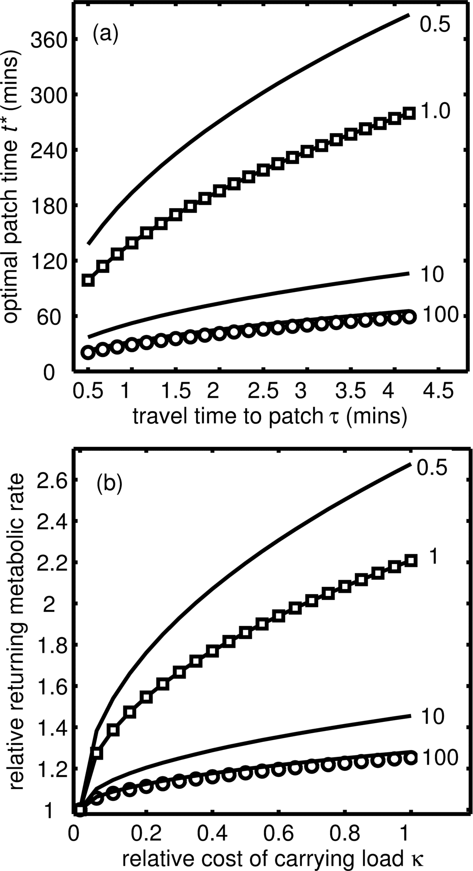

Figure 2
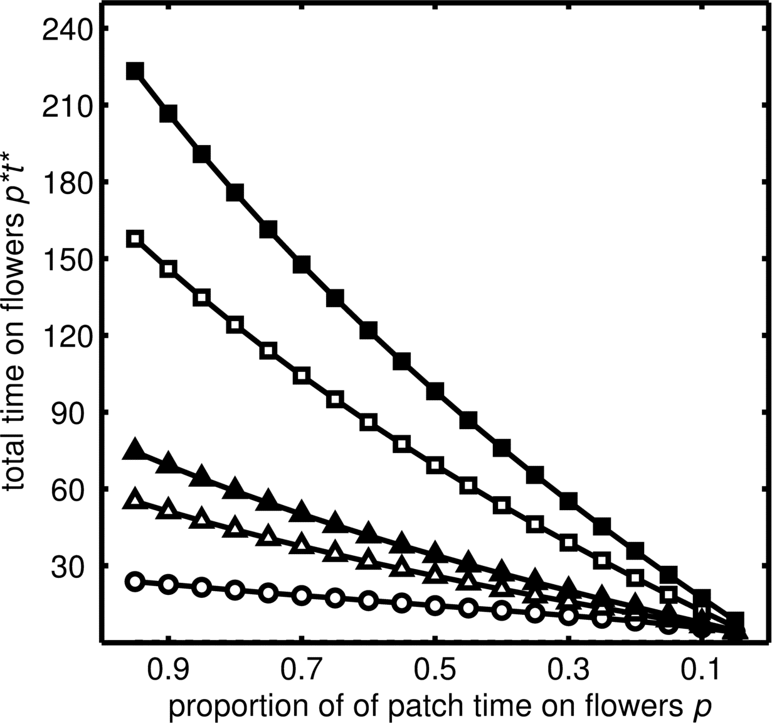

Figure 3

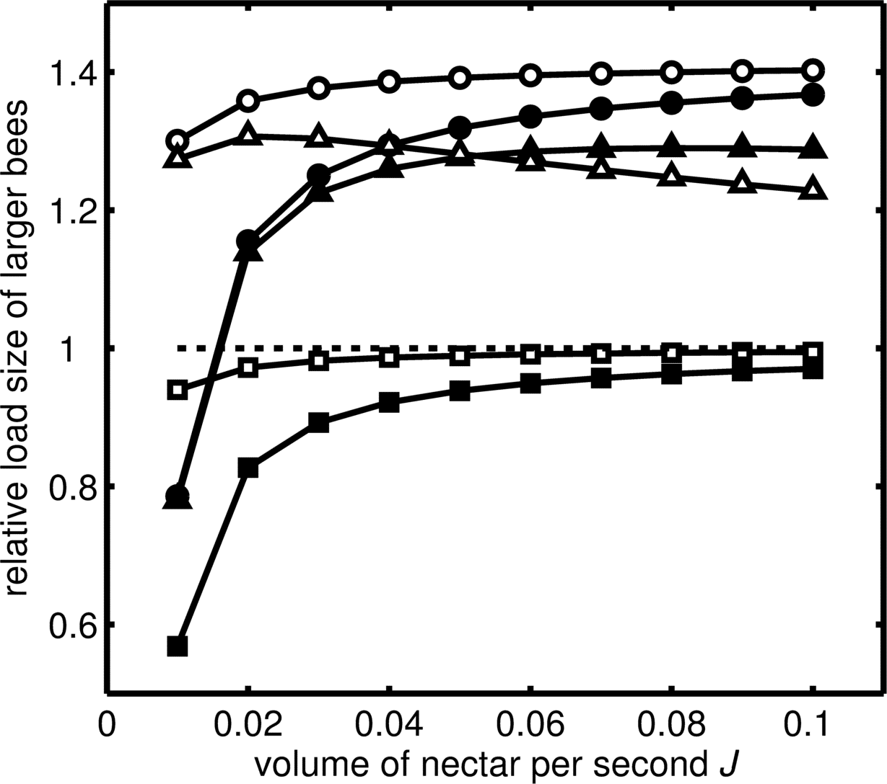
Figure 4
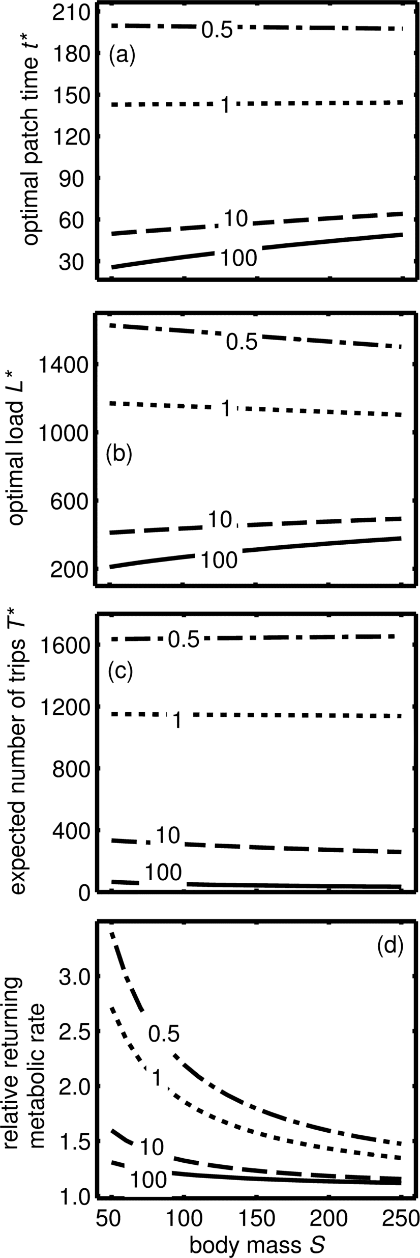
APPENDIX A: Mass-independent energetic costs

Here, we show how energetic costs can be included in the currency of expected lifetime energy gain. Assume that energy is spent at a constant rate 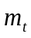 while accumulating load and at rate 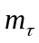 when travelling. Then net energy delivered is

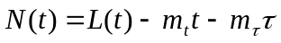. (A1)

We now maximise the expected lifetime net energy delivered

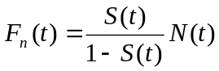. (A2)

From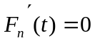

, (A3)

cf. equation (10). If then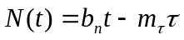, where 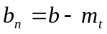. Then
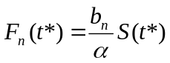 (A4)
cf. equation (11a)
or
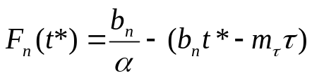, (A5a)
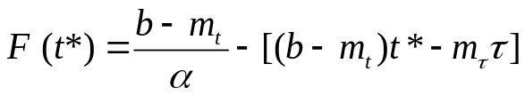 (A5b)
cf. equation (11b).

APPENDIX B: Discrete flower visits

Foraging is represented as a series of visits to flowers. All flowers are the same, i.e. they provide the same energy and impose the same risks. How many flowers should be visited? The bee’s behavioural rule is to keep foraging until n flowers have been visited. If it is still alive after these visits, it returns to nest. In contrast to Clark & Dukas (1994) we work with survival rather than mortality. Let 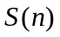= probability of surviving a trip in which bee returns after n flowers are visited. Then
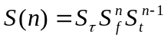 (B1)
where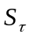is the probability of surviving the round trip travel time, 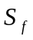is the probability of surviving a visit to a flower and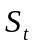is the probability of surviving the journey from one flower to another. The expected number of trips is
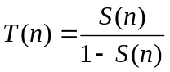. (B2)

The expected lifetime energy delivered is
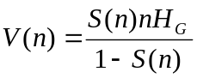, (B3)
where H_{G} is the gross energy gain per flower. Note that the optimal value of n (i.e. the value that maximises V(n)) does not depend on H_{G} but is relevant if we compare flower types.

So far we have looked at gross amount of energy collected. To extend the analysis to net energy delivered, we define 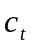 as the energy spent on the journey from one flower to another and 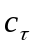 as the energy spent during the round trip travel time. Then net amount of energy A(n) if n flowers are visited is given by
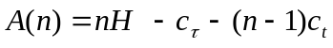 (B4)
where H = net gain per flower. The critical condition for a switch from it being optimal to return after visiting n flowers and it being optimal to return after visiting n + 1 flowers is
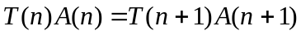 (B5)
or
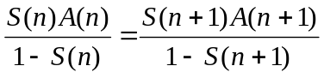. (B6)
From their definitions,
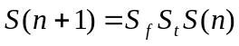 (B7)
and
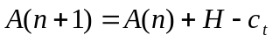 (B8)
From these equations and equation (5) it follows that the critical value 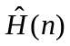 of H for a switch from it being optimal to return after visiting n flowers and it being optimal to return after visiting n + 1 flowers is
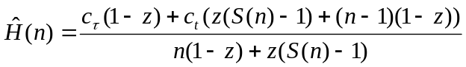 (B9)
where 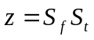. As , 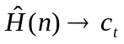
If costs are equal, i.e. 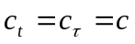 then= c for all n. This condition is not realistic. In general, 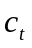will be much smaller than . For example, bumblebees often spend between one and five seconds travelling between flowers (Heinrich 1976; Cartar 1991), whereas total trip durations may be greater than one hour (Heinrich 1976; Westphal et al. 2006). Although travel time must be less than these times, it is clear that travel time can be much greater than five seconds in natural settings (Dramstad 1996, Cresswell et al. 2000). If t is so much smaller than τ that it can be ignored, we get
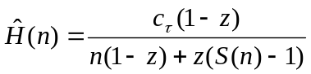. (B10)
Note that 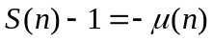, where 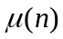is the probability that a bee does not survive a trip in which it returns after n flowers are visited. Let X be the expected number of flowers that will be visited by a forager that has reached its first flower and carries on visiting flowers until it dies. It follows that 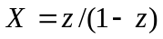and so
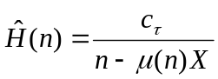. (B11)

APPENDIX C: Mass-dependent energy costs

Lifetime profit to the colony is F(t)=G(t)×T(t) and so from equations (11) and (12) we get
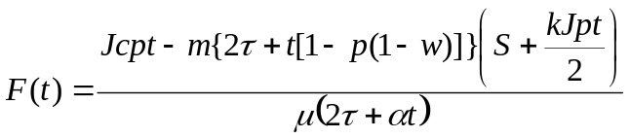. (C1)
Here, we wish to compare the predictions from this currency to those from maximisation of net rate or efficiency. Under our model, the net rate of gain is
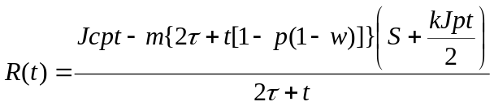, (C2)
and efficiency is
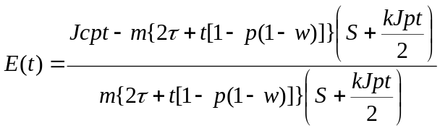. (C3)
Given this we can find the optimal t for each currency:
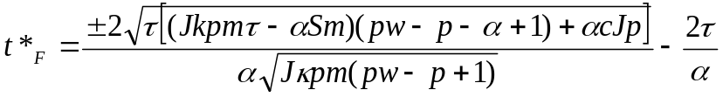, (C4)
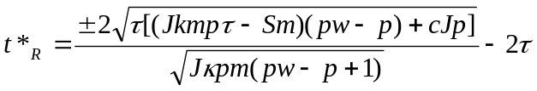, (C5)
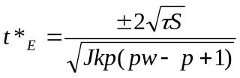. (C6)
It is easy to see that if α=1, 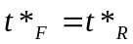. As α gets very large, 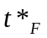is dominated by α², hence 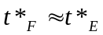 for large α. Thus, the magnitude of α controls whether F(t*) behaves like R(t*) or E(t*),

APPENDIX D: Effects of body size
We are interested in how optimal foraging time and load change with body size, i.e. 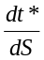and 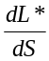. To assess this, we find the value of S at which the optimal load size is maximised (S*):
(D1)
where 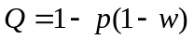 and

When α=1 maximisation of net rate is equivalent to maximising net gain to mortality rate, and so we know that 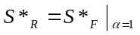, which is positive if
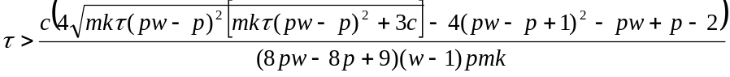. (D2)
Because m is very small, the right hand side is a very large number and the maximisation of load occurs at a negative body size, and so maximisation of rate R would lead to smaller loads being carried by larger individuals across the whole range of possible body sizes.

For maximisation of efficiency, the value of S at which the optimal load size is maximised (S*) is
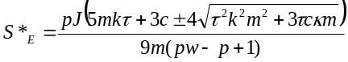 (D3)
which is positive if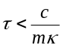.
Since m is very small, the right hand side is a very large number and so maximisation of efficiency would usually lead to greater loads carried by larger individuals.

The equation for S*_{F} is highly complex and so we consider the stationary points where L’(S)=0 to assess its behaviour at small positive values (i.e. in the range of bee masses, see references in Table 1). Solving for α gives only imaginary solutions, but numerical explorations showed that S*_{F} switches from negative when α is small to positive when α is large.

APPENDIX E: Supplementary figures

Figure E1: As Figure 2 but where (a) predation risk declines with size, (b) gain rate increases with size, (c) travel time is optimised, (d) costs and benefits scale with realistic power laws.
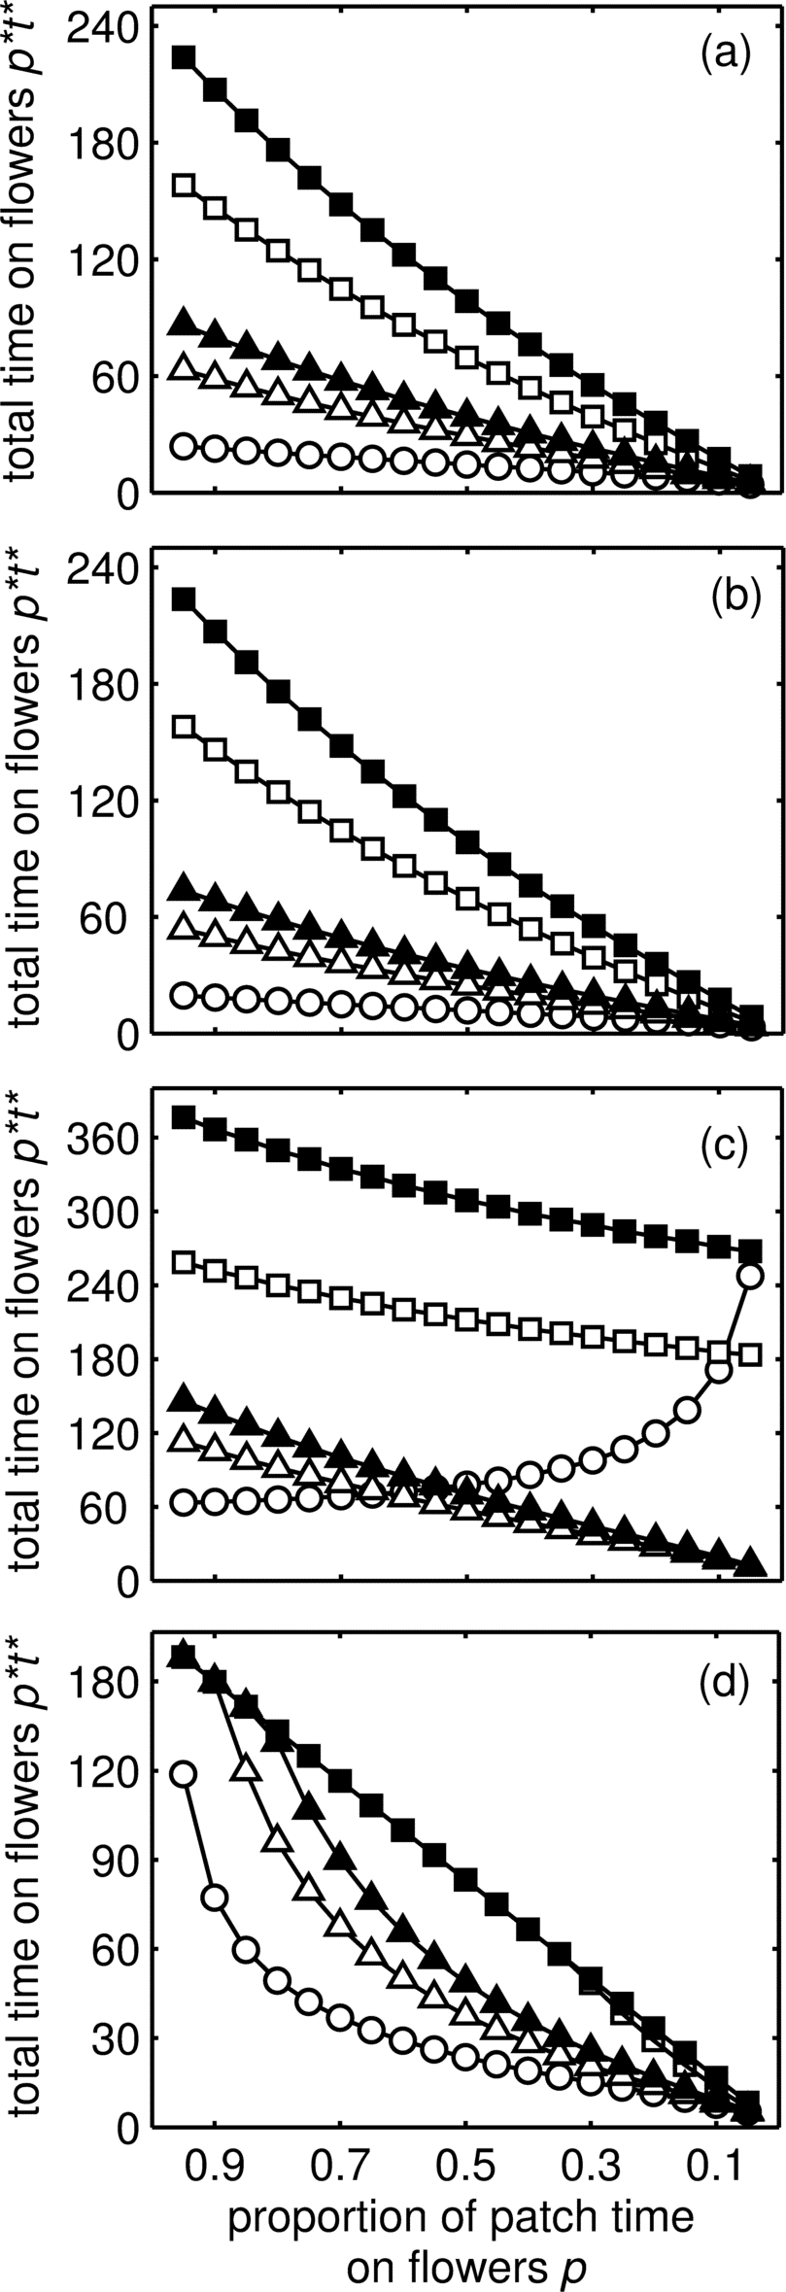
Figure E2: As Figure 3 but where (a) predation risk declines with size, (b) gain rate increases with size, (c) travel time is optimised, (d) costs and benefits scale with realistic power laws.
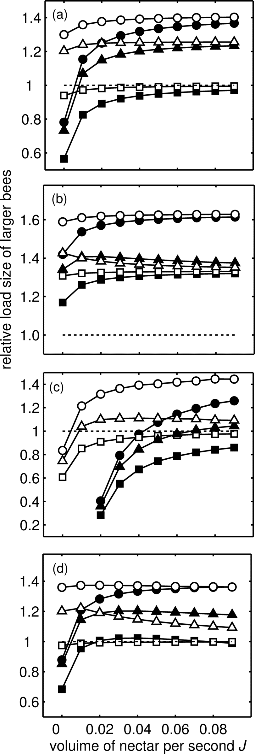

Figure E3: As Figure 4b but where (a) predation risk declines with size, (b) gain rate increases with size, (c) travel time is optimised, (d) costs and benefits scale with realistic power laws.


