Brexit: why uncertainty is bad for economies
September 26, 2016 1.50pm BST
shutterstock.com

Author
- Kevin McMeeking
Associate Professor of Accounting, University of Exeter

Disclosure statement
Kevin McMeeking has received funding from the Institute of Chartered Accountants of Scotland.

Partners
University of Exeter provides funding as a member of The Conversation UK.
The Conversation UK receives funding from Hefce, Hefcw, SAGE, SFC, RCUK, The Nuffield Foundation, The Ogden Trust, The Royal Society, The Wellcome Trust, Esmée Fairbairn Foundation and The Alliance for Useful Evidence, as well as sixty five university members.
View the full list
Republish this article
Republish our articles for free, online or in print, under Creative Commons licence.
- Email
- Twitter6
- Facebook7
- LinkedIn1
- Print
The predicted economic blow of a Brexit vote was core to the Remain campaign before Britain’s referendum on EU membership. Since the vote, the lack of an “Armageddon” has been held up as an example of these fears being overblown. In reality, it is likely to vary significantly across society, affecting people and businesses in different ways. In particular, there is the more nebulous, long-term effect of uncertainty to take into account.
For example, one immediate affect of the vote was a fall in pound sterling to the US dollar – from an average of US$1.42 in the six months prior to the referendum vote to the US$1.30 mark. The evidence of previous plunges in sterling, such as in the wake of Black Wednesday in 1992, suggest that net exporters of goods in the UK will benefit but net importers of goods will suffer.
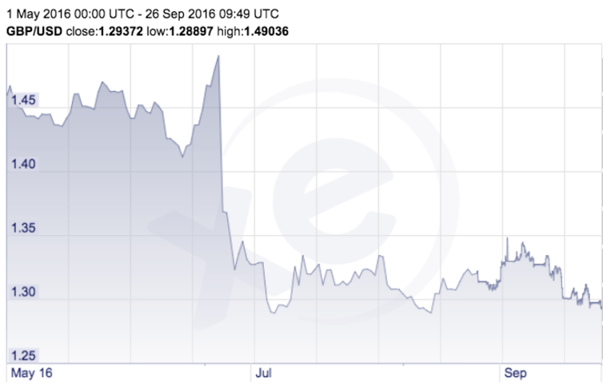GBP/USD exchange rate before and after Brexit. xe.com
Any gains here, however, could be offset by the increased levels of uncertainty surrounding the UK’s relationship with the EU as a result of the vote. The governor of the Bank of England, Mark Carney, has argued that political, economic, regulatory uncertainties will persist while the UK redefines its openness to the movement of goods, services, people and capital.

A market for lemons
That uncertainty is bad for business is a well-established theory in economics. In a seminal paper, Nobel-prize winner George Akerlof created a scenario where buyers couldn’t distinguish between high quality cars and low quality cars (which he called “lemons”) in a second-hand market. Buyers would only pay a fixed price that averages the value of the high quality and the “lemons”. Sellers (with the information advantage) responded by removing good quality cars from the market, only selling “lemons”. This resulted in exchanges that could benefit buyers and sellers being lost and an inefficient market. This information asymmetry, Akerlof showed, also led to a degradation of the quality of goods traded.
Significant resources are invested to mitigate against this information problem in businesses. Companies offer guarantees, warranties and refunds to consumers. Consumers and companies review services before buying them. Annual reports are long and detailed. Company management liaise extensively with interested parties such as analysts and institutional investors. Firms also invest large amounts in derivatives to try to reduce uncertainty and manage their risks. But the government will be hard pressed to use similar strategies.
If British suppliers pass on increased costs that are a likely result of Brexit uncertainty to consumers then UK sales are likely to fall. This is bad news for an economy that is already struggling to boost spending. Early evidence suggests that petrol prices have risen, travel company bookings have fallen and the housing market has slowed. Less visible effects might follow such as a delay to investments from overseas or the removal of services like “roam-like-at-home” rules on phone calls and texts in the EU.
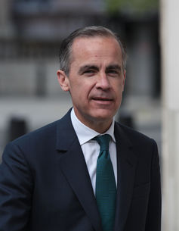Mark Carney: no lemon. Twocoms / Shutterstock.com
The Bank of England’s response has been to cut interest rates to 0.25% – the first cut since 2009 – and to also expand its quantitative easing programme to try to get people spending. The effects of this will take time – and there is, as yet, no guarantee that they will work – but this does not leave the Bank of England with many more fiscal cards left to play.

Lessons from Canada
To assess the actual economic impact of Brexit uncertainty, Canada offers some lessons and the sovereignty movement in Quebec (which almost won a referendum in 1995). Uncertainty here prompted a rise in ten-year bond rates and an adverse reaction from stock markets. Undiversified low-growth firms, with transactions focused in the local markets were the worst affected.
Independence from Canada would be costly for Quebec in three main ways – increased levels of debt, increased tariffs and financial transfers. Brexit might benefit the UK by reducing the costs of regulation and reduced payments into the EU, but it is inconceivable that the UK can enjoy the same trading relationship with its European partners without paying for the privilege – as Norway and Switzerland do.
Uncertainty also affects individuals. If they choose to leave for more stable futures, this could impact the broader economy. This would be particularly damaging for niche high-tech markets and government organisations, companies or industries that rely heavily on EU immigrants for large numbers of employees such as the NHS. A brain drain would leave a skills gap that British employees cannot service leading to a decline in trade. UK universities are concerned that they might see a significant decline in tuition fee income and the loss of academic talent in the short to medium-term.
The overall economic effects will take time to materialise and likely vary across the country. The businesses (and people) that are the least diversified; with little or no access to alternative income streams are likely to be the most at risk during these uncertain times.
- European Union
- Europe
- UK economy
- Brexit
- Uncertainty
- Tweet
- Share
- Get newsletter

You might also like
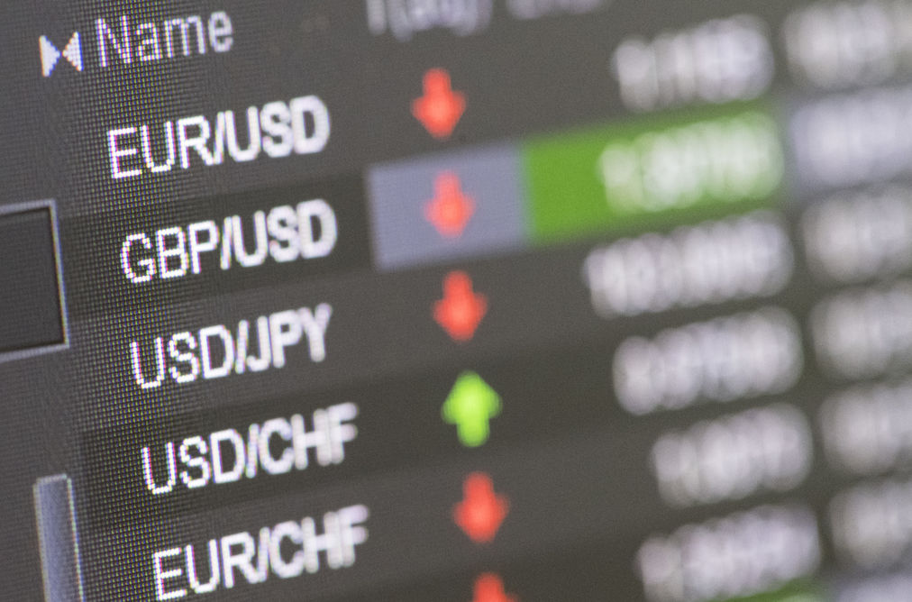

How Brexit triggered a global market meltdown
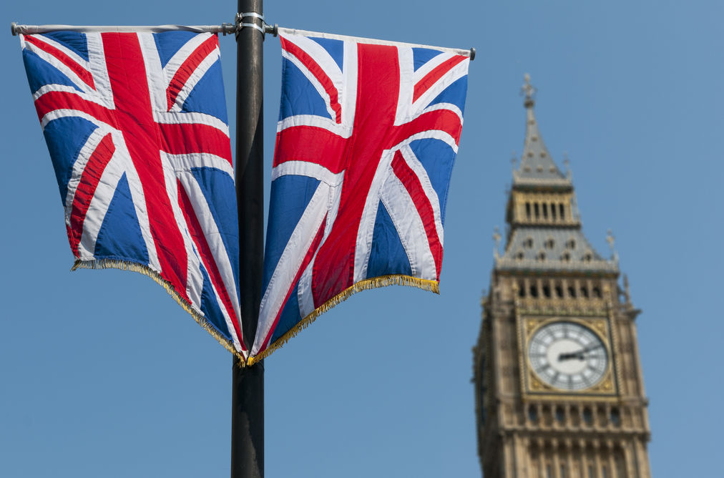

Is Brexit a new ‘Magna Carta’ as Wetherspoon’s boss suggests?
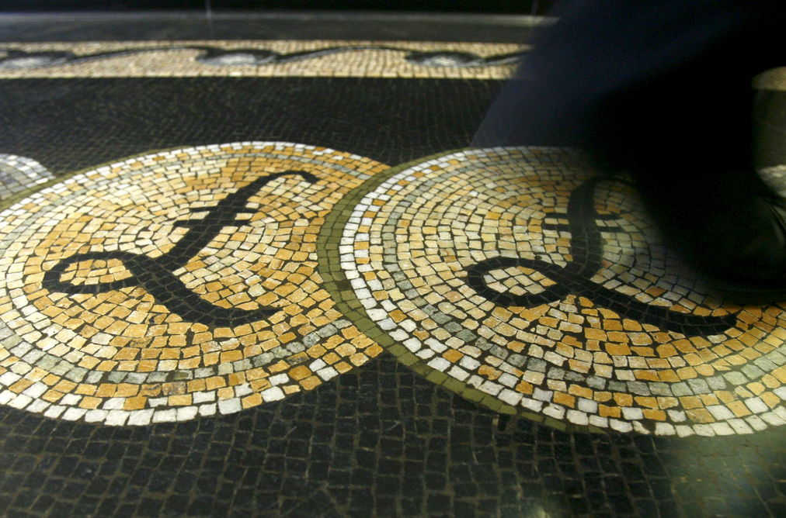

Brexit harms startups but it may not be fatal
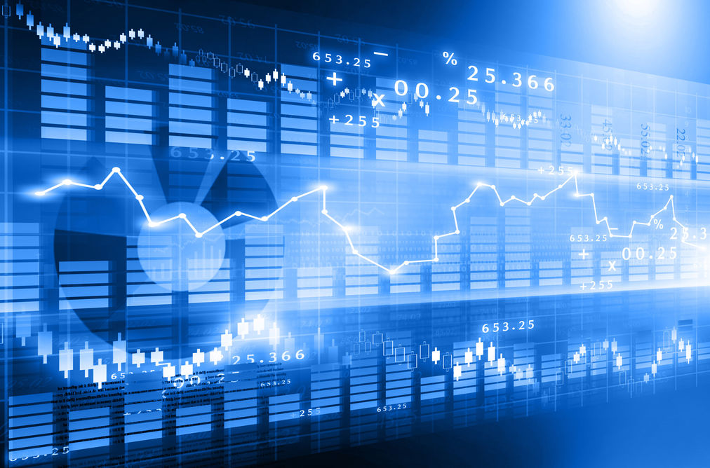

Don’t believe the Brexit prophecies of economic doom
Sign in to comment
5Comments
Oldest Newest

James Briggs
logged in via Google
Everyone knows why uncertainty is bad for economics. What seemed a mystery to the opinion makers is no one wants to be ruled but a faceless bureaucracy that ignores the people.
4 months ago
Report

John Doyle
I think the main point of Brexit has been overlooked. It’s not economics, a casualty, not a cause. Economics is replete with uncertainties and few certainties. Brexit was a vote of no confidence in the status quo situation where the “winners” in the society became so divorced from everyone else that they did not even consider them, as if invisible. For these people who enjoyed the status quo, Brexit came as a real shock, completely unexpected. It has set off a train of similar surprises well beyond Europe. The economies themselves have been badly managed as few understand money and politicians are among the worst offenders.
Just maybe some improvements will result over time. A better distribution of benefits would be a great start.
4 months ago
Report
Show all comments

Most popular on The Conversation
- Bribing kids to eat vegetables is not sustainable – here’s what to do instead
- Why did humans evolve big penises but small testicles?
- The dangers of being a bridesmaid in China mean some brides now hire professionals
- Why UPS drivers don’t turn left and you probably shouldn’t either
- How to escape a maze – according to maths
- Mediocre ‘musical’ La La Land deserves to win at the Oscars – it’s a story for our uninspiring age
- Why this spot on the Jersey coast was like a magnet for Neanderthals
- Six cosmic catastrophes that could wipe out life on Earth
- Shepard Fairey’s inauguration posters may define political art in Trump era
- Falklands ‘wolf’ that baffled Darwin was actually more like a jackal – new study

Events
- Working as a journalist in the media and human rights hostile environment of Ethiopia— York, York
- Webinar: Funding for science master's programmes — Online, Bath and North East Somerset
- Dreams, dice and divination: Islamic art and the supernatural — York, York
- Performing Online Live Experiments 24/7: “An Internet of Laboratory Things” — Milton Keynes, Milton Keynes
- Inside the Car Wash: corruption scandal or a systemic ‘illicit financial Quid Pro Quo’ in Brazil? — London, London, City of
MORE EVENTS

Expert Database

- Find experts with knowledge in:*

The Conversation

Community
- Community standards
- Republishing guidelines
- Friends of The Conversation
- Research and Expert Database
- Events
- Our feeds
- Donate

Company
- Who we are
- Our charter
- Our team
- Our blog
- Partners and funders
- Contributing institutions
- Resour

