Supporting information
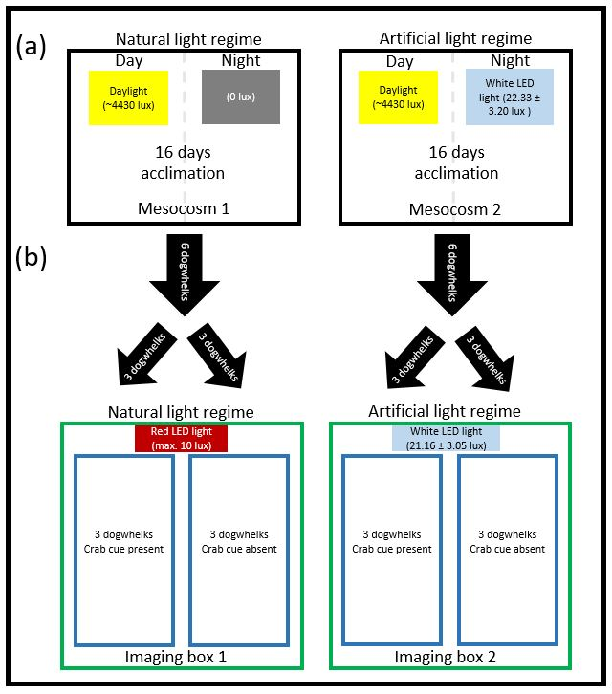
Figure S1. (a) Experimental light treatments for mesocosms in which whelks were held for acclimated behavioural trials and (b) set up for behavioural assessments within imaging black boxes (green boxes). Each imaging box contained two assessment tanks (dark blue boxes) at one end and a digital SLR camera at the other. They were sealed using fitted lids to isolate tanks from surrounding environment. Assessment tanks contained 4.3 l of seawater, as above, and one tank from each assay enclosure was supplied with water containing an olfactory predator cue; the other was supplied with filtered seawater. Twelve trials were performed following this procedure. The behaviour of 12 dogwhelks was assessed in each assay (3 per assessment tank). 12 assessments were performed, meaning behavioural responses were assessed for 144 individuals across the 4 treatments.
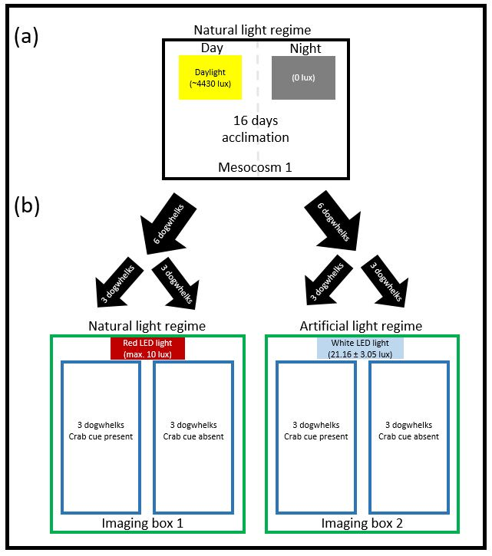
Figure S2. (a) Experimental light treatments for mesocosms in which whelks were held for non-acclimated behavioural trials and (b) set up for behavioural assessments within imaging black boxes (green boxes). Each imaging box contained two assessment tanks (dark blue boxes) at one end and a digital SLR camera at the other. They were sealed using fitted lids to isolate tanks from surrounding environment. Assessment tanks contained 4.3 l of seawater, as above, and one tank from each assay enclosure was supplied with water containing an olfactory predator cue; the other was supplied with filtered seawater. Seven trials were performed following this procedure. The behaviour of 12 dogwhelks was assessed in each assay (3 per assessment tank). 7 assessments were performed, meaning behavioural responses were assessed for 84 individuals across the 4 treatments.

Table S1. Day-night cycle for experimental mesocosms.
Dates (dd/mm/yy) ^{α} | ‘Sunrise’ ^{β} | ‘Sunset’^{γ}
10/04/15 - 16/04/15 | 6:35 | 20:03
17/04/15 - 23/04/15 | 6:20 | 20:14
24/04/15 - 30/04/15 | 6:06 | 20:25
01/05/15 - 07/05/15 | 5:53 | 20:36
08/05/15 - 14/05/15 | 5:41 | 20:47
15/05/15 - 21/05/15 | 5:30 | 20:52
22/05/15 - 28/05/15 | 5:21 | 21:07
29/05/15 - 04/06/15 | 5:14 | 21:16
05/06/15 - 11/06/15 | 5:00 | 21:23
α - dates are inclusive
β - time of day at which the daylight tiles turned on in both mesocosms and the night-time LED lights turned off in the ALAN mesocosm
γ - time of day at which the daylight tiles turned off in both mesocosms and the night-time LED lights turned on in the ALAN mesocosm

Table S2. Selection of random effects terms for inclusion in models used to analyse responses of acclimated whelks. Random effects were included to control for competitive interactions between the three dogwhelks in each tank during each behaviour assessment where their inclusion was found to improve model parsimony. A random effects model was used in the analysis only if its AIC score was lower compared to the model with no random effects by two or more. Models selected for the interpretation of results are underlined.
Response variable | No random effects | Variables included as random effects
 |  | ~1|Rank | ~Treatment|Rank | ~Predator|Rank | All
Reached waterline | 182.91 | 164.19 | 168.17 | 168.12 | 176.12
Speed to waterline | 41.71 | 45.24 | 48.79 | 49.16 | 56.79
Response to prey | 172.36 | 167.20 | 168.95 | 171.01 | 176.95
Foraging distance | 359.62 | 364.02 | 368.02 | 367.92 | 375.92
Prey handled | 117.24 | 116.94 | 120.04 | 120.91 | 128.01

Table S3. Selection of random effects terms for inclusion in models used to analyse responses of acclimated whelks. Random effects were included to control for competitive interactions between the three dogwhelks in each tank during each behaviour assessment. The importance of accounting for these interactions and their nature was assessed by comparing model parsimony between the given alternative random effects models. A random effects model was used in the analysis only if its AIC score was lower compared to the model with no random effects by two or more. Models selected for the interpretation of results are underlined.
Response Variable | No random effects | Variables included as random effects
 |  | ~1|Rank | ~Treatment|Rank | ~Predator|Rank | All
Reached waterline | 103.36 | 93.64 | 97.63 | 97.04 | 105.04
Speed to waterline | 2.03 | 14.10 | 18.10 | 17.51 | 25.51
Response to prey | 117.61 | 100.26 | 103.77 | 101.60 | 109.60
Foraging distance | 104.53 | 107.06 | 111.06 | 111.06 | 119.06
Prey handled | 45.33 | 42.10 | 46.09 | 46.09 | 54.09

Table S4. Post hoc pairwise comparisons of the interacting effects of Light treatment and Predator cue on whether or not dogwhelks responded to the introduction of prey during the non-acclimated experiment (Table 2c). Results that are significant at the 95% or greater confidence level are underlined. No corrections for false discovery rate were performed. ALAN= Artificial Light at Night regime; NL = Natural Light regime; No= No predator cue present; Yes = Predator cue present.
Contrast | Coefficients | SE | Z ratio | p
ALAN,No - NL,No | -0.86 | 0.76 | -1.13 | 0.260
ALAN,No - ALAN,Yes | -1.40 | 0.77 | -1.81 | 0.071
ALAN,No - NL,Yes | 0.32 | 0.79 | 0.40 | 0.689
NL,No - ALAN,Yes | -0.54 | 0.73 | -0.73 | 0.463
NL,No - NL,Yes | 1.18 | 0.79 | 1.50 | 0.134
ALAN,Yes - NL,Yes | 1.72 | 0.80 | 2.15 | 0.032

