Supporting Information:
Modelling effects of honeybee behaviors on the distribution of pesticide in nectar within a hive, and resultant in-hive exposure.
Authors: Jack C. O. Rumkee†; Matthias A. Becher†; Pernille Thorbek‡; Juliet L. Osborne†*
† Environment and Sustainability Institute, University of Exeter, Penryn Campus, Penryn, Cornwall, TR10 9FE, UK
‡Syngenta, Environmental Safety, Jealott’s Hill International Research Centre, Bracknell, Berkshire, RG42 6EY, UK
*corresponding author: email:j.l.osborne@exeter.ac.uk; phone: +44 1326 259474
Number of Pages: 46
Number of Figures: 13
Number of Tables: 6

Table of Contents:

Appendix 1
Figure S1 Gini coefficients and Moran’s I values on days 1 and 30 with description of indices.

Figure S2 The median dose of pesticide received by the adults when 10% of foragers return with pesticide as the number of replicates increases.

Figure S3 The median dose of pesticide received by the adults when 50% of foragers return with pesticide as the number of replicates increases.

Figure S4 The median dose of pesticide received by the larvae when 10% of foragers return with pesticide as the number of replicates increases.

Figure S5 The median dose of pesticide received by the larvae when 50% of foragers return with pesticide as the number of replicates increases.

Figure S6 The sensitivity of the dose received by the adult bees with a change in the number of adult bees

Figure S7 The sensitivity of the dose received by the adult bees with a change in the number of larvae

Figure S8 The sensitivity of the dose received by the adult bees with a change in the concentration of pesticide in the nectar

Figure S9 The sensitivity of the dose received by the adult bees with a change in the proportion of foragers returning with pesticide.

Figure S10 The sensitivity of the dose received by the larvae with a change in the number of adult bees

Figure S11 The sensitivity of the dose received by the larvae with a change in the number of larvae

Figure S12 The sensitivity of the dose received by
the larvae with a change in the concentration of pesticide in the nectar

Figure S13 The sensitivity of the dose received by the larvae with a change in the proportion of foragers returning with pesticide.

Table S1 Description of scenarios and abbreviations.
Table S2 Detailed results from post-hoc pairwise analysis of distribution of median pesticide doses in larvae when 10% of foragers return with pesticide.
Table S3 Detailed results from post-hoc pairwise analysis of distribution of median pesticide doses in larvae when 50% of foragers return with pesticide.
Table S4 Detailed results from post-hoc pairwise analysis of distribution of median pesticide doses in adults when 10% of foragers return with pesticide.
Table S5 Detailed results from post-hoc pairwise analysis of distribution of median pesticide doses in adults when 50% of foragers return with pesticide.

Appendix 2
Table S6 Various parameters used in the model
Complete ODD protocol for model

Appendix 1
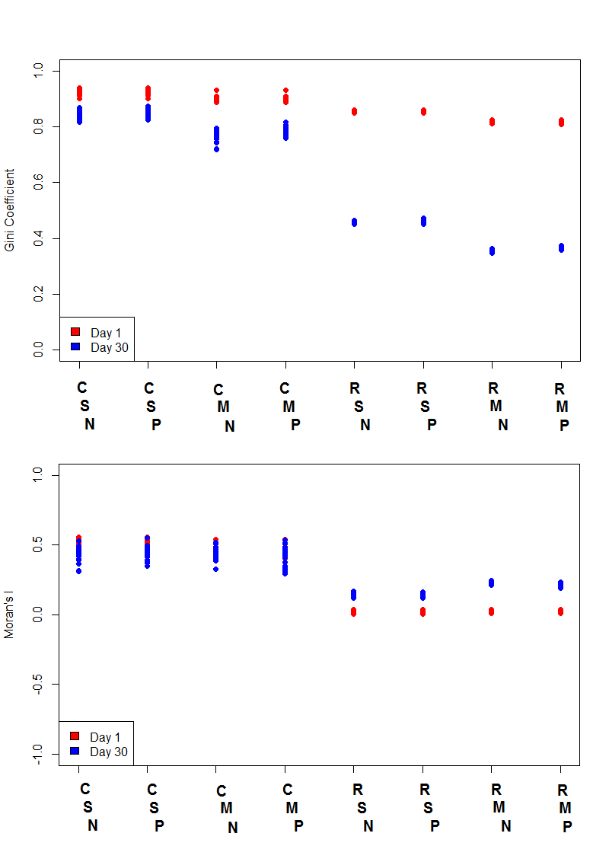
Figure S1

Gini coefficients and Moran’s I indices on days 1 (red) and 30 (blue).

1. The Gini coefficient¹:
(1) $\frac{\sum_{i}{\sum_{j}{\left|x_{i}-x_{j}\right|}}}{2n^{2}μ}$
a measure of inequality representing the mean distance between every pair of values divided by the mean value, giving a measure of inequality that can be compared between scenarios.
2. Moran’s I²:
(2) $\frac{N}{\sum_{i}{\sum_{j}{w_{ij}}} }\frac{\sum_{i}{\sum_{j}{w_{ij}(X_{i}- μ)(X_{j}- μ)}}}{\sum_{i}{w_{ij}{(X_{i}- μ)}^{2}}}$ a measure of spatial autocorrelation of the pesticide amongst the comb cells. This index involves the use of a weighting factor between each pair of values. For this analysis, two such weighting factors were used: i) the Euclidean distance between the two cells in question, and ii) an adjacency factor, 1 if the cells are adjacent and 0 otherwise. These give a value for Moran’s I for both global (i) and local (ii) autocorrelation.
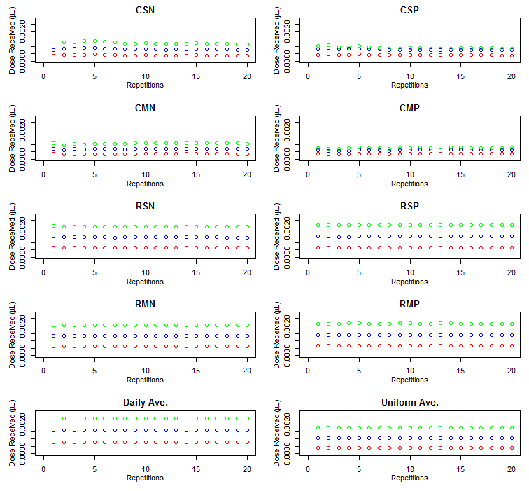

Figure S2
The median dose of pesticide (µg) received by the adult bees when 10% of the foragers return with pesticide in the 8 behavioural scenarios as the number of repetitions increase. The colors represent the day, data is presented from day 10 (red), 20 (blue) and 30(green).

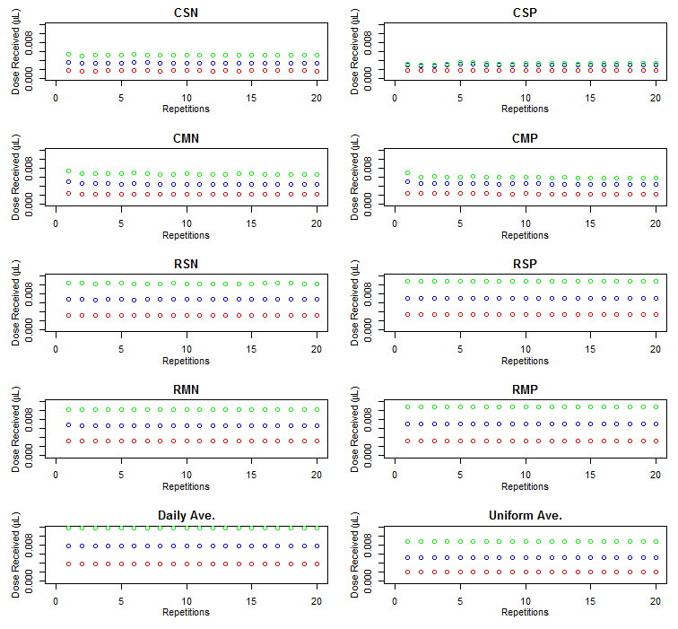

Figure S3
The median dose of pesticide received by the adult bees when 50% of the foragers return with pesticide in the 8 behavioural scenarios as the number of repetitions increase. The colors represent the day, data is presented from day 10 (red), 20 (blue) and 30(green).

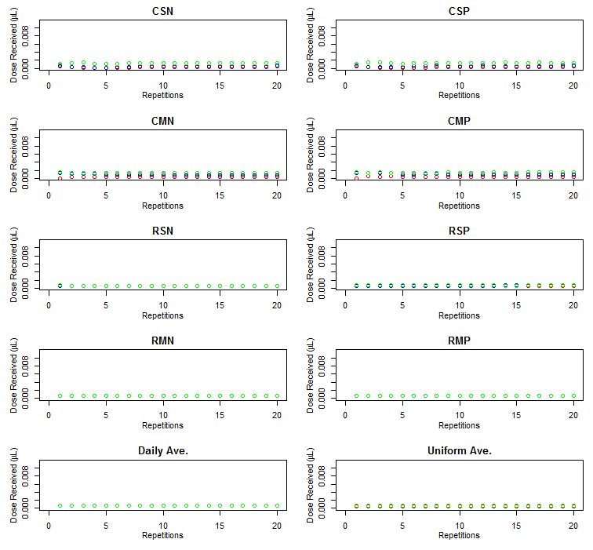
Figure S4
The median dose of pesticide received by the larvae when 10% of the foragers return with pesticide in the 8 behavioural scenarios as the number of repetitions increase. The colors represent the day, data is presented from day 10 (red), 20 (blue) and 30(green).

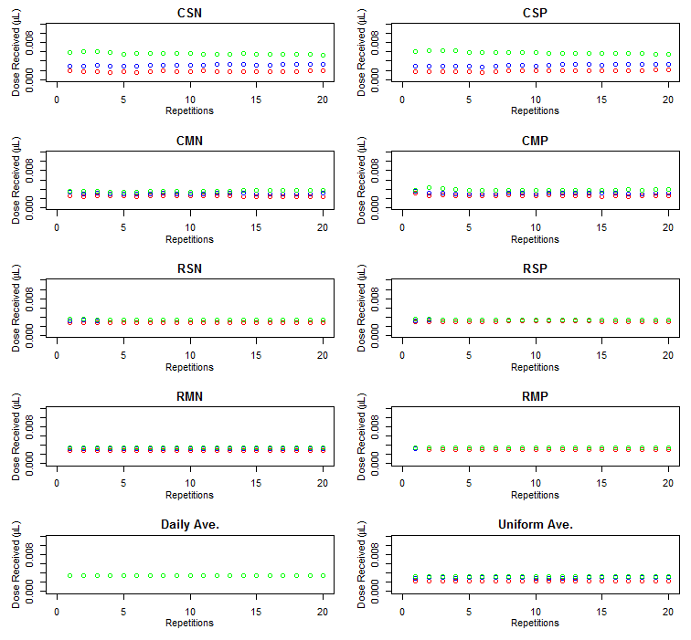
Figure S5
The median dose of pesticide received by the larvae when 50% of the foragers return with pesticide in the 8 behavioural scenarios as the number of repetitions increase. The colors represent the day, data is presented from day 10 (red), 20 (blue) and 30(green).

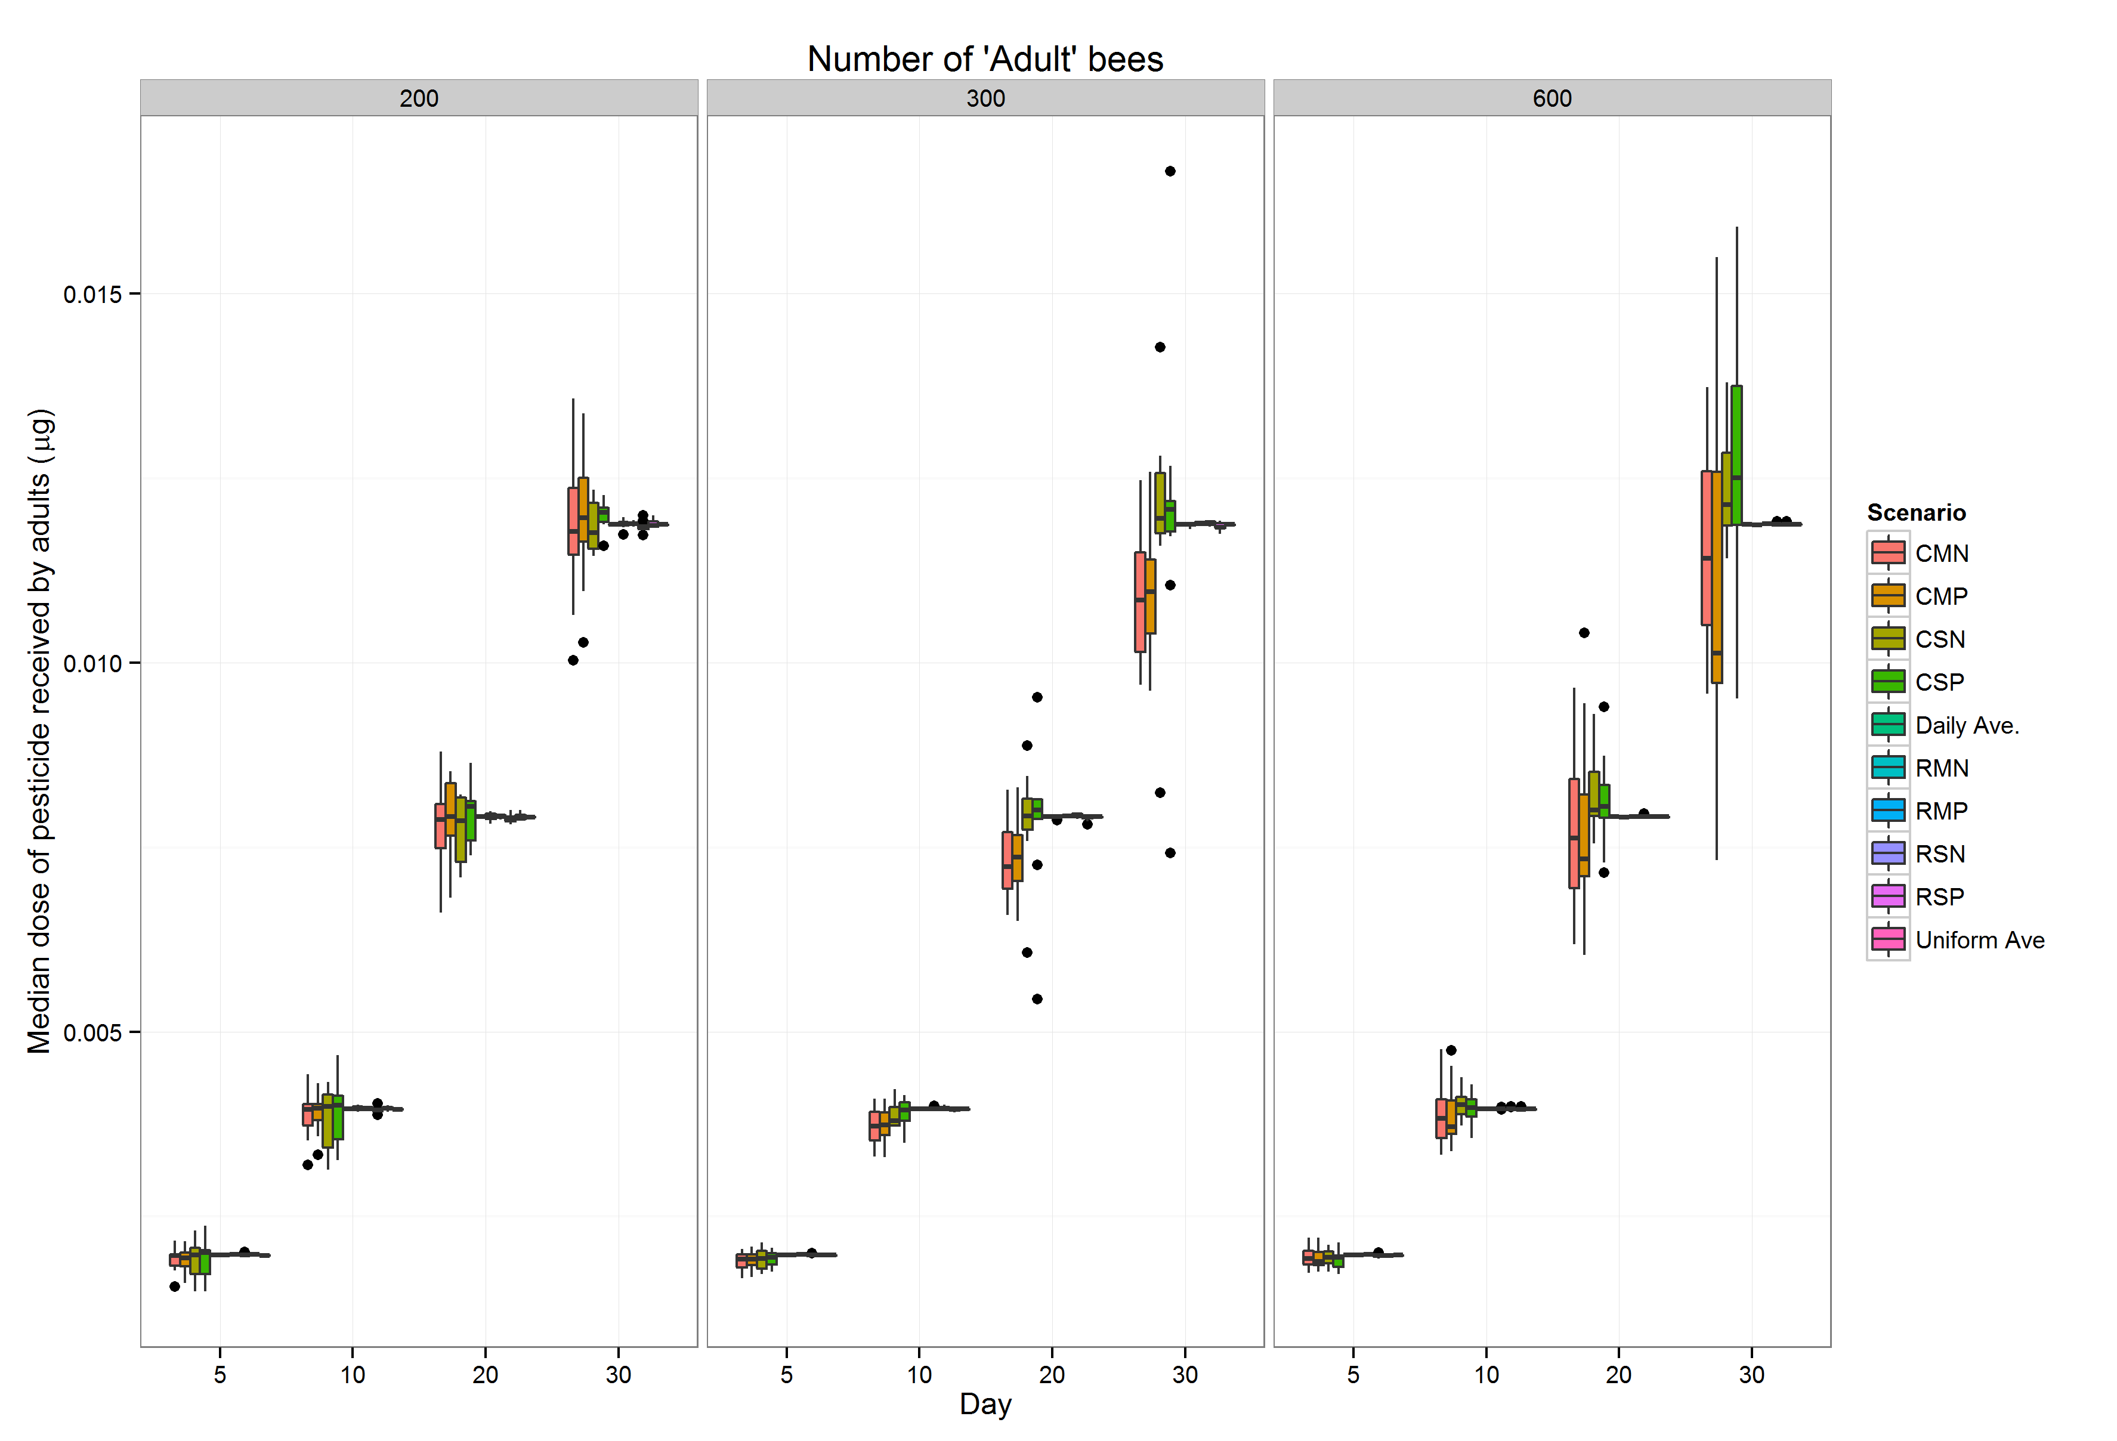
Figure S6
Boxplot of the median dose of pesticide (µg) received by the adult bees in simulations with different numbers of adult bees. The colors represent the scenario.

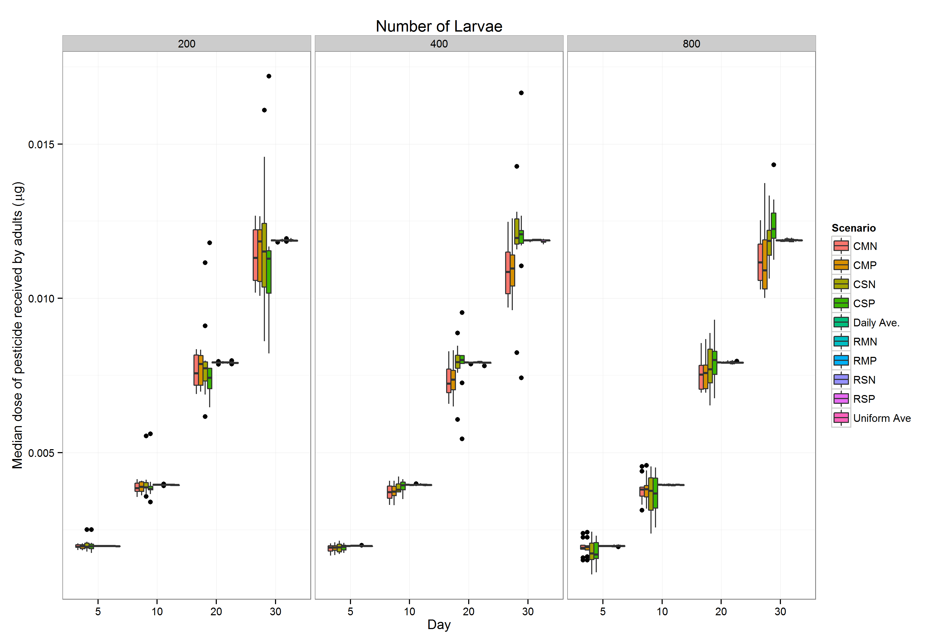
Figure S7
Boxplots of the median dose of pesticide (µg) received by the adult bees in simulations with different numbers of larvae. The colors represent the scenario.

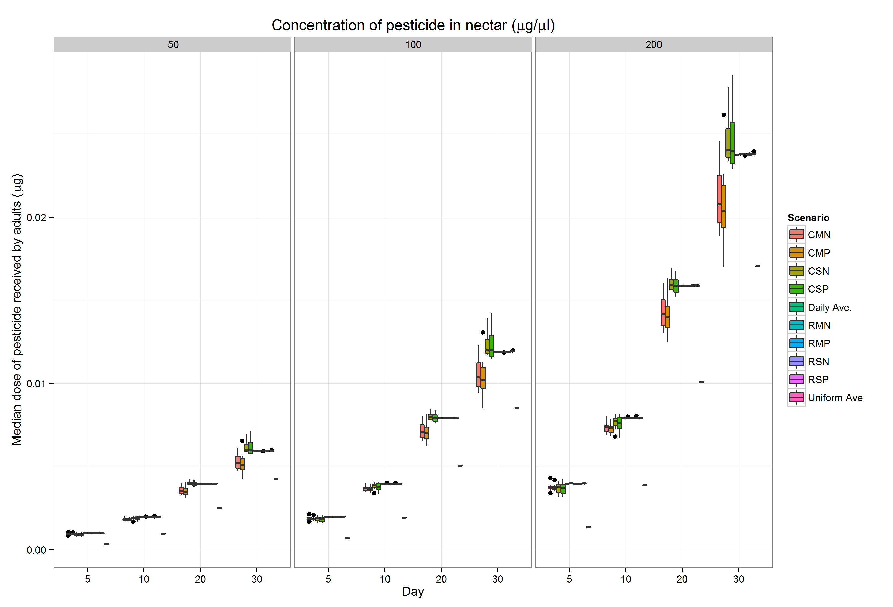

Figure S8
Boxplots of the median dose of pesticide (µg) received by the adult bees in simulations with different pesticide concentrations in the treated nectar. The colors represent the scenario.

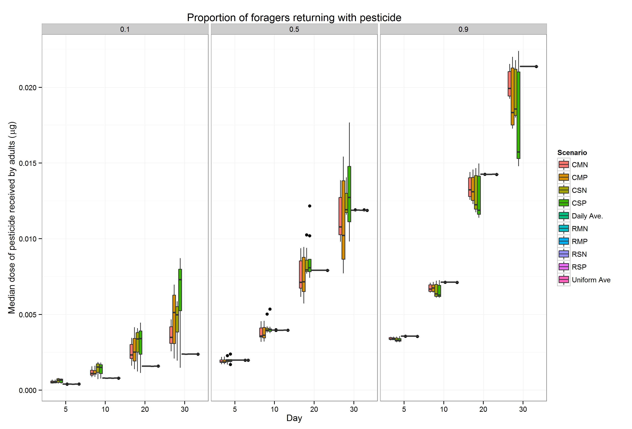
Figure S9
Boxplots of the median dose of pesticide (µg) received by the adult bees in simulations with different proportions of the foraging bees returning with treated nectar. The colors represent the scenario.

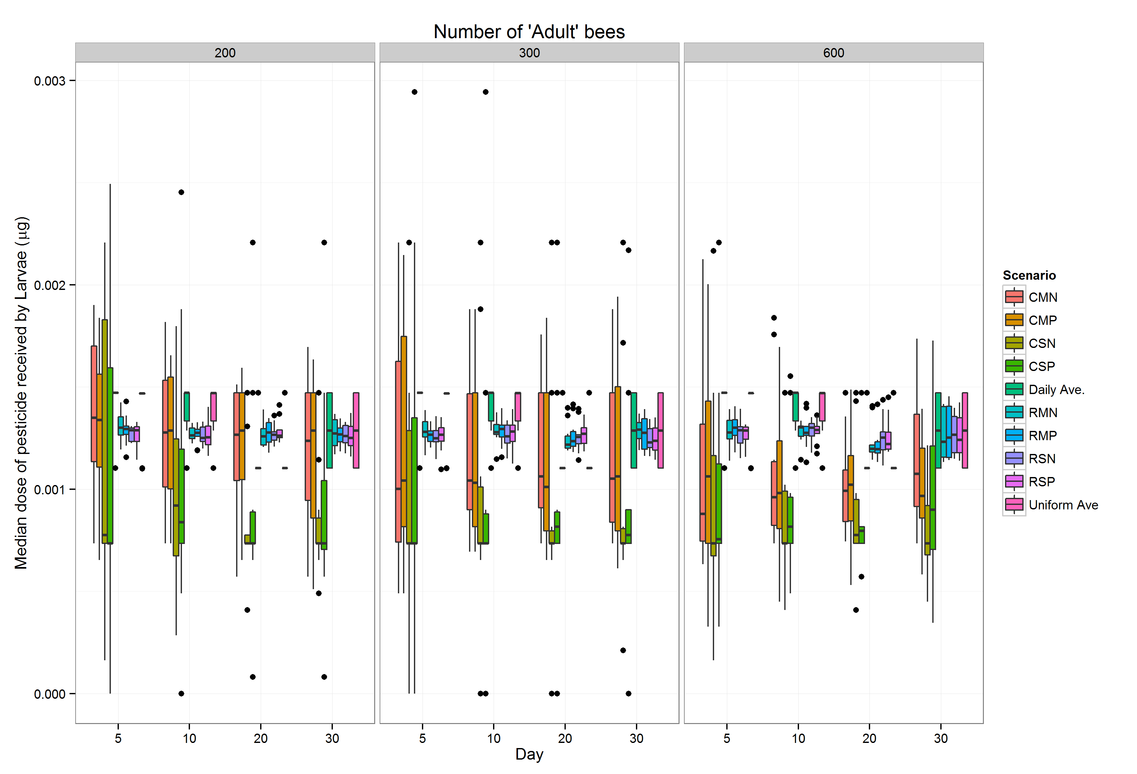
Figure S10
Boxplot of the median dose of pesticide (µg) received by the larvae in simulations with different numbers of adult bees. The colors represent the scenario.

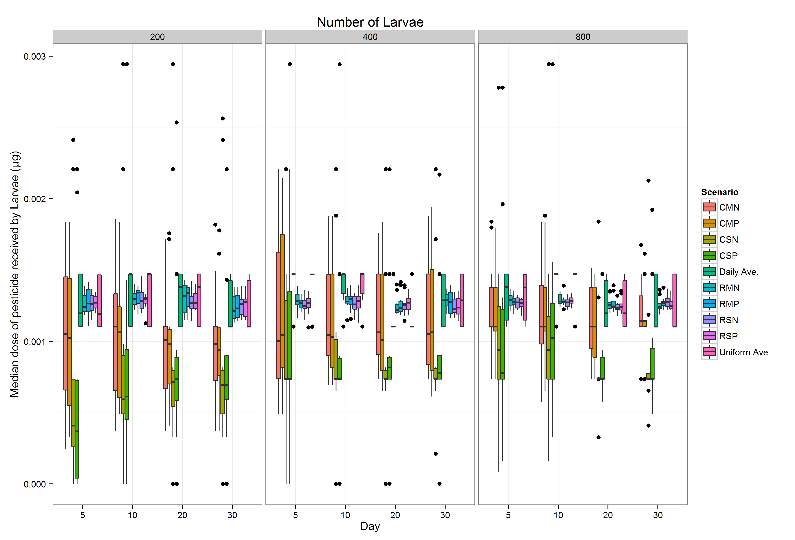
Figure S11
Boxplot of the median dose of pesticide (µg) received by the larvae in simulations with different numbers of larvae. The colors represent the scenario.
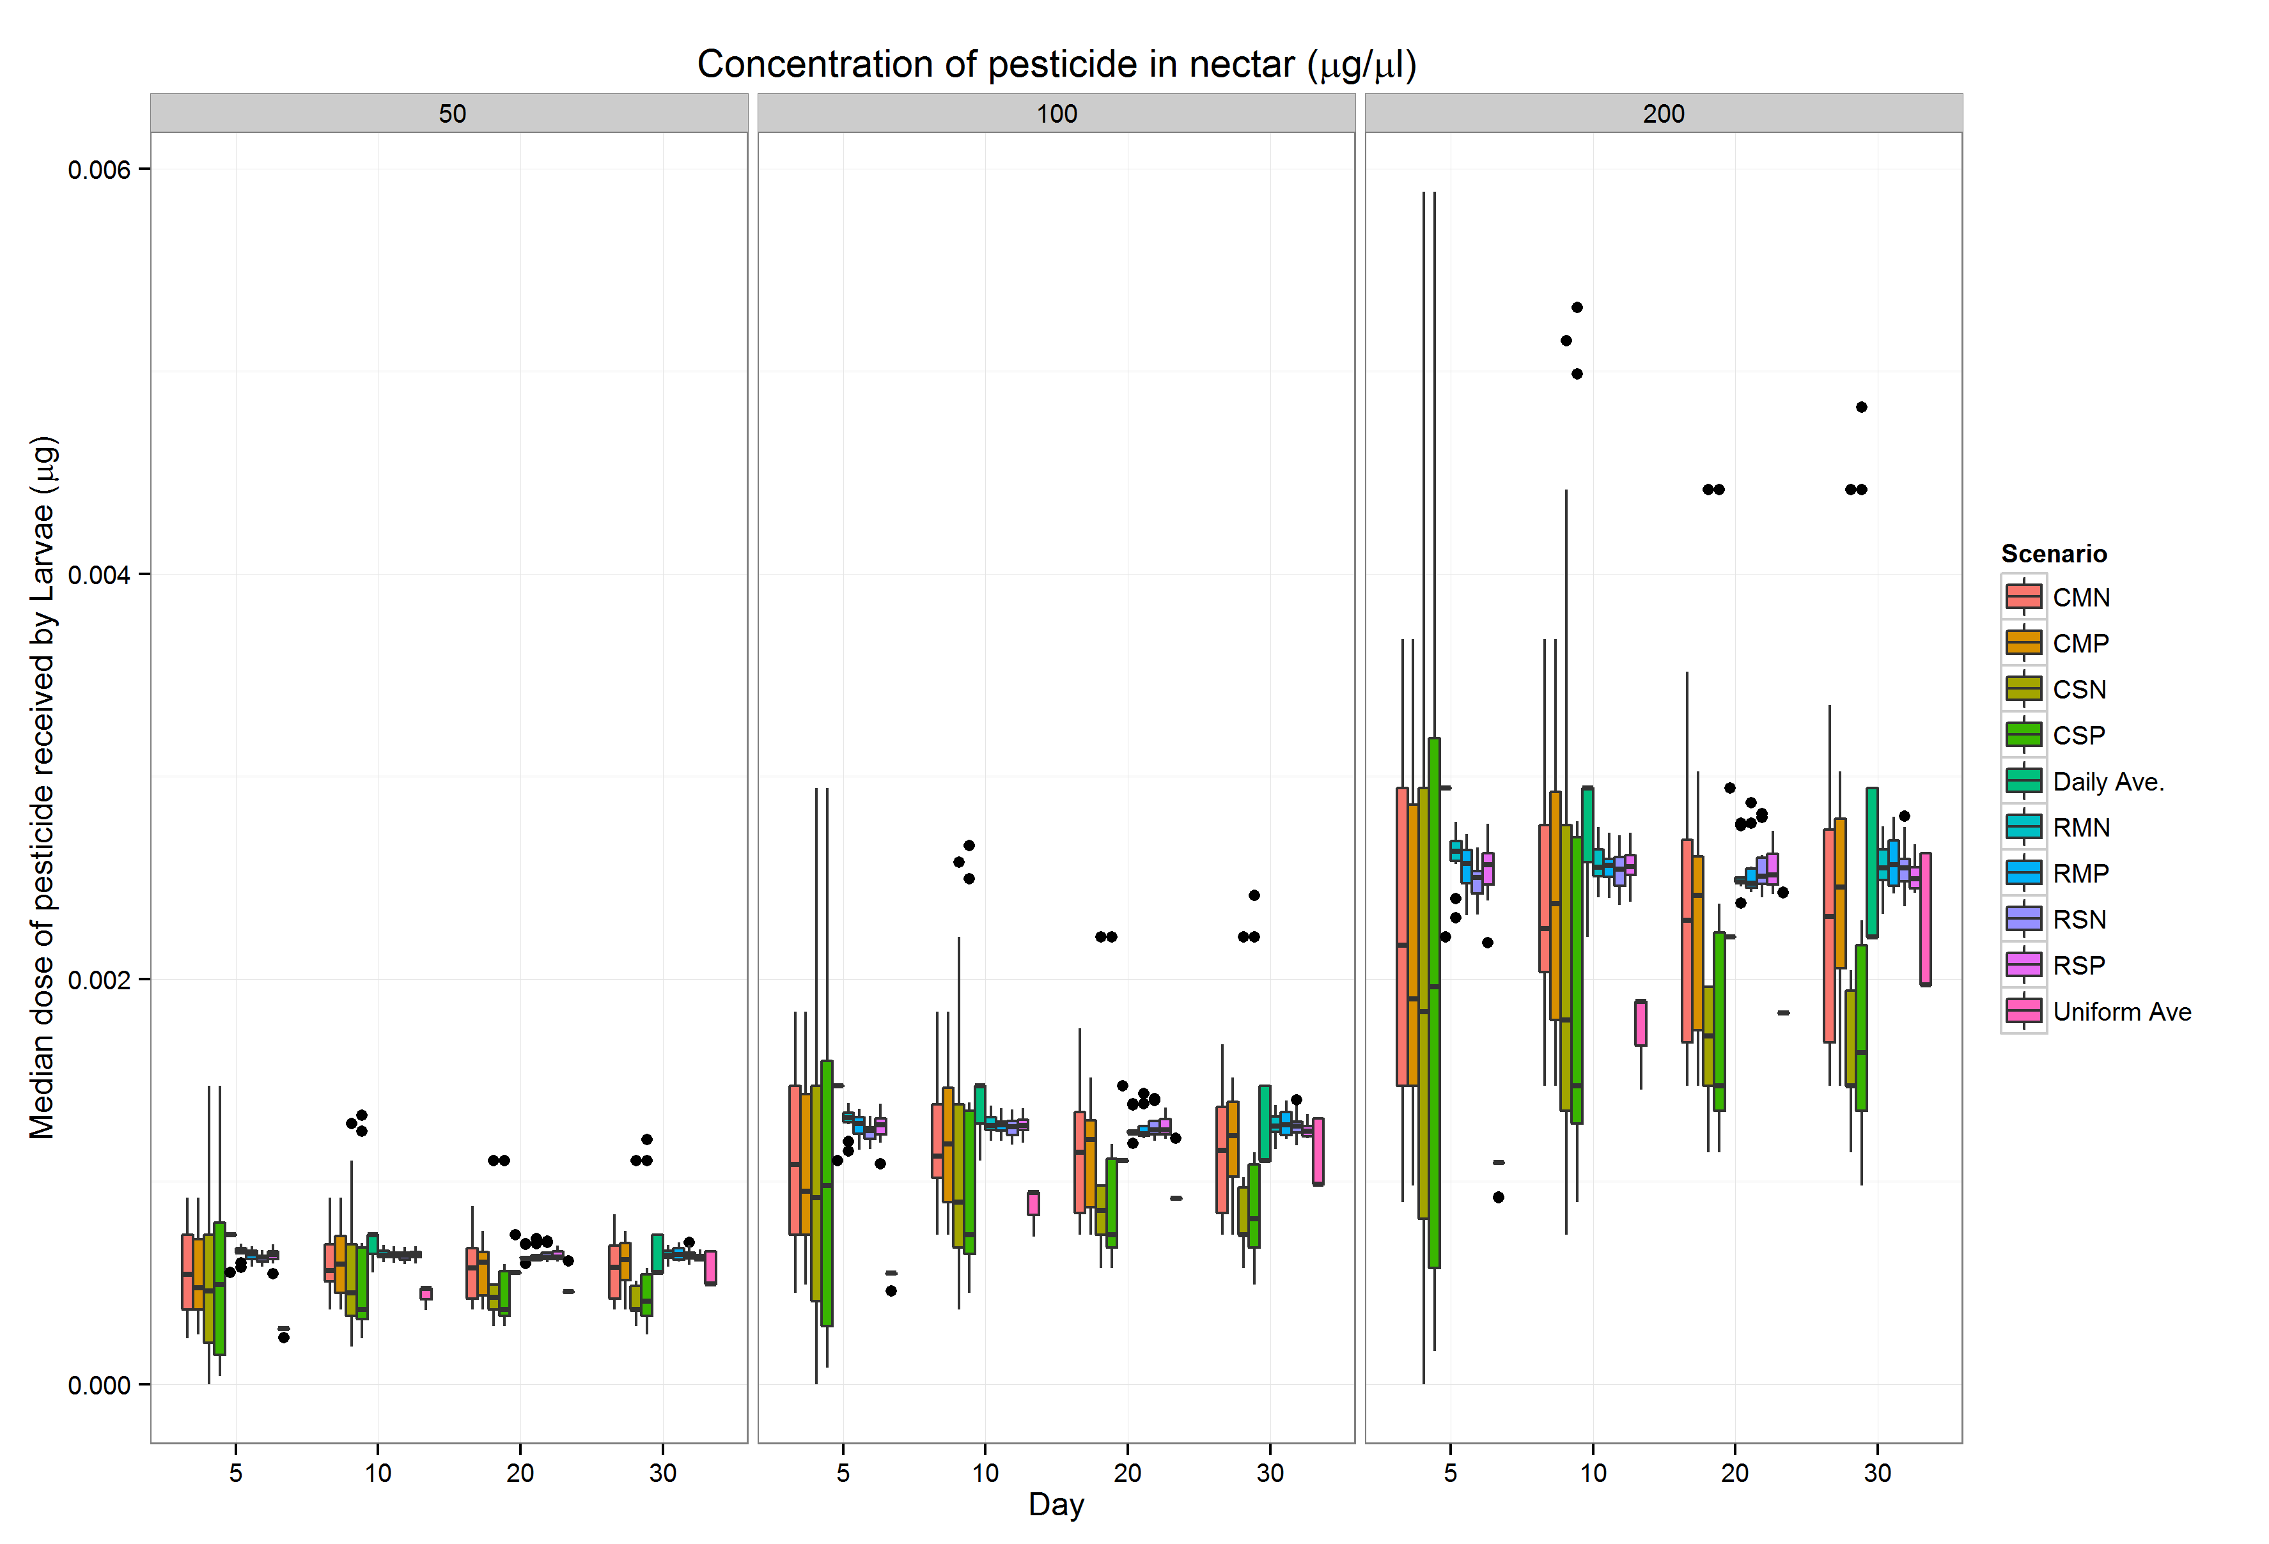

Figure S12
Boxplots of the median dose of pesticide (µg) received by the larvae in simulations with different pesticide concentrations in the treated nectar. The colors represent the scenario.

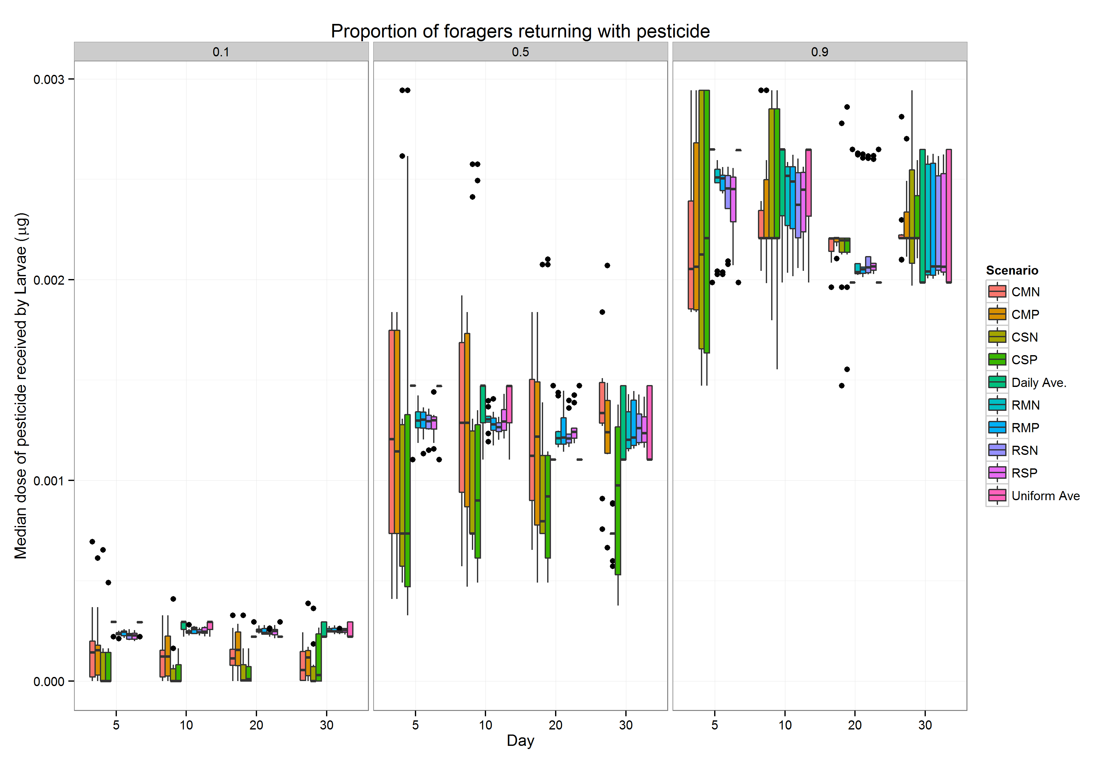

Figure S13
Boxplots of the median dose of pesticide (µg) received by the larvae in simulations with different proportions of the foraging bees returning with treated nectar. The colors represent the scenario.

Abbreviation Scenario
CSN | Clustered storage, Single transfer, No processing
CSP | Clustered storage, Single transfer, Processing
CMN | Clustered storage, Multiple transfer, No processing
CMP RSN | Clustered storage, Multiple transfer, Processing
 | Random storage, Single transfer, No processing
RSP | Random storage, Single transfer, Processing
RMN  RMP | Random storage, Multiple transfer No processing
 | Random storage, Multiple transfer, Processing
D | Daily average pesticide concentration
U | Uniform average pesticide concentration

Table S1
Abbreviations of the ten scenarios presented.

 |  |  |  |  |  |  | Day 10
 | CSN | CSP | CMN | CMP | RSN | RSP | RMN | RMP | D
CSP | 0.623  -
CMN | 0.847  - | 0.224  -
CMP | 0.639  - | 0.016  - | 0.208  -
RSN | 5.297  *** | 4.674  *** | 4.45  *** | 4.658  ***
RSP | 6.469  *** | 5.846  *** | 5.622  *** | 5.83  *** | 1.172  -
RMN | 5.581  *** | 4.958  *** | 4.734  *** | 4.942  *** | 0.284  - | 0.888  -
RMP | 6.906  *** | 6.283  *** | 6.059  *** | 6.267  *** | 1.609  - | 0.437  - | 1.325  -
D | 8.012  *** | 7.389  *** | 7.165  *** | 7.373  *** | 2.715  - | 1.543  - | 2.431  - | 1.106  -
U | 3.68  * | 3.057  - | 2.833  - | 3.04  - | 1.617  - | 2.789  - | 1.901  - | 3.226  - | 4.333  ***
 |  |  |  |  |  |  | Day 25
 | CSN | CSP | CMN | CMP | RSN | RSP | RMN | RMP | D
CSP | 0.423  -
CMN | 2.778  - | 2.355  -
CMP | 3.327  * | 2.904  - | 0.549  -
RSN | 1.762  - | 1.339  - | 1.016  - | 1.565  -
RSP | 2.073  - | 1.65  - | 0.705  - | 1.254  - | 0.311  -
RMN | 2.175  - | 1.751  - | 0.604  - | 1.153  - | 0.413  - | 0.101  -
RMP | 2.688  - | 2.265  - | 0.09  - | 0.639  - | 0.926  - | 0.615  - | 0.514  -
D | 2.847  - | 2.423  - | 0.068  - | 0.481  - | 1.085  - | 0.773  - | 0.672  - | 0.158  -
U | 1.841  - | 1.418  - | 0.937  - | 1.486  - | 0.079  - | 0.232  - | 0.333  - | 0.847  - | 1.005  -

Table S2
Detailed results from post-hoc pairwise analysis of distribution of median pesticide doses in larvae when 10% of foragers return with pesticide.
Z values of the Dunn post-hoc test are presented along with significance. p-value < 0.05 = *, < 0.01 = ** , < 0.001 = ***.

 |  |  |  |  |  |  | Day 10
 | CSN | CSP | CMN | CMP | RSN | RSP | RMN | RMP | D
CSP | 0.148  -
CMN | 2.024  - | 1.877  -
CMP | 2.355  - | 2.207  - | 0.331  -
RSN | 5.215  *** | 5.067  *** | 3.191  - | 2.86  -
RSP | 7.463  *** | 7.316  *** | 5.439  *** | 5.108  *** | 2.248  -
RMN | 5.207  *** | 5.059  *** | 3.183  - | 2.852  - | 0.008  - | 2.256  -
RMP | 7.22  *** | 7.073  *** | 5.196  *** | 4.865  *** | 2.005  - | 0.243  - | 2.013  -
D | 7.881  *** | 7.734  *** | 5.857  *** | 5.526  *** | 2.666  - | 0.418  - | 2.674  - | 0.661  -
U | 2.781  - | 2.633  - | 0.757  - | 0.426  - | 2.434  - | 4.682  *** | 2.426  - | 4.439  *** | 5.1 ***
 |  |  |  |  |  |  | Day 25
 | CSN | CSP | CMN | CMP | RSN | RSP | RMN | RMP | D
CSP | 0.429  -
CMN | 2.505  - | 2.934  -
CMP | 2.642  - | 3.071  - | 0.137  -
RSN | 1.12  - | 1.549  - | 1.385  - | 1.522  -
RSP | 0.09  - | 0.519  - | 2.415  - | 2.551  - | 1.03  -
RMN | 1  - | 1.429  - | 1.505  - | 1.642  - | 0.12  - | 0.91  -
RMP | 0.372  - | 0.8  - | 2.134  - | 2.27  - | 0.749  - | 0.281  - | 0.628  -
D | 0.309  - | 0.738  - | 2.196  - | 2.333  - | 0.811  - | 0.219  - | 0.691  - | 0.063  -
U | 1.953  - | 2.382  - | 0.552  - | 0.688  - | 0.833  - | 1.863  - | 0.953  - | 1.582  - | 1.645  -
Table S3
Detailed results from post-hoc pairwise analysis of distribution of median pesticide doses in larvae when 50% of foragers return with pesticide.
Z values of the Dunn post-hoc test are presented along with significance. p-value < 0.05 = *, < 0.01 = ** , < 0.001 = ***.
 |  |  |  |  |  |  |  | Day 10
 | CSN | CSP | CMN | CMP | RSN | RSP | RMN | RMP | D
CSP | 0.287  -
CMN | 0.647  - | 0.934  -
CMP | 0.317  - | 0.604  - | 0.331  -
RSN | 4.3 *** | 4.013  ** | 4.947  *** | 4.617  ***
RSP | 5.824  *** | 5.537  *** | 6.472  *** | 6.141  *** | 1.524  -
RMN | 4.002  ** | 3.715  ** | 4.65  *** | 4.319  *** | 0.298  - | 1.822  -
RMP | 5.794  *** | 5.507  *** | 6.442  *** | 6.111  *** | 1.494  - | 0.03  - | 1.792  -
D | 7.712  *** | 7.425  *** | 8.359  *** | 8.029  *** | 3.412  * | 1.888  - | 3.71  ** | 1.918  -
U | 0.992  - | 0.705  - | 1.639  - | 1.309  - | 3.308  * | 4.833  *** | 3.01  - | 4.802  *** | 6.72  ***
 |  |  |  |  |  |  |  | Day 25
 | CSN | CSP | CMN | CMP | RSN | RSP | RMN | RMP | D
CSP | 0.691  -
CMN | 0.249  - | 0.443  -
CMP | 1.377  - | 0.686  - | 1.128  -
RSN | 3.939  ** | 4.63  *** | 4.188  ** | 5.316  ***
RSP | 6.1 *** | 6.791  *** | 6.349  *** | 7.477  *** | 2.161  -
RMN | 3.729  ** | 4.42  *** | 3.977  ** | 5.106  *** | 0.21  - | 2.371  -
RMP | 5.77  *** | 6.461  *** | 6.018  *** | 7.146  *** | 1.83  - | 0.331  - | 2.041  -
D | 7.616  *** | 8.307  *** | 7.865  *** | 8.993  *** | 3.677  * | 1.516  - | 3.887  ** | 1.847  -
U | 2.153  - | 2.844  - | 2.401  - | 3.529  * | 1.787  - | 3.947  ** | 1.576  - | 3.617  * | 5.464  ***

Table S4

Detailed results from post-hoc pairwise analysis of distribution of median pesticide doses in adults when 10% of foragers return with pesticide.
Z values of the Dunn post-hoc test are presented along with significance. p-value < 0.05 = *, < 0.01 = ** , < 0.001 = ***.
 |  |  |  |  |  |  |  | Day 10
 | CSN | CSP | CMN | CMP | RSN | RSP | RMN | RMP | D
CSP | 0.385  -
CMN | 2.737  - | 2.352  -
CMP | 3.204  - | 2.819  - | 0.467  -
RSN | 5.543  *** | 5.158  *** | 2.806  - | 2.338  -
RSP | 7.679  *** | 7.294  *** | 4.942  *** | 4.475  *** | 2.136  -
RMN | 5.513  *** | 5.128  *** | 2.776  - | 2.308  - | 0.03  - | 2.166  -
RMP | 7.698  *** | 7.313  *** | 4.961  *** | 4.494  *** | 2.155  - | 0.019  - | 2.185  -
D | 9.34  *** | 8.955  *** | 6.603  *** | 6.136  *** | 3.797  ** | 1.661  - | 3.827  ** | 1.642  -
U | 2.128  - | 1.743  - | 0.609  - | 1.076  - | 3.415  * | 5.551  *** | 3.385  * | 5.57  *** | 7.212  ***
 |  |  |  |  |  |  |  | Day 25
 | CSN | CSP | CMN | CMP | RSN | RSP | RMN | RMP | D
CSP | 0.948  -
CMN | 1.661  - | 2.609  -
CMP | 1.243  - | 2.191  - | 0.418  -
RSN | 4.912  *** | 5.86  *** | 3.251  - | 3.669  *
RSP | 7.023  *** | 7.971  *** | 5.363  *** | 5.78  *** | 2.112  -
RMN | 4.808  *** | 5.756  *** | 3.147  - | 3.565  * | 0.104  - | 2.215  -
RMP | 7.067  *** | 8.015  *** | 5.406  *** | 5.824  *** | 2.155  - | 0.044  - | 2.259  -
D | 8.684  *** | 9.632  *** | 7.023  *** | 7.441  *** | 3.773  ** | 1.661  - | 3.876  ** | 1.617  -
U | 3.221  - | 4.169  ** | 1.56  - | 1.978  - | 1.691  - | 3.803  ** | 1.587  - | 3.846  ** | 5.464  ***

Table S5
Detailed results from post-hoc pairwise analysis of distribution of median pesticide doses in adults when 50% of foragers return with pesticide.
Z values of the Dunn post-hoc test are presented along with significance. p-value < 0.05 = *, < 0.01 = ** , < 0.001 = ***.

Appendix 2

Table S1

Parameters

Parameter | Value | unit | Reference
Size of nectar cell | 360 | µl | Schmickl and Crailsheim 2007³  Camazine 1991⁴
Size of nectar load | 14 | µl | Huang and Seeley 2003⁵  Omholt 1992⁶
Larvae daily nectar volume | 19.68 | µl | Schmickl and Crailsheim 2007³, Harbo 1993⁷.
Adult daily nectar volume | 7.92 | µl | Rortais et al. 2005⁸
Table S6
Values for model parameters.

ODD protocol
Purpose
The purpose of this model was to assess how different food storage and feeding behaviors of the honeybee affect the distribution of pesticide concentration in stored nectar, and explore how different distributions of pesticides affect the proportion of individuals (brood and adult bees) which will be exposed above a theoretical threshold (set to an arbitrary level here but which could be defined based on a pesticide’s toxicity). The model can then be used to assess the complexity required in introducing realistic in-hive pesticide exposure into an existing honeybee colony model (e.g. BEEHAVE ²⁹). In particular, we set out to compare pesticide distributions as a result of the following contrasting behaviors : i) comparing multiple transfers between foragers and receivers (M) as opposed to each forager transferring nectar to a sole receiver (S); ii) comparing when receiver bees store nectar in the comb randomly (R), versus clustering (C) iii) comparing the effect of capping the nectar cells, (as a result of processing to honey) (P) versus no capping (N). We also investigate the impact of differing proportions of foragers bringing pesticide into the colony, a simplified surrogate for pesticide exposure levels in the landscape.
The model is not intended to provide accurate estimates of the absolute values of exposure or toxic effects of pesticide within the hive, rather, it is intended to explore the differences in pesticide distributions in nectar occurring from these simplified behaviors, and therefore establish the level of complexity required for a model such as BEEHAVE ^{12,29} to ensure a conservative assessment of the risk posed by pesticides.

Entities, state variables and scales

Agents/individuals
The model contains three classes of agents: The cells of a single, one-sided hive comb, the bees and the forage patches. The cells of the hive comb are spatial units, implemented as ‘patches’ in NetLogo.
Each cell is characterized by the following state variables: 1) patch_type: patch contains nectar or a larva or is empty; 2) nectar_volume_ul: the current volume of nectar in the cell, measured in µl; 3) pesticide_concentration_uul: the concentration of pesticide in the cell, measured in µgµl⁻¹, if the cell is a nectar cell; 4) cell_nectar_concentration_ugul: the concentration of the sugar, measured in µgµl⁻¹in the nectar contained in the cell;
A single nectar load is assumed to be 14μl, within the range reported by Huang and Seeley (2003) (14.9 ± 9.8 µl)³⁰
The forage patches are characterized by the following variables: 1) nectar_concentration_ugul: the concentration of sugar in the patch, measured in µgµl⁻¹; 2) field_pesticide_concentration_ugul: the concentration of pesticide in the patch, measured in µgµl⁻¹;
Within the class of agents representing the bees, there are four types: 1) foragers; 2) receivers; 3) larvae; 4) the queen. In the rest of the manuscript, ‘adults’ represent a generalized combination of the foragers and receivers (but not nurse bees), who’s feeding requirements are assumed to be the same for simplicity. A nectar load in the model is 14μl³⁰ . This is the amount carried by the adult bees and is constant. Pupae are not considered in the model, as they do not receive nectar during pupation.

The forager bees are characterized by the following variables: 1) pesticide_amount_ug: the amount of pesticide carried by the forager, measured in µg; 2) carrying_nectar?: a Boolean value, true if the forager is still waiting to transfer nectar to a receiver; 3) carrying_2nd_nectar?: a Boolean value, true if, when multiple transfer is active, the forager is waiting to transfer the second load of nectar; 4) nectar_sugar concentration_ugul; the concentration of sugar in the nectar load carried by the forager, measured in µgµl⁻¹;
Receiver bees are characterized by the following variables: 1) pesticide_weight_ug: the amount of pesticide currently carried by the receiver, measured in µg; 2) destination: the receiver’s cell of choice in which to deposit the carried nectar load; 3) nectar sugar_concentration_ugul: the concentration of sugar in the nectar load carried by the receiver, measured in µgµl⁻¹;
Larvae are characterized by the following variables 1) age: the age of the individual in days; 2) pesticide_amount_ug: the amount of pesticide contained in the larvae, measured in µg; 3) cell_choice: the cell the larvae will be fed from.
The queen is characterized by its location on the comb, the only role of the queen in this model is creating new brood with a realistic spatial distribution.
The spatial scale of the model is set to represent a typical comb of a National bee hive³¹ assuming a frame of $34.1$ x 20.3 cm with 4.34 cells per cm². The comb consists of a grid of square cells, 80 x 40, giving 3200 cells, a reasonable estimate of the number of worker cells on one side of a frame (Camazine 1991)²¹.
The model runs in daily time steps with the foraging, receiving and feeding processes looped to implicitly represent hourly behaviors, (e.g. foraging, receiving, storage and feeding) and others happening once per day (processing).
Units
The model keeps track of pesticide and sugar as both concentrations and mass. When dealing with volumes larger than a single bee’s nectar load (such as in a nectar cell or at the forage patch) the substance is stored in the model as a concentration. When being handled by an individual, i.e. in foraging, receiving, storage and feeding, the substance is stored in the model by the mass of the substance. This facilitates the calculations required when nectar is stored or removed from a large source (cell or forage patch) and allows a practical understanding of the potential exposure of individuals to the substance within the hive (individual dose received and pesticide concentration in nectar stores). For concentrations of pesticides and sugar in the model, we use weight per volume (μg/µl). The mass of a substance is measured in μg and when discussing the movement of nectar within the hive we use volume (μl), When calculating the concentration of a substance in the cell when a nectar load is added to it, the following equation is therefore used:
(3) $\frac{\begin{aligned} \\ New Concentration in cell \left[μga.i.µl\right] = \\ \left(Concentration in cell \left[μga.i.{μl}^{-1}\right] ∙volume of nectar in cell \left[μl\right]\right)+\left(Weight in nectar load\left[μg\right]\right)\end{aligned}}{\left(volume of nectar in cell\left[μl\right]+volume of nectar load\left[μl\right]\right)}$

Process Overview and Scheduling
Time in the model is first split into days, at the beginning of the day, the ‘daily update’ procedure is called and at the end of each day nectar is processed. The main procedures of the model (Foraging, receiving storage and feeding) occur once per hour. In the real hive, there will be changes in behaviors throughout the day, however to maintain simplicity of implementation and analysis, each hour in the model is identically parameterized, although foraging and the resultant storage only occurs for a set number of hours. Within these procedures, when all agents perform an action (e.g. all receivers storing nectar) they are called at random to perform this action. Procedures are performed in the following order each day:
Daily update – Occurring at the start of each day, daily count variables are reset to 0. Larvae age, and if they are above the age threshold for pupation (by default 6 days), they are removed from the model as, in reality, they pupate and feeding ceases. Eggs are then laid in empty cells to replace the lost larvae, maintaining a constant number of larvae.
Foraging – Each hour while foraging time remains, a defined percentage of foragers are assigned, at random, to one of the two patches (treated with pesticide or non-treated). They are then given a set volume of nectar of the correct sugar and pesticide concentrations for the patch on which they foraged.
Receiving – After each foraging round, receivers take the nectar loads from foragers, chosen randomly from the population of foragers still waiting to transfer nectar. After securing a nectar load the receiver chooses a cell in which to deposit nectar, depending on the scenario either at random or according to the sugar concentration of the nectar (clustering) and deposits the nectar load in the relevant cell.
Feeding – In the real world adult nurse bees feed the larvae, however as this is the only duty to be performed by nurse bees, in this model, nurse bees are implicit in the behavior of the larvae. Feeding rates in the model do not depend on the source of the nectar, although in a real hive the sugar concentration of the nectar may lead to larvae being fed different volumes¹⁸, the sugar concentration in this model is arbitrary, and by excluding this resultant differential volume used as food we do not limit ourselves to the scenario in which the pesticide is contained in nectar with a higher sugar concentration. Conversion from weight of nectar to volume of nectar would depend on the sugar concentration of the nectar. The sugar concentration of the nectar in this model is solely used as a label to differentiate between the two nectar sources, the fact that the treated nectar has a higher sugar concentration is arbitrary. It is therefore safe to assume the volume to weight ratio of 360 µl of nectar to 500mg (0.72 µl/mg) of nectar as used by Schmickl and Crailsheim³². This ratio is for honey in their model, however nothing is lost in this assumption for nectar in this model as feeding rates are not based on the sugar concentration. Every hour, the closest cell to each larva that contains enough nectar for one feed is chosen, implicitly modelling simplified nurse bee behavior representing the empirical observation that nectar and pollen are removed from close to the larvae more frequently²¹, giving the most extreme scenario. The larvae then feed on the nectar from the relevant cell. Each hour, each larva receives 0.82µl nectar ($163.5 ∙0.72∙0.0069$- 163.5mg required to take one larva to pupation³³, 0.72 conversion to µl, 0.0069 conversion to hours ), assuming 6 days from hatching to pupation, with the conversion of mg to μl as given above. In reality the amount a larva is fed will change based on its age, as well as on the sugar concentration. We have kept the volume of nectar a larva eats constant across each day for simplicity. After the larvae have fed, the adults in the model feed, removing 0.32 µl per day¹⁸. As nurse bees are only implicit they do not feed and their exposure is not considered.
Processing – Nectar cells which are more than 95% full are ‘capped’, so they are no longer available to be fed from or deposited in, and the nectar in them is concentrated, representing the transformation to honey. In the model, this processing is simply the reduction of the volume of the nectar by 75%, maintaining the weight of pesticide in the nectar constant (based on the simplified assumption that the nectar contains 80% water ³⁴, although in reality this is variable dependent on the species and climate, and that honey contains 20% water ³⁵). As the sugar content of the capped nectar is of no consequence in this model and there is no repercussion on the exposure of the bees to the pesticide we consider this extreme simplification of the process is reasonable, acting as a placeholder for potential expansion of the model.
Initialization
At the beginning of the simulation, 150 foragers 150 receivers and 400 larvae are created. In a real brood frame, a much larger proportion of the cells could be filled with larvae during the breeding season, however a single side of a single frame is modelled here providing food for the larvae and adults. Larvae are placed in the comb so there are no more than two cells between each larva, similar to Johnson²². Initially 10% of the comb is filled with control (clean) nectar to represent that the frame has been used for brood and food storage for some time prior to a sudden pesticide-containing nectar flow. The concentration of pesticide in the nectar of the forage patch is set arbitrarily to 100 μg pesticide/µl, intentionally high to ensure pesticide reaches the in-hive bees. The model was created to test the extremes of the behaviors and not the precise movement of pesticide into the comb and will therefore not provide realistic values of pesticide in the individual bees. Instead an arbitrary value allows us to focus on how the different behaviors alter how the pesticide moves through the hive and the resulting heterogeneity of pesticide residues in nectar, adults and brood to evaluate which, if any of the extremes would be the worst-case scenario in terms of risk of exceeding a given toxicity threshold. The sugar concentration of the nectar acts purely as a label as to the source of the nectar, as there is some evidence that nectar could be clustered together based on sugar concentration²⁴. This difference in sugar concentration between nectar from the two patches serves only to test receiver bee behavior; in reality the sugar concentration will be highly dependent on species and climate.
In this model, the pesticide does not dissipate and is not metabolized in the individual bees, e.g. during feeding of larvae. Dissipation and metabolism would be highly product specific and could greatly reduce the exposure of individuals to pesticide, by leaving it out from the model we ensure a conservative estimate of the exposure and maintain generality.

Design Concepts

Basic Principles
The basic principles of the model are those regarding the food storage, processing and feeding behaviors of the honeybee. The deposition of nectar in the comb has been reported,
or modelled in the past, as a random process¹⁵or by
following rules leading to a global pattern ¹⁶. Yet others, have demonstrated that the concentration of sugar in the nectar could affect how nectar from different sources is
stored ¹⁷. Multiple transfer of nectar from foragers to receivers has been
shown in numerous studies^{18,19}, with 1.9 – 2.7 transfers being a representative number of transfers, and has the effect
of supplying increased information to foragers about the state of the colony¹⁹while also potentially mixing nectar from different sources, increasing homogeneity of any pesticides being brought into the hive.

Emergence
The distribution of pesticide concentrations in the honey cells and in the larvae emerge from the foraging, storage and feeding procedures.

Adaptation
As nectar is brought into the hive and is stores receiver bees, if storing nectar in clusters, will ensure that they store nectar in or next to cells containing nectar of the same nectar concentration.

Sensing
Individuals are aware of the nectar quantity and quality (i.e. sugar concentration) in the honey cells on a global scale. They are also able to sense distance, allowing them to choose the nearest cell to store nectar in or take nectar from or to place nectar of similar concentrations together.

Interaction
There are three sources of interaction in the model: (1) between receivers and foragers when nectar is transferred, (2) between receivers and cells where nectar is deposited, and (3) between the larvae and the cells when the larvae feed.

Stochasticity
In one of the scenarios, the receiver bees place nectar at random in the comb as opposed to placing nectar near other nectar of similar sugar concentrations already in the comb. The location of nectar in the comb upon initialization is stochastic. The precise layout of brood in the comb upon initialization is affected by randomized cell choices made by the queen.

Observation
The outputs from the model are the values for the pesticide amount in each larvae and pesticide concentration in each hive cells on each day. For each patch, due to nectar processing into honey, increasing the sugar and pesticide concentration as water is removed, pesticide amount per mg of sugar in the nectar/honey will also be recorded.

Initialization
At the beginning of the simulation, 150 foragers 150 receivers and 400 larvae are created. In a real brood frame, a much larger proportion of the cells could be filled with larvae during the breeding season, however a single side of a single frame is modelled here providing food for the larvae and adults. Larvae are placed in the comb so there are no more than two cells between each larva, similar to Johnson²². Initially 10% of the comb is filled with control (clean) nectar to represent that the frame has been used for brood and food storage for some time prior to a sudden pesticide-containing nectar flow. The concentration of pesticide in the nectar of the forage patch is set arbitrarily to 100 μg pesticide/µl, intentionally high to ensure pesticide reaches the in-hive bees. The model was created to test the extremes of the behaviors and not the precise movement of pesticide into the comb and will therefore not provide realistic values of pesticide in the individual bees. Instead an arbitrary value allows us to focus on how the different behaviors alter how the pesticide moves through the hive and the resulting heterogeneity of pesticide residues in nectar, adults and brood to evaluate which, if any of the extremes would be the worst-case scenario in terms of risk of exceeding a given toxicity threshold. The sugar concentration of the nectar acts purely as a label as to the source of the nectar, as there is some evidence that nectar could be clustered together based on sugar concentration²⁴. This difference in sugar concentration between nectar from the two patches serves only to test receiver bee behavior; in reality the sugar concentration will be highly dependent on species and climate.
In this model, the pesticide does not dissipate and is not metabolized in the individual bees, e.g. during feeding of larvae. Dissipation and metabolism would be highly product specific and could greatly reduce the exposure of individuals to pesticide, by leaving it out from the model we ensure a conservative estimate of the exposure and maintain generality.

Input
The model does not rely on inputs from files or other models; the environment in the model is simple with just two food patches providing constant food.

Sub Models
There are four main procedures in the model, the foraging procedure, the receiving procedure, the processing procedure and the larval feeding procedure.

Foraging Procedure
All foragers are assigned to the control patch initially, and are given a nectar load with no sugar and the control sugar concentration. To simulate a treated patch being visited by a proportion of the foragers (default 0.25) that proportion of the foragers are chosen at random and their nectar variables are altered to represent the treated patch sugar concentration and pesticide amount. Real foraging in the honeybee colony is complicated and beyond the scope of this model if it was to be captured fully, this submodel is therefore simplified to the requirements of the model.
Receiving Procedure
After the foraging procedure, all the foragers are carrying a nectar load and queuing for the receiver bees. Each receiver bee then selects a forager from the population of foragers still carrying nectar. The receiver then takes the nectar from this forager, setting the sugar concentration and pesticide amount of its nectar load to that of the foragers. If multiple transfer is under investigation, two different foragers may be visited by the same receiver Gregson et al 2003). The pesticide amounts from each forager are halved as it is assumed that both foragers transfer equal volumes. And the final nectar concentration is calculated as the sum of the individual concentrations each multiplied by half the volume of a nectar load divided by the volume of a nectar load. The receiver bees then store the nectar in the comb. If the receivers are set to act randomly, each receiver selects a cell at random, with enough room for a nectar load, to deposit their nectar load into, if they are acting non-randomly, they select a cell at random from all cells containing nectar with the same sugar concentration as their nectar load (± a range) and empty cells surrounding these. The receiver then moves to their chosen cell and add their nectar quantity to it and add their pesticide amount to the existing pesticide amount which is then divided by the new total quantity of nectar to give a concentration.

Processing Procedure
If nectar processing is enabled, when a nectar cell is more than 95% full, it will be processed to honey. Both the sugar concentration and the pesticide concentration will increase. Once the process is complete, the cell may be capped and removed from the possible cells for use by storing receivers or larvae, but counted in the measure of pesticide in the hive. Nectar is assumed to be 80% water (high estimate) and honey will be defined as 20% water. Therefore as a conservative estimate we can assume that the nectar loses 75% of its volume.

Feeding procedure
Each larvae selects the closest cell containing enough nectar for one feed to itself. From Harbo et al 2003, it takes 163.5mg of nectar to raise a larvae to adulthood, and, assuming as in Schmickl and Crailsheim 2007³, a cell can hold 500mg of nectar or 360µl, so it takes 117.72 of nectar to raise a larvae to adulthood. This value is divided by 6, the number of days a larvae exists in the model and then by 24 as the larvae are fed hourly, giving an hourly larval feeding amount of 0.82µl. The larvae takes an amount of pesticide equal to the pesticide concentration in the cell * 0.82 * 0.000001, to give the pesticide amount per larval hourly feeding amount in L.
Nectar is also removed from the comb to represent adult bee feeding. For each forager and receiver, each hour 0.33 µl are removed (calculated from a daily adult feeding amount of 11mg). As nurse bees are only implicit they do not feed and their exposure is not considered. This removal takes place randomly, with cells being chosen at random and nectar removed at random until enough removal has taken place.

(1) Ceriani, L.; Verme, P. The origins of the Gini index: extracts from Variabilità e Mutabilità (1912) by Corrado Gini. J. Econ. Inequal. 2011, 10 (3), 421–443.
(2) Moran, P. A. P. Notes on Continuous Stochastic Phenomena. Biometrika 1950, 37 (1/2), 17–23.
(3) Schmickl, T.; Crailsheim, K. HoPoMo: A model of honeybee intracolonial population dynamics and resource management. Ecol. Modell. 2007, 204 (1-2), 219–245.
(4) Camazine, S. Self-organizing pattern formation on the combs of honey bee colonies. Behav. Ecol. Sociobiol. 1991, 28 (1).
(5) Huang, M. H.; Seeley, T. D. Multiple unloadings by nectar foragers in honey bees: a matter of information improvement or crop fullness? Insectes Soc. 2003, 50 (4), 330–339.
(6) Omholt, S. W. (Norges L. A. (Norway). I. for H. The heuristic value of mathematical modelling for elucidation of the honey production dynamics of Apis mellifera colonies. Nor. J. Agric. Sci. 1991.
(7) Harbo, J. R. Effect of brood rearing on honey consumption and the survival of worker honey bees. J. Apic. Res. 1993, 32 (1), 11–17.
(8) Rortais, A.; Arnold, G.; Halm, M. P.; Touffet-Briens, F. Modes of honeybees exposure to systemic insecticides: estimated amounts of contaminated pollen and nectar consumed by different categories of bees. Apidologie 2005, 36 (1), 71–83.
(9) Becher, M. A.; Grimm, V.; Thorbek, P.; Horn, J.; Kennedy, P. J.; Osborne, J. L. BEEHAVE: a systems model of honeybee colony dynamics and foraging to explore multifactorial causes of colony failure. J. Appl. Ecol. 2014, 51 (2), 470–482.
(10) EFSA Panel on Plant Protection Products and their Residues (PPR). Statement on the suitability of the BEEHAVE model for its potential use in a regulatory context and for the risk assessment of multiple stressors in honeybees at the landscape level. EFSA J. 2015, 13 (6), 4125.
(11) British Standard Bee Hive Frame Dimensions http://www.dave-cushman.net/bee/bsframedimensions.html.
(12) Harbo, J. R. Effect of brood rearing on honey consumption and the survival of worker honey bees. J. Apic. Res. 2015.
(13) Potts, S. G.; Vulliamy, B.; Roberts, S.; O’Toole, C.; Dafni, A.; Ne’eman, G.; Willmer, P. G. Nectar resource diversity organises flower-visitor community structure. Entomol. Exp. Appl. 2004, 113 (2), 103–107.
(14) Frankel, S.; Robinson, G. E.; Berenbaum, M. R. Antioxidant capacity and correlated characteristics of 14 unifloral honeys. J. Apic. Res. 2015.
(15) Montovan, K. J.; Karst, N.; Jones, L. E.; Seeley, T. D. Local behavioral rules sustain the cell allocation pattern in the combs of honey bee colonies (Apis mellifera). J. Theor. Biol. 2013, 336, 75–86.
(16) Johnson, B. R. Pattern formation on the combs of honeybees: increasing fitness by coupling self-organization with templates. Proc. Biol. Sci. 2009, 276 (1655), 255–261.
(17) Greco, M. K.; Lang, J.; Gallmann, P.; Priest, N.; Feil, E.; Crailsheim, K. Sugar concentration influences decision making in Apis mellifera L . workers during early-stage honey storage behaviour. 2013, 3 (3), 210–218.
(18) Kirchner, W. H.; Lindauer, M. The causes of the tremble dance of the honeybee, Apis mellifera. Behav. Ecol. Sociobiol. 1994, 35 (5), 303–308.
(19) Hart, a. G.; Ratnieks, F. L. W. Why do honey-bee (Apis mellifera) foragers transfer nectar to several receivers? Information improvement through multiple sampling in a biological system. Behav. Ecol. Sociobiol. 2001, 49 (4), 244–250.

