Heteroatom-doped porous carbons with enhanced carbon dioxide uptake and excellent methylene blue adsorption capacities

Binling Chen ª, Zhuxian Yang ª, Guiping Ma ^{a,b}, Dali Kong ª, Wei Xiong ^{c}, Jinbo Wang ^{c}, Yanqiu Zhu ª, Yongde Xia ^{a*}
ª College of Engineering, Mathematics and Physical Sciences, University of Exeter, Exeter
EX4 4QF, United Kingdom
^{b} State Key Laboratory of Chemical Resource Engineering, Beijing Laboratory of Biomedical Materials, Beijing University of Chemical Technology, Beijing 100029, PR China
^{c} School of Chemistry and Chemical Engineering, Chongqing University of Science and
Technology, Chongqing, P. R. China

Corresponding Author
*E-mail: y.xia@exeter.ac.uk
ABSTRACT
Heteroatom nitrogen and oxygen-doped porous carbon materials were for the first time generated via a one-pot carbonization of metal-organic framework under argon saturated water steam at an elevated temperature. The water steam carbonization of metal-organic frameworks is a novel approach to generate carbon materials with large pore volumes, high surface areas, abundant nitrogen content and enhanced oxygen-containing functional groups. The resulting porous carbon materials exhibited excellent performance in both the carbon dioxide uptake and methylene blue removal from wastewater. A carbon dioxide uptake capacity of 4.00 mmol g⁻¹ at room temperature and a methylene blue adsorption capacity of 98.5% can be achieved. This report offers an alternative strategy to develop metal-organic-frameworks-derived porous carbon materials with new functionalities to meet the specific needs in various adsorption applications.

1. Introduction
Global warming and water pollution are currently amongst the major environmental challenges, which have attracted intensive worldwide research attentions. The efforts to effectively reduce CO₂ emission and remove pollutants from industrial wastewater demand the utilization of advanced functional materials. Porous carbon materials are excellent candidates which have been widely used for decades in water purification, gas storage and separation [1-5]. Various approaches have been developed to generate different carbon materials, including pyrolysis of wood or coal [6], etching of metal carbides [7], sol-gel processing [8], and template methods [5, 9]. It has been considered that the template method is very promising, as it allows to produce the desirable and controllable features in the resulting carbon materials [10]. Zeolites, porous silicas and aluminosilicates are traditional inorganic templates. Combined with the use of different carbon precursors, such as propylene and furfuryl alcohol, various porous carbon materials can be generated via a hard template approach [11-14].
As a new class of inorganic-organic crystalline porous materials [15, 16], Metal Organic Frameworks (MOFs) possess high surface areas, large pore volumes and various building units, and have emerged as ideal precursors and sacrificial templates for the generation of metal-free carbon materials [17-24]. Zeolitic Imidazolate Frameworks (ZIFs) possess the characteristics of both zeolites and MOFs, therefore are promising templates/precursors for the production of porous carbon materials. For instance, using ZIF-8 as the template and carbon precursor, and furfuryl alcohol as the second carbon source, Xu’s group first reported the generation of nanoporous carbon materials [24]. Later, Yamauchi’s [20, 25] and Xia’s [17] groups modified the process and achieved similar results by a direct carbonization of ZIF at elevated temperatures and under inert gas atmosphere without using any other external carbon sources. In these processes, nanostructured porous carbon with a narrow pore size distribution and a high surface area can be generally obtained from the parental ZIF material [17, 20, 25].
Lightweight heteroatoms doped on the surface of porous carbon materials is a facile approach to induce electron deficiency and increase the polarity of carbon frameworks without compromise their porosities, resulting in remarkable changes of their properties and applications. In particular, the introduction of heteroatoms such as nitrogen and oxygen into carbonaceous materials is an effective approach to modify the local elemental composition of host materials. Their catalytic performance can be consequently improved by breaking electro-neutrality and modulating the electronic properties of graphitic materials. Moreover, their catalytic performance can be also improved by tailoring their surface chemistry and creating charged sites favourable for adsorption [26]. It is reported that the heteroatom types, heteroatom contents and lattice structures in the carbon materials can all remarkably influence the sorption and catalytic performances of the materials [26].
Heteroatom nitrogen or oxygen can be generally introduced into porous carbons via carbonization of nitrogen-containing or oxygen-containing carbon precursors. The presence of N-rich organic imidazolate unit as its integral part in porous ZIFs provides a unique approach to readily produce N-doped porous carbon materials [17, 20, 25]. Water steam can be functioned as a weak oxidizing agent to efficiently activate porous carbons [27] and it can potentially introduce oxygen-containing functional groups onto the surface of porous carbons. To the best of our knowledge, the report on the use of water steam in the synthesis of porous carbon materials derived from ZIFs is rare, which provides a novel strategy to generate functional porous carbon materials.
In this study, the preparation of heteroatoms N and O co-doped porous carbon materials via one-pot carbonization of parental ZIF-8 in water steam atmosphere was investigated. The effect of synthesis conditions on the oxygen and nitrogen contents, the structures and textural properties of the carbon materials was analyzed. The applications of the generated N, O-codoped porous carbons in CO₂ uptake and removal of methylene blue from wastewater were evaluated and the observed results were elucidated.

2. Experimental
We used zinc nitrate hexahydrate and 2-methylimidazole to synthesize the ZIF-8 template [28]. We then used 0.25 g ZIF-8 to prepare the porous carbon materials in a tube furnace at 800 °C. A set of three samples was prepared under different conditions. Sample A was generated in Ar saturated water vapor with a flow rate of 20 ml/min at 800 ºC for 3 hours. Sample B was prepared constantly in Ar saturated water vapor with a flow rate of 20 ml/min throughout the heating up step, the maintaining at target temperature (800 ºC/3 hours) step and the cooling down step. Sample C was prepared under Ar atmosphere without water steam at 800 ºC for 3 hours. All the powders were washed with 1 mol L⁻¹ HCl at room temperature for three times, followed by washed with distilled water until achieving the neutral pH value. The yield of the water vapor synthesized sample is around 35 wt%.
X-ray diffraction (XRD) profiles were measured at a 0.02º step size and a 1 s step time under a Cu Kα radiation (40 kV-40 mA). Raman spectra were recorded using a 532 nm laser excitation under laser power of 6 mW in the backscattering arrangement. Transmission electron microscopy (TEM) images were received on a JOEL-2100 at 200 kV, using powdered sample dispersed on a holey carbon Cu grid. Thermogravimetric analysis (TGA) was measured by a TA SDT Q600 machine coupled with an Hiden QGA gas analysis mass spectrometer (MS) in the exhaust emission, operated from room temperature to 800 ºC, at a heating rate of 10 ºC/min and under an air flow rate of 100 ml/min. Volumetric N₂ gas sorption, as well as the CO₂ uptake measurement, was measured by a Quantachrome Autosorb-iQ machine. Prior to the analysis, the powder sample was evacuated at 200 °C for 3 h. The textural features were determined based on N₂ sorption at -196 °C. The micropore surface area and micropore volume of samples were obtained via t-plot analysis of the N₂ sorption data. The CO₂ uptake was measured at 0 and 25 °C. The Brunauer-Emmett-Teller (BET) method was used to work out the surface areas based on the adsorption data of P/Po in the range of 0.02-0.22, and the total pore volume was obtained from adsorption data at P/Po ca. 0.99. X-ray photoelectron spectroscopy (XPS, Kratos AXIS ULTRA spectrometer) was used to analyze the surface functional groups. It has a mono-chromated Al KR X-ray source (1486.6 eV), with a 15 kV anode potential and a 10 mA emission current.
To evaluate the adsorption capacities of the resulting materials for methylene blue (MB), 20 mg of the as-prepared porous carbon sample was added into a 100 mL of 20 ppm MB water solution under magnetic stirring. During the adsorption process, small amount of suspension sample was taken out at intervals and the concentration of MB was assessed using a UV-vis spectrophotometer.

3. Results and discussion
The structure of ZIF-8 precursor is firstly checked by XRD (Fig. S1a), and the parental ZIF-8 demonstrates the zeolite-type sodalite structure. The XRD patterns for the as-synthesized porous carbons (Fig. 1a) show two typical broad peaks at 2θ = 23º and 43º, which are assigned to the (002) peak of graphitic carbon and the (101) peak that is related to the honeycomb lattice in single-layer graphene [29]. The broadness of the (002) peaks and the low intensity of the (101) peaks indicate these carbon materials are basically amorphous. Raman spectra of the samples (Fig. 1b) clearly display two featured broad bands at 1366 cm⁻¹ (D band) and 1593 cm⁻¹ (G band). The D band is related to the defected carbon, while the G band results from the graphitic in-plane vibrations of ideal sp² carbons [22]. The value of I_{D}/I_{G} provides a useful index to compare the crystallinity of carbon materials [30]. The I_{D}/I_{G} value of carbon A, B and C from Raman measurements is 1.12, 1.15 and 1.09 respectively, indicating these porous carbons are not very well crystalized [20]. The I_{D}/I_{G} value is in good agreement with XRD results. Comparing the I_{D}/I_{G} value among those three samples, it suggests that water steam can generate extra defects in carbon samples, and longer water steam treatment results in a higher amount of defects in carbon materials.

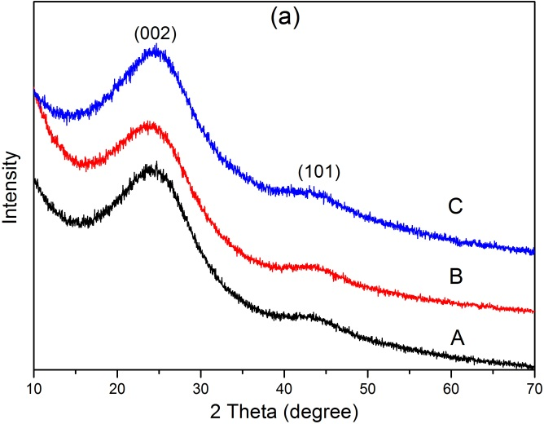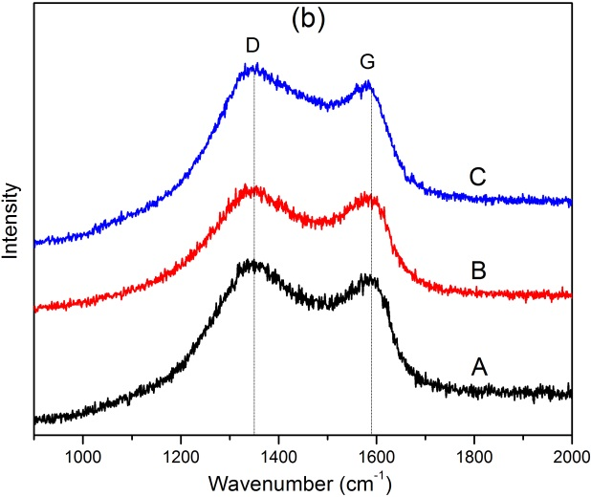
Fig. 1. (a) Powder XRD patterns and (b) Raman spectra of the Sample A, B and C.
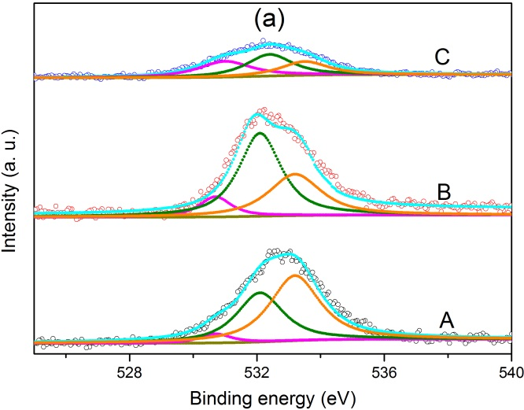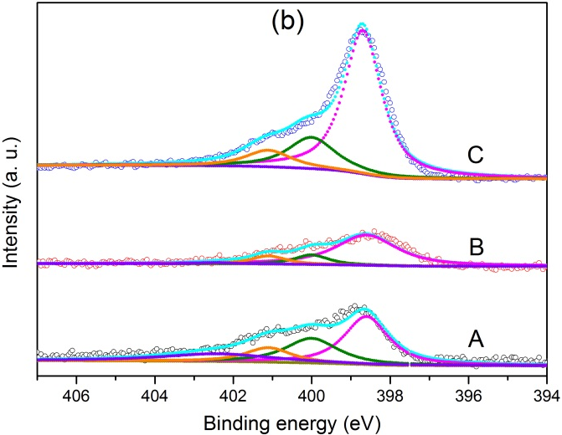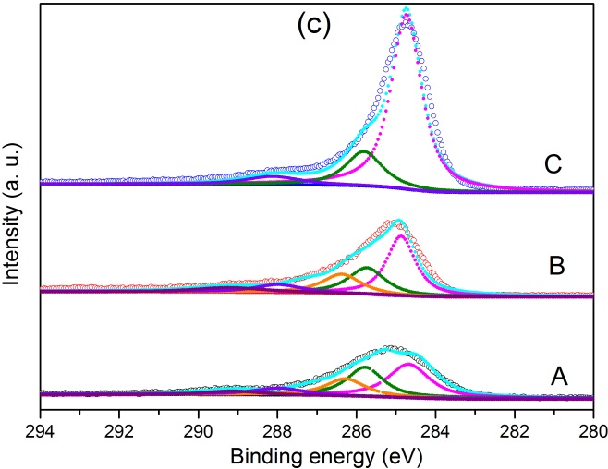
Fig. 2. XPS results of (a) O 1s, (b) N 1s and (c) C 1s of the as-synthesized carbon materials.
The XPS spectra (Fig. 2) clearly show the presence of element O, N and C in all the as-synthesized carbon materials. The O 1s spectra (Fig. 2a) can be deconvoluted into three peaks centred at 530.7, 532.1 and 533.2 eV, corresponding to the functional groups of HO-C=O, C=O and C-OH respectively [31], implying the presence of different O-containing functional groups. It is worth noting that the O 1s peak intensity of sample A and B is higher than that of sample C, suggesting the water steam treatment is beneficial to the increasing in oxygen content, which is consistent with the elemental analysis results (shown in Table 1). N 1s spectra (Fig. 2b) can be deconvoluted into four peaks at binding energy of approximately 398.6, 400.0, 401.1 and 402.4 eV, which can attribute to pyridinic N, pyrrolic N, graphitic N and N-O respectively [32]. The C 1s spectra (Fig. 2c) show the deconvoluted peaks at binding energy of 284.6, 285.4, 286.8 and 288.1 eV, corresponding to the presence of C=C, C-N, C-OH and C=O respectively [32, 33]. The elemental analysis results of all the samples are shown in Table 1. Both sample A and B show much higher O content than that of sample C and actually the oxygen content in sample A and B is 2 and 2.5 times of that in sample C, indicating water steam treatment significantly increases the amount of oxygen species into the resulting carbon materials. On the other side, N content in the water steamed samples is remarkably reduced and the N content level in samples A and B is only 66% and 48% of that in sample C. This is probably due to the high volatility of N species in water steam environment at high temperature. In addition, as presented in Table 1, both the O and N contents of all the carbon materials measured from XPS and EDX are very close, suggesting the homogenous dispersion of O and N species in all the studied samples.
Table 1 Textural properties, the content of composition, CO₂ uptake and MB adsorption capacities of carbon materials derived from different conditions.
Sample | Water steam condition | Nitrogen contentª /wt % | Oxygen contentª / wt % | Surface area^{b} / m² g⁻¹ | Pore volume^{c}  / cm³ g⁻¹ | CO₂ uptake^{d}  / mmol g⁻¹ | MB adsorption after 4 hr / %
A | Short time | 11.5  (11.4) | 11.2 (13.3) | 1465 (1324) | 0.79 (0.61) | 4.00  (6.43) | 94
B | Long time | 8.3  (7.9) | 13.8 (15.0) | 1694 (1509) | 1.02 (0.69) | 3.68  (6.05) | 98
C | N/A | 17.4  (15.4) | 5.5 (4.7) | 1049 (964) | 0.55 (0.45) | 3.35  (5.07) | 19
ª The data are obtained from EDX, while the value in parenthesis are obtained from XPS analysis.
^{b} The data in parenthesis are microporous surface area.
^{c} The data in parenthesis are microporous pore volume.
^{d} The data are obtained at 25 ºC and 1 bar, while the value in parenthesis are obtained at 0 ºC and 1 bar.

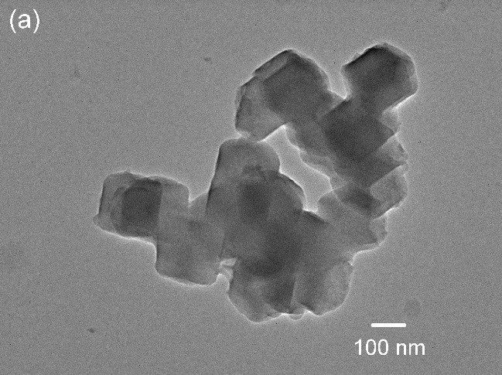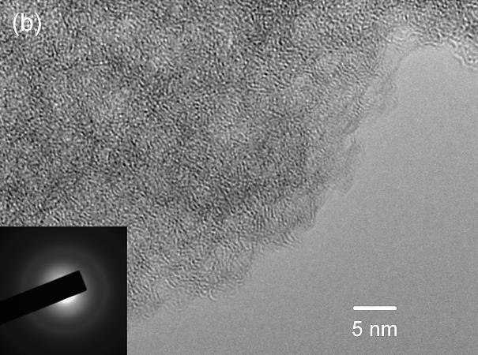
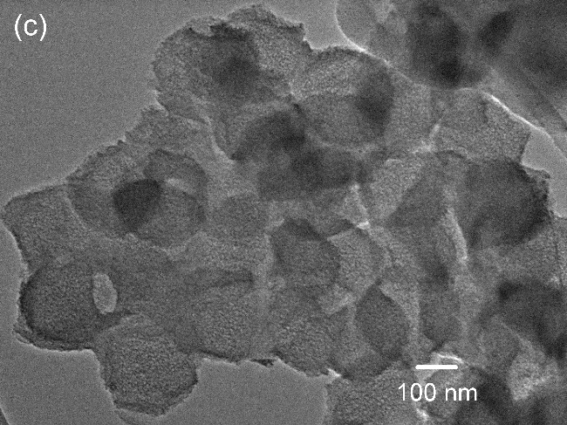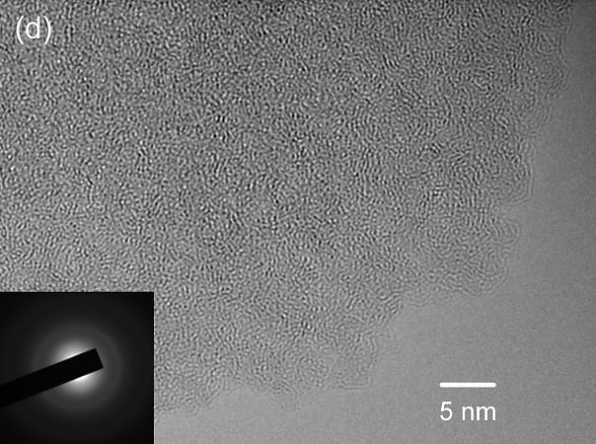
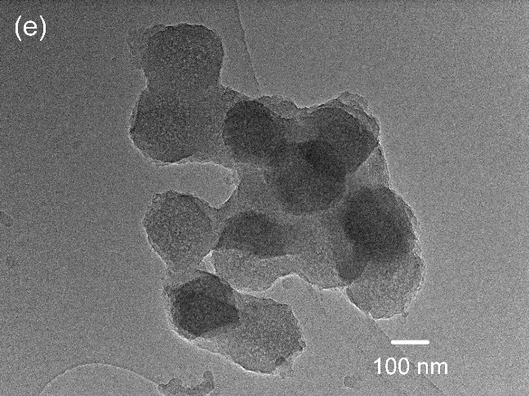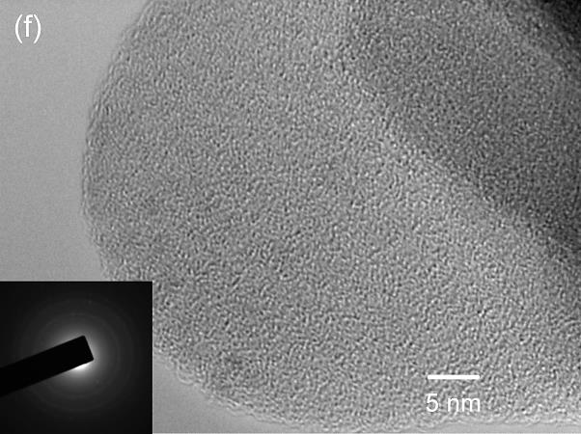
Fig. 3. TEM images of the carbon material A (a and b), B (c and d) and C (e and f).
The morphologies of the resulting materials are measured by TEM analysis. The parental ZIF-8 precursor shows the typical rhombic dodecahedron with particle sizes of 100-150 nm (Fig. S1b). All the carbon samples exhibit spherical-like particles with smaller sizes around 100-130 nm, and the small carbon particles tend to have agglomerations (shown in Fig. 3). Under high resolution, as shown in Fig. 3b, d and f, some pore channels in the carbon domains are distinguishable. In addition, the selected area electron diffraction patterns (SAED) (inset in Fig. 3b, d and f) of samples also confirm the carbon samples are amorphous.
The textural properties of the as-synthesized carbon samples are analyzed and the results are summarized in Table 1. As shown in Fig. 4a, the N₂ sorption of the materials all exhibit combined type I with type IV isotherms at varied relative pressure range. The adsorption–desorption isotherm branches are irreversible, with hysteresis loops between their adsorption and desorption branches. The hysteresis loops suggest the formation of mesoporous structures. Sample A, B and C has a specific surface area of 1465, 1694 and 1049 m² g⁻¹ and pore volume of 0.79, 1.02 and 0.55 cm³ g⁻¹, respectively. Comparing with sample C, samples A and B exhibit a 40-61% increase in specific surface area and up to 1.8 times improvement in pore volume, indicating water steam can significantly improve the surface area and pore volume of the resulting carbon materials. Moreover, all the carbon materials show high micropore surface areas (964–1509 m² g⁻¹) and micropore volumes (0.45–0.69 cm³ g⁻¹), which contribute to 90-92% and 68-82% of their total surface area and total pore volume, respectively. Based on N₂ adsorption branch data, the pore size distribution (PSD) is further analyzed using a Non-Local Density Functional Theory (NLDFT) model. As shown in Fig. 4b, all the carbon materials exhibit a relative sharp PSD centred at 1.2 nm. The formation of supermicropores in the range of 1.3–2.0 nm can also be observed for all the carbon samples. Another broad PSD centred at 4.0 nm for samples A and B suggests the presence of mesopores. In addition, both the levels of supermicropores and mesopores increase under the water steam processing condition. Longer water steam process results in dramatically increase in the supermicropores and mesopores formation. Combined with N₂ sorption isotherms analysis and PSD results, it can be concluded that the water steam processing can not only affect the surface area and pore volume, but also change the pore diameters of the resulting carbon materials. This may be due to the fact that during the carbonization process, water steam functions as an activating agent to produce extra pores and increase the oxygen content in the resulting carbon materials A and B, and consequently improve their textural properties.

Fig. 4. (a) N₂ sorption isotherms curves of Sample A, B and C, and (b) their corresponding pore size distribution curves.

As shown in Fig. 5a of the TGA curves, all the samples exhibit a small weight loss event below 100 ºC, corresponding to the removal of adsorbed water (Fig. 5d). In addition, the TGA curves of all the samples show a single weight loss event centred at around 540 ºC, which arises from the burn-off of the oxygen-containing, nitrogen-doped carbon species in air, as confirmed by the emission of CO₂, H₂O and trace amount of NO₂ in their MS signals (see Fig. 5b, c and d).

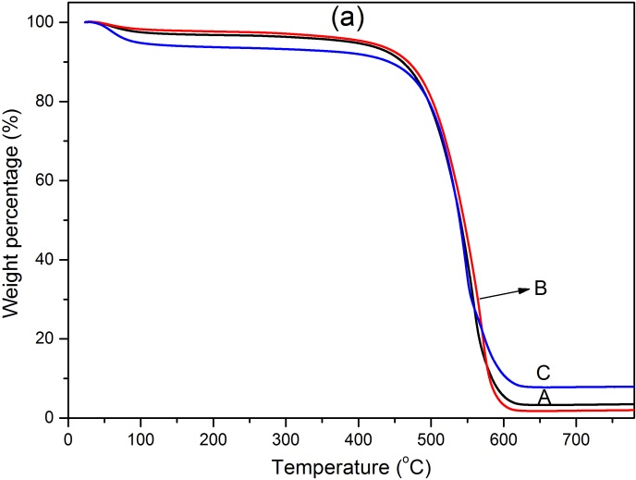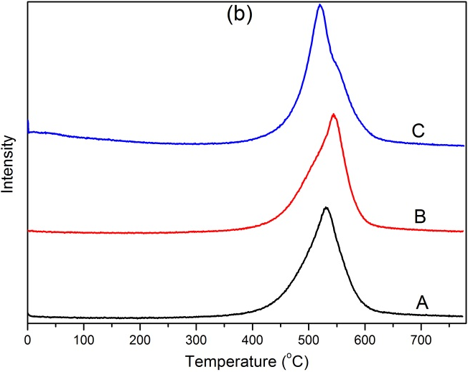
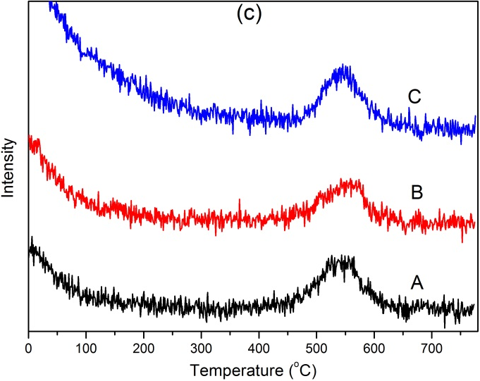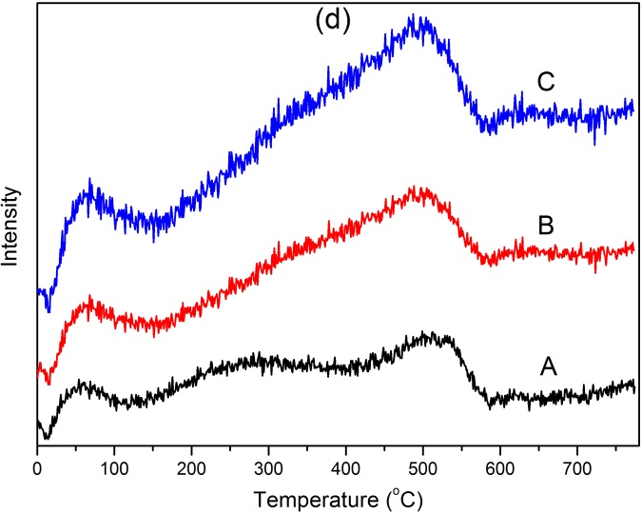
Fig. 5. (a) TGA curves of Sample A, B, and C, and their corresponding MS curves for (b) CO₂, (c) NO₂ and (d) H₂O.

CO₂ adsorption capacities at 25 ºC for all the porous carbon samples are presented in Fig. 6a and the value of CO₂ uptake capacities at 1 bar are summarized in Table 1. It is worth noting that the CO₂ adsorption data is highly reproducible, almost identical over several runs, with variations below 1% in uptake capacity through the entire pressure range. At 25 ºC and 1 bar, the CO₂ adsorption capacity for sample A, B and C is 4.00, 3.68 and 3.35 mmol g⁻¹, respectively. As shown in Fig. 6a, at 25 ºC and pressure below 0.2 bar, sample C with lower surface area but higher nitrogen content outperforms sample A and B with higher specific surface area but lower nitrogen content in the CO₂ uptake, indicating the important role of the basic N species for CO₂ adsorption. In the pressure range of 0.2 to 0.5 bar, sample C outperforms carbon B. However, when the pressure is higher than 0.5 bar, the CO₂ uptake capacities of sample A and B outperform sample C, implying that the textural properties and the nitrogen content are both important in the CO₂ adsorption process at 25 ºC [17, 34]. As shown in Fig. S2 and Table 1, the CO₂ adsorption capacities at 0 ºC and 1 bar for sample A, B and C is 6.43, 6.05 and 5.07 mmol g⁻¹, respectively. Similarly, the observed trend of CO₂ uptake at 0 ºC is similar to that at 25 ºC. Therefore, it suggests that the CO₂ uptake is determined by both the textural properties and the nitrogen content, which is consistent with previous observation [34]. However, one cannot rule out that the surface modification with oxygen species may also play a role in the CO₂ adsorption. The hydrophilic oxygen-containing functional groups such as –OH and –COOH in sample A and B, may be beneficial to enhance the interaction between the adsorbents and CO₂ molecules.
The observed CO₂ uptake capacity (4.0 mmol g⁻¹ at 25 ºC and 1 bar) of the water steam treated N, O- codoped porous carbon materials in this work, is higher than that of traditional molecular sieves [35] and N-doped porous carbon derived from ZIF-8 [17], and is comparable to the value for other N-doped porous carbon materials made via different synthesis strategies [34, 36, 37], suggesting this type of porous carbons to be potential candidates for CO₂ uptake.

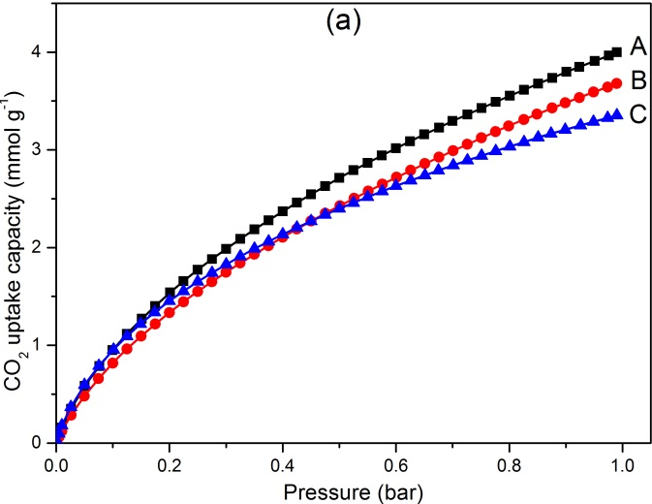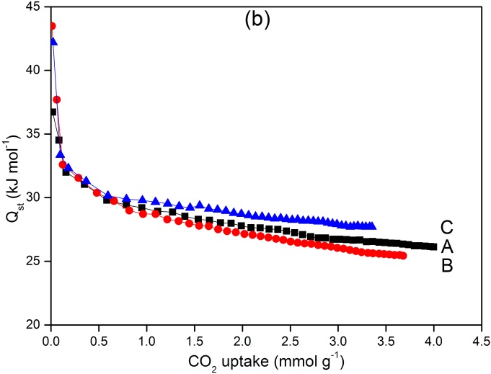
Fig. 6. (a) CO₂ adsorption capacities at 25 ºC and (b) the CO₂ isosteric heat Q_{st} of the studied porous carbon materials.

The CO₂ adsorption energy (i.e., isosteric heat of adsorption, Q_{st}) is then calculated based on the Clausius-Clapeyron equation [38]. The resulting curves of Q_{st} vs CO₂ uptake are shown in Fig. 6b. The initial Q_{st} of sample A, B and C is 37, 43 and 42 kJ mol⁻¹, respectively. The adsorption Q_{st} of C is similar to the previous reports of other typical N-doped porous carbon, but higher than those of most MOF-derived carbons [34]. It is interesting to note that sample B and C exhibit higher initial Q_{st} value than that of sample A, indicating a stronger interaction between the carbon adsorbents and CO₂ molecules. An attempted explanation for this is as follows: since sample B has the highest oxygen content, which may result in a strong acid-base interaction between the hydrophilic oxygen-containing functional groups and the CO₂ molecules; sample C, due to the highest nitrogen content and the presence of nitrogen functional groups that may increase its surface polarity and basicity, thus can form strong acid-base interaction on its surfaces [39]. Therefore, it can be concluded that the presence of both oxygen functional groups and nitrogen functional groups play important roles in determining the initial adsorption energy.
At higher coverages, the Q_{st} of sample A, B and C has an average value of 25-28 kJ mol⁻¹. Detailed analysis shows that at higher CO₂ coverages, sample B, which contains the lowest nitrogen content, highest oxygen content and highest textural properties, exhibits the lowest Q_{st} of 25 kJ mol⁻¹; sample A, possessing the intermediate nitrogen content, intermediate specific surface area and intermediate textural properties, shows an intermediate Q_{st} of 27 kJ mol⁻¹; while sample C that has the highest nitrogen content, the lowest oxygen content and the lowest textural properties, exhibits the highest Q_{st} of 28 kJ mol⁻¹ at higher coverages. Therefore, these results suggest that at higher CO₂ coverages, nitrogen content plays a dominant role in determining the interactions between the carbon adsorbents and CO₂ molecules, which is clearly different from their performances at lower CO₂ coverages.

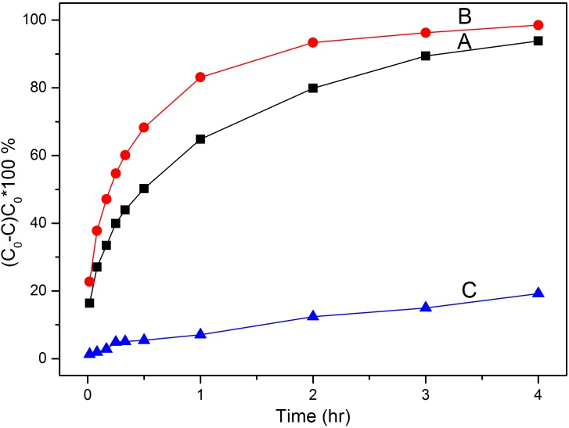
Fig. 7. Adsorption performances of different porous carbon materials for the removal of methylene blue from wastewater solution.

Fig. 7 shows the time dependence of the percentage of the adsorbed methylene blue (MB). After 4 h, sample A, B and C adsorbs 94, 98 and 19% MB from wastewater solution respectively, indicating that water steam processed samples (A and B) have higher MB adsorption capabilities. In addition, both samples A and B exhibit much faster MB adsorption capacities in the first 1 h comparing with that of sample C. The higher and faster MB adsorption ability of sample A and B may be due to the following reasons. Firstly, the high porosity and open pore network of carbons can facilitate the diffusion of MB molecules whose dimensional size is of 1.43 nm × 0.61 nm × 0.4 nm, which is compatible with the pore range of 1.0 to 4.2 nm of carbon samples (Fig. 4b); Secondly, the oxygen-containing functional groups (e.g. -COOH groups) on the surfaces of sample A and B, may also be helpful to increase the interaction of functional porous carbons with the MB molecules, and consequently improve the MB adsorption [40].
Adsorption kinetics analyses are carried out using the pseudo-first-order and pseudo-second-order kinetic model to understand the mechanism of adsorption [41]. The pseudo-first-order equation and pseudo-second-order equations are given as follows:
$$\log\left(Q_{e}-Q_{t}\right)=logQ_{e}-\frac{k_{1}}{2.303}t$$
$$\frac{t}{Q_{t}}=\frac{1}{{k_{2}Q_{e}}^{2}}+\frac{t}{Q_{e}}$$
where $k_{1}$ (min⁻¹) is the adsorption rate constant of pseudo-first-order model,$k_{2}$ (g mg⁻¹ min⁻¹) is the adsorption rate constant for the pseudo-second-order model, $Q_{e}$ (mg g⁻¹) and $Q_{t}$ (mg g⁻¹) are the amount on adsorbent at equilibrium and time $t$, respectively.
The linear plots (Fig. S3) of $\log\left(Q_{e}-Q_{t}\right)$ vs. $t$ and ($t/Q_{t}$) vs. $t$ are drawn for the pseudo-first-order and pseudo-second-order models, respectively. The adsorption rate constants $k_{1}$ and $k_{2}$ can be obtained from the plot of experimental data. The adsorption rate constants, the calculated $Q_{e}$, and the correlation coefficients R² for the two kinetic models of the as-synthesized carbons are summarized in Table 2. As shown in Table 2, the correlation coefficients (R²) of the pseudo-first-order model are 0.90, 0.88 and 0.94 for A, B and C, respectively, while for the pseudo-second-order model, the R² values of A, B and C are all higher than 0.95. By using the pseudo-first-order model, the calculated $Q_{e}$ value is 85.5 mg g⁻¹ for A and 92.0 mg g⁻¹ for B, while the calculated $Q_{e}$ value from the pseudo-second-order model for sample A and B is 97.2 and 100.2 mg g⁻¹, respectively, which is consistent with the experimental data (Fig. 7). Therefore, it can be concluded that the adsorption of MB on these carbons is dominated by the pseudo-second-order model.

Table 2 Kinetic parameters of the pseudo-first-order rate equation and the pseudo-second-order rate equation for MB adsorption on as-synthesized porous carbon materials.
Sample | Pseudo-first-order kinetics |  |  |  | Pseudo-second-order kinetics
 | k ₁  /min⁻¹ | $Q_{e}$/ mg g⁻¹ | R² |  | k ₂  / g mg⁻¹ min⁻¹ | $Q_{e}$/ mg g⁻¹ | R²
A | 0.0840 | 85.5 | 0.90 |  | 0.00046 | 97.2 | 0.96
B | 0.1426 | 92.0 | 0.88 |  | 0.00089 | 100.2 | 0.95
C | 0.0213 | 19.9 | 0.94 |  | 0.00030 | 26.8 | 0.95

The high MB adsorption capacity $Q_{e}$ (up to 100 mg g⁻¹) for the water steam treated N, O codoped porous carbon materials in this work, is almost double of the value for magnetic porous carbon microspheres [42] and comparable to the reported value for porous carbon monoliths templated from silica gel [43], which enable this type of porous carbons to be promising candidates for MB removal from wastewater solution.

4. Conclusions
In summary, we have successfully prepared nitrogen, oxygen-codoped porous carbon materials from ZIF-8 by a one-step carbonization approach under argon saturated with water steam. The water steam plays as both the oxidizing agent and the activating agent during the process. The oxygen and nitrogen contents, textural properties of the resulting ZIF-derived porous carbon materials are fully characterized and their applications in CO₂ uptake and MB adsorption are evaluated. The resulting carbon materials show tunable oxygen content up to 13.8 wt% and nitrogen content up to 17.4 wt%, a surface area of 1049-1694 m² g⁻¹, and a pore volume of 0.55-1.02 cm³ g⁻¹. The N, O-codoped porous carbon materials exhibit enhanced CO₂ uptake capacity of 4.00 mmol g⁻¹ at 25 ºC and 1 bar. The major parameters that affect the CO₂ adsorption energy depend on the CO₂ coverages. Moreover, the water steam treated porous carbon materials exhibit excellent adsorption abilities for MB removal from wastewater solution. Kinetics studies show that the MB adsorption process is dominated by a pseudo-second-order adsorption model. The capacities for CO₂ uptake and removal of methylene blue on optimal steam processed sample are better than or comparable to those of the reported data. This work provides a novel approach for the synthesis of functional porous carbon materials derived from MOFs with high adsorption performance.

Acknowledgements
The authors are grateful to the Royal Society, the Royal Academy of Engineering and University of Exeter for financial supports.

Appendix A. Supplementary data
Supplementary data related to this article can be found at

References

[1] A. Pozio, M. De Francesco, A. Cemmi, F. Cardellini, L. Giorgi, J. Power Sources 105 (2002) 13-19.
[2] J. Lee, J. Kim, T. Hyeon, Adv. Mater. 18 (2006) 2073-2094.
[3] Z. Yang, Y. Xia, R. Mokaya, J. Am. Chem. Soc. 129 (2007) 1673-1679.
[4] F. Cheng, Z. Tao, J. Liang, J. Chen, Chem. Mater. 20 (2008) 667-681.
[5] H. Nishihara, T. Kyotani, Adv. Mater. 24 (2012) 4473-4498.
[6] D. Lozano-Castelló, M.A. Lillo-Ródenas, D. Cazorla-Amorós, A. Linares-Solano, Carbon 39 (2001) 741-749.
[7] Y. Gogotsi, A. Nikitin, H. Ye, W. Zhou, J. E. Fischer, B. Yi, H. C. Foley, M. W. Barsoum, Nature Mater. 2 (2003) 591-594.
[8] J. Biener, M. Stadermann, M. Suss, M.A. Worsley, M. M. Biener, K. A. Rose, T. F. Baumann, Energy Environ. Sci. 4 (2011) 656-667.
[9] Y. Xia, Z. Yang, R. Mokaya, Nanoscale 2 (2010) 639-659.
[10] A. B. Fuertes, J. Mater. Chem. 13 (2003) 3085-3088.
[11] Y. Xia, G. S. Walker, D. M. Grant, R. Mokaya, J. Am. Chem. Soc. 131 (2009) 16493-16499.
[12] Y. Xia, R. Mokaya, Adv. Mater. 16 (2004) 1553-1558.
[13] T. Kyotani, Z. Ma, A. Tomita, Carbon 41 (2003) 1451-1459.
[14] Y. D. Xia, R. Mokaya, Adv. Mater. 16 (2004) 886-891.
[15] K. S. Park, Z. Ni, A. P. Côté, J. Y. Choi, R. Huang, F. J. Uribe-Romo, H. K. Chae, M. O’Keeffe, O.M. Yaghi, PNAS 103 (2006) 10186-10191.
[16] A. Phan, C. J. Doonan, F. J. Uribe-Romo, C. B. Knobler, M. O’Keeffe, O. M. Yaghi, Acc. Chem. Res. 43 (2010) 58-67.
[17] F. Bai, Y. Xia, B. Chen, H. Su, Y. Zhu, Carbon 79 (2014) 213-226.
[18] Q. Wang, W. Xia, W. Guo, L. An, D. Xia, R. Zou, Chem. Asian. J. 8 (2013) 1879-1885.
[19] S. Zhong, C. Zhan, D. Cao, Carbon 85 (2015) 51-59.
[20] W. Chaikittisilp, M. Hu, H. Wang, H. -S. Huang, T. Fujita, K. C. W. Wu, L. -C. Chen, Y. Yamauchi, K. Ariga, Chem. Commun. 48 (2012) 7259-7261.
[21] N. L. Torad, R. R. Salunkhe, Y. Li, H. Hamoudi, M. Imura, Y. Sakka, C. -C. Hu, Y. Yamauchi, Chem. Eur. J. 20 (2014) 7895-7900.
[22] J. -W. Jeon, R. Sharma, P. Meduri, B. W. Arey, H. T. Schaef, J. L. Lutkenhaus, J. P. Lemmon, P. K. Thallapally, M. I. Nandasiri, B. P. McGrail, S. K. Nune, ACS Appl. Mater. Interfaces 6 (2014) 7214-7222.
[23] B. Liu, H. Shioyama, T. Akita, Q. Xu, J. Am. Chem. Soc. 130 (2008) 5390-5391.
[24] H. -L. Jiang, B. Liu, Y. -Q. Lan, K. Kuratani, T. Akita, H. Shioyama, F. Zong, Q. Xu, J. Am. Chem. Soc. 133 (2011) 11854-11857.
[25] N. L. Torad, M. Hu, Y. Kamachi, K. Takai, M. Imura, M. Naito, Y. Yamauchi, Chem. Commun. 49 (2013) 2521-2523.
[26] H. Wang, T. Maiyalagan, X. Wang, ACS Catal. 2 (2012) 781-794.
[27] M. Wu, Q. Zha, J. Qiu, X. Han, Y. Guo, Z. Li, A. Yuan, X. Sun, Fuel 84 (2005) 1992-1997.
[28] J. Cravillon, S. Münzer, S.-J. Lohmeier, A. Feldhoff, K. Huber, M. Wiebcke, Chem. Mater. 21 (2009) 1410-1412.
[29] T. Belin, F. Epron, Mater. Sci. Eng., B 119 (2005) 105-118.
[30] A. C. Ferrari, Solid State Commun. 143 (2007) 47-57.
[31] B. Chen, G. Ma, D. Kong, Y. Zhu, Y. Xia, Carbon 95 (2015) 113-124.
[32] M. Favaro, L. Ferrighi, G. Fazio, L. Colazzo, C. Di Valentin, C. Durante, F. Sedona, A. Gennaro, S. Agnoli, G. Granozzi, ACS Catal. 5 (2015) 129-144.
[33] M. Favaro, F. Carraro, M. Cattelan, L. Colazzo, C. Durante, M. Sambi, A. Gennaro, S. Agnoli, G. Granozzi, J. Mater. Chem. A 3 (2015) 14334-14347.
[34] Y. Xia, R. Mokaya, G. S. Walker, Y. Zhu, Adv. Energy Mater. 1 (2011) 678-683.
[35] R. V. Siriwardane, M. -S. Shen, E. P. Fisher, J. A. Poston, Energy Fuels 15 (2001) 279-284.
[36] J. Wang, Y. Lin, Q. Yue, K. Tao, C. Kong, L. Chen, RSC Adv. 6 (2016) 53017-53024.
[37] H. S. Kim, M. S. Kang, W. C. Yoo, J. Phys. Chem. C 119 (2015) 28512-28522.
[38] H. Pan, J.A. Ritter, P.B. Balbuena, Langmuir 14 (1998) 6323-6327.
[39] M. D. Soutullo, C. I. Odom, B. F. Wicker, C. N. Henderson, A. C. Stenson, J. H. Davis, Chem. Mater. 19 (2007) 3581-3583.
[40] Q. Zhang, J. Yu, J. Cai, R. Song, Y. Cui, Y. Yang, B. Chen, G. Qian, Chem. Commun. 50 (2014) 14455-14458.
[41] Y. S. Ho, G. McKay, Process Biochem. 34 (1999) 451-465.
[42] H. Zhang, L. Chen, L. Li, Y. Yang, X. Liu, J. Porous Mater. 24 (2017) 341-353.
[43] X. He, K. B. Male, P. N. Nesterenko, D. Brabazon, B. Paull, J. H. T. Luong, ACS Appl. Mater. Interfaces 5 (2013) 8796-8804.

