Cannabidiol reverses attentional bias to cigarette cues in a human experimental medicine model of tobacco withdrawal.
Hindocha, C^{1*}., Freeman, T.P^{1,2}., Grabski, M³., Stroud, J¹., Crudgington, H¹., Davies, A¹., Das, R.K¹., Lawn, W¹., Morgan, C.J.A^{1,4}., Curran, H.V.¹
¹Clinical Psychopharmacology Unit, University College London, WC1E 7HB
²National Addiction Centre, Institute of Psychiatry, Psychology and Neuroscience, King’s College London, London, SE5 8BB, United Kingdom.
³School of Experimental Psychology, University of Bristol, 12a Priory Road, BS81TU, Bristol.
⁴Psychopharmacology and Addiction Research Centre, University of Exeter, UK
Word count
Abstract: 262 (250)
Main body: 4048 (/4000)

Running Head: CANNABIDIOL FOR TOBACCO WITHDRAWAL

Correspondence to: Chandni Hindocha, Clinical Psychopharmacology Unit, University College London, 1-19 Torrington Place, London, WC1E 7HB. Email: c.hindocha@ucl.ac.uk

Abstract
Current pharmacological treatments for smoking cessation have limited efficacy and can produce significant side effects. Cannabidiol (CBD), the non-intoxicating cannabinoid, may be a promising novel smoking cessation pharmacotherapy with anxiolytic properties and minimal side effects. This randomized, double-blind crossover laboratory study utilised an experimental medicine approach to investigate whether CBD would reduce withdrawal symptomology, salience and liking of cigarette cues following overnight abstinence in dependent cigarette smokers. Thirty non-treatment seeking, dependent, cigarette smokers attended three sessions. The first was a fixed satiated session, followed by two overnight abstinent sessions in which they were randomised to receive either 800mg oral CBD or placebo (PBO). Compliance on all sessions was biologically verified. Their reactivity to pictorial tobacco cues was recorded using an attentional bias task and an explicit rating task. Withdrawal, craving, side effects, heart rate and blood pressure were assessed at multiple timepoints. Tobacco abstinence increased attentional bias when participants were treated with placebo (p=.001, d =.789) compared to satiation. However, CBD reversed this effect, such that automatic attentional bias was directed away from cigarette cues (p=.007, d: .704) and no longer differed from satiety (p=.82). CBD reduced explicit liking of cigarette images, compared to placebo (p=.036). Craving and withdrawal were greater in abstinence and unaffected by CBD. Systolic blood pressure decreased under CBD during abstinence. In the first study to investigate CBD for nicotine withdrawal, our results highlight a reduction in the salience of drug cues as a key neurocognitive mechanism through which CBD may assist with the treatment of tobacco and other substance use disorders.

Introduction

Over 1.1 billion people smoke worldwide (WHO, 2015). Although this number is decreasing in the western world (Frazer et al. 2016), it is still estimated that six million people will die per year due to cigarette smoking. A primary addictive driver of cigarette smoking is nicotine withdrawal. Withdrawal occurs upon cessation and includes physiological symptoms (headaches, nausea), affective symptoms (anxiety, depression and irritability) and impaired cognitive performance (delay discounting, response inhibition) (Grabski et al, 2016) which peak within the first few days (Hughes, 2007). Some evidence suggests withdrawal severity predicts relapse (Hughes, 2007; Killen and Fortmann, 1997; Patterson et al, 2010; Piasecki et al, 2003), prevention of which is one of the greatest challenges in the treatment of addiction (Potenza et al, 2011). Even when using the most effective smoking cessation drug (varenicline), a majority still fail to maintain long-term abstinence (Schnoll and Lerman, 2006). Nicotinic medications may also have unpleasant side effects e.g. weight gain (Cahill et al, 2016).
There is mounting evidence that the endogenous cannabinoid (eCB) system is involved in motivation for rewards including modulating the rewarding effects of drugs (Hindocha et al, 2017b; Lawn et al, 2016; Parsons and Hurd, 2015; Prud'homme et al, 2015; Zlebnik and Cheer, 2016). In relation to nicotine dependence, antagonists of the CB1 receptor, e.g. rimonabant, decrease nicotine conditioned place preference (CPP), self-administration (Forget et al, 2005; Le Foll and Goldberg, 2004) and in human clinical trials, rimonabant has been shown to increase abstinence rates by 1.6 times (Cahill and Ussher, 2011; Robinson et al, 2017). Although potentially effective, rimonabant was withdrawn from the market due to serious neuropsychological side effects.
Cannabidiol (CBD) is the second most abundant cannabinoid in cannabis and has broad therapeutic benefits; its mechanism of action is diverse, incompletely elucidated, and includes antagonism at 5-HT receptors (Campos and Guimarães, 2008; Zanelati et al, 2010) and a partial agonism at dopamine D2 receptors (Seeman, 2016). It increases extracellular anandamide by Fatty Acid Amide Hydrolase (FAAH) inhibition (Bisogno et al, 2001; De Petrocellis et al, 2011). Interestingly, inhibiting anandamide reuptake decreases nicotine CPP and possibly self-administration in rats (Gamaleddin et al, 2011; Scherma et al, 2012 however see Merritt et al., (2008) for enhanced nicotine CPP in FAAH knockout mice). CBD has a low affinity to the CB1 receptor (Pertwee, 2008) and this is unlikely to the candidate mechanism for its actions.
The psychological properties of CBD are suggestive of a potentially ideal drug for smoking cessation. These include its lack of intoxicating and subjective effects (Babalonis et al, 2016; Haney et al, 2015; Hindocha et al, 2015), antipsychotic (Leweke et al, 2012; Leweke et al, 2015; Schubart et al, 2014) and anxiolytic (Bergamaschi et al, 2011; Fusar-Poli et al, 2009) effects in humans. Its anxiolytic properties may be particularly relevant, as anxiety is a primary symptom of tobacco withdrawal (Hughes, 1992). The first human pilot study to investigate CBD as a treatment for nicotine dependence randomised participants to either one-week of ad-hoc CBD or placebo inhaler and were instructed to use it when they had the urge to smoke. CBD reduced the number of cigarettes smoked by almost 40% (Morgan et al, 2013). This preliminary study did not investigate any neurocognitive mechanisms through which CBD may assist with the treatment of smoking cessation. However, on the basis of previous findings, the authors proposed a reduction in the salience of drug cues could be one candidate mechanism.
Attentional bias is an important in-lab predictive marker of the salience of drug cues, it is heightened during acute abstinence (albeit weakly in meta-analysis, due to multiple methodologies : Grabski et al, 2016), predicts short-term relapse (Waters et al, 2003) and is thought to play a causal role in addiction (Franken, 2003). The short exposure interval is particularly important as tobacco abstainers show greater salience to drug cues only in the short exposure (Freeman et al, 2012). CBD may reduce the salience of smoking cues which would be consistent with preclinical and human neuroimaging research (Ren et al, 2009). In human naturalistic research, cannabis with high, in comparison to low, levels of CBD reduced cue salience to cannabis-related stimuli in a visual probe task (Morgan et al, 2010). This was only observed at the short stimulus exposure interval which taps ‘automatic’ bias, i.e. that which is not subject to conscious cognitive control. As such, CBD may target an important process in relapse and have a role as an adjunct cessation pharmacotherapy. Ren et al. (2009) showed CBD (5–20 mg/kg) attenuated cue-induced heroin seeking behaviour and relapse (during active heroin intake) in a rat model of addiction which was significant even two weeks after CBD administration. Furthermore, human pilot research showed a single dose of CBD can attenuate cue-induced craving in heroin users and was maintained for 24 hours (Hurd et al, 2015). Neuroimaging has elucidated that CBD modulates activity of areas in the brain highly associated with different aspects of salience attribution including the striatum, hippocampus and prefrontal cortex (Bhattacharyya et al, 2015). Therefore, there is a strong rationale to examine CBD as a potential treatment for tobacco and other substance use disorders where the salience of cues is key.
The present study utilises an experimental medicine approach to investigate CBD’s potential to target processes relevant to smoking cessation. Human laboratory studies of smoking abstinence provide an efficient, cost-effective, mechanistic evaluations of medications for smoking behaviour (Lerman et al, 2007), which may further help facilitate translational research. This is the first study to investigate CBD for nicotine withdrawal in humans. We hypothesised that ~12-hour nicotine abstinence, relative to satiety, would produce a range of symptoms consistent with nicotine withdrawal in dependent cigarette smokers, specifically, increased craving and withdrawal, greater attentional bias in the short exposure and liking of cigarette related stimuli. Secondly, we hypothesised that CBD in comparison to placebo, would attenuate craving, withdrawal symptomology, attentional bias and liking of cigarette related stimuli.

Material and Methods

Design and participants
Thirty participants attended 3 sessions (7.85 ± 2.77 days between sessions). Participants smoked as normal before their first (baseline) session, verified with expired Carbon Monoxide (CO) ≥ 10 p.p.m (Bedfont Scientific, Harrietsham, UK). Participants then attended two sessions after overnight (~12 h) abstinence, verified by CO ≤ 10ppm (Benowitz et al, 2002). A double-blind placebo-controlled crossover design was implemented to investigate the effects of 800mg oral CBD, in comparison to placebo (PBO), after overnight abstinence. Treatment order for abstinent sessions was randomised and counterbalanced.
Dependent cigarette smokers were recruited from the local community and through online message boards. Inclusion criteria were: i) age 18-50 years, ii) smoking ≥10 cigarettes a day for at least the last year, iii) FTND score ≥ 4 (moderate dependence) (Heatherton et al, 1991), iv) smoking first cigarette within an hour of waking, iv) negative drug urine screen for all drugs on the first session. Exclusion criteria were: i) use of nicotine replacement therapy or any other nicotine pharmacotherapy, ii) self-reported recent use of cannabis or other illicit drugs, iii) recent (past 4 weeks) or on-going use of e-cigarettes, iv) current mental or physical health issues or learning impairments v) pregnancy or breast feeding vi) allergies to cannabidiol, gelatine, lactose, microcrystalline cellulose or chocolate.

Power calculation
We calculated an N of 20 would be necessary to have power of 0.95 to detect a large effect size of d=0.78 (F=0.38). This was based on the difference in the number of cigarettes smoked pre- to post- one week of CBD inhaler vs. placebo in Morgan et al. (2013). This sample size was increased by 50% to adjust for “winner’s curse”, or the tendency for effect sizes estimates from an initial positive finding to be over-inflated (Button et al, 2013) yielding a final sample of 30.

Drug administration
Participants were administered 800mg oral CBD doses (pure synthetic (-)-CBD, STI Pharmaceuticals, Essex, England) or matched placebo (lactose powder) in capsules in a double-blind, counterbalanced manner. The 800mg dose was chosen as it has shown efficacy for schizophrenia, increased extracellular anandamide levels (Leweke et al, 2012), and should be sufficient to influence salience attribution after a single dose (Bhattacharyya et al, 2015). 800mg produces an increase in plasma concentrations after administration (Cmax = 77.9 ±25 ng/mL, Tmax=180 minutes ).

Assessments

Visual probe task
This task was implemented as a measure of attentional bias, adapted from Charles et al (2015). The smoking (target) and composition-matched neutral (non-target) images were taken from Mogg et al (2003) who provide a complete description of the stimuli. Each trial began with a fixation point (500 ms). A pair of images then appeared on the left and right of the screen for either a short (200 ms) or long (500 ms) duration to assess automatic orienting and controlled attention processing, respectively. Image pairs were then replaced by a probe (an arrow pointing upwards or downwards) in the location of either the neutral or smoking related image. The probe remained on screen until the participant responded to identify the probe orientation (upwards or downwards) by pressing one of two appropriate response keys (k/m) as quickly and accurately as possible. Probes replaced the cigarette-related and neutral images equally often. The right/left position of image type, probe location, and stimulus duration were counterbalanced. Trials were displayed in a single block, with each pair presented eight times, producing 80 critical trials and 32 neutral trials. The task began with 4 buffer trials. Trial order was randomised each time the task was run. The task was programmed with Experiment Builder (SR Research, Ontario, Canada).
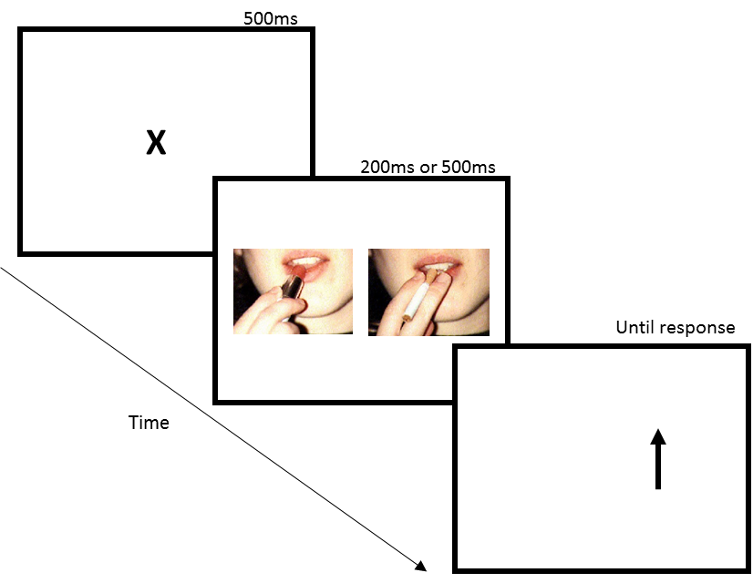
Fig 1. Trial structure for the visual probe task. Example of cigarette (right) and matched neutral stimuli (left) provided

Pleasantness Rating Task (PRT)
This task tapped explicit liking and reaction time to the same pictures used in the visual probe task. Each trial began with a fixation cross of 500ms, followed by either a cigarette or neutral cue, presented in a randomised order for 3000ms. Stimuli were matched on brightness and complexity. Stimuli for cigarettes involved smoking-related scenes were the same as the visual probe. Participants rated the pleasantness of each image on a scale of -3 (very unpleasant) to +3 (very pleasant). Two dependent variables of valence and reaction time were recorded. 3 versions were available for counterbalancing. The experiment was built and conducted using Psychopy (Peirce, 2007, 2009).

State questionnaires
Withdrawal was assessed with the Mood and Physical Symptoms Scale (MPSS) (West and Hajek, 2004). Craving was assessed with Questionnaire of Smoking Urges–Brief (QSU-B) (Tiffany and Drobes, 1991). Participants completed a 6-item Side Effect form for CBD which included “strong drug effect”, “good drug effect”, “willing to take drug again”, “like drug effect”, “I have an upset stomach” and “I have a headache”. Each item was rated 3 times over abstinent sessions on a 10 point visual analogue scale from “not at all” to “extremely”.

Trait Questionnaires
The Fagerström test for Nicotine Dependence (FTND) was used to assess nicotine dependence (Heatherton et al, 1991). Anxiety was assessed with the Trait Anxiety Inventory (STAI; (Spielberger et al, 1970)). Depression was assessed with Beck Depression Inventory (BDI-II; (Beck et al, 1961). A comprehensive drug history was also taken (Hindocha et al, 2017a). Premorbid Verbal Intelligence was assessed with the Spot The Word Task (Baddeley et al, 1993).

Procedure
After telephone screening, eligible participants attended a baseline ‘satiated session’ prior to which they smoked as normal. This involved further screening assessments (urine test, pregnancy test, spot the word) as well as the same assessments as on the abstinent days. On the satiated day, participants completed state measures of craving (QSU-B) and withdrawal (MPSS), were asked to smoke a cigarette (Marlboro Gold) at the beginning of the session to ensure satiation then completed the task battery. On abstinent sessions, participants attended two 3.5 hour sessions separated by one week after overnight abstinence. They provided a CO reading then completed state questionnaires (QSU-B, MPSS). CBD or matched placebo was then orally administered. After drug administration, participants completed half the trait questionnaires in each session. At 1h (T1) and 2h (T2) after drug administration, they again completed the MPSS and QSU-B. At 2.5 hours, they completed the visual probe and PRT. At 3.5h after drug administration, participants completed the MPSS and QSU-B (T3). All participants provided written informed consent. Ethical approval was given by UCL Ethics Committee. Participants were reimbursed £10/hour.

Statistical analysis
Statistical analyses were performed in the Statistical Package for Social Scientists (SPSS 21; IBM, Chicago, IL). Visual inspection of diagnostic plots was used to check for normality. Outliers > 1.5 x the interquartile range (IQR) were winsorized to the next highest value. For the PRT, 4.2% of the data was missing due to technical issues and were replaced with the means of the condition.
The visual probe, PRT, MPSS and QSU were analysed using repeated measures ANOVA with two a priori orthogonal Helmert contrasts to investigate main effects. The first describes the main effect of abstinence i.e. satiated (SAT) vs. abstinent (CBD+PBO), the second describes the main effect of drug i.e. CBD vs. PBO. Interactions were explored via pairwise post-hoc comparisons, Bonferroni-corrected locally within each omnibus term. Task specific factors included exposure time (long, short) for the visual probe, stimulus type (cigarette, neutral) for the PRT-RT. The MPSS and QSU utilised an additional task specific factor of time (T1(pre-drug), T2, T3). Given side effects, HR, systolic and diastolic BP was only taken once on SAT session, these data were analysed with a 2 (CBD, PBO) x 3 (T1 (pre-drug), T2, T3) ANOVA.
Only correct trials were analysed for the visual probe. Responses >2000 and <200ms were removed. Following Mogg et al (2005), bias scores were calculated for the visual probe and PRT such that a positive score indicates a bias towards cigarette cues. For the visual probe, this was calculated as the difference in RT between when the probe replaced the neutral in comparison to cigarette stimulus (RT_neutral – RT_cigarette); for the PRT-Valence it was calculated as cigarette_valence – neutral_valence.

Results

Participant characteristics
30 participants (14 female) took part. Demographics and trait measures can be found in table 1. Use of other drugs was minimal in this population (table 2).
Table 1. Participants’ demographic and trait variables.
n | 30
Age | 28.07 (8.66)
FTND score | 5.56 (1.13) range 4-8
Cigarettes per day | 13.5 (2.39) range 10-20
Time to first cigarette (mins) | 25.50 (15.87)
Years smoked | 9.55 (7.36)
Years smoking >10+ cigarettes/day | 8.17 (7.08)
Lifetime quit attempts (n=25) | 3.20 (3.91)
Most Successful quit attempt (days) | 100.48 (163.47)
BMI | 23.98 (7.78)
Spot the Word | 48.03 (4.15)
STAI | 40.53 (9.40)
BDI | 10.36 (7.54)

Drug use
Table 2: Drug use history (N = the number of people who used the drug in the past year).
 | Alcohol | Cannabis | MDMA | Cocaine
N | 26 | 14 | 9 | 9
Last used (days) | 6.39 (10.13) | 100.00 (68.30) | 84.66 (82.22) | 100.00 (56.12)
Years used | 13.08 (8.68) | 8.29 (4.61) | 4.55 (1.59) | 3.33 (2.12)
Days per month | 11.43 (8.85) | 0.75 (1.30) | 0.67 (1.32) | 0.5 (1.15)
Amount per session | 7.10 units (3.23) | 0.87 joints (0.69) | 258.33mg (144.70) | 800mg (0.83)

Manipulation checks
Self-reported time since last smoked and an objective measure of expired CO both indicate that participants were abstinent on abstinent sessions. For further details see the supplementary materials.

Attentional Bias

Visual probe task
We found a condition x exposure interaction (F(2,58)=4.66, p=.013, ηp²= .138). The interaction showed that under the short exposure, there was greater attentional bias to cigarette cues in the PBO condition, in comparison to SAT (MDiff= 45.15ms (SE: 10.48), p=.001, d: .789), as well as greater attentional bias in the PBO condition in comparison to CBD (MDiff= 36.47ms (SE: 10.90), p=.007, d: .704) but not between SAT and CBD (MDiff= -8.68ms (SE: 7.77), p=.82). Follow up one-sample t-tests against 0 showed both SAT (t(29)= -4.42, p<.001), and CBD (t(29)= -2.54, p=.017) were more significantly more negative than zero, and PBO was significantly more positive than 0 (t(29)=2.63, p=.014). Under the long condition, none of these comparisons were significant. Additionally, there was a significant difference between short and long exposure times for CBD (MDiff= -20.94 (SE: 8.13), p=.015) but not under SAT (p=.263) or PBO (p=.155). There was a main effect of abstinence (F(1,29)=9.52, p=.004, ηp²=.274) which showed there was a greater attentional bias under abstinence versus satiation. There was a main effect of drug which was subsumed under the condition x exposure interaction. There was no main effect of exposure time (F(1,29)=2.14, p=.155 ηp²=.069).
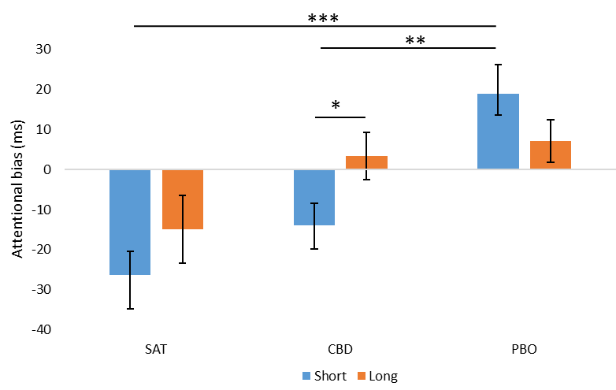
Figure 2: Attentional bias across each session for both short and long exposure times. Error bars are ±SEM. * p≤ .05, ** p≤ .01, *** p≤ .001

Pleasantness Rating Task

Valence (Fig. 3a)
A one way ANOVA on bias scores (CigValence-NeutralValence) revealed a significant main effect of drug (F(1,29)=7.41, p=.011, ηp²=.203), indicating a lower bias towards cigarettes images on CBD compared to PBO. There was no main effect of abstinence (F(1,29)=0.53, p=.472, ηp²=.018).

RT (Fig. 3b)
There was a main effect of abstinence (F(1,29)=7.41, p=.011, ηp²=.204) where participants were slower in the satiated condition (M:1.87, SE:0.11) than in the abstinent sessions (CBD: 1.69, SE: 0.07, PBO: 1.70, SE: 0.08). There was no main effect of drug, stimulus type or drug x stimulus type interaction (F(2, 58) =.131, p=.876, ηp² =.004).
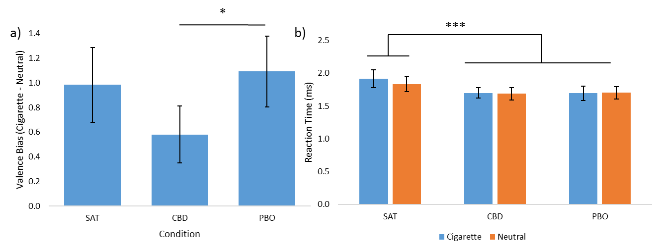
Figure 3: a) Bias in pleasantness rating (calculated as cigarette valence minus neutral valence) for all three conditions and b) reaction time with the factor of stimulus type included. Error bars are ±SEM. * p≤ .05, ** p≤ .01, *** p≤ .001

Craving (Fig 4a)
There was a condition x time interaction (F(4,116)=21.38, p<.001, ηp²=.424) which was driven by significant differences between satiated and abstinent sessions on the first two time-points (all p‘s <.001). At T3, no differences emerged between conditions. There was also a main effect of abstinence (F(1,29)=29.92, p<.001, ηp²=.51) and time (F(1.63,47.31)=20.76, p<.001, ηp²=.418). There was no main effect of drug.

Withdrawal (Fig. 4b)

MPSS total
There was a main effect of abstinence (F(1,29)=12.04, p=.002, ηp²=.293) which showed higher MPSS total scores on abstinence days in comparison to satiated. There was also a main effect of time (F(2,58) =11.35, p<.001, ηp²=.281) which showed in all sessions that withdrawal decreased at T2 then increased at T3. There was no main effect of drug or condition x time interaction. Analysis from the additional MPSS questions (amount of time spent with urges, and strength of urges) can be found in the supplementary materials.
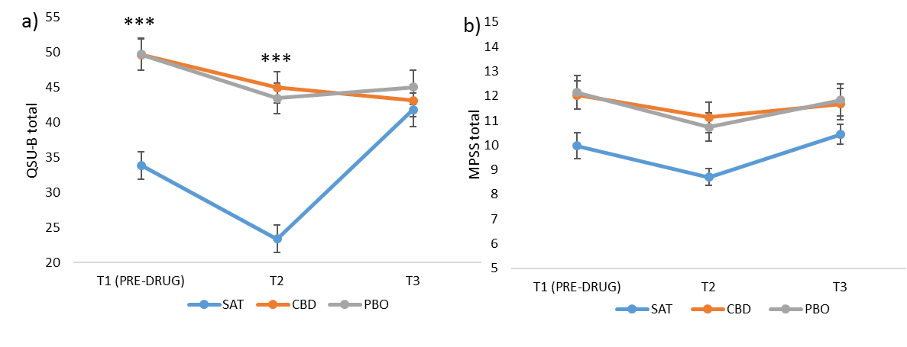
Figure 4: Scores for the a) QSU-B (craving) and b) MPSS total (withdrawal) as a function of time and condition. Error bars are ±SEM. * p≤ .05, ** p≤ .01, *** p≤ .001

Cardiovascular

Heart rate
There was a main effect of time (F(1.35, 39.07) =33.73, p<.001, ηp²=.540) which showed HR decreased over time. No other main effects or interactions emerged.

Blood pressure
For systolic blood pressure was a main effect of drug (F(1,29)= 6.72, p=.015, ηp²=.188) which showed higher blood pressure in the placebo condition (M: 114.16 SE: 1.43) compared to CBD (M: 110.75 SE: 1.463). There was also a main effect of time (F(2,58) =13.24, p<.001, ηp²=.313) which showed that systolic blood pressure decreased over time. There were no main effects or interactions for diastolic blood pressure.

Side effects
There were no main effects of drug or interactions between drug and time for any of the six items. Full analysis can be found in the supplementary materials.

Correlations
There were no correlations between PRT-Valence and attentional bias or between craving, withdrawal and attentional bias or with trait measures. Trends towards positive and medium-large correlations emerged between bias in valence on the PRT and craving scores (T3) in the SAT (r(30)=.46, p=.01) and PBO (r(30)=.38, p=.04) but not for CBD (r(30)=.27, p=.14).

Discussion
This study employed an experimental medicine approach to investigate the utility of a single dose of CBD in a laboratory model of nicotine withdrawal. We found evidence that CBD shifted attentional bias away from cigarette cues in comparison to placebo, such that it was no longer significantly different from attentional bias under satiety. Simultaneously, we observed a reduction in explicit liking during abstinence such that cigarette stimuli were rated as less pleasant after CBD than placebo. These neurocognitive effects occurred in the absence of any changes in subjective states such as craving and withdrawal between CBD and placebo. This suggest that CBD may have specific effects on the evaluative and motivational-salience reducing properties of drug cues which is consistent with clinical (Hurd et al, 2015; Morgan et al, 2010) and preclinical (Ren et al, 2009) research. Moreover, no side-effects or psychoactive or significant cardiovascular effects were noted. These results support the potential of CBD it the treatment of addictive disorders.
A reduction in the implicit salience of drug cues of a large effect size was observed in the CBD condition (vs. placebo) after overnight abstinence in dependent cigarette smokers. That is to say that participants were faster to detect probes replacing smoking (vs. control) cues under placebo. This was observed in the short exposure time only, consistent with our hypothesis and with previous findings that smokers of high CBD:THC cannabis strains had a reduced attentional bias to both cannabis and food stimuli in at a short (but not long) exposure compared to those who had a low CBD:THC ratio (Morgan et al, 2010). The short exposure time to related to implicit automatic processing and initial orientation to cues, and less likely to do with awareness than the long attentional bias (Field and Cox, 2008) which may be why it did not correlate with explicit liking or questionnaire measures of craving and withdrawal.
These results suggest that the mechanism by which CBD exerts its observed anti-addictive effects are early and directly on the normalisation of the salience of drug cues and is in line with the incentive salience model of drug addiction (Robinson and Berridge, 2001). Previous research using the visual probe tasks has also highlighted a role of automatic attentional bias in tobacco dependence, showing sensitivity to tobacco abstinence (Freeman et al., 2012) and acute administration of a dopamine D2/D3 agonist (Freeman et al., 2015). Given that attentional bias may predict smoking cessation outcomes (Waters et al, 2003), CBD may be useful in aiding early abstinence by reducing the salience of drug-related cues.
The neurobiological mechanism by which CBD may exert these effects is unclear, however a promising candidate is through normalisation of extracellular anandamide, via inhibition of FAAH. FAAH inhibitors have been shown to reduce nicotine self-administration and CPP in rats and monkeys as well as nicotine-induced dopamine release in the nucleus accumbens (Forget et al, 2009; Justinova et al, 2015; Panlilio et al, 2013; Scherma et al, 2008). Here, we were unable to collect anandamide levels, however this putative mechanism requires further research as more potent FAAH inhibitors may provide more anti-addictive effects than CBD. This also may be the mechanism by which CBD may alleviate psychotic symptoms in people with schizophrenia (Leweke et al, 2012). Interestingly, there may be a common biological substrate that underlying both smoking and psychosis which involves changes in salience attribution or ‘aberrant salience’ (Freeman et al, 2014; Kapur, 2003). Indeed previous research suggests CBD modulates activity in the areas of the brain associated with salience attribution during an attentional salience task (Bhattacharyya et al, 2012; 2015).
As well as effects of CBD on implicit attentional bias, we saw a reduction in explicit liking for cigarettes under CBD in comparison to placebo. Explicit liking is important in regards to addiction because it partly indexes the reinforcing value of a drug. Users of high, in comparison to low, CBD: THC ratio cannabis showed lower self-reported liking of cannabis stimuli which follows the same pattern as the present study (Morgan et al, 2010) and may be related to endocannabinoid involvement in hedonic experiences (Mahler et al, 2007). However, there was no difference between abstinence and satiated sessions as we had hypothesised, and has previously been shown (Field et al, 2004). Moreover, in this study, we found trends towards positive medium sizes correlations between valence and craving but only for the satiated and placebo session, but not under CBD, thus adding validity to the PRT and likely because both are explicit measures.

Limitations
This study has some limitations. Firstly, we used an experimental medicine approach to investigate mechanistic effects of single dose CBD during tobacco withdrawal therefore it is unclear whether these effects will translate to the clinic and how long the effects last. The visual probe task only provides a cross-sectional snapshot of attentional bias at a specific time point in a laboratory setting, and in this case Ecological Momentary Assessment may be more indicative of attentional bias in actual drug taking environments. Additionally, use of eye tracking, fMRI and/or EEG would have provided additional information on the time course and neural correlates of attentional bias. Moreover, only a single dose of CBD was given; future research needs to investigate the repeated dosing and a range of doses (Zuardi et al, 2017). Finally, compliance with abstinence instructions were based on self-report, therefore we could not verify that participants had not used other nicotine products, apart from cigarettes (verified with CO), however, craving and withdrawal scores were markedly higher under abstinence than satiation suggesting this was not the case.

Conclusions
In conclusion, this study shows that after overnight tobacco abstinence, cigarette smokers given CBD, in comparison to placebo show a reduced salience of cigarette cues and reduced liking of cigarette cues, in the absence of any reductions in withdrawal or craving. This study highlights the potential utility of CBD as a treatment for tobacco and other substance use disorders and suggests that one mechanism by which CBD may exert its effects on addiction is via a reduction in salience of drug cues.

REFERENCES
Babalonis S, Haney M, Malcolm RJ, Lofwall MR, Votaw VR, Sparenborg S, et al (2016). Oral cannabidiol does not produce a signal for abuse liability in frequent marijuana smokers. Drug Alcohol Depend.

Baddeley A, Emslie H, Nimmo‐Smith I (1993). The Spot‐the‐Word test: A robust estimate of verbal intelligence based on lexical decision. Br J Clin Psychol 32(1): 55-65.

Beck AT, Ward C, Mendelson M (1961). Beck depression inventory (BDI). Arch Gen Psychiatry 4(6): 561-571.

Benowitz NL, Jacob III P, Ahijevych K, Jarvis MJ, Hall S, LeHouezec J, et al (2002). Biochemical verification of tobacco use and cessation. Nicotine & Tobacco Research 4(2).

Bergamaschi MM, Queiroz RHC, Chagas MHN, de Oliveira DCG, De Martinis BS, Kapczinski F, et al (2011). Cannabidiol reduces the anxiety induced by simulated public speaking in treatment-naive social phobia patients. Neuropsychopharmacology 36(6): 1219-1226.

Bhattacharyya S, Crippa JA, Allen P, Martin-Santos R, Borgwardt S, Fusar-Poli P, et al (2012). Induction of psychosis by Delta9-tetrahydrocannabinol reflects modulation of prefrontal and striatal function during attentional salience processing. Arch Gen Psychiatry 69(1): 27-36.

Bhattacharyya S, Falkenberg I, Martin-Santos R, Atakan Z, Crippa JA, Giampietro V, et al (2015). Cannabinoid modulation of functional connectivity within regions processing attentional salience. Neuropsychopharmacology 40(6): 1343-1352.

Bisogno T, Hanuš L, De Petrocellis L, Tchilibon S, Ponde DE, Brandi I, et al (2001). Molecular targets for cannabidiol and its synthetic analogues: effect on vanilloid VR1 receptors and on the cellular uptake and enzymatic hydrolysis of anandamide. British journal of pharmacology 134(4): 845-852.

Button KS, Ioannidis JP, Mokrysz C, Nosek BA, Flint J, Robinson ES, et al (2013). Power failure: why small sample size undermines the reliability of neuroscience. Nature Reviews Neuroscience 14(5): 365-376.

Cahill K, Lindson‐Hawley N, Thomas KH, Fanshawe TR, Lancaster T (2016). Nicotine receptor partial agonists for smoking cessation. The Cochrane Library.

Cahill K, Ussher MH (2011). Cannabinoid type 1 receptor antagonists for smoking cessation. The Cochrane Library.

Campos AC, Guimarães FS (2008). Involvement of 5HT1A receptors in the anxiolytic-like effects of cannabidiol injected into the dorsolateral periaqueductal gray of rats. Psychopharmacology (Berl) 199(2): 223-230.

Charles M, Wellington C, Mokrysz C, Freeman T, O'Ryan D, Curran H (2015). Attentional bias and treatment adherence in substitute-prescribed opiate users. Addict Behav 46: 100-105.

De Petrocellis L, Ligresti A, Moriello AS, Allarà M, Bisogno T, Petrosino S, et al (2011). Effects of cannabinoids and cannabinoid‐enriched Cannabis extracts on TRP channels and endocannabinoid metabolic enzymes. British journal of pharmacology 163(7): 1479-1494.

Field M, Cox WM (2008). Attentional bias in addictive behaviors: a review of its development, causes, and consequences. Drug Alcohol Depend 97(1-2): 1-20.

Field M, Mogg K, Bradley BP (2004). Eye movements to smoking-related cues: effects of nicotine deprivation. Psychopharmacology (Berl) 173(1): 116-123.

Forget B, Coen KM, Le Foll B (2009). Inhibition of fatty acid amide hydrolase reduces reinstatement of nicotine seeking but not break point for nicotine self-administration--comparison with CB(1) receptor blockade. Psychopharmacology (Berl) 205(4): 613-624.

Forget B, Hamon M, Thiébot M-H (2005). Cannabinoid CB1 receptors are involved in motivational effects of nicotine in rats. Psychopharmacology (Berl) 181(4): 722-734.

Franken IH (2003). Drug craving and addiction: integrating psychological and neuropsychopharmacological approaches. Prog Neuropsychopharmacol Biol Psychiatry 27(4): 563-579.

Freeman T, Morgan C, Beesley T, Curran H (2012). Drug cue induced overshadowing: selective disruption of natural reward processing by cigarette cues amongst abstinent but not satiated smokers. Psychol Med 42(01): 161-171.

Freeman T, Stone J, Orgaz B, Noronha L, Minchin S, Curran H (2014). Tobacco smoking in schizophrenia: investigating the role of incentive salience. Psychol Med 44(10): 2189-2197.

Fusar-Poli P, Crippa JA, Bhattacharyya S, Borgwardt SJ, Allen P, Martin-Santos R, et al (2009). Distinct effects of Δ9-tetrahydrocannabinol and cannabidiol on neural activation during emotional processing. Arch Gen Psychiatry 66(1): 95-105.

Gamaleddin I, Guranda M, Goldberg SR, Le Foll B (2011). The selective anandamide transport inhibitor VDM11 attenuates reinstatement of nicotine seeking behaviour, but does not affect nicotine intake. British journal of pharmacology 164(6): 1652-1660.

Grabski M, Curran HV, Nutt DJ, Husbands SM, Freeman TP, Fluharty M, et al (2016). Behavioral tasks sensitive to acute abstinence and predictive of smoking cessation success: A systematic review and meta‐analysis. Addiction.

Haney M, Malcolm RJ, Babalonis S, Nuzzo PA, Cooper ZD, Bedi G, et al (2015). Oral Cannabidiol does not Alter the Subjective, Reinforcing or Cardiovascular Effects of Smoked Cannabis. Neuropsychopharmacology.

Heatherton TF, Kozlowski LT, Frecker RC, Fagerstrom KO (1991). The Fagerstrom Test for Nicotine Dependence: a revision of the Fagerstrom Tolerance Questionnaire. Br J Addict 86(9): 1119-1127.

Hindocha C, Freeman TP, Schafer G, Gardener C, Das RK, Morgan CJ, et al (2015). Acute effects of delta-9-tetrahydrocannabinol, cannabidiol and their combination on facial emotion recognition: a randomised, double-blind, placebo-controlled study in cannabis users. Eur Neuropsychopharmacol 25(3): 325-334.

Hindocha C, Freeman TP, Xia JX, Shaban NDC, Curran HV (2017a). Acute memory and psychotomimetic effects of cannabis and tobacco both ‘joint’ and individually: a placebo-controlled trial. Psychol Med: 1-12.

Hindocha C, Lawn W, Freeman TP, Curran HV (2017b). Individual and combined effects of cannabis and tobacco on drug reward processing in non-dependent users. Psychopharmacology (Berl).

Hughes JR (1992). Tobacco withdrawal in self-quitters. J Consult Clin Psychol 60(5): 689.

Hughes JR (2007). Effects of abstinence from tobacco: valid symptoms and time course. Nicotine & Tobacco Research 9(3): 315-327.

Hurd YL, Yoon M, Manini AF, Hernandez S, Olmedo R, Ostman M, et al (2015). Early Phase in the Development of Cannabidiol as a Treatment for Addiction: Opioid Relapse Takes Initial Center Stage. Neurotherapeutics 12(4): 807-815.

Justinova Z, Panlilio LV, Moreno-Sanz G, Redhi GH, Auber A, Secci ME, et al (2015). Effects of Fatty Acid Amide Hydrolase (FAAH) Inhibitors in Non-Human Primate Models of Nicotine Reward and Relapse. Neuropsychopharmacology 40(9): 2185-2197.

Kapur S (2003). Psychosis as a state of aberrant salience: a framework linking biology, phenomenology, and pharmacology in schizophrenia. Am J Psychiatry 160(1): 13-23.

Killen JD, Fortmann SP (1997). Craving is associated with smoking relapse: findings from three prospective studies. Exp Clin Psychopharmacol 5(2): 137.

Lawn W, Freeman TP, Pope RA, Joye A, Harvey L, Hindocha C, et al (2016). Acute and chronic effects of cannabinoids on effort-related decision-making and reward learning: an evaluation of the cannabis ‘amotivational’hypotheses. Psychopharmacology (Berl): 1-16.

Le Foll B, Goldberg SR (2004). Rimonabant, a CB1 antagonist, blocks nicotine-conditioned place preferences. Neuroreport 15(13): 2139-2143.

Lerman C, LeSage MG, Perkins KA, O'Malley SS, Siegel SJ, Benowitz NL, et al (2007). Translational research in medication development for nicotine dependence. Nat Rev Drug Discov 6(9): 746-762.

Leweke F, Piomelli D, Pahlisch F, Muhl D, Gerth C, Hoyer C, et al (2012). Cannabidiol enhances anandamide signaling and alleviates psychotic symptoms of schizophrenia. Translational psychiatry 2(3): e94.

Leweke FM, Mueller JK, Lange B, Rohleder C (2015). Therapeutic Potential of Cannabinoids in Psychosis. Biol Psychiatry.

Mahler SV, Smith KS, Berridge KC (2007). Endocannabinoid hedonic hotspot for sensory pleasure: anandamide in nucleus accumbens shell enhances' liking'of a sweet reward. Neuropsychopharmacology 32(11): 2267.

Mogg K, Bradley BP, Field M, De Houwer J (2003). Eye movements to smoking‐related pictures in smokers: relationship between attentional biases and implicit and explicit measures of stimulus valence. Addiction 98(6): 825-836.

Mogg K, Field M, Bradley BP (2005). Attentional and approach biases for smoking cues in smokers: an investigation of competing theoretical views of addiction. Psychopharmacology (Berl) 180(2): 333-341.

Morgan CJ, Das RK, Joye A, Curran HV, Kamboj SK (2013). Cannabidiol reduces cigarette consumption in tobacco smokers: preliminary findings. Addict Behav 38(9): 2433-2436.

Morgan CJ, Freeman TP, Schafer GL, Curran HV (2010). Cannabidiol attenuates the appetitive effects of Δ9-tetrahydrocannabinol in humans smoking their chosen cannabis. Neuropsychopharmacology 35(9): 1879-1885.

Panlilio LV, Justinova Z, Goldberg SR (2013). Inhibition of FAAH and activation of PPAR: new approaches to the treatment of cognitive dysfunction and drug addiction. Pharmacol Ther 138(1): 84-102.

Parsons LH, Hurd YL (2015). Endocannabinoid signalling in reward and addiction. Nat Rev Neurosci 16(10): 579-594.

Patterson F, Jepson C, Loughead J, Perkins K, Strasser AA, Siegel S, et al (2010). Working memory deficits predict short-term smoking resumption following brief abstinence. Drug Alcohol Depend 106(1): 61-64.

Peirce JW (2007). PsychoPy—psychophysics software in Python. J Neurosci Methods 162(1): 8-13.

Peirce JW (2009). Generating stimuli for neuroscience using PsychoPy. Front Neuroinform 2.

Pertwee R (2008). The diverse CB1 and CB2 receptor pharmacology of three plant cannabinoids: Δ9‐tetrahydrocannabinol, cannabidiol and Δ9‐tetrahydrocannabivarin. British journal of pharmacology 153(2): 199-215.

Piasecki TM, Jorenby DE, Smith SS, Fiore MC, Baker TB (2003). Smoking withdrawal dynamics: I. Abstinence distress in lapsers and abstainers. J Abnorm Psychol 112(1): 3.

Potenza Marc N, Sofuoglu M, Carroll Kathleen M, Rounsaville Bruce J (2011). Neuroscience of Behavioral and Pharmacological Treatments for Addictions. Neuron 69(4): 695-712.

Prud'homme M, Cata R, Jutras-Aswad D (2015). Cannabidiol as an Intervention for Addictive Behaviors: A Systematic Review of the Evidence. Substance abuse : research and treatment 9: 33-38.

Ren Y, Whittard J, Higuera-Matas A, Morris CV, Hurd YL (2009). Cannabidiol, a nonpsychotropic component of cannabis, inhibits cue-induced heroin seeking and normalizes discrete mesolimbic neuronal disturbances. The Journal of Neuroscience 29(47): 14764-14769.

Robinson JD, Cinciripini PM, Karam-Hage M, Aubin HJ, Dale LC, Niaura R, et al (2017). Pooled analysis of three randomized, double-blind, placebo controlled trials with rimonabant for smoking cessation. Addict Biol.

Robinson TE, Berridge KC (2001). Incentive‐sensitization and addiction. Addiction 96(1): 103-114.

Scherma M, Justinová Z, Zanettini C, Panlilio LV, Mascia P, Fadda P, et al (2012). The anandamide transport inhibitor AM404 reduces the rewarding effects of nicotine and nicotine‐induced dopamine elevations in the nucleus accumbens shell in rats. British journal of pharmacology 165(8): 2539-2548.

Scherma M, Panlilio LV, Fadda P, Fattore L, Gamaleddin I, Le Foll B, et al (2008). Inhibition of Anandamide Hydrolysis by Cyclohexyl Carbamic Acid 3′-Carbamoyl-3-yl Ester (URB597) Reverses Abuse-Related Behavioral and Neurochemical Effects of Nicotine in Rats. J Pharmacol Exp Ther 327(2): 482-490.

Schnoll RA, Lerman C (2006). Current and emerging pharmacotherapies for treating tobacco dependence. Expert opinion on emerging drugs 11(3): 429-444.

Schubart CD, Sommer IE, Fusar-Poli P, de Witte L, Kahn RS, Boks MP (2014). Cannabidiol as a potential treatment for psychosis. Eur Neuropsychopharmacol 24(1): 51-64.

Seeman P (2016). Cannabidiol is a partial agonist at dopamine D2High receptors, predicting its antipsychotic clinical dose. Transl Psychiatry 6: e920.

Spielberger CD, Gorsuch RL, Lushene RE, Vagg PR (1970). State-trait anxiety inventory (STAI). BiB 2010: 180.

Tiffany ST, Drobes DJ (1991). The development and initial validation of a questionnaire on smoking urges. Br J Addict 86(11): 1467-1476.

Waters AJ, Shiffman S, Sayette MA, Paty JA, Gwaltney CJ, Balabanis MH (2003). Attentional Bias Predicts Outcome in Smoking Cessation. Health Psychol 22(4): 378-387.

West R, Hajek P (2004). Evaluation of the mood and physical symptoms scale (MPSS) to assess cigarette withdrawal. Psychopharmacology (Berl) 177(1-2): 195-199.

Zanelati T, Biojone C, Moreira F, Guimaraes F, Joca S (2010). Antidepressant‐like effects of cannabidiol in mice: possible involvement of 5‐HT1A receptors. British journal of pharmacology 159(1): 122-128.

Zlebnik NE, Cheer JF (2016). Beyond the CB1 Receptor: Is Cannabidiol the Answer for Disorders of Motivation? Annu Rev Neurosci.

Zuardi AW, Rodrigues NP, Silva AL, Bernardo SA, Hallak JEC, Guimaraes FS, et al (2017). Inverted U-Shaped Dose-Response Curve of the Anxiolytic Effect of Cannabidiol during Public Speaking in Real Life. Front Pharmacol 8: 259.

